PENCIL GRIP & CONTROL Progression Map
FISTED GRIP | DIGITAL PRONATE GRIP | 4 FINGER GRIP  HIGH INDEX | HOOKED WRIST OR EXTENDED WRIST | CROSS THUMB | THUMB TUCK | JOINT OF INDEX FINGER AND THUMB IN A FLEXED POSITION | INDEX FINGER JOINT IN HYPER EXTENDED POSITION | THUMB IN HYPER EXTENDED POSITION | STATIC TRIPOD GRIP  3 FINGER GRASP  ALL FINGERS MOVE AS ONE | LATERAL TRIPOD | DYNAMIC TRIPOD GRIP
1-2 YEARS | 2-3 YEARS | 3-4  YEARS | 4-6  YEARS |  |  |  |  |  |  |  | 6-7  YEARS
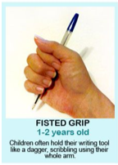 | 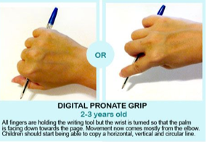 | 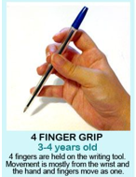 | 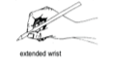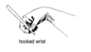 | 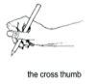 | 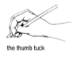 | 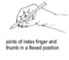 | 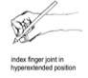 | 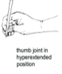 | 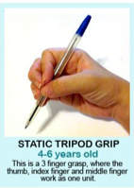 | 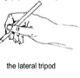 | 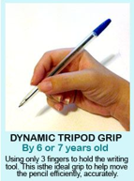  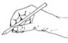
Pencil is held in the palm.  All fingers and thumb are used.  Movement is from the shoulder; the arm and the hand move as a unit.  Light scribbles are produced with this pencil grip. | All fingers are holding the pencil but the wrist is turned so that the palm  is facing down towards the page.  Movement comes mostly from the elbow and the shoulder is now  stabilized.  Horizontal lines, vertical lines and circular lines are able to be copied. | Fingers are held on the pencil shaft opposite the thumb, beginning to  form the arc between the thumb and index finger.  Movement occurs from the wrist; the hand and fingers move as a whole  unit.  Zigzag lines, crossed lines and simple humans can be drawn with this  grip. | A three-finger grasp, where the thumb, index finger and middle finger  work as one unit.  Movement is usually from the wrist with this static grasp.  A static quadropod grip has a fourth finger involved.  Triangles, circles and squares can be copied with this grip. |  |  |  |  |  |  |  | Pencil is held in a stable position between the thumb, index and middle  finger.  The ring and little fingers are bent and rest comfortably on the table.  The index finger and thumb form an open space. Movement comes from the fingertips.  This is the ideal grip to move the pencil efficiently,  accurately and for letter formation practice.
Develop small muscles and arches of the hands.  Develop wrist stability. | Work on a vertical surface to stimulate wrist stability.  Develop open web space. | Work on a vertical surface to stimulate stability in the shoulder, arm, wrist and hand. | Develop web space.  Develop finger opposition.  Develop thumb stability.  Inroduce tripod grip.  Triangle pencil grip may be used |  |  |  |  |  |  |  | No action needed

Prerequisites to handwriting
Before handwriting instructions can begin, children must have the following
•Small muscle development
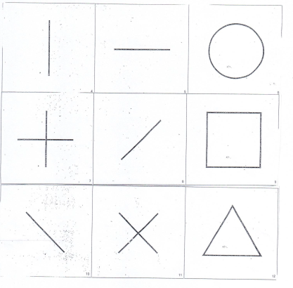
•Eye-hand coordination
•The ability to hold utensils or writing tools
•The capacity to smoothly form basic strokes such as circles and lines

•Letter perception, including the ability to recognize forms, notice likenesses and differences
•Orientation to printed language; which involves the visual analysis of letters and words and right-left discrimination

Developing open web space
The thumb web space is that space between your thumb and pointer finger that makes an “O” when you make the “OK” sign. In order to grasp small items with your thumb and index finger, you need to oppose the tip of your thumb to the tip of your pointer finger. Not only do the tips of the fingers need to touch, but the thumb must rotate at the joint closest to your hand. This opposition is needed to manipulate and grasp small items like shoe laces, buttons, and zippers.
When kids write or colour with that web space area squashed shut, it’s a sign of problems. Then might be compensating for thumb instability, underdeveloped hand arches, and/or poor strength. Each of these problem areas will lead to difficulties with handwriting, dexterity, manipulation of small items like beads, and pencil grasp.

Writing with a closed web space is inefficient and will cause poor and slow handwriting, especially as children grow and are expected to write at faster speeds. A closed web space while attempting to manage fasteners such as buttons and zippers will lead to fumbling and difficulty.
An important piece of an open thumb space is the components that make up the skill. These include arch development, opposition of the thumb to the pointer finger, rotation of the thumb CMC joint, and flexion of the MCP and IP joints.
To encourage arch development try these ideas:
Tearing small pieces of paper
Shaking dice within the hand
Rolling small pieces of play dough into balls

HERE ARE MORE EASY WAYS TO ENCOURAGE AN OPEN THUMB WEB SPACE:
Remember, while completing these activities, encourage the child to flex the thumb IP joint and to rotate the thumb to oppose the fingers. This promotes an open thumb web space, and not a squashed space!
Pushing small pegs into a pegboard
Pinching clothes pins
Tweezer activities
Popping bubble wrap
Connect 4 game
Using an eye dropper to transfer water
Stringing beads
Wind-up toys
Holding coins in hand and posting

