*Wycliffe Road*

*Urmston M41 5AH*

*Tel: 0161 748 4362*

*Email: admin.@urmstonprimaryschool.com*

*Headteacher: Mr S Parker* ***‘Growing Together. Empowered to be more’***

Friday 6th September 2024

Dear Parents and Carers,

**Reading at UPS!**

During a child’s time at Urmston Primary School, we do our best to promote a positive reading culture, where children not only learn the skills of reading and comprehension, but where we aim, every day, to foster a love and joy of purely reading for enjoyment where children can escape the real world and dive into one of thousands of imaginary worlds.

Throughout school, we aim to ensure that our children become competent and joyful readers, but this can only be truly achieved if reading occurs at home as well as at school and it becomes an enjoyable habit for our children. This will set them up on their journey towards the next phase of their education.

**Expectations**

It is with this in mind, that the expectation is you all ensure your children read at home. We do not always expect that all of this reading be heard by an adult in the house and in fact, actively encourage the children to read independently and manage their own time effectively, particularly as they move through the juniors. It may also be with an older sibling, grandparent, carer or even at after school clubs if time allows. However, we should all ensure that our children are reading at least three times a week - really, we’d like to aim for every day! It doesn’t have to be for long, but should be purposeful and not only help with children’s fluency and understanding but primarily nurture a love of reading and books.

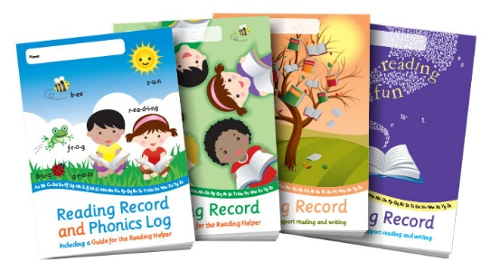**Reading Records**

Our reading record are more bespoke for each phase of your child’s reading journey. The middle pages of each reading record provide information for you to support your child as their reading skills develop. There are also extra activities that you may want to use to support your child further.

We do ask that **Reading Records are signed by an adult** in the house and are handed in by each child once a week to be checked by the teacher – although the day this is checked will be determined by your child’s teacher. It is important to note that this should firstly be the reading scheme book given by school, but we really want these to be supplemented with others that they can either be read to or read themselves – they could be magazines, leaflets, comics, newspaper articles, novels or short stories…anything that gets the children exposed to different types of texts. When you do this, and when you read with the children, whatever it is, do **please make a note of it in reading records** so that the adults in school can perhaps ask them about what they’ve read and pique their interest further. ***We have told the children that if their reading record is not up to date, we will be making a call to you at home to make expectations clear.*** This is something we hope we don’t need to do often, but we will do it nonetheless – reading is that important and we need your support with this.

**Bug Club - Using the printed books**

Inside every printed book there are notes to help you make the most of reading with your child.

**Inside front cover:** for younger children, these notes identify words with which children may need help and give ideas and strategies to help you feel confident that you know how best to help. For older children, the notes are intended to deepen each child’s understanding of the book. They provide background information about the time or place the book was written or sometimes information about the author or illustrator.

**Inside back cover:** these notes suggest puzzles and challenges that help children think about their reading. These include ‘Find it!’ activities that encourage children to revisit the text; ‘Share it!’ tasks that may involve making or writing something, and other ideas that offer ideas for further reading.

**Using the online reading world**

If you have access to an internet connection, your child can enjoy reading **Bug Club** books online as well as in print. Each child has a unique homepage and can log into it by following these steps:

1. Go to [**www.activelearnprimary.co.uk**](http://www.activelearnprimary.co.uk/)
2. Enter the login details.(Found in their reading record)
3. Your child’s homepage will appear.

**Reading a book online**

We allocate books to your child according to their reading levels. These books will appear in the ‘My Stuff’ area of their personal homepages.

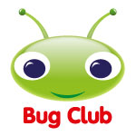Throughout the books there are quiz questions for your child to complete. To answer a question, just click on the bug icon. Your child does not need to finish all the quiz questions in one sitting and can come back to a book later.

When your child has finished all the quiz questions in a book, he or she will earn ‘ActiveLearn Coins’. By reading more books, your child will earn enough coins to ‘buy’ a reward in one of the many reward schemes. The answers to the quiz questions will be sent back to our teacher site so that we can see how your child is progressing. We will also be able to assign more books for your child to read if the virtual book bag is running low.

When your child has finished a book, it will move to ‘My Library’. Children can read these books again if they want to, or they can choose new books from ‘My Stuff’.

**Please also make a note of any books that you read online with your child in their reading record so that we don’t allocate a hard copy of a book that they have already read.**

**Getting involved**

**The reader**

Until they are fluent readers, younger children will benefit from reading aloud to you as often as possible. By the time they are in Years 5 or 6, many children prefer to read silently to themselves. Create quiet opportunities for them to do so, but then talk to them about the book they are reading.

**Sharing reading**

When sharing a book with your child, try to take opportunities to talk about the book - before, during and after reading.

**Before reading:** look at the book cover and talk about your child’s expectations. Is the book likely to be fiction or non-fiction? Have you read other books together about these characters or by this author? What does your child think the book is going to be about?

**While reading:** support your child when unknown words need tackling: you can sound them out, split them into syllables, or identify suffixes and prefixes. Remind your child to listen to the words while reading them, to make sure that they make sense. Have a ‘meaning check’ every now and again to ensure that your child understands the text.

**After reading:** talk about the book. What was it about? Did it match your child’s expectations? Ask questions beginning with the words *how* and *why* to check that your child has been able to read between the lines. Ask whether anything seemed puzzling. Then ask your child to explain what the best and worst bits of the book were, and why.

We thank you in advance for your continued support in helping the children at UPS to grow together and in empowering them to be more.

Yours sincerely,

*Mrs Hall (*English Lead*) and all the staff at UPS.*