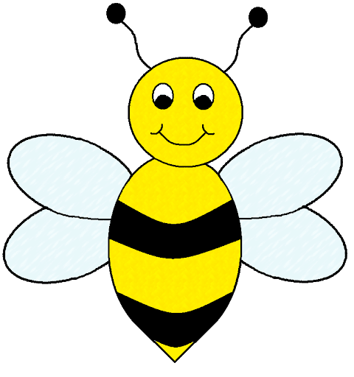

Helping your child

in Reception

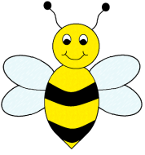

**Welcome to Reception!**

Reception is such a big year for the children! Not only are they experiencing school life for the first time but also learning new rules and routines, establishing new friendships, developing far more independence and building foundations for all of their future learning. It can be a daunting prospect for some children (and parents!) but please be rest assured! Your children are amazing little people who are far more resilient than we often realise, and will find their feet in no time at all!

This year is going to be slightly different due to the implications of Covid-19 so your child will not have as many opportunities to visit their new class and meet their new teacher as we would like. In some cases, this may cause greater anxiety than usual. We are fully expecting there to be some tears in the mornings! Leaving Mummies and Daddies can be very daunting when starting somewhere new and this is completely normal. We also know we’ll have some children who will skip through the door like they’ve been coming forever! The most important thing is that we put your child’s emotional well-being at the front of all we do. It is just as important to us as it is for you that your child feels happy, safe and comfortable in our reception environment and we will keep you informed at every step along the way as to how their transition is going.

This leaflet is designed to give you ideas of how you can help your child to succeed in Reception. It aims to give information about the sorts of things your child will need to be able to do, as well as highlighting the important role that you can play in your child’s education. We have tried to make the information as easy to follow as possible but if you would like to know more, then please come in and ask a member of staff.

Your support is greatly appreciated, and building a relationship between parents and our school is invaluable. We look forward to working together to help your children be the best that they can be!

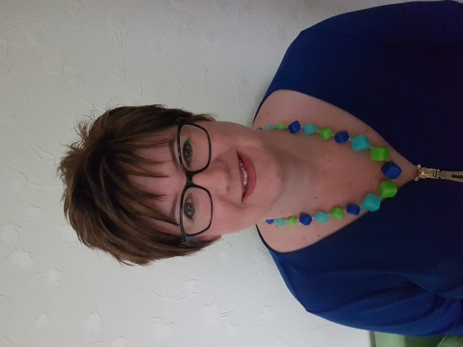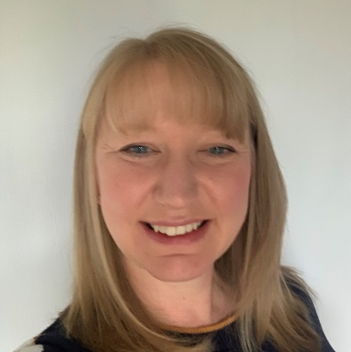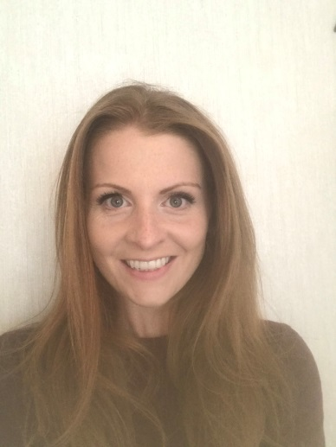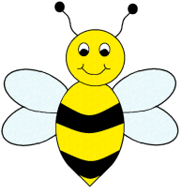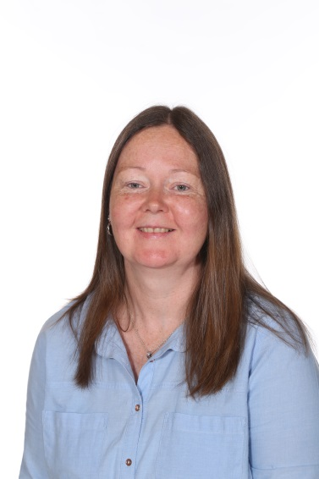

**Our Reception Team**

Mrs McNutt Mrs Pichford Mrs Czarnopis

(Class 5 Teachers) (Teaching Assistant)

Mrs Gilbert Mrs Spinks

(Class 6 Teacher) (Teaching Assistant)



Mrs Saint Mrs Peattie Ms Finan

(Class 7 Teacher) (Reception Teacher) (Teaching Assistant)



**Learning Journeys**

“The Learning Journey is a continuous journey through which children build on all the things they have already experienced and come across new and interesting challenges. Every child’s learning journey takes a personal path based on their own individual interests, experiences and the curriculum on offer”

Every child in Reception will have a Learning Journey online using ‘Tapestry’ (our learning journey and tracking provider), which celebrates their learning and achievements during their reception year at Urmston Primary School. You will receive login details to this, enabling you to look at a selection of photos/observations each term and make your own regular contributions. Their learning journey will contain observations, photographs and assessment of child initiated learning to highlight your child’s achievements. Each child will also have a writing book and a folder of their recorded work which will be sent home at the end of the school year.

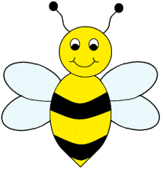

**Working Together**

We would love for you to be a part of this learning journey by contributing any of your child’s achievements at home as this will support us in creating a more complete picture of your child. This is best when it is behaviour / achievements your child has demonstrated completely **independently**. You can share this with us via Tapestry, advise us verbally, provide a photo, send in certificates and medals for us to look at, make a note in your child’s reading diary or fill in a wow moment sheet. We always love to hear all the wonderful things your child has been up to outside of school!

**Seesaw**

We use Seesaw as a means of communicating everything we get up to as a class during the week and any other messages directly from the teachers. You can download the Seesaw app or can access our page directly from our school website.

[www.urmstonprimary.com](http://www.urmstonprimaryschool.com)

(Click on ‘Children’ and then ‘Class I5, ‘Class I6’ or ‘Class I7’ to see what our children have been getting up to)

This is a great conversation starter to use with your children, especially when they tell you they can’t remember what they have done at school! We also send out a paper newsletter each week detailing our learning from the week.



**How to prepare for September**

* As we have been unable to invite you into our school this Summer for a look around, it would be a really nice idea for you to walk by our school with your child before September for them to have a little look at the building and playground through our railings.
* Please share the photos we will be sending to you of our school and staff with your child. If your child has any questions, please e-mail them to us and we’d be happy to answer them.
* Take a look at our current class webpage to see what this year’s Reception children have been getting up to.
* Let your child try on their new school uniform and school shoes before starting school.
* Let your child practise dressing and undressing in preparation for our P.E. lessons
* Encourage independence when putting on and fastening their coat
* Encourage your child to wipe themselves after using the toilet
* Teach your child about the importance of flushing the chain and washing their hands properly after using the toilet so that we don’t pass around any germs.
* Establish a good sleep routine for your child.
* Talk together! Talk to your child without distractions from the TV, radio or tablet. Talk about shared experiences that you have enjoyed such as visits, shopping trips, or things you have seen.
* Talk about the importance of healthy eating and discuss the weekly menu choices with your child.
* Recognise and talk through your child’s feelings and different emotions, this will help them to understand and communicate how they are feeling with staff.
* Sing songs and rhymes together to develop their vocabulary and awareness of rhyme, rhythm and alliteration.
* Read lots of stories together and talk about what has happened
* Play I-Spy
* Help your child get used to recognising their own name
* If you want to help your child write their own name, please teach them to start with a capital letter followed by lowercase letters, and encourage correct letter formations
* Practise counting together and look for numbers in the environment

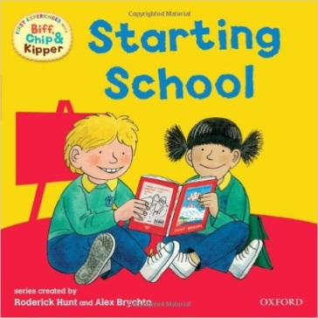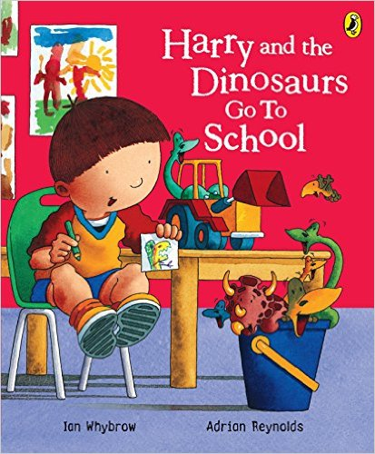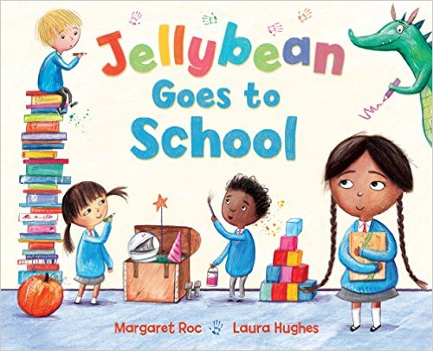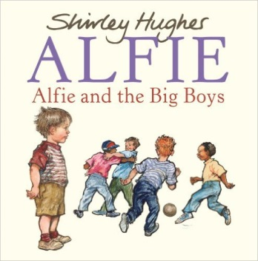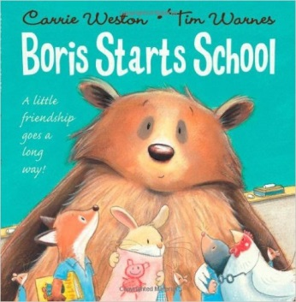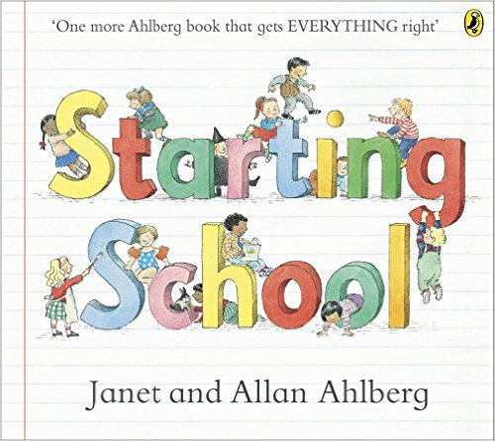

**How to prepare for September**

There are lots of lovely story books about starting school which you could share with your child:

**‘Starting School’** by Janet and Alan Ahlberg

**‘Boris starts School’** by Carrie Weston and Tim Warnes

**‘Alfie and the Big Boys’** by Shirley Hughes

**‘Jellybean goes to School’** by Margarer Roc and Shirley Hughes

**‘Harry and the Dinosaurs go to School’** by Ian Whybrow and Adrian Reynolds

**‘Biff, Chip and Kipper: Starting School’** by Roderick Hunt and Alex Brychta

**‘Topsy and Tim start school’** by Jean and Gareth Adamson

**‘Come to School too, Blue Kangaroo’** by Emma Chichester Clark

*You will be able to listen to recordings of most of these books on YouTube too.*



**EYFS Curriculum**

**The Early Years curriculum is split into 7 areas.**

**Prime areas**

* Personal, Social and Emotional Development
* Communication and Language
* Physical Development

**Specific areas**

* Literacy
* Mathematics
* Understanding of the World
* Expressive Arts and Design

These 7 areas are the broken down further into a total of 17 aspects of learning. Within each aspect there are objectives which the children work towards.

**Characteristics of Effective Learning**

Underpinning the Early Years Curriculum are the Characteristics of Effective Learning:

• Playing and exploring (engagement)

• Active learning (motivation)

• Creating and thinking critically (thinking)

Each area of learning has an Early Learning Goal that we hope your child will reach by the end of Reception. The children’s progress is closely monitored throughout the year so that interventions can be made for any children requiring a little more help.



**Personal, Social and Emotional Development**

**Children in the EYFS will learn to do the following:**

* Find ways to calm themselves, through being calmed and comforted by their key person.
* See themselves as a valuable individual.
* Build constructive and respectful relationships
* Express their feelings and consider the feelings of others.
* Show resilience and perseverance in the face of challenge.
* Identify and moderate their own feelings socially and emotionally
* Think about the perspectives of others.
* Manage their own needs.



**Personal, Social and Emotional Development**

How I can help at home:

* Encourage friendships with other children
* Have friends round to play
* Help your child to learn how to share and take turns
* Play board games
* Help develop your child’s interests and skills
* Provide opportunities for them to do things on their own
* Encourage independence
* Encourage your child to get dressed independently
* Talk about your feelings and how your child feels
* Be consistent in your approach to rules at home
* Make time for one to one interaction with your child
* Talk to them about their day
* Try new activities



**Communication and Language**

**Children in the EYFS will learn to do the following:**

* Learn new vocabulary.
* Use new vocabulary through the day.
* Ask questions to find out more and to check they understand what has been said to them.
* Articulate their ideas and thoughts in well-formed sentences.
* Connect one idea or action to another using a range of connectives.
* Describe events in some detail.
* Use talk to help work out problems and organise thinking and activities, and to explain how things work and why they might happen.
* Develop social phrases.
* Engage in story times.
* Retell the story, once they have developed a deep familiarity with the text; some as exact repetition and some in their own words.
* Use new vocabulary in different contexts.
* Listen carefully to rhymes and songs, paying attention to how they sound.
* Learn rhymes, poems and songs.
* Engage in non-fiction books.
* Listen to and talk about selected non-fiction to develop a deep familiarity with new knowledge and vocabulary.



**Communication and Language**

**How you can help at home:**

* See reading ideas and questions
* Play Simon says
* Ask questions about their day, interests, experiences
* Talk about what they have done, what they are going to do and talk about things happening in the future e.g. Holidays
* Join in with role play activities
* Act out their favourite fairy tale
* Make up their own stories
* Spend quality time talking e.g. over dinner, away from noise and distractions
* Talk about your day. Did anything funny happen?
* What was the best thing about your day?
* Talk about tomorrow or the rest of the week. Is anything exciting or interesting going to happen?
* Talk whilst out and about —things you can see, places things come from how things have changed over time, notices and pictures on walls, look at magazines and talk about the pictures, look at toys and talk about how they work, where you are going, what you expect to see, how you are feeling, things that have happened in the news.

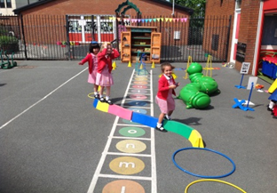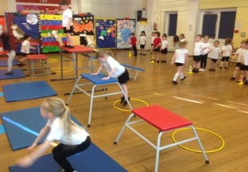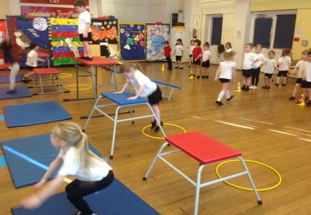

**Physical Development**

**Children in the EYFS will learn to do the following:**

* Revise and refine the fundamental movement skills they have already acquired: - rolling - crawling - walking - jumping - running - hopping - skipping – climbing
* Progress towards a more fluent style of moving, with developing control and grace.
* Develop the overall body strength, co-ordination, balance and agility needed to engage successfully with future physical education sessions and other physical disciplines including dance, gymnastics and sport.
* Develop their small motor skills so that they can use a range of tools competently, safely and confidently. Suggested tools: pencils for drawing and writing, paintbrushes, scissors, knives, forks and spoons.
* Use their core muscle strength to achieve a good posture when sitting at a table or sitting on the floor.
* Combine different movements with ease and fluency.
* Confidently and safely use a range of large and small apparatus indoors and outside, alone and in a group. Develop overall body-strength, balance, co-ordination and agility.
* Further develop and refine a range of ball skills including: throwing, catching, kicking, passing, batting, and aiming. Develop confidence, competence, precision and accuracy when engaging in activities that involve a ball.
* Develop the foundations of a handwriting style which is fast, accurate and efficient.
* Know and talk about the different factors that support their overall health and wellbeing: - regular physical activity - healthy eating - toothbrushing - sensible amounts of ‘screen time’ - having a good sleep routine - being a safe pedestrian
* Further develop the skills they need to manage the
* school day successfully: - lining up and queuing

- mealtimes - personal hygiene



**Physical Development**

How I can help at home:

**Essential skills**

* Encourage your child to get themselves dressed and undressed independently - using buttons, zip-ping up their own coat
* Teach your child about being hygienic e.g. washing their hands after going to the toilet, before touching food, after touching animals, etc.
* Talk about keeping safe whilst out and about e.g. crossing the road
* Encourage use of a knife and fork when eating
* Support your child in holding a pencil effectively
* Have fun at the park- climbing, balancing, managing risks
* Take your child out on a bike or scooter
* Obstacle courses
* Talk to your child about healthy eating
* Skipping
* Ball skills
* Dancing to different styles of music
* Play board games
* Encourage your child to help you with chores, e.g. washing windows, cleaning the car, sweeping up leaves.
* Threading
* Playing with play dough
* Writing their name using a pencil, paint, chalk outside
* Practise cutting skills

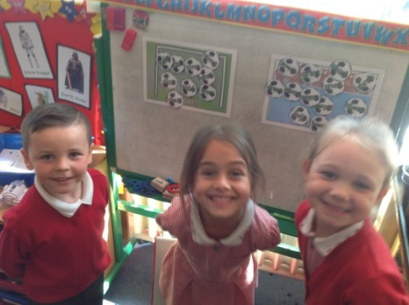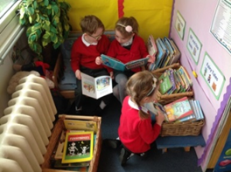

**Literacy**

**Reading**

**Children in the EYFS will learn to do the following:**

* Read individual letters by saying the sounds for them.
* Blend sounds into words, so that they can read short words made up of known letter– sound correspondences.
* Read some letter groups that each represent one sound and say sounds for them.
* Read a few common exception words matched to the school’s phonic programme.
* Read simple phrases and sentences made up of words with known letter–sound correspondences and, where necessary, a few exception words.
* Re-read these books to build up their confidence in word reading, their fluency and their understanding and enjoyment.

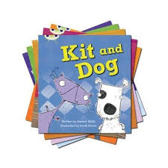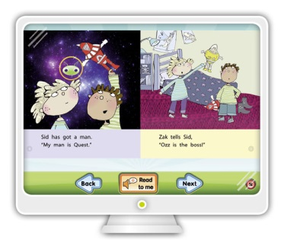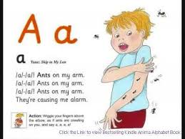

We teach phonics using the ‘Letters and Sounds’ phonics programme, along with the Jolly Phonics actions and rhymes.

You will be given a separate booklet detailing all of our phonics teaching and you will also be invited along to a Phonics Evening in the Autumn term.

Once your child has completed Phase 2 of Phonics, they will be sent home a reading scheme book that they will be able to read aloud to you. We use ‘Phonics Bug’ books initially and a little later in the year, you will also be given login details to the Active Learn website, enabling you to access additional e-books from the Phonics Bug scheme.

Your child will read individually with the teacher or teaching assistant for at least the first term. Following on from this, they will then take part in Guided Reading with the teacher each week. This is where the children work within a small group, all reading the same text. These reading sessions have clear learning objectives which the children are taught and then put into practice. Further information regarding Guided Reading will be sent to you as your child begins these sessions.

Your child will read individually with the teacher or teaching assistant for at least the first term. Following on from this, they will then take part in Guided Reading with the teacher each week. This is where the children work within a small group to read the same text. These reading sessions have clear learning objectives which the children are taught and then put into practice. Further information regarding Guided Reading will be sent to you as your child begins these sessions.

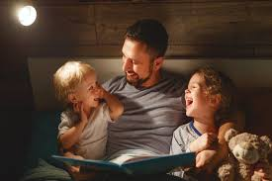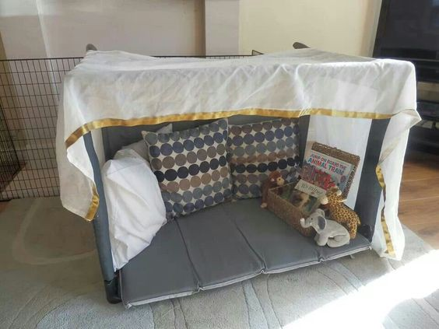

**Literacy**

**Reading**

**How you can help your child:**

* Set aside a special time for just you and your child
* Read/share with your child what they think will happen in the story from looking at the pictures
* Use the suggested questions (see over) with your child when reading.
* When out and about, encourage your child to read signs, instructions, etc.
* When reading unfamiliar words, break up the word into phonemes to sound it out and blend, e.g. c-a-t, sh-o-p,

c-oa-t.

* In the home encourage your child to read with you, e.g. recipe instructions, TV guide, cereal boxes, etc.
* Encourage children to sound out words which are new or have been in their reading books previously
* Join a library—it’s free!
* Read to your child or share books with them whenever possible.
* Encourage all members of the family to share and read books with your children
* Create a reading den!

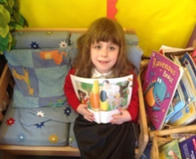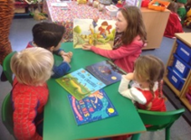

**Literacy**

**Reading**

**Suggested questions:**

**Fiction**

* Who are the main characters?
* What is the story about?
* How does the main character feel throughout the story? Which words show this?
* Which is your favourite part and why?
* Which character would you be in the story?
* How did X feel when………? Why?
* What do you think will happen next?
* How else could the story have ended?
* Which is your favourite character and why?
* Where is the story set?

**Non-Fiction:**

* Can you find a title?
* What is the book about?
* What is a contents page?
* On what page will we find X?
* Can you find bullet points?
* How do the pictures help?
* What is a glossary and why does it help you?

**General:**

* Where does the sentence start? How do you know this?
* Where does the sentence end? How do you know this?
* How many words are there in the sentence?

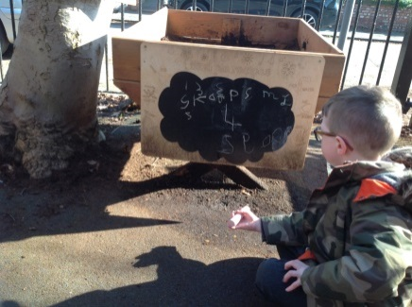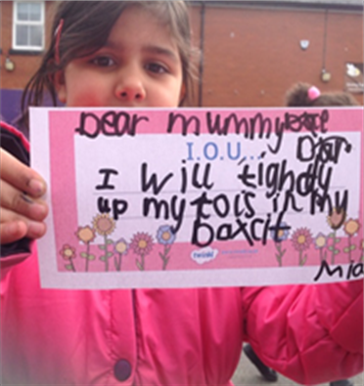

**Literacy**

**Writing**

**Children in the EYFS will learn to do the following:**

* Form lower-case and capital letters correctly.
* Spell words by identifying the sounds and then writing the sound with letter/s.
* Write short sentences with words with known sound-letter correspondences using a capital letter and full stop.
* Re-read what they have written to check that it makes sense.



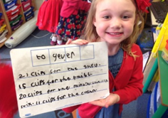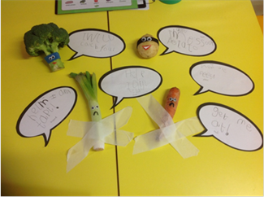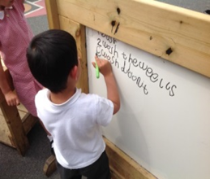

**Literacy**

**Writing**

**How I can help at home**:

* Ensure your child sits at a table to write

(Pencils are better for practising writing rather than pens)

* Use the correct letter formation
* Provide your child with a variety of opportunities to practise handwriting. Eg, writing birthday cards, notes, lists, letters, diaries.
* Use a variety of materials to write with—sand, paint, water, chalk
* Trace the letters for your child first and let them go over the top of your writing with a different colour.
* Give your child time to practise their handwriting.
* Make it fun - graffiti an old top, make a treasure hunt around the house with clues on post-it notes, make signs for bedroom doors, etc.

 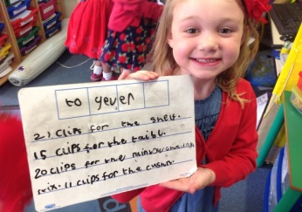

**Literacy**

**Writing**

**How I can help my child with writing tasks at home**

* Talk it through—share ideas and get the children to listen to your ideas.
* Write it together by sounding out the words.
* Remember, in Reception we expect much of the spelling to be phonetically plausible. It may not be spelt correctly but the spelling matches the spoken sounds, e.g. I can see a laideeburd.
* Help your child learn the spellings of the high frequency words we send home in book bags, especially the ‘tricky’ words.
* Encourage your children to write at home about anything that they want to.
* Share their writing and listen to what they have written.
* Find (if possible) a quiet space for your child to complete their writing.
* Create a writing box with special pens and paper.
* Perhaps you could treat your child to a special writing book and pencil. This could encourage your child to write more and is a lovely keepsake for you to see how their writing has developed.



**Mathematics**

**Children in the EYFS will learn to do the following:**

* Count objects, actions and sounds.
* Subitise.
* Link the number symbol (numeral) with its cardinal number value.
* Count beyond ten.
* Compare numbers.
* Understand the ‘one more than/one less than’ relationship between consecutive numbers.
* Explore the composition of numbers to 10.
* Automatically recall number bonds for numbers 0–10.
* Select, rotate and manipulate shapes in order to develop spatial reasoning skills.
* Compose and decompose shapes so that children recognise a shape can have other shapes within it, just as numbers can.
* Continue, copy and create repeating patterns
* Compare length, weight and capacity.



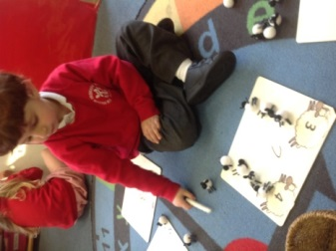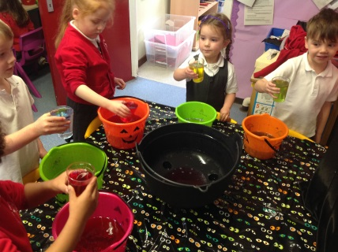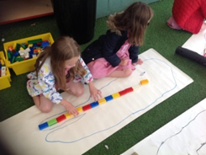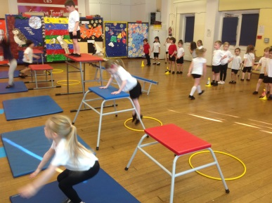

**Mathematics**

**How you can help at home**

**Have a go at the following activities:**

* Baking—weighing ingredients
* Finding numbers in everyday life
* Have a number hunt when walking to school or driving in the car, e.g. the first person to spot a number 8 is the winner!
* Sharing sweets
* Playing shop at home
* Use a calendar—what day is it to-day? What date?
* Bingo—you can cover all the areas of maths through this game
* Card games—Snap, Pairs and matching games
* Identify shapes in everyday life
* Complete jigsaws together
* Online activities-

[www.ictgames.co.uk](http://www.ictgames.co.uk)

[www.busythings.co.uk](http://www.busythings.co.uk)

[www.topmarks.co.uk](http://www.topmarks.co.uk)



**Understanding of the World**

**Children in the EYFS will learn to do the following:**

* Talk about members of their immediate family and community.
* Name and describe people who are familiar to them.
* Comment on images of familiar situations in the past.
* Compare and contrast characters from stories, including figures from the past.
* Draw information from a simple map.
* Understand that some places are special to members of their community.
* Recognise that people have different beliefs and celebrate special times in different ways.
* Recognise some similarities and differences between life in this country and life in other countries.
* Explore the natural world around them.
* Describe what they see, hear and feel whilst outside.
* Recognise some environments that are different to the one in which they live.
* Understand the effect of changing seasons on the natural world around them.

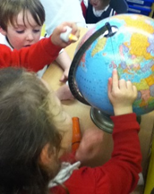

**Understanding of the World**

**How I can help at home:**

* Collect natural objects
* Go on nature walks
* Use the computer/ IPads
* Use the telephone
* Select a channel on the TV
* Bring in photographs from holidays or trips to share with the class
* Bake together and talk about the changes in the ingredients
* Talk about different environments and countries
* Talk about the weather and changes in seasons
* Discuss and find out about different animals, insects, dinosaurs, birds, people etc
* Involve your child when out shopping—encourage them to find items
* Encourage your child to ask questions about the world around them
* Ask them questions about the world around them
* Ask them questions about their experiences
* Talk about your own experiences past and present.
* Talk about different cultures
* Talk about similarities and differences between themselves and others

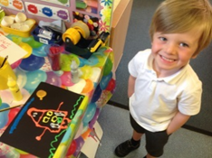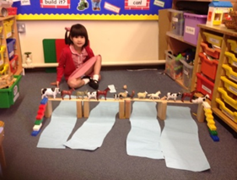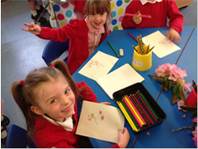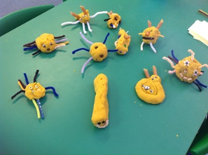

**Expressive Arts**

**and Design**

**Children in the EYFS will learn to do the following:**

* Explore, use and refine a variety of artistic effects to express their ideas and feelings.
* Return to and build on their previous learning, refining ideas and developing their ability to represent them.
* Create collaboratively, sharing ideas, resources and skills.
* Listen attentively, move to and talk about music, expressing their feelings and responses.
* Watch and talk about dance and performance art, expressing their feelings and responses.
* Sing in a group or on their own, increasingly matching the pitch and following the melody.
* Develop storylines in their pretend play.
* Explore and engage in music making and dance, performing solo or in groups.



**Expressive Arts and Design**

**How I can help at home:**

* Encourage your child to paint/ draw by providing them with different materials indoors and outdoors e.g. paper, pencils, chalk, paints, old sheets, wall paper, different sized brushes
* Play music to your child
* Dance to different styles of music
* Sing all different types of songs with your child
* Make dens outside
* Encourage all ideas of creative thinking
* Provide materials for weaving—ribbon, wool, string
* Let your child mix their own paints
* Make and play with play-dough
* Let them help you with painting
* Baking
* Use puppets to act out fairy tales and traditional stories such as The Three Little Pigs
* Experiment with different ways of making things such as using card, paper, cardboard—which works best
* Junk-modelling
* Explore different ways of attaching things together
* Let your child design what they are going to make

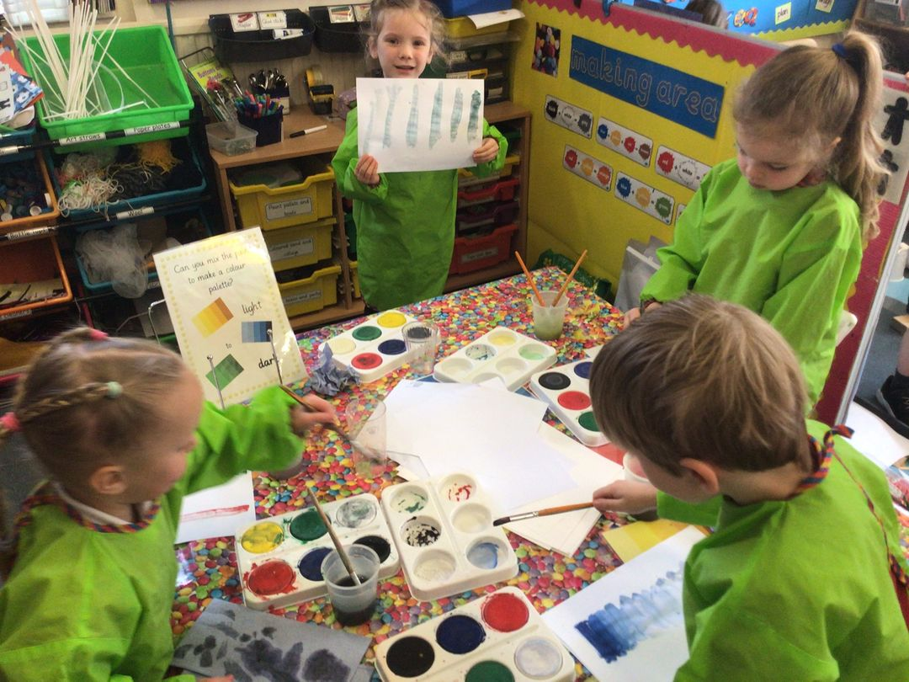

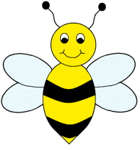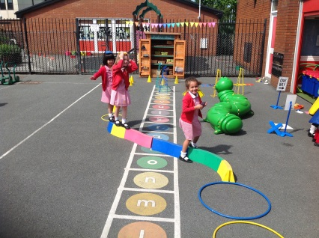

**What else you can do to support**

**your child at school**

* Encourage your child to be responsible for their own belongings
* Label their clothes
* Try to read little and often with your child and please sign their reading diary every time they have read a book with you
* Provide your child with a P.E kit which needs to be in school from Mondays to Fridays.
* Provide your child with a book bag and water bottle (water only please) which they can bring to school each day.
* Use our website to keep up to date with what is going on in school.

[www.urmstonprimary.com](http://www.urmstonprimary.com)

(Click on ‘Children’ and then ‘Class I5, ‘Class I6’ or ‘Class I7’ to see what we have been getting up to)

**Other Useful Websites**

* [www.ictgames.co.uk](http://www.ictgames.co.uk)
* [www.phonicsplay.co.uk](http://www.phonicsplay.co.uk)
* [www.topmarks.co.uk](http://www.topmarks.co.uk)
* [www.busythings.co.uk](http://www.busythings.co.uk)

(login details for Busythings available)