

**Relational Behaviour and Regulation Policy**

**OUR SCHOOL VALUES and VISION:**

**In our school we are kind, respectful, happy, responsible, proud and resilient and we work together to help everyone adhere to these values. More so than ever, we’ll all be living and learning by these values in our school, and promoting doing so by ‘being more’ at home**

Contents

Rationale 4

Rights and responsibilities 4

Principles 4

Active good behaviour 5

Roles and Responsibilities 5

Children 5

Staff 5

Teachers 6

Parents and families 6

Expectations 7

Class expectations 7

Whole school expectations 7

Approaches 7

A Graduated Approach 7

Individual and group intervention 8

Self-regulation 8

Emotion coaching 8

PACE/PLACE 9

Staff training 9

How do we encourage good behaviour? 10

‘Managing’ Behaviour 10

Rewards 10

In EYFS 10

In KS1 and KS2 11

Managing Out of Class Behaviour 12

Circle Time, class assemblies and ‘friendship groups’ 12

Equality Incidents 13

Opportunities to reflect, correct and grow 13

Conclusion 14

Our Vision for the Education of the children in Urmston Primary School 14

Appendix 1: A Restorative Approach 16

Appendix 2: Equity and Equality 19

Appendix 3: UN Convention on the Rights of a Child 20

Appendix 4: Expectations and Behaviour Pathway 21

Appendix 5: Emotion Coaching 23

Appendix 6: The PACE / PLACE approach 24

Appendix 7: Glossary of terms 25

# Rationale

At Urmston Primary School we have a positive, restorative approach to behaviour which is based on several key principles. These reflect our school values, our relationships with the children, and our awareness of their needs and experiences, particularly in being aware of attachment, developmental trauma and anxiety and how this may affect our children. A restorative approach (see Appendix 1) is underpinned by our values and is weaved into many of the processes set out in this policy and the day-to-day running of our school. Taking such an approach enables our children to learn about the importance of reflecting on their behaviours and their emotions, the impact they have on both their own and others’ wellbeing, and what they might do to enhance this. We utilise attachment aware and emotion coaching approaches in our everyday interactions with our children and apply the PACE/PLACE approach to ensure they feel safe, loved and confident enough to reflect on their feelings in a way which enables them to develop independence in effectively regulating their emotions. This will enable them to be in a more positive mindset to learn and grow, to become kind and responsible young citizens, and to enjoy successful and positive relationships.

# Rights and responsibilities

Urmston Primary is a UNICEF Rights Respecting School and, as such, recognises that children have the right to be cared for and to feel safe, to learn, to have a sense of belonging, and to achieve. In enabling these rights, it is everyone’s responsibility to look after each other and not to hurt others, to allow others to feel valued, to be included, and to learn through positive behaviours. The United Nations Conventions on the Rights of the Child can be found in the appendix.

# Principles

* To acknowledge **equity over equality** and that all children have different needs that may require different approaches (see Appendix 2)
* To work positively with each child to help their personal, social, physical and emotional development
* To be aware of the social, emotional, and communication needs of our children and
* To encourage our children to be ‘active’ in their good behaviour rather than passive
* To encourage our children to be independent and take responsibility for their own actions
* To encourage our children to reflect on their behaviour and consider the impact that it has on others in our school community
* To respond positively to appropriate or improved behaviour rather than to focus on unacceptable behaviour
* To reward appropriate or improved behaviour in line with a focus on a growth mindset and resilience
* To provide a consistent approach to behaviour management throughout the whole school, with a clear pathway in considering accountability, consequence, and taking responsibility for our actions
* To provide good adult role models who consistently model our school values and positive language
* To work with parents on all aspects on behaviour management

# Active good behaviour

At UPS, we believe that good behaviour comes in two forms: ***active*** and ***passive***. We understand that our children have their own personalities and behaviours and we celebrate

their uniqueness. Nonetheless, we will always praise active good behaviour.

Passive good behaviours in the classroom might be exhibited by those children who are quiet and don’t interrupt, whereas active good behaviour is illustrated by those learners who engage in the lesson, ask and answer questions, leading and supporting other learners.

Passive good behaviour in the playground might be shown by someone who doesn’t drop litter, whereas the action of removing the litter is positive in itself, especially in the influence that it can have upon others. The same goes for kindness – not being unkind is different to being pro-active and calling out unkindness. We feel that promoting and encouraging active good behaviour will help our community to thrive…and make the world a better place! Our children relate this to part of our motto, of ‘being more’.

# Roles and Responsibilities

***Everyone shares the responsibility to ensure positive behaviour is maintained in our school.***

## Children

In being members of our school family, children are to:

* Be ***kind*** to everyone
* Treat everyone with ***respect***
* Take ***responsibility*** for your own mistakes
* Be ***resilient*** in learning from your mistakes!
* Support everyone in being ***proud*** of themselves
* Realise that others do make mistakes and help them to put them right
* Work to the best of your abilities, and allow others to do the same
* Follow the positive example set by the school staff
* Take care of and ***respect*** property and the environment - in and out of school
* Co-operate and work together with other adults

## Staff

All staff at UPS realise that developing positive relationships is everyone’s business and we all have a responsibility to model what this looks like. Staff are prepared to listen to everybody’s perspective, with the intent to understand feelings, emotions and the needs of the children, and how these might impact on behaviours. They also realise that this should be done whilst maintaining clear boundaries and expectations. Our staff understand the principles of equity and equality and the children getting what they need, and are intent on promoting kind, respectful and responsible behaviour, and being consistent in reminding our children of their own responsibilities in maintaining the rights of others. Our Emotional Literacy Support Assistant (ELSA) and Inclusion Practitioner (IP) work with specific children as needed, both for behaviour and to assist in them identifying and regulating their emotions. Staff are to:

* Actively promote our school values
* Be ***kind*** to everyone, especially yourself!
* Treat everyone (both children and adults) fairly and with ***respect***
* Wherever possible, be aware of the experiences and emotional needs and anxieties of the children in order to interact appropriately.
* Raise the self-esteem of others (both children and adults) and help them to be the best that they can be
* Encourage and praise ‘active’ good behaviour and ‘being more’
* Use key active listening skills, especially when considering the restorative and PACE/PLACE approach and
* Provide a challenging, interesting and relevant curriculum that keep all children engaged and excited by their learning
* Create an environment that is both physically and emotionally pleasant, safe and secure
* Use rewards and sanctions fairly and consistently
* Be a positive role model, showing active good behaviours and praising those in others
* Foster relationships with parents so that all children can see that the key adults in their lives share a common aim
* Recognise that each person is an individual
* Be aware of each child’s needs

## Teachers

The class teacher has the responsibility of setting the tone, the structure and the procedures within their classroom, all with the intention of providing a safe and secure environment for the children to learn in. Teachers maintain high expectations of the children and are clear and consistent on their approach to managing behaviour, in order to allow the children to achieve their potential and demonstrate how to treat each other with kindness, with respect and with responsibility. It is important that in the absence of the class teacher, whoever leads the class takes on the same principles to maintain a culture of certainty and consistency.

## Parents and families

It is extremely important that our school makes expectations clear to our families and that our families will work with our school and the actions that we take...from the moment the child starts school. It is imperative that our children see the strong and positive relationships of mutual trust and respect that school and families have and that this can be a model for their responsible and respectful choices. Parents can discuss emotion coaching, self-regulation and restorative approaches with the class teachers and with the senior leadership team. School and home working together and having a consistent approach is integral to our children’s emotional and behavioural development. Parents are to:

* Remind children of our school values
* Make children aware of appropriate behaviour in all situations
* Encourage and praise ‘active’ good behaviour and ‘being more’
* Encourage independence, ***responsibility*** and self-discipline
* Show an interest in what their child does at school
* Foster a relationship with the school so that all children can see that the key adults in their lives share a common aim
* Be aware of the school values, rules and expectations
* Support the school in the implementation of this policy

# Expectations

## Class expectations

At the start of the school year, the class teacher will work with the children to set out expectations and a culture of positive behaviour,based upon positive language choices rather than on the negative. These will stem from our school values but provide clear expectations for what positive behaviour looks like (see Appendix 4).

## Whole school expectations

Whole school expectations are linked to, and consistent with, those displayed in Appendix 4. Children are expected to act kindly, respectfully and responsibly to ensure a safe and happy environment for everybody to learn together within.

# Approaches

Our aim is to support our children to be independent in ‘regulating’ their emotions so that they are able to access their best selves and show positive, collaborative behaviours, both now and in the future. The restorative approach supports this process, as does emotion coaching and the PACE/PLACE attachment aware frameworks.

## A Graduated Approach

It is incredibly important that we recognise the challenges that we face in education and in schools. We need to differentiate according to SEMH needs and intervene as appropriate, with this being monitored alongside the Assess-Plan-Do-Review (APDR) cycle laid out in our SEND policy. It is important to be aware of and consider the following:

* Indicators of SEMH should be clearly recognised to ensure that it is not just pupils who are displaying observable and active/’acting out’ behaviours. Pupils who display more passive behaviours (such as being withdrawn, disengaged, risk averse, anxious, refuse to accept praise, reluctant to speak) are in danger of going unnoticed because their behaviour might be less challenging to manage.
* Labelling or viewing pupils whose behaviour is externalised as ‘less vulnerable’ than those who internal possible emotional distress should be avoided.
* Early intervention is imperative for addressing both active and passive behaviours to ensure low level difficulties can be addressed early.
* There should be an awareness of the tendency to make judgements around behaviour (e.g. as ‘mad’ or ‘bad’), and to see all behaviour as an indicator of emotions that should be responded to empathetically and in a caring and sensitive way. This can be challenging when a child acts in a way that hurts or frightens others.

Children who are particularly vulnerable may need specific approaches tailored to their specific needs and their experiences, which again may link to attachment or developmental trauma. This may involve working with the local SENAS (Special Educational Needs Advisory Service) and Behaviour and Inclusion teams.

## Individual and group intervention

Above and beyond the universal support offered to all of our children, there will be times when further bespoke support is needed to support our children’s emotional, social and behavioural development. In some cases this may include one-to-one support, but it also may include intervention such as play therapy, lego therapy, drawing and talking therapy, or specific work with our ELSA or IP.

## Self-regulation

Children have always needed time to regulate their emotions and some find this more challenging than others, for all manner of reasons, be that their previous or ongoing experiences or their anxieties. Often, we may not be aware of these reasons, but it is our responsibility to support our children in managing their emotions in the most effective way that they can. Children in every class understand the zones of regulation and are prompted to recognise how they are feeling. In order to be fully inclusive, and in line with our SEND policy, there are all manner of resources and tools that we use to enable our children to regulate, which is needed due to anger, anxiety and numerous other emotions that could stem from a variety of triggers, both identifiable and not (some of which could well be linked to attachment or trauma). Special Educational Needs, including those who have diagnosed neurodiversity and those who may present with particular ‘traits’, mean that children may need myriad tools to support them staying attentive and helping them to learn. These may include time outs, regulations stations/wiggle zones, wobble cushions, weighted blankets, blue tac, fidgets, and other resources to support.

## Emotion coaching

Emotion coaching helps us support our children to understand, regulate and reflect on their behaviour. The language used enables us to further build positive, trusting relationships with the children and helps them to feel safe and supported, again with the intention of helping them to be independent moving forwards. It involves ***being aware*** of feelings and using language which ***recognises and empathises*** with the child’s emotions, ***validates these feelings***, helps children to ***recognise their behaviours*** and then look at ways to ***positively solve problems*** both at that point and in the future. Appendix 5 gives examples of the language used.

## PACE/PLACE

Being ‘attachment aware’ means empathy, connection, attunement, trust and co-regulation. It involves how we communicate with the children both verbally and non-verbally. An attachment aware approach involves using the acronym, **PACE**, a concept and means of communication developed by Dan Hughes.

**PLAYFULNESS** means creating an atmosphere of lightness and interest when communicating. It involves being open, ready, calm, relaxed and engaged.

**ACCEPTANCE** is about actively communicating to the child, that you accept the wishes, feelings, thoughts, urges, motives, and perceptions that are underneath the outward behaviour. Unconditionally accepting a child makes them feel secure, safe and loved.  
  
**CURIOSITY** is wondering about the meaning behind the behaviour of the child.  
Curiosity lets the child know that the adults understand and are interested in understanding them. Without judgement, children become aware of their inner life.  
  
**EMPATHY** is the adult, demonstrating that he or she knows how difficult an experience is for the child. The adult is telling the child that she will not have to deal with the distress alone. Empathy gives a sense of compassion for the child and their feelings.  
  
More recently, the acronym **PLACE** has been used, to indicate a fifth element: love.  
  
**LOVE** is about creating loving relationships – all children need love.

The rationale behind this is that when children feel safe and confident, they are more able to be reflective, to grow and to become more independent and resilient.   
  
More information can be found at https://ddpnetwork.org/about-ddp/meant-pace/

# Staff training

Staff CPD is integral to a positive school culture. Staff members want the best for their children and are reflective upon their practice. They are willing to express their desire for personal professional development with regard to the increasing variety of needs of our children and have. All staff have accessed training and briefings on various areas of special educational need, neurodiversity, attachment and developmental trauma, as well as metacognition and how our brains work differently, and what might trigger various mental and emotional responses. In addition, specific staff members have been on individual training courses including again, responding to attachment needs, responding to ADHD and autism in schools, girls and autism, sensory needs, trauma informed support, emotion coaching, and helping children to manage anxieties. Furthermore, our ELSA and IP have been on additional courses relating to their roles, including training on emotional regulation, sensory needs and neurodiversity, adverse childhood experiences, demand avoidance, trauma, attachment, bereavement and a host of other areas of need.

Training and professional reading is ongoing.

# How do we encourage good behaviour?

* Everyone will follow the school values of being **kind, respectful, happy, responsible, proud** and **resilient;**
* In all areas of school life, all staff will take responsibility for embedding our school values and positively promoting the expectation that these be adhered to;
* Class, year group, phase and key stage assemblies will be used to promote our values and the behaviours associated with these;
* Children will be encouraged to recognise positive behaviours in both themselves and others;
* School and classroom rules along with our ethos will be frequently revisited and discussed with the children;
* Improvements and achievements in behaviour will be noticed and communicated to the child and his/her parents;
* VIPs (‘Values In Practice’) will be peer role models and respected as such, guiding younger peers to act with respect and responsibility.
* **‘Extrinsic motivators’ such as stickers, parent postcards, ‘value points’, will given as initial motivators to further nurture a culture of intrinsic value in doing ‘what is right’ and following our school values.**

# ‘Managing’ Behaviour

## Rewards

The vision for our school is for our children to move on to secondary school wanting to be kind, respectful, resilient, responsible young people because it makes their own and others’ lives better. Children will be praised for positive behaviours. Common language and behaviours based upon our values will be used around school. We will place great emphasis on the children following our school values and behaving positively for its own sake – being **kind, respectful, happy, responsible, proud and resilient,** and the impact these values can have on others, is reward in itself. This is intrinsic reward.

However, our school realises that sometimes, ‘extrinsic motivators’ will help children along the way, celebrating and role-modelling our values and positive, active behaviour. Therefore, children will be rewarded accordingly through a variety of means, based upon the age of the children and the teachers’ discretion on what else might motivate them.

## In EYFS

The focus of our behaviour management will be on positive reinforcement and rewarding good behaviour. Throughout each day, staff will praise children for upholding our school values.

In Nursery, each child has their own little pot which they can collect ‘proud poms’ in. These are awarded by the teacher when they are proud of a child’s behaviour. When 5 poms are collected, they can choose a small prize from the teacher’s box.

In each Reception classroom, there is a rainbow, sun and thinking cloud displayed. Each morning, all children’s names will be on the sun. If a child shows that they are ‘being more’ by demonstrating actively good behaviour, this will be rewarded by asking the child to move their name to the rainbow. They can then write their name on a rainbow ticket and post it into the special box/bucket. At the end of each week, a name will be drawn from the box/bucket to receive a small prize. Children can put multiple tickets into the box throughout the day/week.

If a child demonstrates undesired behaviour, they will be given several reminders and a short restorative chat. If the behaviour continues, they will then be asked to move their name to the ‘thinking cloud’. This means they will have a longer restorative conversation with their teacher at the next available opportunity (usually lunchtime for morning incidents and the end of the day for afternoon incidents). Once this chat has taken place, they will move their name back to the sunshine for a fresh start. Importantly, it is made very clear what the purpose of the ‘thinking cloud’ is – to promote reflection about the choices that we make and how we might change them next time as we consider our school values.

## In KS1 and KS2

In KS1, a system of rewards has been introduced to clearly establish positive behaviours amongst our youngest children. Throughout our Infant Department the ***Rainbow Reward Chart*** is used. Whilst this is a whole class approach, it is done so in considering the needs of individual children, highlighting positive behaviours, and expectations based on their needs.

As a child moves along the rainbow for displaying our school values, they receive a rainbow sticker that they can place on their rainbow charts. Once a child receives five rainbow stickers, they receive a certificate during assembly. This ‘extrinsic motivator’ is used a means to promote intrinsic positive behavioural choices linked to our school values.

Each class in the Junior Department has its own system for managing the behaviour of their children in class and are used as each class teacher deems appropriate. However, consistency in managing behaviour is maintained through the whole school system (see Appendix 4)

Examples of rewards across the whole school might be:

* Verbal praise
* Parent postcards
* ‘Bee Awards’
* Value points
* Privileges
* Allocation of monitor roles
* Extra playtimes
* Speaking to parents
* Sending to other staff for positive attention
* Peer praise

***Value points*** are given to individual children and to classes when they display particular values. These class totals are tallied up and shared in Friday’s assembly so we can see which have illustrated the most kindness, happiness, respect, resilience, responsibility and pride, as well as looking at how we are doing collectively in working together as a whole key stage and a whole school…’being more’ to make our school community and happier place to be.

In addition, across the school, ***Values Badges*** are awarded to individual children for when they have demonstrated ‘being more’ with a particular value. When they collect all of these badges, they receive a UPS keyring.

## Managing Out of Class Behaviour

We believe that every effort must be made to ensure that the values and expectations of the classrooms are echoed around the school and at lunchtimes and playtimes. Children are expected to move around the school buildings quietly and calmly, showing respect for their surroundings.

Across the school, if children are aggressive at play times and physically harm another child, they will immediately be sent to a member of SLT and their parents called straight away.

The behaviour management of lunch staff also forms an important part of a safe and calm culture. All staff have been briefed on the needs of children, particularly in considering children’s neurodiversity and the language used when we to talk to children. Lunchtime staff communicate issues to the class teacher with an SLT member being out to support larger issues that may arise. Lunch staff also give out ‘values points’ mentioned below, for those children who display those particular values.

VIP (‘Values In Practice’) pupils are instrumental in promoting active good behaviour at UPS. They are responsible for modelling our school values and supporting other children in the way they play and manage their relationships and feelings.

# Circle Time, class assemblies and ‘friendship groups’

All classes, including the Nursery, participate in regular Circle Time or ‘class assemblies’. These provide opportunities to reflect upon our ethos and to raise children’s self-esteem.

All circle times/class assemblies have a clear structure. This includes games to encourage positive relationships; activities that focus on our school values; problem solving which encourage children to listen to each other and celebration of successes. Circle Time/class assemblies occasionally focuses on lunchtime behaviour.

Children also have ‘friendship groups’. These groups offer much the same opportunity but involve the children moving to their own groups including different year groups in their key stage, providing them with the opportunity to talk about whole school issues, giving them a further voice, and enabling staff the chance to promote discussion on debate on our school values, current affairs, and how we can make our school, our community, and our world a better place by ‘being more’.

# Equality Incidents

All racist, homophobic or sexist incidents are treated in a serious manner and in line with the school’s Equity and Equality Policy.

# Opportunities to reflect, correct and grow

In life, we all make mistakes and it is our job to support our children in taking responsibility for their actions so that they can reflect and make informed choices that benefit themselves and others in the future.

There are no punitive measures that we take at Urmston Primary. Every behaviour that our children present with is for a reason and it is imperative that this comes with an opportunity to reflect and grow. Appendix 4 shows what might happen as a result of our children’s behaviours, all providing that restorative opportunity to grow and improve as young people.

It should be noted that not all actions taken by staff are made common knowledge. There are times where discretion is key and both children and parents should acknowledge that they might not find out about all of the actions taken with other children following the behaviours that they display.

Behaviour incidents should be discussed individually with the child and where appropriate, logged on the school’s online communication system, CPOMS, so that any patterns emerging can be identified to help appropriately support that child. If children have either repeatedly shown decision-making that does not adhere to our school values, or have been involved in an incident of inappropriate behaviour, they may be asked to complete a restorative thought sheet, providing them with the opportunity to reflect upon their actions with a view to putting things right. The teacher, or a member of SLT, will use this as a stimulus for facilitating a restorative conversation so that reflection and growth can take place.

The class teacher should discuss repeated behaviour issues with the Deputy Head or the Headteacher. Repeated or serious negative behaviour should be discussed with parents, and parents and the school will work together to help the child reflect and improve their behaviour. Where necessary, this may include daily feedback, targets charts or behaviour action plans**.** In extreme circumstance, suspension or exclusion may be discussed with parents. Should this need arise, school will follow national guidelines and liaise with the local authority inclusion and behaviour teams. Where children need additional support to help manage their behaviour, provision is established through consultation with the child, parents and class teacher. This may also include advice from the school’s SENCO or external agencies, such as the educational psychology service. A consistent school approach ensures effective transition between schools and other institutions and effective strategies for managing the behaviour of individual children will be passed to the next teacher and receiving school.

# Conclusion

At Urmston Primary School we see behaviour as encompassing all aspects of school life. We do not see it as an area which is ‘bolted on’ to the curriculum, or as a separate part of school life, but part of our positive, safe and loving culture and the following of our school values throughout our curriculum. We believe that all people involved with our school - teaching and support staff, children, parents and governors - share a responsibility for the effective implementation of behaviour strategy at Urmston Primary School. If this responsibility is acknowledged by all it will undoubtedly lead to a better standard of education and quality of experience for all our pupils at Urmston.

It is our aim that children leave our school with strong values, take responsibility for their own actions and learn from them. We hope that they move on to secondary school making their own choices because they are right ones, rather than because they might get into trouble if they don’t follow the rules. We hope that the empathy that we aim to embed will enable children to reflect and realise the impact that their positive and negative behaviour has on themselves and on others in society. Furthermore, it is our hope that we can nurture empathy amongst our pupils for those whose behaviour can be challenging and even aggressive. We intend to do this by reminding our children that we all have our own stories…we don’t always know what is going on in each other’s lives to lead us act in the way we do.

# Our Vision for the Education of the children in Urmston Primary School

At the centre of all we do are our children. We are committed to recognising the important and unique nature of their needs at this, the start of their learning journey, and we aim to provide them with the best possible start to their education, preparing them for their future. Expectations of everyone are high and the careful planning of a rich and diverse curriculum, tailored to the distinct needs of our children, allows all to meet challenges, reach their potential and to achieve success. The learning, teaching, achievement and attitudes of every child matter regardless of individual talents and limitations.

We are a learning community with a vision shared by all and a commitment to providing a caring and happy environment in which children can learn and develop. Our children have only one childhood and it is our duty to make their learning experiences vivid, real, challenging and enjoyable.

***This policy should be read in conjunction with our policies for safeguarding, equality, anti-bullying and e-safety.***

**Date of policy: September 2024**

**Review date: Autumn 2025**

**Headteacher: *Simon Parker***

**Chair of Governors: *Stephen Smith***

# Appendix 1: A Restorative Approach

**What is Restorative Practice?**

Being ‘Restorative’ focuses on building positive relationships based on our school values, particularly in being ***responsible*** for our actions and showing ***respect*** for others. In turn this creates a community that is supportive, accountable and respectful and supports our children in making positive choices because it is right, not because they’ll get into trouble if they don’t! We believe that every individual is responsible for their own behaviour. The Restorative framework is based upon ‘knowing the effect that I have on others’. Making changes to the way we approach incidences and issues provides children, and others, the opportunity to think about how they relate to each other and how they can find positive ways of repairing harm caused, rather than focusing solely on punishing poor behaviour or individuals avoiding taking responsibility for their actions. Children and adults are encouraged to put things right together. We understand the importance of modelling positive language and behaviour and take time to develop positive and meaningful relationships with colleagues and pupils. When positive relationships are developed and connections are made individuals are less likely to cause harm to others or choose to damage relationships.

A restorative approach encourages children to reflect upon their behaviours and the impact that it has on others. Through facilitated dialogue and negotiation, relationships can be repaired and apologies can be made. As a result, the needs of all of those involved are met and important learning through sharing thoughts and feelings takes place.

***What skills are needed to facilitate and partake in restorative dialogue?***

The dialogue that takes place requires the ability to:

* Establish a respectful rapport with people;
* Listen and respond calmly, empathically and without interruption or judgement to all sides of an issue;
* Inspire a sense of safety and trust;
* Encourage people to express their thoughts, feelings and needs appropriately;
* Appreciate the impact of people’s thoughts, feelings, beliefs and unmet needs on their behaviours;
* Encourage those involved in the problem to find their own solutions.

**The Restorative Approach - Dealing with inappropriate behaviour**

Incidences of negative behaviour are dealt with in a fair, ***respectful*** and appropriate way, with the key focus on individuals taking ***responsibility*** for their behaviour, repairing any harm done, rebuilding and restoring relationships. The key principle when dealing with issues is to give all the people involved a chance to have their say and become actively involved in the process. ***All members of staff and children will know that issues will be dealt with fairly with a ’no blame’ approach.*** When there have been incidences between two children, key questions will be asked to find out what has happened and how the individuals involved can make things right again, or repair the harm caused. Our aim is not to ask ‘Why?’ something has happened but to determine what has led up to an issue and resolve it in a positive way. Those involved in an incident are taken through a ***restorative dialogue*** and are therefore supported in coming to understand the harm that has been caused to all parties. These dialogues will often be facilitated by a member of staff as soon as possible after the event.

This learning framework can be used in a wide range of contexts:

* A one way conversation with one person listening and asking questions and the other talking;
* A two way conversation, with both people taking turns to ask and answer questions;
* ***A small meeting when one impartial person – a facilitator – poses questions to two people who have had a difficulty, or when harm has been done, and who want to repair their relationship;***
* A larger, facilitated meeting involving children, parents/carers, colleagues or others who have an important role to play (a ‘Restorative Conference’);
* A facilitated circle involving part of or all of a class, a staff team or a group.
* These contexts may be led by any member of teaching staff and responsibility may often be passed on to a member of the Senior Leadership Team.

**The Restorative Questions:**

Although restorative dialogue involves sharing thoughts and feelings and being listened to, the conversations are very much based upon a structure which allows all staff members to be consistent and fair in their facilitation, using the relational skills mentioned previously. Restorative dialogue will include the following questions which have been shared and discussed with staff:

***What happened?***

Drawing out each person’s story one at a time, starting with the person who has caused the harm. The aim is not to come to a definitive conclusion on what has happened, but for each person to have their point of view listened to.

***Why did it happen?***

Giving each person the opportunity to explain the motivations and reasons for the incident with a key focus on each taking responsibility for the part that they played.

***How do you think this person feels about what has happened?***

***What do you think and feel about that?***

Enabling each person to state what they were thinking and feeling at the time, before and since, who has been affected and how?

***How do you feel now after listening to how your actions have made this person feel?***

Encouraging reflection and how actions affect others.

***Who else has been harmed/affected and how by your actions?***

Encouraging children to think about the wider implications of who has been affected (e.g. families)

***How do you feel about what this person has said?***

Encourages further dialogue and offers the person affected the chance to respond.

***What do we need to feel better, move on, repair harm and rebuild relationships?***

***What do you think needs to happen next/to make things right with each other and with the school community?***

Empowers children further in considering what any next steps/sanctions might include.

**How do those people agree and negotiate meeting the needs identified above and what support might they need to do this?**

Staff support pupils in this process but try to ensure the pupils form their own agreement when possible. The children can consider how they can make appropriate amends in line with the values of our school community and the sanctions set out in our behaviour policy. This approach encourages those involved to identify ways in which a relationship can be repaired or how they can move forward. By giving pupils this responsibility we are empowering and supporting them in developing their own strategies for avoiding and resolving conflict. We also believe that if pupils reach their own agreement as to how to move forward after a conflict, they are more likely to abide by it than if it is suggested by an adult or imposed upon them. By involving the pupils in the design of the agreement we give them ownership over it and ensure it is helping them to resolve the situation and make amends in their own way. All staff working within our school use active listening skills when dealing with a conflict. This enables them to draw out more from those involved.

**The Restorative Approach and use of consequences**

When using consequences at Urmston Primary School, the child(ren) should always be involved in a restorative conversation and be an active part of deciding upon any consequences, ensuring they are constructive and allow the child to learn from what has happened, as opposed to a sanction being imposed and the child seeing themselves as the victim of punishment. We aim to help the children look out at the harm they have caused to others and see that their sanction is a way of putting things right with the person who has been hurt, as well as with the school community, which expects a high standard of good behaviour. Some children with social, emotional or mental health difficulties require time to calm down and this is an important part of developing a child's self-management skills. ‘Time outs’ can be offered to children before an incident is dealt with.

**Implementation of the Restorative Approach – Practicalities**

At Urmston Primary School, we recognise that all children are unique individuals and therefore we are flexible in the manner in which we address any incidences of negative behaviour. The stages of the Restorative Approach underpin our method in dealing with behaviour issues but we are conscious that we adapt our approach to ensure it is suitable for the pupil’s age and level of understanding. When working with pupils in the Early Years Foundation Stage our focus is on the initial stages of the Restorative Approach. Staff working with these pupils focus on helping them to grasp the concepts of feelings and how they are caused. Modelling, small group work, peer support and visual resources such as photographs are all used to support the pupils’ understanding and development of empathy. This approach is also adapted for other pupils throughout the school. Pupils with low levels of emotional maturity or with Special Educational Needs can require support in recognising how their actions have affected others or how they feel about an incident. Pupils are supported in developing their understanding of the Restorative Approach using tailored resources, lessons and at their own pace. Children identified as having significant social, emotional or mental health needs may require an alternative approach, which will be discussed and decided upon by the team around the child on an individual basis. Staff use their discretion and knowledge of the pupils involved to determine how best to implement this approach and who to involve.

# Appendix 2: Equity and Equality

Being fair is not about giving everyone the same (equality), but rather giving everyone what they need (equity). The image below should speak for itself.

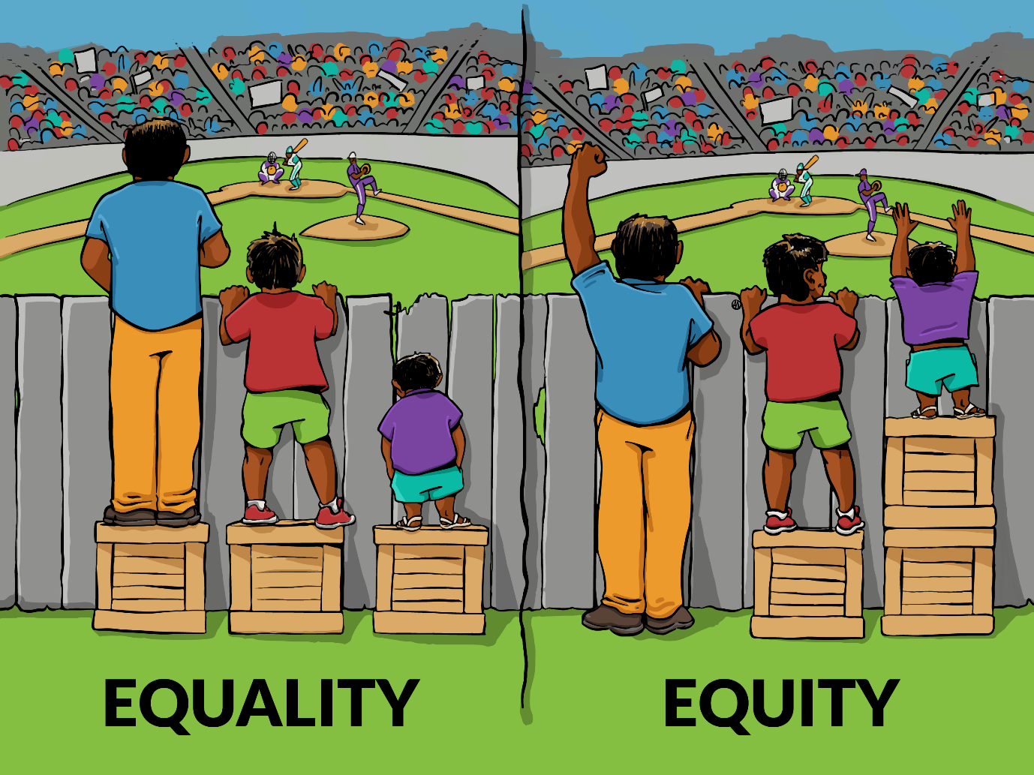

# Appendix 3: UN Convention on the Rights of a Child

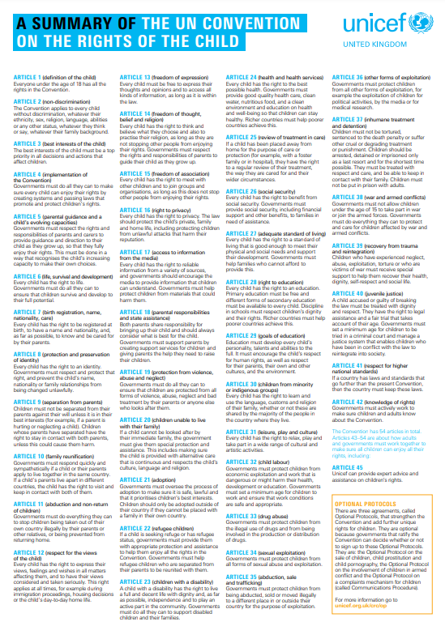

# Appendix 4: Expectations and Behaviour Pathway

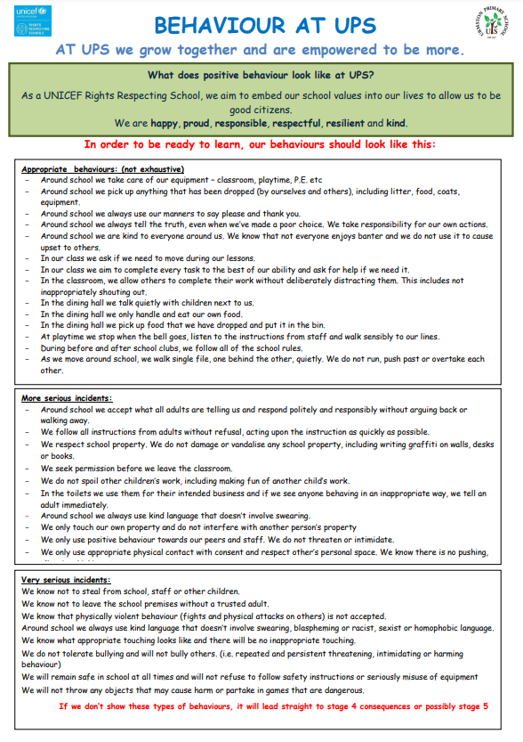

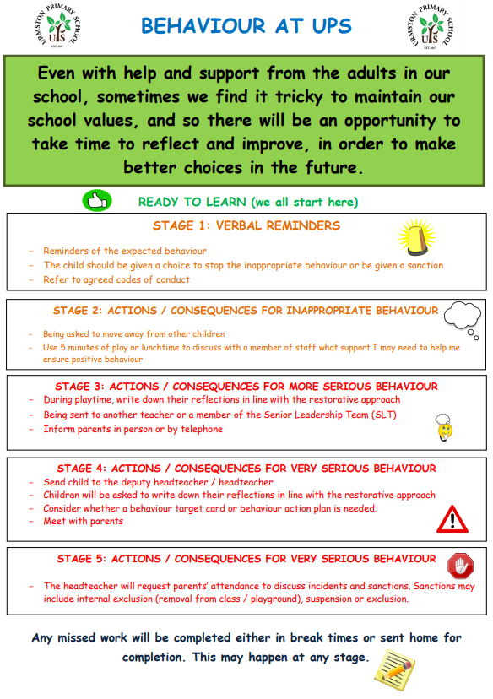

# Appendix 5: Emotion Coaching

**Validation of emotions (empathetic listening)**

*Labelling*

Look for physical and verbal signs of the emotion being felt; Take on the child’s/young person’s perspective; Use words to reflect back child’s emotion and help child/young person to label emotion.

*“I wonder if you are feeling angry.”*

*“I can see that you are…(describe what you can see)”*

*“I wonder if you might be feeling angry?”*

*“The way you are feeling is making you/made you angry.”*

*“You’re angry about…”*

*“I know you are feeling angry…”*

*“I can see that something’s not quite right – can you tell me about it…”*

*Empathising*

Affirm and empathise with the emotion; allow to calm down.

*“I’m sorry that happened to you, you must have felt angry.”*

*“I can see that you get angry when that happens/when I do this.”*

*“I would feel angry if that happened to me.”*

*“That would make me angry.”*

*“I understand why you are angry.”*

*“It’s normal to feel angry about that.”*

*“It’s ok to feel angry about that.”*

*“I get that you are angry.”*

*“I can understand you’re feeling angry – I would too.”*

*“I know you’re feeling angry – I would feel the same.”*

*Limit setting (where necessary)*

Separate emotion from the behaviour (actions); clarify what is acceptable expression of emotion i.e. behaviour and what is not – set the limit; allow to calm down.

*“It’s ok to feel angry, but we use kind hands in school.”*

*“I can see that you feel annoyed. It isn’t kind to shout at your teacher.”*

*“You are probably feeling cross because you want to go and play outside with your friends. Remember, we need to show that we are feeling calm and ready to listen first.”*

*Problem solving*

*Exploring*

Exploring the feelings that give rise to the behaviour/problem/situation etc. – be specific.

*“How were you feeling when that happened?”*

*“What did it make you feel like?”*

*“Have you felt that way before?”*

*“What does your body feel like?”*

*“What feelings are you having?”*

*“What does it make you want to do?”*

*“Can you remember what happened to make you feel like that?”*

*“Can you tell me what happened?”*

*‘Problematising’*

Identifying alternative, more appropriate and more productive ways of expressing and/or managing feelings and behaviour/actions; Empowering child/young person to recognize feelings, behaviour and taking ownership/responsibility of actions and finding ways to self-regulate in future.

*“Let’s think of what we could have done instead.”*

*“Can you think of a different way?”*

*“Can you remember feeling this way before and what you did?”*

*“Have you thought about doing this instead?”*

*“Can you remember what we said before?”*

*“How did you handle it last time?”*

*“What did you do last time this happened?”*

*“Can you remember what we discussed last time?”*

*“Can you remember how you solved it before?”*

*Solutions*

Agreeing possible solutions – scaffolding suggestions where appropriate

*“Try and do this next time you feel like this.”*

*“Let’s decide what you will do next time you feel like this.”*

*“What do you think you can change next time?”*

*“What could you try next time?”*

*“Can you remember what we agreed…?”*

*“Can you try…next time?”*

# Appendix 6: The PACE / PLACE approach

The link below provides examples of the approach and the language used to enable our children to feel safe and confident in reflecting on the behaviours and to grow increasingly independent:

<https://www.oxfordshire.gov.uk/sites/default/files/file/children-and-families/PACEforteachers.pdf>

# Appendix 7: Glossary of terms

**ACEs:** Adverse Childhood Experiences that may affect a child’s feelings and behaviours

**APDR:** The Assess-Plan-Do-Review cycle of support which aims to address children’s special educational needs and disabilities. These are dynamic but reviewed with parents and carers termly.

**Attachment aware:** Having an understanding of how trauma may affect children and their brains. It is about knowing the children well and having a careful balance of nurture and gentle challenge.

**‘Being more’:** Our UPS motto. It means active positive behaviour to make our own and others’ lives better through our kindness, respect, responsibility and often our resilience.

**Developmental trauma:** A term used to describe the impact of early, repeated trauma and loss which happens within the child’s important relationships, and usually early in life. Types of trauma are broad, can be complex, and will impact different children in different ways.

**ELSA:** Emotional Literacy Support Assistant – a specifically trained, skilled, knowledgeable and experienced member of staff who works with children to support their emotional development.

**Emotion coaching:** helps us support our children to understand, regulate and reflect on their behaviour. The language used enables us to further build positive, trusting relationships with the children and helps them to feel safe and supported, again with the intention of helping them to be independent moving forwards. It involves ***being aware*** of feelings and using language which ***recognises and empathises*** with the child’s emotions, ***validates these feelings***, helps children to ***recognise their behaviours*** and then look at ways to ***positively solve problems*** both at that point and in the future. Appendix 5 gives examples of the language used.

**Equality:** Giving everybody the same

**Equity:** Giving people what they need

**Extrinsic motivator:** Driven by external reward rather than simply doing what is ‘right intrinsically’. Often used as a means of enhancing an understanding of intrinsic motivation and positive behaviours.

**Intrinsic reward/motivation:** Doing something because it is enjoyable and satisfying rather than for external recognition or reward.

**IP:** Inclusion Practitioner – a well-trained, skilled, knowledgeable and experienced member of staff who works with vulnerable children, SEND pupils and those who may need social and emotional support for anxiety, self-esteem, etc.

**Metacognition:** An awareness and understanding of thought processes and how the brain works to retain information. Often referred to as ‘thinking about thinking’.

**Neuro-diversity:** A word used to describe the different thinking styles that affect how people communicate with the world around them. It is an umbrella term - a word that sums up lots of different things. It includes conditions like autism, ADHD, dyslexia, dyspraxia, dyscalculia and tourette's.

**PACE/PLACE:** A concept and means of communication based on playfulness, acceptance, curiosity, empathy and love. When children feel safe and confident, they are more able to be reflective, to grow and to become more independent and resilient.

**Self-regulation:** A term used to explain the importance of children being able to reflect upon and manage their emotions through various strategies.

**Relational Behaviour approach:** A belief that through positive relationships, children learn to feel safe, belong, understand themselves, others and the world.

**Resilience:** One of our school values. A holistic term used to describe an acknowledgement of the importance of making mistakes, learning from them and growing because of them. It is also a recognition that when things don’t go the way we would have liked, there are things that we can do to help us move on and grow.

**Sensory needs:** Sensory experience is how we all understood the world around us. It is important to recognise that at times we all seek sensory information that makes us feel better and sometimes we retreat from sensory information if it makes us feel overwhelmed. It is also important to remember that we all interpret sensory information (touch, sights sounds, tastes) differently and this can affect how we think, feel and behave.

**SEMH:** Social, Emotional and Mental Health

**SEND:** Special Educational Needs and Disabilities

**SENAS:** Local Special Educational Needs Advisory Service who support and advise schools on how they might provide the best support for their children.

**Zones of Regulation:** The use of four colours to help children self-identify how they are feeling and helps them to self-regulate. It supports children in recognising their own triggers, learn to read facial expressions, develop problem-solving skills, and become more attuned to how their actions affect other people.