

Reception Weekly Learning Update
19th September 2025
First Full Week
Well, we sure do have some tired boys and girls! Well done for completing your first full week. Although a lot of children have been to other settings before, a school day is very different to what they are used to. The children are remembering so many new rules, new routines and lots of new names and faces. This is all very tiring. We hope you have a restful weekend!
The Colour Monster  We read the books ‘The Colour Monster’ and ‘The Colour Monster goes to School’ this week to introduce the language of emotions. We have introduced lots of alternative vocabulary for the feelings of happy, sad, angry, calm and scared and have started to talk about what these emotions feel like and how we can try to change our feelings. The children have enjoyed collaging, painting and drawing colour monsters throughout the week too. | Maths  This week, we have started some maths teaching based on sorting and identifying sets. The children learnt that when objects are grouped together, this is called a set. This could be sets of toys, sets of colours etc. They also learnt that there are different ways to sort objects into sets eg you can sort objects by colour or size or shape. Maybe you could have a go at this activity at home….  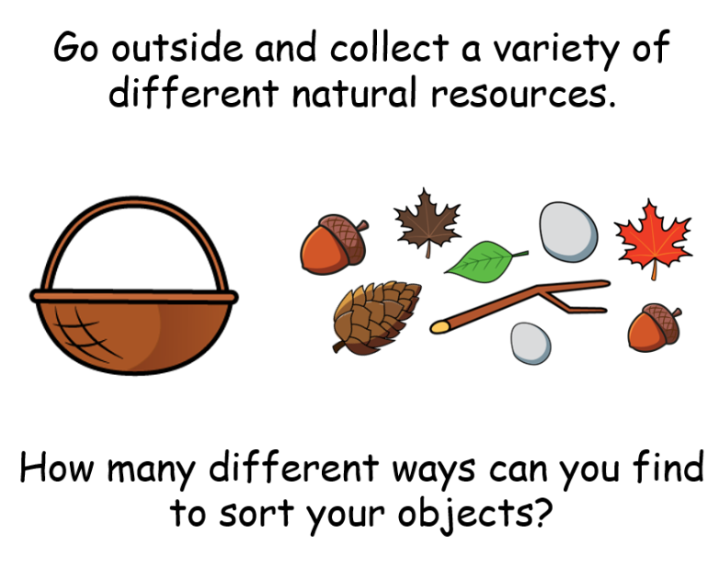
Family Drawings
We have looked at different families this week and learnt that everyone’s family is different and have celebrated these differences. We introduced the word ‘unique’ and what this meant. I wonder if your child can tell you? The children have made pebble representations of their families and drawn lovely pictures of their families too which we are going to be displaying on the wall in our classroom for everyone to see. Thank you for all of the family photos you have been sending in. It’s not too late if you haven’t managed to yet.
Next week:
Our first P.E. lesson will be on Thursday morning. Please can you send in PE kits if you haven’t done so already. To help with the process of getting changed, please can you ensure that all uniform is labelled, including shoes. This will really help when getting changed back into school uniform. As you can imagine, it is very difficult to identify your own jumper etc when everyone has the same. Thank you

