 |  | Introductions
5min | 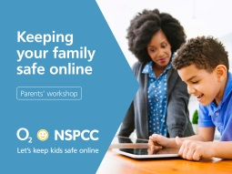 | Welcome  Introductions  Housekeeping  Key message – The O2 and NSPCC partnership; bringing technical and safeguarding expertise together to help families get the most from the digital world.
1min |  | O2 introduction to the partnership
2min | 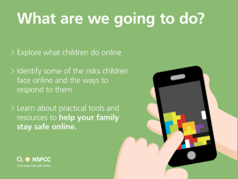 | What are we talking about today?  - What children do online  - Talk about some potential risks and ways to respond  - Practical things to help keep your family safe online.  We won’t be able to cover everything but hopefully you’ll feel more confident to start having simple conversations with your children and aware of where you can go to find out more.
2min |  | Engaging activity  Ask some questions to find out more about the group, these are to give you an idea:  - Hands up if you’re a parent / grandparent  - If you have children under 6  - Have teenagers  - Have you talked to your children about online safety  - Know where to go if you were worried about online safety
(10min til here)  2min |  | Technology is amazing  It plays a big part in our lives, we have smart phones, tablets, play games, send emails, use apps, shop.  Children love using technology, they see the online world as creative, fun and exciting.  IBM predicted in 2016 there would be more people owning a phone than a toothbrush (we cannot verify this but it sounds fun)  Sometimes as adults the way we talk about technology and the conversations we have with children about technology does not reflect this and can be negative eg ‘you’ve been on there for too long’ We don’t necessarily have the positive conversations asking what they are doing, why they like it, what they are getting out of it.  By having more balanced conversations they are more likely to come to us if they are worried about anything.
 |  | Exploring online inc worries and risks
3min | 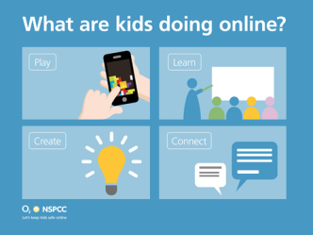 | Ask the group what they think children are doing online (this can be flipcharted but doesn’t have to be)  Over 90% of children aged 5-15 are online (Ofcom 2015)  What children are doing and like online is the same as what they do in the real world  Play – this is part of being a child, it helps with development and social skills. There are lots of educational games like Minecraft.  Create – Children create lot of different things at school and they are doing this online too. They use sites like Popjam to create pictures. There are apps to create videos, be a hairdresser etc  Connect – Be sociable, talk to friends, family.  Learn – Lots of opportunity to learn, they might do there homework or find information online.  Key message – The best way to find out what they are doing is to ask them. Maybe ask them to show you there favourite thing to do online. This will give you a way to support and encourage them and explore the online world together, just like you would offline.
(15)  5min |  | App quiz – keep this quick and simple, don’t get drawn in.  2 mins - Using the app sheet ask parents to work together or alone to see how many apps they recognise.  2mins – Hand out the answer sheet.  Ask the group how they did and any they were surprised at.  We will go into more detail in a min when we talk about what NetAware has taught us.
(20)  1min | 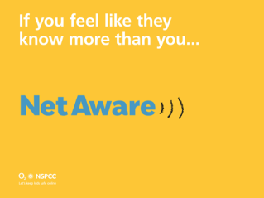 | Leading on from all these apps, we have a website you can use to find out more about these apps. It’s called NetAware.  This slide will take the group through NetAware and how it works.
1min | 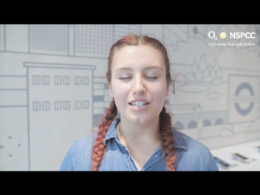
(22) | 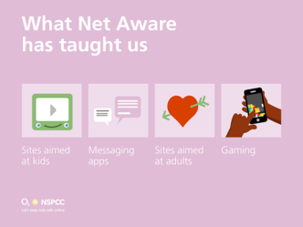 | This is where we go into more detail about apps  Keeping up to date with technology can be challenging and sometimes keeping children safe online even harder.  We want to tell you a few things NetAware has taught us.  Sites for kids:  Club Penguin – virtual world game, multi player, can chat to others  Popjam – creative, share drawings, picture and audio messages.  Moshi Monsters – online game, adopt and look after a pet  Designed to be safe spaces for children.  You tube kids – designed for younger children, you can set the timer, set channels and programmes.  Messaging apps  Whats App, Messenger, Kik, Snap chat.  Do you remember when people would just send a text? These days there are lots of different apps. Many children use these sorts of apps more than social networks.  Snap chat – kids may think they are more anonymous but remember you can do a screen grab.  Ask children to do a ‘billboard’ test before posting. EG if you wouldn’t want it on a billboard don’t post it.  Sites for adults  Some of the sites children use are not aimed at them so It’s no surprise they will come across content that’s not appropriate for them.  Video chat apps are a good example eg ChatRoulette, ooVoo, Omegle, Meow Chat and meetMe.  Gaming  You can play games with people across the world so it’s important to know the games they are playing and who with.  We talk to children about PEGI ratings but it’s become common place for parents to let their children play games that are rated for adults. Like COD, you can see the review on NetAware, we need to make sure the games are appropriate for the child’s age. As they might come across content that upsets them.  NetAware also has a newsletter you can sign up to.
(27)  3min |  | Thinking about all this what worries do you have about what your children might be doing on line?  This can be done as a whole, in pairs, small groups. Give them a couple of mins.  Trainers pay attention to what’s happening in the group and summarise rather than getting drawn in to specifics.  Key concerns might be talking to strangers, bullying, sexting, too much time online etc.  Key message – We need to understand the risks in the same way we would in the real world so we can manage them.
 |  | What you can do
(30)  3 | 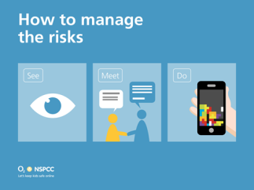 | They things you are worried about are probably the same concerns children have.  It can feel overwhelming as the risks are wide but to simplify this we have put the risks into 3 categories.  See – a lot of the internet wasn’t designed for children so it makes sense that they might come across something inappropriate.  Answer – parenting tools, parental controls, filters etc  Meet – they might become ‘friends’ with people they don’t know, they could be vulnerable to bullying or inappropriate friendships and grooming.  Answer – speak to them about healthy friendships in the same way you would with real life friends or social situations.  Do – Overshare information or photos, bully others sometimes unintentionally, run up debts without realising.  Answer – agree rules and boundaries, whether it’s the amount of time online, money they spend, consequences. Use tools like passwords to manage and protect.  Role model with your own online behaviour.  Keep talking about it.
(33)  2 | 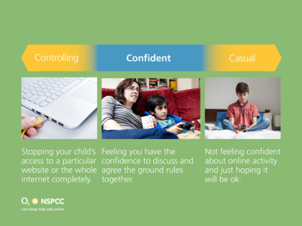 | It can sometimes be a bit daunting. You may be feeling one of these –  You can ask the group to put hands up/ stand in a line to show how they fit into this chart.  Keeping up to date can be a challenge but it’s important to take this challenge up as any other parenting task. It’s OK to be worried about your child’s online safety but there is help.  From being here we hope you’ll go away today feeling more confident to start or continue to have those conversations with your child.  Starting conversations –  - What do they do online  - Where they go  - Who they meet  Involve others in the family so you’re all familiar with the information/boundaries etc as children may want to speak to someone other than a parent.
(35) | 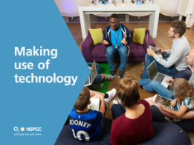 | One of the things we want to make you aware of are the technology you can use to help keep our children safe.  There are loads of tools but often people are unaware of them.
(35)  1 |  | O2 input
(36)  2 | 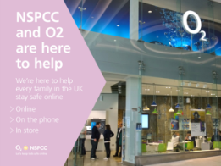 | O2/NSPCC are here to help.  Our mission is to keep every family in the UK safe online. TO do this we have created ways to support people, especially parents.  As well as the info and resources we’ve already talked about there are places you can go and people you can talk to –  Online safety booklet  Online hub www.O2.co.uk/nspcc  In store magazine  Net Aware  Share Aware
(38)  3 | 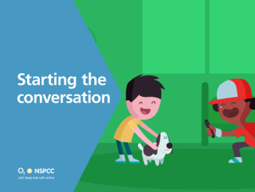 | Since launching Share Aware over 7million people have watched the films.  Using the films are a great way of starting the conversations with children.  There’s also a guide with top tips in.
(41)  1 | 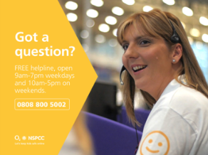 | If you wanted to speak to someone face to face you can pop into any O2 store and ask for help. Or you can book an appt with a guru.  We also have a dedicated helpline.  Q: What might you call the helpline about?  A: Getting a new device for Christmas and setting it up.
 |  | Ending
(42)  1 | 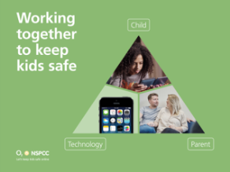 | Everyone working together; parents, children also need to take responsibility to keep themselves safe. Use the tools that are available.  Today we have covered;  Child’s online world  Risks  Ways to respond  We’ve told you about some practical tools you can use.
(43) | 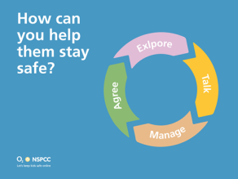 | Our simple guide in 4 easy steps:
 | 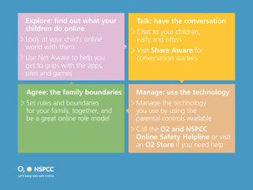 | Explore –Netaware helps you to get to grips with apps, sites and games  Talk – talk early and often, keep conversations going  Manage – technology, use parental controls and seek help  Agree – rules and boundaries and role model  Now it’s over to you.
(45) | ,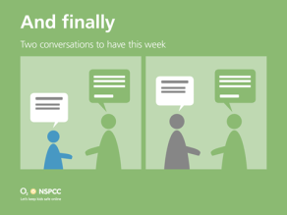
 | 