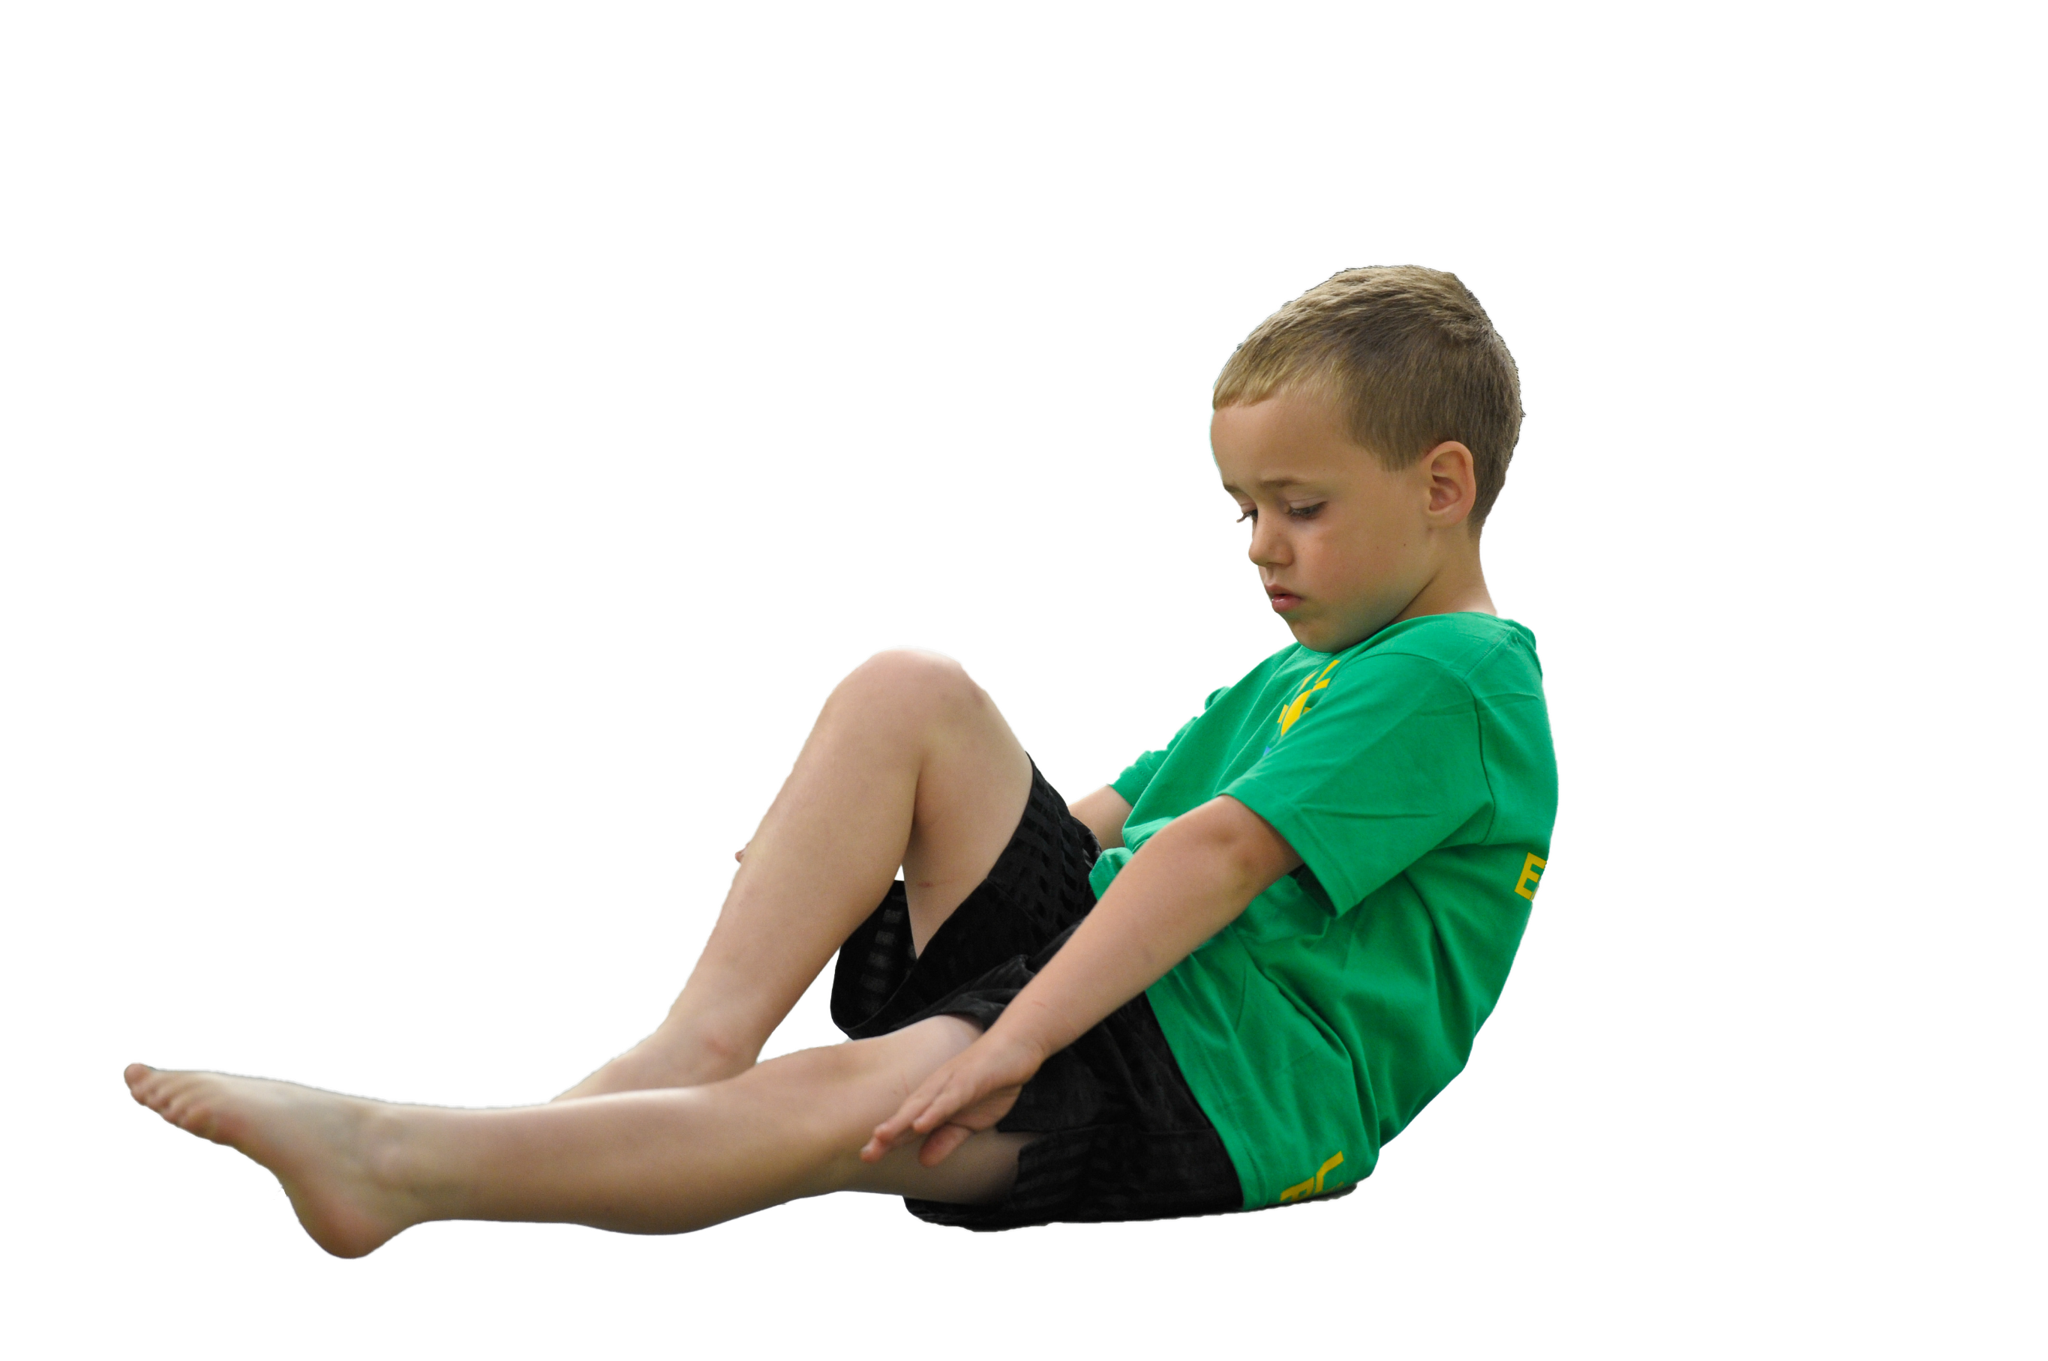
Ursuline Catholic Primary School
Sports Premium Statement
2019-20

Support for review and reflection - considering the 5 key indicators from DfE, what development needs are a priority for your setting and your students now and why? Use the space below to reflect on previous spend, identify current need and priorities for the future.

Key achievements to date: | Areas for further improvement and baseline evidence of need:
- Indoor PE established from YR – Y6 (40 minutes per week)  - Foundations laid in improving quality of outdoor PE (40 minutes per week, YR to Y6)  - Foundations laid in previous school year to extend pupil access to competitive sport  - Success in inter-school sports  - Breakfast, lunchtime and after school clubs established (Archery, Curling, Gymnastics, Football, Judo, Netball)  - Sporting achievement included in rewards assembly  - Newsletters provides parents with updates on sporting achievements and wellbeing activities in school  - Annual sports days comprising participation for all pupils and competitive events  - Yoga taught across the school (curricular and extra-curricular)  - Annual Y6 Residential Visit promotes resilience and team work  - Outdoor and indoor multi sports courts established  - Links with local sports clubs/coaches  - Competition days introduced in all year groups, linked to PER curriculum (skill-game based) | - The quality of outdoor PE for all pupils  - Integration of PE and sport into a curriculum which gives all pupils the knowledge and cultural capital they need to succeed in life  - Linking being active to mental wellbeing  - Provision of a progressive cross curriculum based healthy lifestyle programme in Key Stages 1 and 2  - Access to a broad range of competitive sports for reluctant pupils and those who do not get to represent the school in team events  - Expand use of House Teams to facilitate ‘Intra-School’ competitive sport  - Further success in inter school competitive sport  - Improve teachers’ outdoor PE teaching skills

Meeting national curriculum requirements for swimming and water safety | Please complete all of the below:
What percentage of your current Year 6 cohort swim competently, confidently and proficiently over a distance of at least 25 metres?  N.B. Even though your children may swim in another year please report on their attainment on leaving  primary school. | 97%
What percentage of your current Year 6 cohort use a range of strokes effectively [for example, front crawl, backstroke and breaststroke]? | 10m front and back only - 95%  25m front and back only – 92%  25m front and breast stroke – 51%
What percentage of your current Year 6 cohort perform safe self-rescue in different water-based situations? | Treading water collecting brick - 95%  Brick only – 97%  Treading water only – 92%
Schools can choose to use the Primary PE and Sport Premium to provide additional provision for swimming but this must be for activity over and above the national curriculum requirements. Have you used it in this way? | Yes/No

Action Plan and Budget Tracking
Capture your intended annual spend against the 5 key indicators. Clarify the success criteria and evidence of impact that you intend to measure to evaluate for students today and for the future.

Academic Year: 2019/20 | Total fund allocated: £19600 | Date Updated: Nov 2019
Key indicator 1: The engagement of all pupils in regular physical activity – Chief Medical Officer guidelines recommend that primary school children undertake at least 30 minutes of physical activity a day in school |  |  |  | Percentage of total allocation:
 |  |  |  | %
School focus with clarity on intended impact on pupils: | Actions to achieve: | Funding allocated: | Evidence and impact: | Sustainability and suggested next steps:
To broaden PE curriculum to nurture and enhance sport performance | Teach requisite skills  - introvert (individual)  - extrovert (team)  - endurance (daily mile)  - teamwork/competitiveness  - awareness and respect in a team environment  Termly intra school Cross-Country  ‘5 a Day’ & ‘Go Noodle’ in class activities | £1300
Key indicator 2: The profile of PE and sport being raised across the school as a tool for whole school improvement |  |  |  | Percentage of total allocation:
 |  |  |  | %
School focus with clarity on intended impact on pupils: | Actions to achieve: | Funding allocated: | Evidence and impact: | Sustainability and suggested next steps:
The integration of PE and sport into a curriculum which gives all pupils the knowledge and cultural capital they need to succeed in life | - Subjects to be linked thematically and, where possible, enriched by work around major international sporting events (Rugby World Cup, World Athletics Championships, UEFA 2020, Tokyo Olympics)  - ‘Run to Tokyo’ – daily mile integrated into wider curriculum (mathematics – calculation of aggregated distance run; geography – map reading to locate milestones from ‘Crosby to Tokyo’; SMSC – communities, settlements, landscapes passed through on journey)  - Relationships & Sex Education – building teamwork,resilience & relationships through sport  - Using and applying PE skills (e.g. stretching and warm up) to deepen understanding in science (respiratory, circulatory and skeletal systems)  - Wellbeing Matters Newsletter – e.g. highlights ‘Five Ways to Wellbeing’ including being active (can improve mental wellbeing as well as being good for physical health)  - Embed PawsB Mindfulness Programme  - Whole school singing (beneficial to good physical health) through Children’s Opera programme  - Implement a progressive cross curriculum based healthy lifestyle programme in Key Stages 1 & 2 | £1500
S

Key indicator 3: Increased confidence, knowledge and skills of all staff in teaching PE and sport |  |  |  | Percentage of total allocation:
 |  |  |  | %
School focus with clarity on intended  impact on pupils: | Actions to achieve: | Funding  allocated: | Evidence and impact: | Sustainability and suggested  next steps:
Teachers’ continual professional development in teaching outdoor PE (by commissioning Premier Sports as provider) | - Deepen teacher knowledge of curriculum, specialised training and rules/skills associated with a range of sports  - Teachers enabled to teach engaging and skilful classroom based lessons in the event of bad weather preventing outdoor PE  - Teachers observe Premier Sports Expert Coach, team teach with her and then lead with her support  - Tournament Days enable teachers to apply deeper knowledge and acquired skills in a competitive environment  - Teachers enabled to identify gifted & talented/underachievers through training in use of Portal  - Teachers improve understanding of PE routines (warm up, skills based, game based, cool down, ‘we have learned’) | £10218  £2145  £5928
Key indicator 4: Broader experience of a range of sports and activities offered to all pupils |  |  |  | Percentage of total allocation:
 |  |  |  | %
School focus with clarity on intended  impact on pupils: | Actions to achieve: | Funding  allocated: | Evidence and impact: | Sustainability and suggested  next steps:
- Preparation for and participation in various organised sporting events across Crosby & District, Merseyside (NB Football, Cross-Country)  - Commissioning of Premier Sports to offer different sporting experiences through Tournament Days | Teach skills and rules of:  - Badminton  - Squash  - Tag Rugby  Teach skills and rules of different Track & Field events:  - Javelin  - Shot Put  - Multi Skills | £135
Key indicator 5: Increased participation in competitive sport |  |  |  | Percentage of total allocation:
 |  |  |  | %
School focus with clarity on intended  impact on pupils: | Actions to achieve: | Funding  allocated: | Evidence and impact: | Sustainability and suggested  next steps:
- Access to a broad range of competitive sports for reluctant pupils and those not selected for school teams  - Further success in inter school competitive sport | - Embed ‘Intra-School’ Tournament Days (one per term per year group)  - Participate in Crosby & District competitions (mixed boys & girls Football; Multi-Skills; Swimming; Inclusive Festival; Gymnastics; Mini Tennis; Netball; Cricket; Quad Kids)  - Girls’ Football team entered into Crosby & District League  - Y6 Pupils selected for Bootle & District Boys participate in regular fixtures | £500

