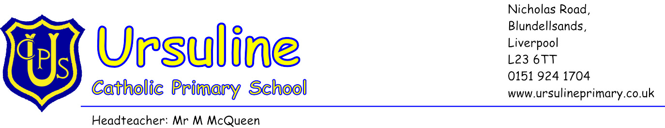
24th June 2014

Dear Parent/Carer

Universal Free School Meals for KS1 Children

From the beginning of next term, significant changes are happening to school food: cooking is back on the curriculum, every pupil in reception, year 1 and 2 will be eligible for free school meals and from January, new food standards are being introduced. These are three of the 16 actions in the School Food Plan, which aims to transform what children eat in schools and how they learn about food (see www.schoolfoodplan.com).
I wanted to write to you to explain these changes and, importantly, to ask you to fill out the enclosed forms so that the school can prepare for these changes.
Good food and good food culture has been shown to lead not only to healthier, happier and more fulfilled children, but to improved educational attainment. Evidence from those areas that already provide universal free school meals is that children eat more healthily and perform better academically. Schools in those areas have also reported improved behaviour and atmosphere as a result of all pupils eating together every day.
New standards for school food have recently been published and will come into force in January. By following them, we can be sure that our pupils will get the nutrition they need across the whole school day.
We believe that the school lunchtime is a great opportunity for all our children to sit down together and enjoy their healthy and tasty meal, while developing their social skills. We therefore hope that all parents will take up this offer of a free school meal for our infant pupils.
I hope you will take advantage of this opportunity for your child to enjoy a healthy, balanced and nutritious meal every day. Accordingly, I would be grateful if you could complete and return the attached slip to school by Friday 4th July. Please be advised that half a term notice is required if you wish to change your childs lunch arrangements.
Thank you for your co-operation.
Yours sincerely
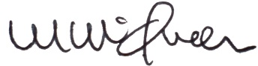
Mr McQueen
Headteacher

Ursuline Catholic Primary School

Universal Free School Meals September 2014

I can confirm that _____________________(Childs name)

Will be staying for the free school meal

Will be bringing his/her own packed lunch

Please return this slip to:

Ursuline Catholic Primary School
Nicholas Road
Blundellsands
Crosby
L23 6TT

