Employers who support Valley College

Work Placements

The Raft Foodbank |  | Job Title - Food Bank Assistant
The Whitaker Museum and Art Gallery |  | Job Title - Domestic Cleaning
The Garage Café | 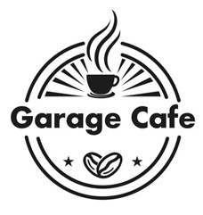 | Job Title - Café Assistant
Oh Happy Sign |  | Job Title - Session Assistant
Haslingden Library |  | Job Title - Library Assistant
Freshfields |  | Job Title – Horticulture Assistant
Turf Cote Nursing Home |  | Job Title – Activity Assistant
The Station Hotel |  | Job Title - Domestic Cleaning
@ The Grange Blackpool |  | Job Title – Horticulture Assistant
Palatine Library  Blackpool |  | Job Title - Library Assistant
Pitt Stop Café  Blackpool |  | Job Title - Café Assistant
Blackpool Community  Grocery  Blackpool |  | Job Title - Shop Assistant

