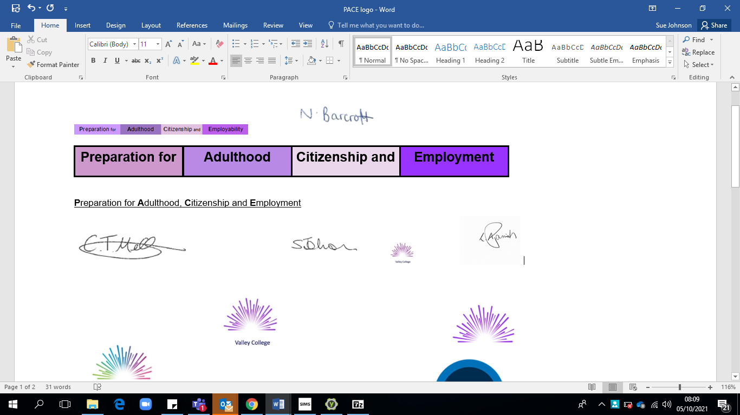

**VALLEY COLLEGE ACCESSIBILITY PLAN**

|  |  |
| --- | --- |
| Document Owner | Valley College Administration Manager |
| Date implemented | Sept 2022 |
| Date reviewed | Sept 2024 |
| Date next review | Sept 2025 |
| Date approved by Directors | Nov 2022 |
| Associated documents | <https://www.legislation.gov.uk/ukpga/2010/15/schedule/10> |
| Published on website | Yes |
| Purpose | To set out the College procedure on accessibility. This policy complies with our funding agreement. |
| Scope | Learners, Staff, Directors and Stakeholders |
| Equality, Diversity & Inclusivity | Valley College is committed to promoting equality, good relations and to challenging discrimination. This is reflected in all College policies, procedures, processes and practice.  Equality, diversity and inclusivity are embedded throughout the organisation. This plan should be applied in accordance with this ethos.  If you would like a copy of this document in a different format, such as large print, please contact the Valley College Office who will provide help with alternative formats. |

**Aims**

Schools and colleges are required under the Equality Act 2010 to have an accessibility plan. The purpose of the plan is to:

* Increase the extent to which disabled learners can participate in the curriculum
* Improve the physical environment of the college to enable disabled learners to take better advantage of education, benefits, facilities and services provided
* Improve the availability of accessible information to disabled learners

Our college aims to treat all its learners fairly and with respect. This involves providing access and opportunities for all learners without discrimination of any kind.

Valley College is committed to promoting equality, good relations and to challenging discrimination. This is reflected in all College policies, procedures, processes and practice.

Equality, diversity and inclusivity are embedded throughout the organisation and we are committed to ensuring staff are trained in equality issues with reference to the Equality Act 2010, including understanding disability issues.

The college supports any available partnerships to develop and implement the plan.

Our college’s complaints procedure covers the accessibility plan. If you have any concerns relating to accessibility in college, the complaints procedure sets out the process for raising these concerns.

We have included a range of stakeholders in the development of this accessibility plan, including learners, staff and Directors.

**Information gathering**

In meeting the duty to collect and publish this information we have looked more closely at the following in order to formulate a meaningful access plan.

Key starting points have been to assess:

• The nature of the college population for whom the college is planning

• Learners in college and the range of SEN needs

• The level of staff awareness of Equalities legislation

• The PSD curriculum

• The physical environment of the college

• The ways in which information is currently provided for learners

• Destination outcomes for learners

**Legislation and guidance**

This document meets the requirements of [schedule 10 of the Equality Act 2010](http://www.legislation.gov.uk/ukpga/2010/15/schedule/10) and the Department for Education (DfE) [guidance for schools on the Equality Act 2010](https://www.gov.uk/government/publications/equality-act-2010-advice-for-schools).

The Equality Act 2010 defines an individual as disabled if they have a physical or mental impairment that has a ‘substantial’ and ‘long-term’ adverse effect on their ability to undertake normal day to day activities.

Under the [Special Educational Needs and Disability (SEND) Code of Practice](https://www.gov.uk/government/publications/send-code-of-practice-0-to-25), ‘long-term’ is defined as ‘a year or more’ and ‘substantial’ is defined as ‘more than minor or trivial’. The definition includes sensory impairments such as those affecting sight or hearing, and long-term health conditions such as asthma, diabetes, epilepsy and cancer.

Schools are required to make ‘reasonable adjustments’ for learners with disabilities under the Equality Act 2010, to alleviate any substantial disadvantage that a disabled learner faces in comparison with non-disabled learners. This can include, for example, the provision of an auxiliary aid or adjustments to premises.

**Action plan**

This action plan sets out the aims of our accessibility plan in accordance with the Equality Act 2010.

|  |  |  |  |  |  |  |
| --- | --- | --- | --- | --- | --- | --- |
| **AIM** | **CURRENT GOOD PRACTICE** | **OBJECTIVES** | **ACTIONS TO BE TAKEN** | **PERSON RESPONSIBLE** | **DATE TO COMPLETE ACTIONS** | **SUCCESS CRITERIA** |
| **Increase access to the curriculum for learners with a disability** | * The PACE curriculum addresses the needs of learners as individuals in the preparation for adulthood. * Our college offers a differentiated curriculum for all learners. * We use resources tailored to the needs of learners who require support to access the PACE curriculum. * Specialist support is timetabled across the week and relevant agencies involved. * Curriculum resources include examples of people with protected characteristics. * Targets are set effectively and are appropriate for learner’s outcomes. * The curriculum is reviewed to make sure it meets the needs of all learners * Priority is placed upon learner participation, to promote and develop independence * Learners access work placements and community projects with the support of PACE staff. * Learner aspirations are reflected in learner destination data * Sport and leisure activities include a range of activities to ensure all learners are able to access the curriculum fairly. | To continue to develop the Quality of Education continue to improve the curriculum Intent, Implementation and Impact. | Learner Voice meetings to continue to include learner input to curriculum.  Staff training as identified by Sa number if internal and external sources to increase the confidence in staff in delivering the PACE curriculum.  Work placements and offsite visits to continue to be risk assessed and include ensuring venues are accessible to all learners, or that adaptations can be made to ensure this.  New Careers Lead post to continue to widen the opportunities for learners to access the community, in Rossendale and Blackpool.  Extended Services Lead to implement and embed a Wider Curriculum Offer. | SLT  Extended Services Lead  Careers Lead  Class based staff  Learners  Stakeholders | Summer 2025 | Destination data will reflect learner aspirations and track the sustainability of such destinations.  Accreditation data will evidence learner achievements.  Stakeholder surveys will reflect learners felt able to fully participate in the PACE curriculum.  EHC plan outcomes for learners are met. |
| AIM | CURRENT GOOD PRACTICE | OBJECTIVES | ACTIONS TO BE TAKEN | PERSON RESPONSIBLE | DATE TO COMPLETE ACTIONS | SUCCESS CRITERIA |
| **Improve and maintain access to the physical environment** | * The Ewood Campus was purpose built to meet the wide range of needs that our learners present. * An area of the existing portacabin has been utilised to accommodate growth in numbers in Rossendale. * The Oracle has a range of facilities that can be accessed by our learners. * Both sites are fully accessible for all learners, staff, and visitors. Learners in Rossendale have access to fully accessible hygiene rooms and an MSE room, horticulture area, café which is open to the public and hydro pool. The outdoor environment includes a MUGA which is also fully accessible. * At the Oracle in Blackpool learners have access to a newly refurbished gymnasium, dance studio, and café area. The outdoor environment includes space which is fully accessible. * On both sites there is a car park with allocated parking spaces for those learners, advocates and visitors who require their use. The provision of these disabled parking spaces is in close proximity to both of the entrances to the building. It is ensured that these spaces are not used inappropriately or blocked by other vehicles. * Access to both car parks is level with no obstacles. Ramps are in situ where necessary. * Rossendale have hoists and an Achiever bed to accommodate the needs of learners who may require them. * Both sites have wide corridors to accommodate the use of wheelchairs including large electric chairs. * All learners assessed as requiring a PEEP, have one completed. * At The Oracle there are stairs but there is a fully functioning lift to the additional floors. * In the event of a fire Evacuation Chairs are available and staff training has been delivered. * On admission to Valley College an assessment is made regarding the needs of each individual learner to ensure that facilities are accessible and where appropriate any necessary identified adaptations will be made to ensure accessibility. | To maintain the accessibility of the Ewood Campus and The Oracle site for Valley College learners, staff and visitors.  Enquire about moving premises in both locations as numbers increase. | To continue to ensure the physical environment is improved and maintained with the growth in learner numbers.  The Oracle is proposed to have additional adaptations made to meet the needs of all learners.  In Rossendale building work commences this academic year to create more space for growth in numbers. | SLT  Extended Services Lead  Careers Lead  Class based staff  Learners  Stakeholders  OT  Blackpool County Council | Summer 2025 | Stakeholder surveys will demonstrate that learners are happy with the Valley College site and facilities.  Health and Safety Audit will reflect a positive outcome for both sites. |
| **AIM** | **CURRENT GOOD PRACTICE** | **OBJECTIVES** | **ACTIONS TO BE TAKEN** | **PERSON RESPONSIBLE** | **DATE TO COMPLETE ACTIONS** | **SUCCESS CRITERIA** |
| **Improve the delivery of information to learners with a disability** | On both sites we use a range of communication methods to make sure information is accessible. This includes:   * Internal signage * Large print resources * Communication in Print and pictorial or symbolic representations * Total Communication Approach | To ensure information is successfully delivered to all learners to ensure that they are well-informed. | Continue to gain SALT input on communication strategies and appropriate support.  Subject Leaders and Champions to improve this area of the curriculum.  CPD opportunities enhance the skills and Knowlege of staff within Valley College. | SLT  Extended Services Lead  Careers Lead  Class based staff  Learners  Stakeholders | Summer 2025 | Continued improved access for all cohorts of learners.  Continue to liaise with both Lancashire County Council and Blackpool County Council to improve premise and align with growth of college. |

**4. Monitoring arrangements**

This document will be reviewed every **3** years, but may be reviewed and updated more frequently if necessary.

It will be reviewed by the Directors Committee and the Principal.

It will be approved by the Directors Committee and the Principal.

**5. Links with other policies**

This accessibility plan is linked to the following policies and documents:

Health and safety policy

Equality information and objectives (public sector equality duty) statement for publication

Special educational needs (SEN) information report

Supporting learners with medical conditions policy

|  |  |  |
| --- | --- | --- |
|  | **Name/Initials:** | **Date:** |
| **Written By:** | KS/EM/SJ | November 2022 |
| **Reviewed:** | KS/SJ | September 2023 |
| KS/SJ | September 2024 |
|  |  |
|  |  |