It’s hard to believe that we are already in October but I would like to take this opportunity to thank you for your co-operation with the new routines. I would also like to extend my warmest thanks to the staff team here at Valley along with the pupils who have all been superb. It has been lovely welcoming all the pupils back to school and they have soon adjusted to the new way of doing things.
The school had a good response to the recent Remote Learning Survey so, again, my thanks to all those parents who took the time to complete this short form.

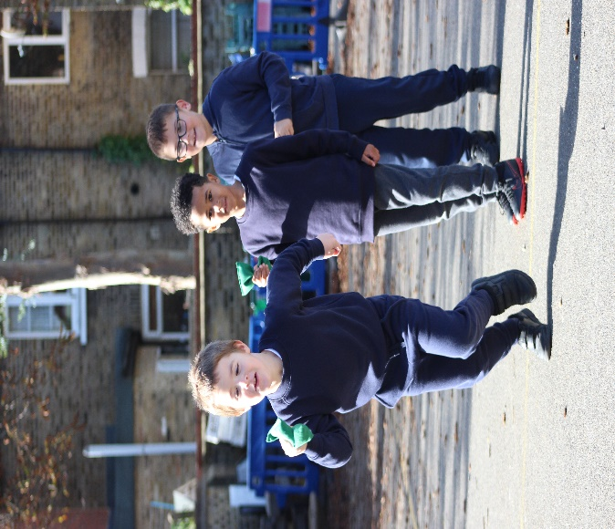  Morning Snack  As pupils in Years 4, 5 and 6 are eating a little later than normal at lunchtime, it might be beneficial to send you child to school with a slightly more substanial snack for morning break.  Ideas could include:  - Pitta Bread + Babybel  - Chicken / Ham / Cheese Wrap  - Piece of Fruit + Oat Cakes  - Piece of Fruit + Soreen Snack-Size Malt Loaf  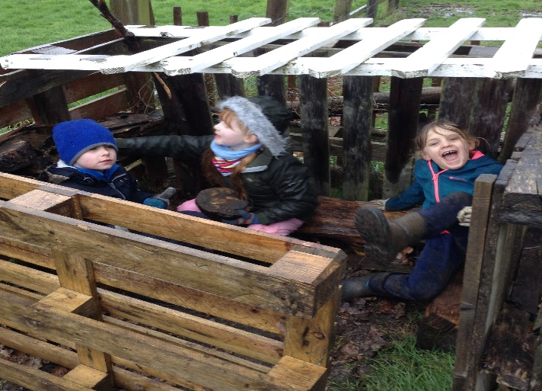  PICTURE CAPTION: Lorem ipsum dolor sit amet, consectetur adipiscing elit. | 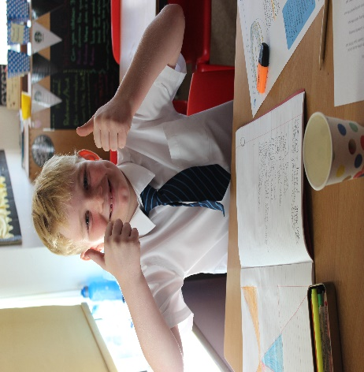  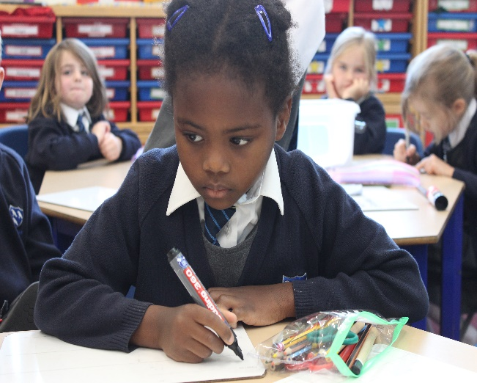  Attendance & Punctuality
 | Despite the mixed media coverage of the full reopening of schools and the varying degrees of anxiety we all felt about welcoming pupils back to school, I am pleased to annoucne that up to Friday 2nd October, the overall school attendance was 95% - thank you everyone for this great start.  As we head through the autumn period, the usual colds will be present I’m sure so please do check the infographic at the end of this newsletter to check whether you should be sending your child to school. | Being punctual for school is also really important. All pupils should have arrived at school by 9am each morning. Arriving late for school can negatively affect pupils’ self-esteem as well as their academic progress as they miss out on Green Pen Learning activites which address misconceptions from the day before.
IN THIS ISSUE
TITLE OF THE TOPIC | TITLE OF THE TOPIC | TITLE OF THE TOPIC
Valley Athletes Lead the Way |  | Black History Month  Valley would like to say a big THANK YOU to all those parents and friends of the school who have offered their time to talk to the pupils during Black History Month.  As you will already know, this year we have a focus on Key Workers and pupils will receive presentations from Doctors, Surgeons, Bank Managers, Hair Stylists, Teachers, Web Designers and Nurses.  Throughout the month, pupils will engage in an art project on skin tones and and will also write a pledge to accompany their artwork.  We are really lucky to be welcoming one of our very own parents, Carmen Armelia, to read her recently published book Curl Crown.  Earrings  For health and safety reasons, the uniform policy states that pupils should not wear hoop earrings. Small stud earrings are allowed to be worn. Since Septmeber, there are a number of pupils wearing hoop earrings so parents are kindly aksed to check their child’s earings before leaving for school each day.
Valley is immensley proud of some of its pupils who have been keeping very active of late. Five pupils from the school took part in a Junior Triathlon at Hever castle recently with some stand out performances from  Congratulations also go to Benji who recently received a trophy at his local rugby club for Player of the Week.  While Valley is not running its extra-curricular timetable this term, many clubs in the community have started to operate once again so now is the perfect time to try something new. | 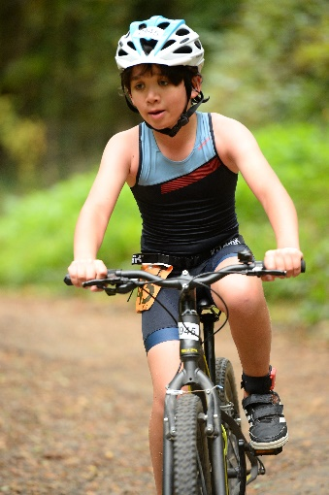  PICTURE CAPTION: Lorem ipsum dolor sit amet, consectetur adipiscing elit. Fusce vel laoreet orci. In eget auctor mi.  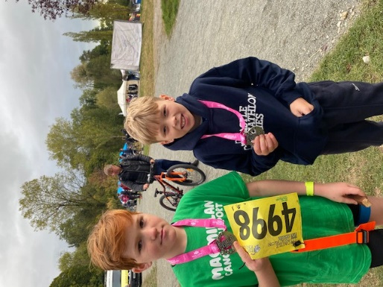  PICTURE CAPTION: Lorem ipsum dolor sit amet, consectetur adipiscing elit. Fusce vel laoreet orci. In eget auctor mi.
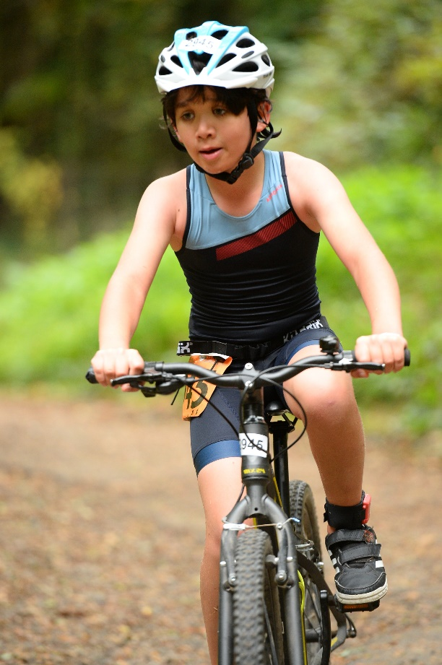
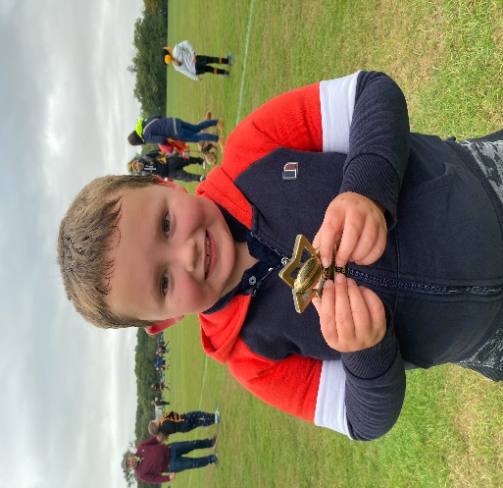

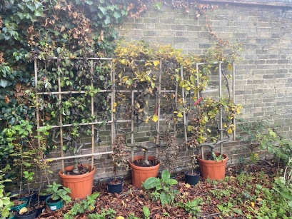
Mayor of London Greener City Fund
You will recall that Valley Primary School received £30,000 of grant funding from the Mayor of London’s Greener City Fund.  We are continuing to work through the action plan that was put in place and soon we will see new planters located around the playground with different species of tree. | 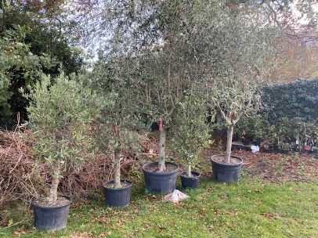  In the orchard, the raised beds have now arrived in preparation for the pupils to start growing their own and we are just in the process of finalising the plans for an outdoor learning space which will be located on the school field.
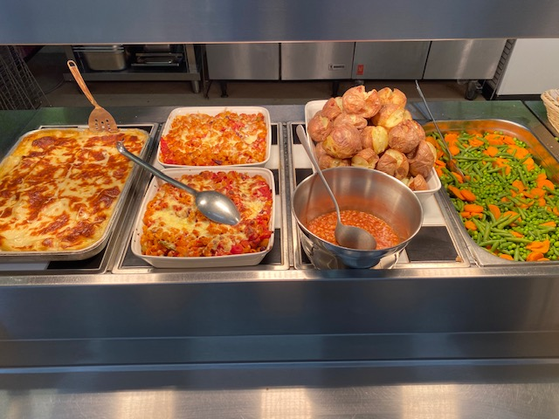  PICTURE CAPTION: Lorem ipsum dolor sit amet, consectetur adipiscing elit. Fusce vel laoreet orci. In eget auctor mi. |  | Pupils’ Dietary Needs  In order for a pupil’s dietary intolerance or allergy to be recognised and the approptiate measures put in place, parents must complete the offical paperwork and get these signed off by a mdecial professional.  If you require nay further information, please contact Mrs. Bradley who will be happy to provide you with the relevant paperwork.  Valley Primary School strives to be a nut-free school so parents are kindly reminded that pupils should not be bringing nuts to school in their packed lunch box or nut-based products such as chocolate spread or peanut butter.

Parking Around the School Instagram
Parents are reminded once again not to mount the pavements around the school when dropping off and collecting pupils at the beginning and end of the school day. Also, parents should not block the driveways of local residents or park in communcal driveways such as that found in Shelby Court. I have been informed by some local residents recently that illegal and irrespsonible parking has been reported to Bromley Council. |  |  | Valley Primary School continues to use Instagram as one of its methods of communications with parents. The school’s account now has over 400 parents following and, if you would like to follow this private account, please send a follow request to @valleyprimaryschool. When requesting to follow, please provide the name and class of your child in a DM (Direct Message).

The last topic of the newspaper.
Lorem ipsum dolor sit amet, consectetur adipiscing elit. Fusce vel laoreet orci. In eget auctor mi. Maecenas ipsum purus, imperdiet ullam- corper quam sit amet, malesuada semper sem. Duis elit quam, sagittis sed justo at, condimentum porttitor velit. Vivamus rutrum a enim eget molestie. Sed pharetra diam metus, id ornare dolor lobortis quis. Integer gravida, ipsum non venenatis pretium, elit mauris ultrices neque, quis tincidunt arcu velit sed dolor. Suspendisse non lacus at orci hendrerit tincidunt. Quisque consequat faucibus luctus. Ut sollicitudin arcu mauris, non dictum est viverra vitae. Proin dolor massa, aliquet sit amet pharetra quis, efficitur a massa. Praesent dolor tortor, feugiat id porttitor a, scelerisque non purus. Sed ac fermentum velit. In vitae mollis quam. Praesent sit amet maximus eros, quis mollis odio. Nunc eget dignissim est. Donec eget justo nec turpis | euismod turpis, sit amet suscipit mauris. Sed sed ullamcorper lectus. Sed eros nisi, consequat et auctor vel, placerat quis massa. Mauris elementum efficitur diam elementum vulputate. Integer ullamcorper ligula quis enim efficitur, non pellentesque nunc facilisis. Sed mollis et arcu vitae suscipit. Etiam scelerisque ante vel nibh bibendum, et inter- dum odio venenatis. Mauris congue venenatis nibh, vitae condimentum massa varius vel. Lorem ipsum dolor sit amet, consectetur adipiscing elit. Fusce vel laoreet orci. In eget auctor mi. Maecenas ipsum purus, imperdiet ullamcorper quam sit amet, malesuada semper sem. Duis elit quam, sagittis sed justo at, condimentum porttitor velit. Vivamus rutrum a enim eget molestie. Sed pharetra diam metus, id ornare dolor lobortis quis. Integer gravida, ipsum non venenatis pretium, elit mauris ultrices neque, quis tincidunt arcu velit sed dolor. Suspendisse non lacus at orci hendrerit tincidunt. Quisque consequat faucibus luctus. Ut sollicitudin arcu mauris, non dictum est viverra vitae.
