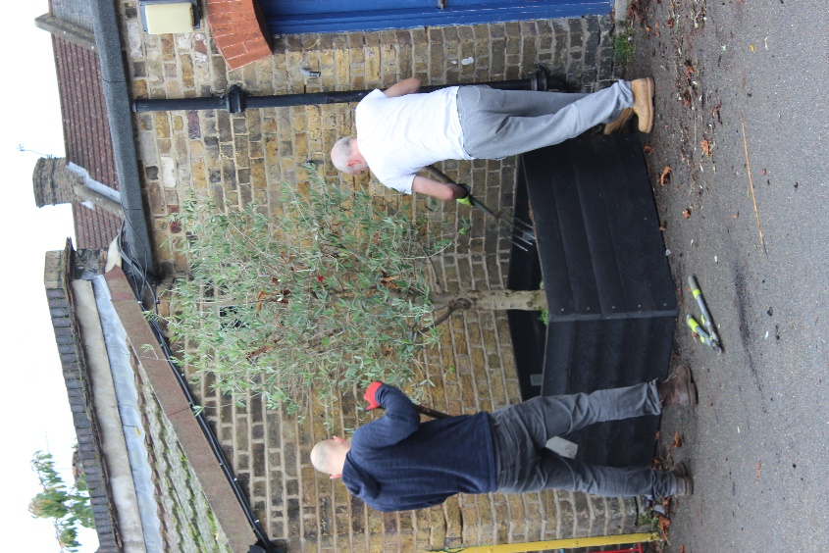
Well, here we are in the second half of the autumn term and, following last Saturday’s Downing Street announcement, it is set to be another eventful seven weeks. Sadly, this half-term will not be marked with the usual chorus of Christmas song but, we will endeavour to mark the festive period in a small way where we can. I would like to take this opportunity to thank all those parents who came along to plant a tree just before half-term and an extra-special thank you to those who gave of their time a week last Saturday to plant up the planters on the school playground – your assistance is very much appreciated.

Parent Consultations  This month’s Parent Consultations will take the form of telephone conversations. Each parent will be allocated the usual 10 minutes to discuss your child’s progress to date.  The timetable for consultations is below and your child’s Interim Report will be sent home on the Friday before your telephone consultation.  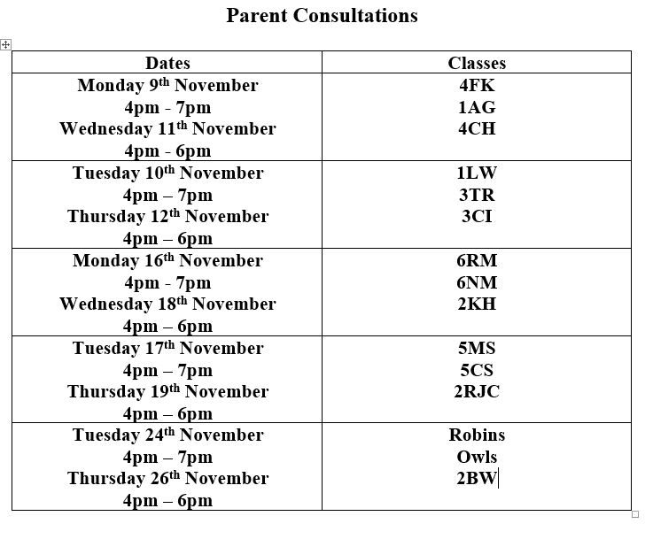 | 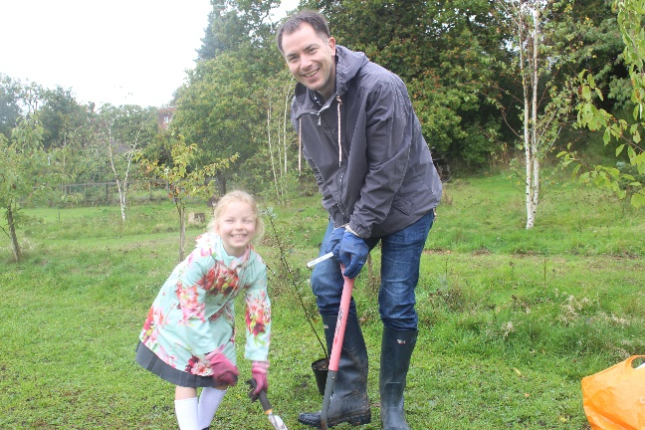  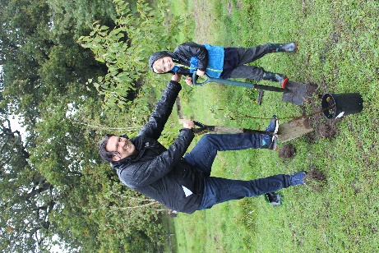  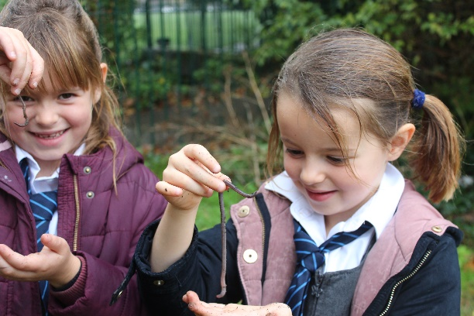  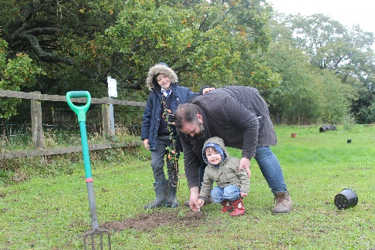  Attendance & Punctuality
 | With the second lockdown starting on Thursday, the school risk assessment has been updated and some necessary adjustments have been made to different aspects of the school day.  Wherever possible, parents are kindly asked to wear face coverings for both drop-off and collection and to maintain social distancing at all times on the school playground. It is also important that parents adhere to the timings in the table to the right and leave the playground as soon as your child has been collected. Thank you for your continued co-operation in this very important matter. | 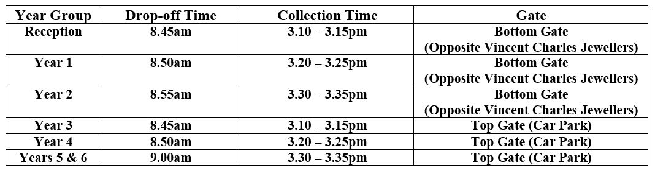  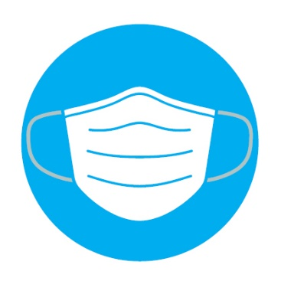
Black History Month |  | Bikeability Success  Our congratulations go to those Year 6 pupils who recently achieved success in their Bikeability course. ?? pupils participated in the 3-day course with many gaining their Level 1 and 2 Bikeability qualification.  As Valley Primary School works towards achieveing their Gold Award in the sustainable school travel STARS scheme, we might see some of these Year 6 pupils cycling to and from school from Springtime onwards.  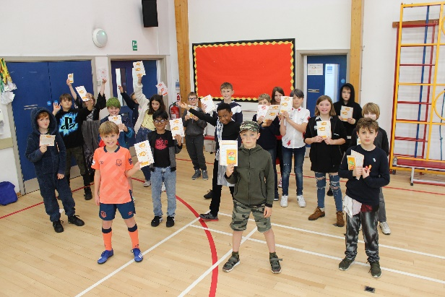  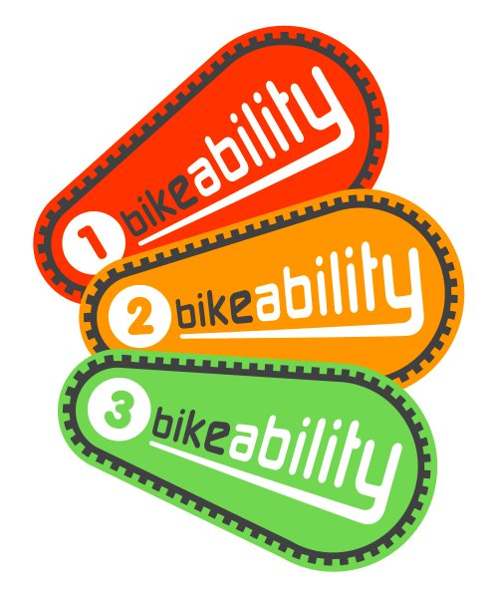  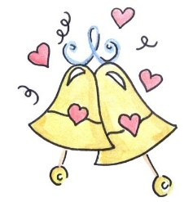  Our congratulations go to Mr House who got married during the October half-term. I’m sure you’ll join me in wishing Mr and Mrs. House every future happiness together.  Wedding Congratulations  Earthquake  We hope that no Valley families were affected by the recent earhtquake in the Aegean area. If, however, familiy or friends have been cuaght up in this natural disaster, please do speak to a member of staff to discuss any support that might be necessary.
A bug THANK YOU to the parents and friends of the school who contributed to last month’s Black History Month activities.  The pupils enjoyed learning about the working lives from a variety of professionals and we were very lucky to host Carmen Armelia, a Valley parent, to read her recently-published book, Curly Crown.  Throughout the month of October, in their PHSCE lessons, pupils learnt more about diversity and worked on art activities that focussed on skin colour.  Thank you to all those parents who returned the surey we sent out as part of Black History Month and, if you still havne’t done so, there’s still time. | 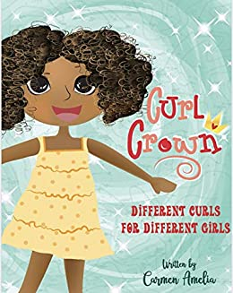  Alfonso taking part in the  Junior Triathlon  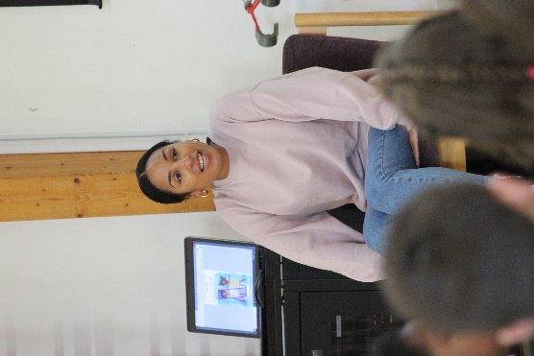  Some of the pledges made by pupils during Black History Month
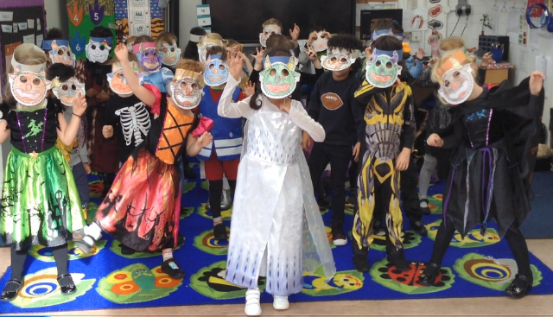
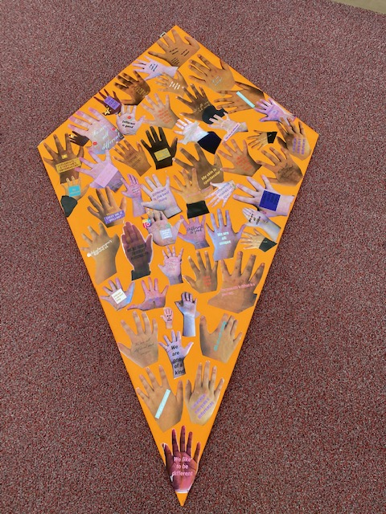
Our Reception pupils learnt about Oti Mabuse, a ballroom dancer from South Africa. Here they are practicing their own version of Monster Mash.
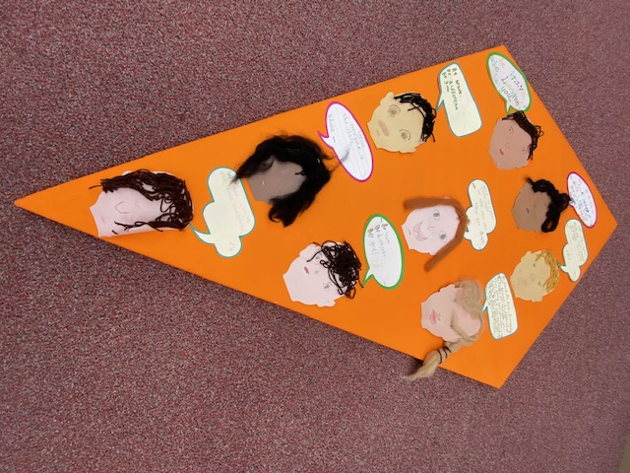
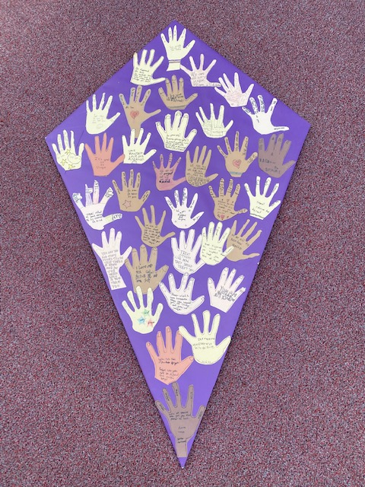

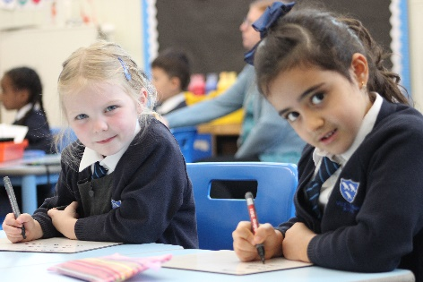
Virtual Open Days
The second half of the Autumn Term would normally see us welcome prosepctive parents for next year’s Reception intake. Unfortunately, we are unable to run the Open Day tours this year and all of the information will be communicated via the Open Day 2020 tab on the school website. I would like to thank the Year 6 pupils who have helped produce the Open Day material and some of the  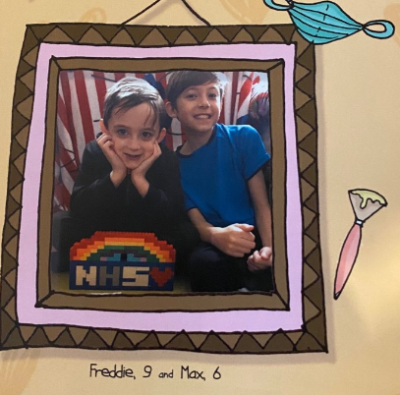 | pupils will join me in a series of virtual Q&A sessions in the coming weeks.  If you know of friends and family who are looking for a Reception place for September 2021, please encourage them to visit the school website ahead of the clsoing date for Reception applications on 15th January 2021.  Many congratulations to brothers Freddie and Max who have had  their work published in a book called Rainbows.  The boys submitted their lockdown poems which they originally  wrote as part of the school’s home-learning. |  |  |  |  |  |  |  |  | 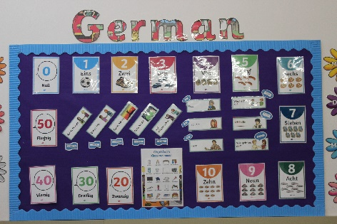 |  |  | Poems Published
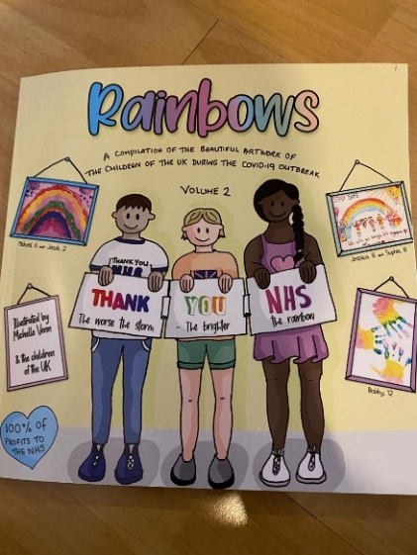  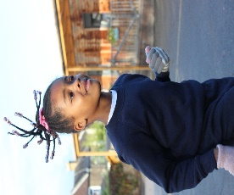  PE Kit Reminder  Just to remind you tst wear the correct PE kit to school on  Their PE days. This consists of a plain white T-shirt and plain  navy shorts or plain navy tracksuit. PE lessons are an  important part of the curriculum at Valley and, as such,  pupils must wear the correct items of school uniform for  these lessons. |  |  |  |  |  |  |  |  |  |  | PTA Fundraising  Thank you to all those who took part in Freaky Friday just  Before the half-term break. Over £500 was raised for the  PTA and plans are now well underway for this year’s  Virtual Christmas Fair.
Poppy Appeal  This year’s poppy-theemed items have been a huge success with the pupils. There are only a few enamel badges left and some of the paper poppies. These will be available up until Wednesday 11th November should any more pupils wish to make a donation to the Royal British Legion’s Poppy Appeal. |  |  |  |  |  |  | Instagr Instagram Keeping in Touch  Valley Primary School continues to use Instagram as one of its methods of communication with parents.  The school’s account now has over 400 parents following and, if you would like to follow this private account, please send a follow request to:  @valleyprimaryschool  When requesting to follow, please provide the name and class of your child in a DM  (Direct Message).
My Child Is Poorly – What Do I Do?

Please check the infographic below to check whether you should be sending your child to school.

Scenario: | A pupil shows symptoms of COVID-19
Symptoms:  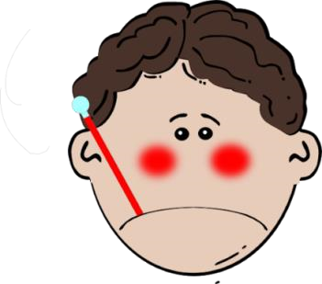 | - Temperature over 37.8 degrees (or hot to touch on your chest and back) or  - A new and continuous cough (this means coughing a lot for more than an hour or 3 or more coughing episodes in 24hrs) or  - A loss or change to your sense of smell or taste
Next steps: | - Pupil to remain off school for 10 days from symptom onset  - Members of the household should self isolate for 14 days  - A test should be arranged and, if negative, they can return to school  - Other pupils from the class or year group bubble will not need to self-isolate in the first instance

Scenario: | A pupil tests positive for COVID-19
Symptoms:  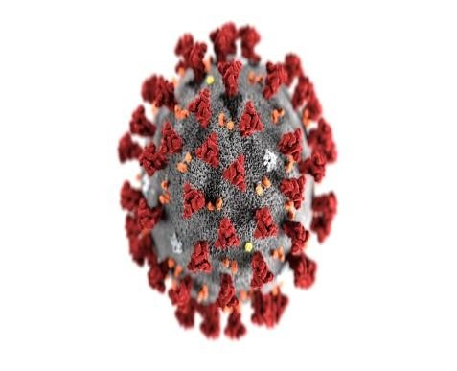 | - Temperature over 37.8 degrees (or hot to touch on your chest and back) or  - A new and continuous cough (this means coughing a lot for more than an hour or 3 or more coughing episodes in 24hrs) or  - A loss or change to your sense of smell or taste
Next steps: | - Everyone in the class / year group bubble need to self-isolate for 14 days  - Pupils in the class / year group bubble need to stay off school for 14 days even if they are tested and receive a negative result

