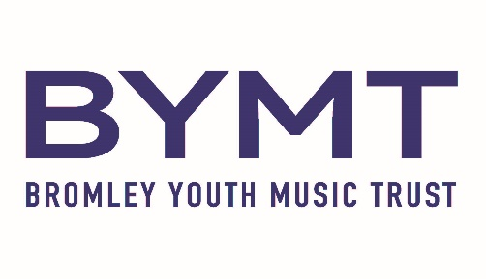

**Southborough Lane, Bromley BR2 8AA**

**Tel: 020 8467 1566 Email: contact@bymt.co.uk**

BYMT provides children with exciting opportunities to learn musical instruments or sing.

Lessons are held at your child's school during school hours and provided by visiting specialist music tutors.

We are also able to offer musical instrument and vocal lessons for adults at the BYMT Centre on Southborough Lane.

Please complete an online application form selecting your child's school and instrument choice. For instruments not offered at your school, there may be an opportunity to learn at the BYMT Centre Southborough Lane, outside of school hours.

[www.bymt.co.uk](http://www.bymt.co.uk)

**September 2025 - July 2026 Fees:**

- Individual 15 minute lessons or 2 sharing a 30 minute lesson: £116.25 per term*

- Individual 20 minute lesson: £155.00 per term*

- Individual 30 minute lesson: £232.50 per term*

* Based on 30 lessons per school year.

**INSTRUMENT HIRE**

BYMT has an extensive range of instruments available for hire for students of all experience, including adult learners.

Hire Fees:

£35.00 per term to hire a violin (1/2 size or smaller), pBones and pTrumpets.

£56.00 per term to hire all other instruments (please note we are unable to hire keyboards, pianos or guitars).