MC900434395[1]



Have you had an argument or fall out with a peer?

You could go and see a peer mediator at playtime.

They will listen to both sides of the dispute and

help you decide how the problem can be solved.

It is not about getting someone into trouble; it is about resolving a problem peacefully *before* things get worse.

The peer mediators will keep this promise:

**OUR PROMISE:**

* We won’t gossip
* We won’t take sides
* We won’t tell you what to do

You will need to keep to these rules:

**RULES FOR MEDIATION:**

* You will be able to talk without being interrupted
* You will all get the chance to tell your story
* You must be respectful at all times to each other and use each other’s names

By talking and listening to each other you should be able to come to an agreement that everyone is

happy with and one that makes sure the same

problem doesn’t arise again.

**At Valley we…**

**Care – Learn together - Aim high- Be honest - Look after what we have**



**Be READY**

**BE KIND AND CONSIDERATE**

**Be Safe**



**At Valley we aim to sort out problems using a Restorative Approach.**

**Restorative Language**

Restorative Language is a calm, fair and respectful way of communicating which allows each person to express their thoughts and feelings. It helps maintain positive relationships within the school. If there has been a conflict, it focuses on the harm that has been caused and ways to repair the harm and restore the relationship.



**A Restorative Approach will help people to:**

* Tell the truth;
* Be responsible;
* Being accountable for their own actions;
* Think about how actions affect others;
* Recognise, describe and understand different emotions.

**Care**

**Learn together**

**Aim high**

**Be honest**

**Look after what we have**



**The Valley Vibe**

**Because we…**

**Care – Learn together - Aim high - Be honest**

**Look after what we have**

**We are…**

**Ready – Kind and Considerate - Safe**

**So we…**

**Hang up our coats and bags**

**Look after our belongings**

**Help to keep the corridor tidy**

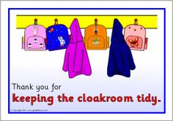



**The Valley Vibe**

**Because we…**

**Care – Learn together - Aim high - Be honest**

**Look after what we have**

**We are…**

**Ready – Kind and Considerate - Safe**

**So we…**

**Walk quietly and calmly in the corridors and on the stairs**

**Hold the door for others**

**Stay in our place in the line**

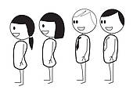



**The Valley Vibe**

**Because we…**

**Care – Learn together - Aim high - Be honest**

**Look after what we have**

**We are…**

**Ready – Kind and Considerate - Safe**

**So we…**

* ***Understand that lots of things will be different***



* ***Listen to the adults so we learn the new routine***



* ***Do our best to keep to Social Distancing***



* ***Wash our hands for 20 seconds whenever we are asked to***



* ***Keep clean and hygienic – always use tissues***



* ***Talk to an adult if you are worried or upset***



* ***Be friendly and kind to everyone in your Bubble***

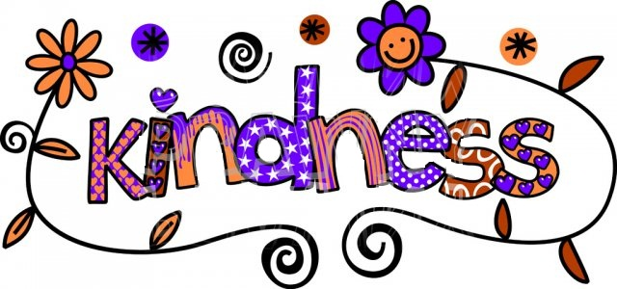

**LUNCH HALL**

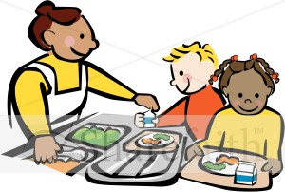  

**The Valley Vibe**

**Because we…**

**Care – Learn together - Aim high - Be honest**

**Look after what we have**

**We are…**

**Ready – Kind and Considerate - Safe**

**So we…**

**Say *please, thank you and excuse me***

**Walk in the hall and line up calmly**

**Have good table manners and talk quietly**

**Be considerate of the adults who are looking after us**

**Keep the tables and floor clean**

**Choose a healthy, balanced meal**

**‘PLAYBUS’ CLIMBING FRAME**

**MAXIMUM 30 CHILDREN**

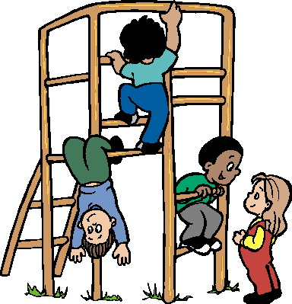  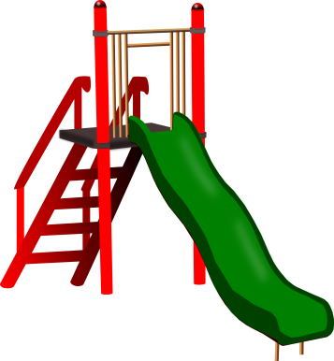

**The Valley Vibe**

**Because we…**

**Care – Learn together - Aim high - Be honest**

**Look after what we have**

**We are…**

**Ready – Kind and Considerate - Safe**

**So we…**

**Climb safely, not jumping off or climbing over the top bars**

**Use the slide safely, one person at a time, sitting up and facing forwards**

**Walk, not run in the playbus area**

**PLAYGROUND EXPECTATIONS**

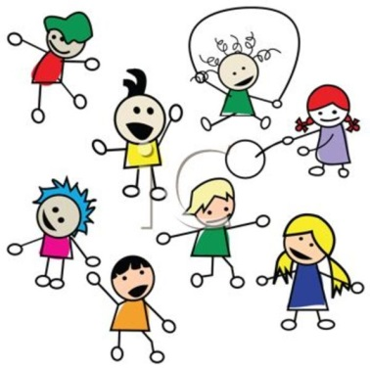 

**The Valley Vibe**

**Because we…**

**Care – Learn together - Aim high - Be honest**

**Look after what we have**

**We are…**

**Ready – Kind and Considerate - Safe**

**So we…**

**Keep to the playground zones and playtime routines**

**Show kindness by allowing others to join in our games and not leaving anyone out**

**Look after the equipment and help to tidy up**

**Be considerate of the adults who are looking after us**

**Stop and stand still for the first bell**

**Walk to the line for the second bell then stand in line calmly and quietly**

**POD EXPECTATIONS**

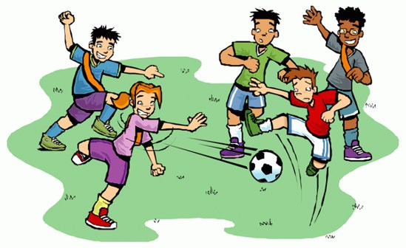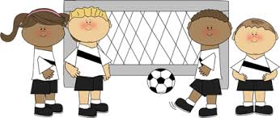



**The Valley Vibe**

**Because we…**

**Care – Learn together - Aim high - Be honest**

**Look after what we have**

**We are…**

**Ready – Kind and Considerate - Safe**

**So we…**

* **Choose teams fairly, with equal numbers in each and a mix of abilities**
* **Make sure everyone has the chance to play, changing teams when the adult asks**
* **Play with good team spirit, both to our own and the other team**
* **Play safely and fairly, keeping to the rules**
* **Listen to and respect the decisions of the adult on duty**



**The Valley Vibe for Remote Learning**

**Because we…**

**Care – Learn together - Aim high - Be honest**

**Look after what we have**

**We are…**

**Ready – Kind and Considerate - Safe**

**So we…**

* ***Understand that the high standards of behaviour that we expect in the classroom are expected in online lessons.***
* ***Keep our microphones on mute, except when the teacher asks us to contribute.***
* ***Be on time and be appropriately dressed.***
* ***Come prepared for the lesson, with any equipment we need.***
* ***Only use the chat or posts when asked to by the teacher and use them appropriately and respectfully.***



**Because we…**

**Care – Learn together - Aim high - Be honest**

**Look after what we have**

**We are…**

**Ready – Kind and Considerate - Safe**

**Follow the**

**The Valley Vibe**

**…to earn house tokens!**

***The house with the most tokens at the end of each half-term will win an ‘Own Clothes Day’.***

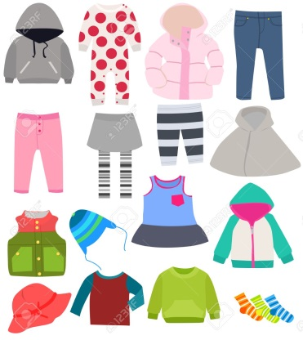

**The following adults have the tokens and are looking out for great behaviour!**

* ***Adults on the playground and in the lunch hall***
* ***Adults in Breakfast Club and After School Club***

**Adults in the lunch hall, adults on the playground, adults at Breakfast Club and After School Club are all on the look out to give out House Tokens**