

**Bromley Y Webinars**

**Joining our webinars is easy** – just click on the link below and look at the topics and dates that you are interested in, **scan the QR code in the posters above or visit our website calendar.  They will take you to Eventbrite where you can book your place.**

* **Bromley Y** [Website](https://drive.google.com/file/d/1k5k9rGqWqnjm3cGexrq0MqUZKLWgX9fV/view) Calendar

There is a pre-recorded version of the Primary webinar ‘Helping Children with Fears and Worries’ that parents can access here: [**https://www.youtube.com/watch?v=LUopyNA-g6Y**](https://www.youtube.com/watch?v=LUopyNA-g6Y)

If you have concerns about your child’s emotional wellbeing and/or behaviour the Bromley Y website is a really useful starting point to look at the options available for getting support.

[**https://bromley-y.org/for-parents-carers.html**](https://bromley-y.org/for-parents-carers.html)

**Text Support for Young People, with a Bromley Y practitioner**

Young people can text Bromley Y on the number in the poster, to ask for support from a practitioner at The Signpost.   *Please note., this service is for pupils aged 11+ so is only suitable for older Year 6 pupils.*

* [Click here](https://drive.google.com/file/d/1DcH1jTs96bD1WbNiuFOwH69yDnvl6A7X/view?usp=sharing) to see our poster with more information about The Signpost text support service.
* Watch our [Video](https://bromley-y.org/video.html) about The Signpost and how it works.

**Support calls**

If you are concerned about your child, parents can also request a support call from a member of the Mental Health Support Team. Please see below for the information from Bromley Y.

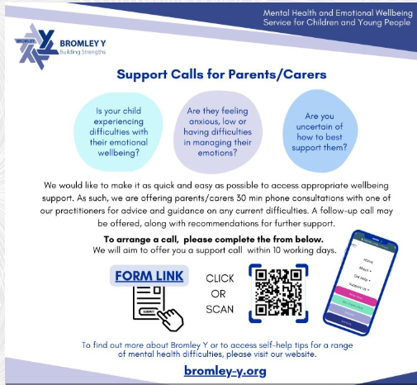

**The Targeted Support offer from Bromley Y**

The school can refer to Bromley Y for children identified as having low to moderate mental health needs. Due to the high level of demand for the service, practitioners may ask if parents have accessed the Support Calls and the Webinars first.

This page on the Bromley Y website has guidance on questions to consider when deciding if a referral for targeted support is needed. <https://bromley-y.org/for-parents-carers.html#next>

The targeted support is evidence-based **parent led intervention** working primarily with a parent to help them understand their child’s difficulties better and support them to support their children through their difficulties.