AUTUMN TERM OVERVIEW
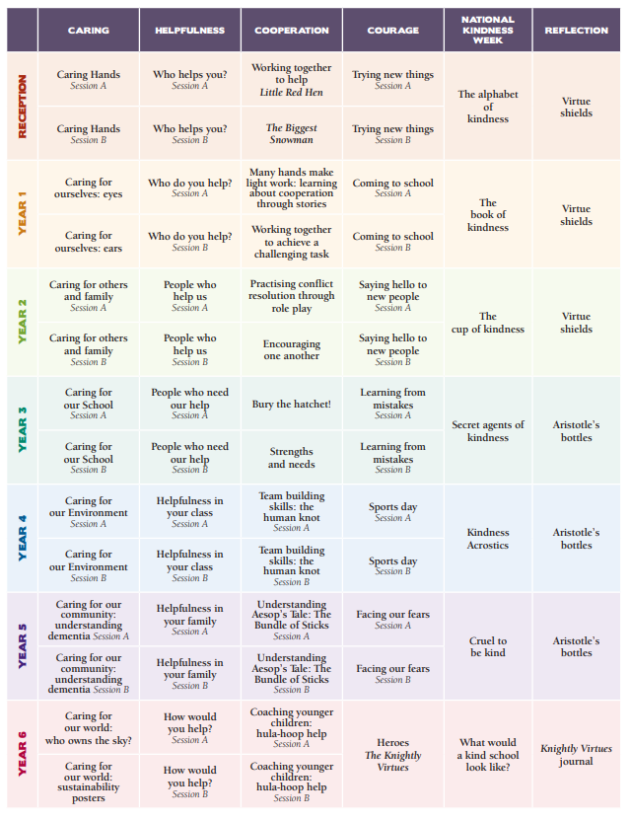

SPRING TERM OVERVIEW
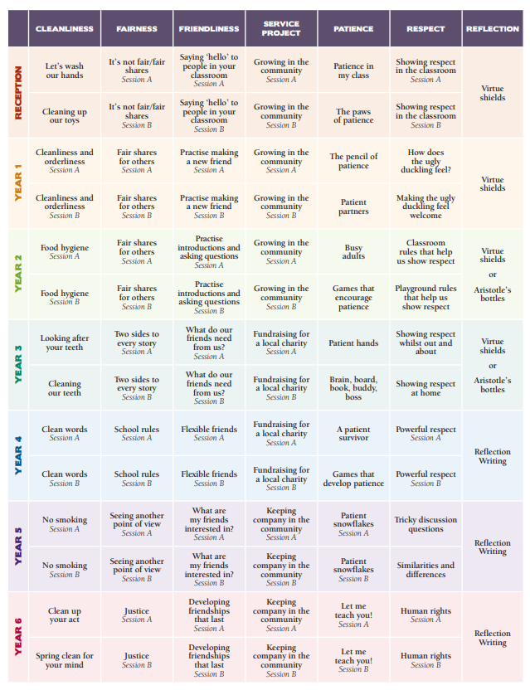

SUMMER TERM OVERVIEW
