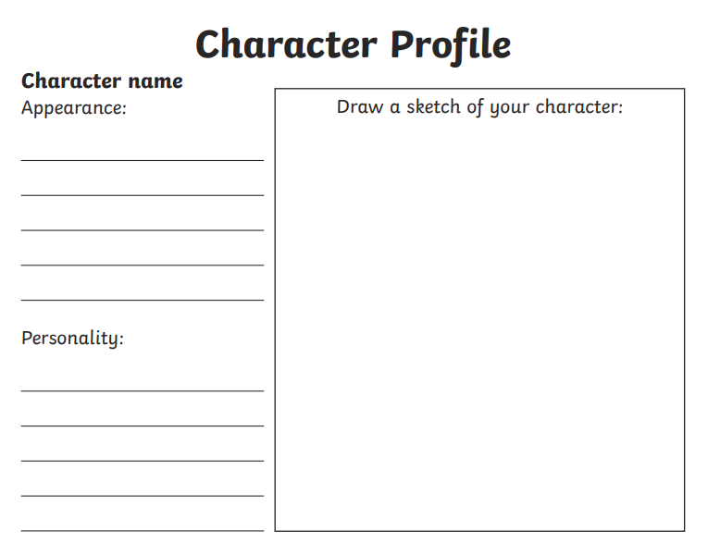
On the profile sheet below list some key words to describe your character. Try to look over the script that you have for ideas or use the picture at the bottom of the page for ideas about Romeo’s appearance.

