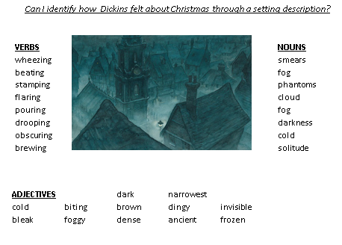
Find and write the meaning of these words as part of a sentence.
- Invisible
______________________________________________________________________________________________________________________________________________________

- dense ______________________________________________________________________________________________________________________________________________________
- dingy ______________________________________________________________________________________________________________________________________________________
- obscuring ______________________________________________________________________________________________________________________________________________________
- bleak ______________________________________________________________________________________________________________________________________________________
Write 5 Sentences using the key words to describe the setting at Christmas.
____________________________________________________________________________________________________________________________________________________________________________________________________________________________________________________________________________________________________________________________________________________________________________________________________________________________________________________________________________________________________________________________________________________________________________________________________________________________________________________________________________________________________________________________________________________________________________________________________________________________________________________

