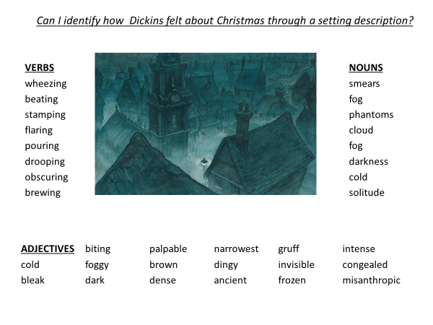Look up the meaning of these words.
Where could you have used them in the text? Use the original text to help you!
- Misanthropic ______________________________________________________________________________________________________________________________________________________

- Palpable ______________________________________________________________________________________________________________________________________________________
- Dingy ______________________________________________________________________________________________________________________________________________________
- Gruff ______________________________________________________________________________________________________________________________________________________
- Congealed ______________________________________________________________________________________________________________________________________________________
Plan and write 5 sentences using the key words to describe the setting at Christmas.
__________________________________________________________________________________________________________________________________________________________________________________________________________________________________________________________________________________________________________________________________________________________________________________________________________________________

