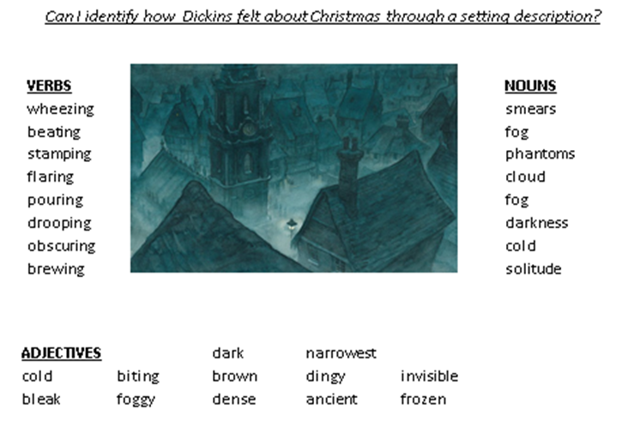

Find and write the meaning of:

1. solitude __________________________________________________________________________________________________________________________________________________________________________
2. dense __________________________________________________________________________________________________________________________________________________________________________

Write 2 sentences using expanded noun phrases (with):

1. __________________________________________________________________________________________________________________________________________________________________________
2. __________________________________________________________________________________________________________________________________________________________________________

Use 2 of the listed fronted adverbial as a sentence opener to describe the setting:

|  |  |
| --- | --- |
| In the blink of an eye, | Meanwhile, |
| At the corner of the bleak street, | Without a sound, |

_________________________________________________________________________________________________________________________________________________________________________________________________________________________________________________________________________________________________________________________________________________________________________________________________________________________________________________________________________________