Emotional Wellbeing and Mental Health at Valley

UNIVERSAL APPROACH
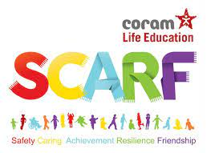
This is about the things we do as part of our everyday learning at school, that help us keep mentally healthy.

- We learn about looking after our wellbeing as part of our PSHE lessons.
- We talk about emotional wellbeing in some of our assemblies.
- We have special activities planned each February, as part of Children’s Mental Health Week.
- Bromley Y come into school for assemblies, workshops and group work.
- Sometimes we have additional workshops, such as Fantastic Fred.
- We have a Restorative Approach to behaviour, which teaches us to talk about emotions, empathise and take responsibility for our own actions.
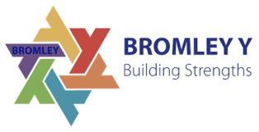
- We have Peer Mediators to help us if we have a conflict, and Opal leaders/Sports leaders to help us have happy playtimes.
- We have Wellbeing Ambassadors who work with the Wellbeing Committee to continue to improve pupil and staff wellbeing.
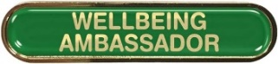
- We have Worry Monsters and ‘I would like my teacher to know’ boxes in all our classrooms.
- We have ‘drop-in’ sessions where you can talk with Mr Jackson, Mrs Mulla, Mrs Crawford Jones or Mrs Coulson if something is worrying you.

STAGE 1
If you, a parent or carer, or your teacher is worried about your emotional wellbeing, this is what will happen first.
- The teacher will have a meeting with your parent/carer and you (if you would like to be there).
- We might plan some adjustments to what happens in the classroom or at playtime, depending upon what is affecting you.
- The teacher will tell your parent/carer about the webinars and resources provided by Bromley Y. These can help parents to help their children.
STAGE 2
If you, a parent or carer, or your teacher continues to be worried about your emotional wellbeing, this is what will happen next.
- The teacher will have another meeting with your parent/carer and you (if you would like to be there) to see if the adjustments we have tried so far have helped.
- Your teacher will talk to Mrs Coulson or Mrs Crawford-Jones. They might want to talk to you so we can plan the best support for you.
STAGE 3
Mrs Crawford-Jones, Mrs Mulla, Mr Jackson or Mrs Coulson will plan some support for you. This will last for a fixed number of sessions. This could be individual or group work. Here are some examples of focussed sessions that might be offered.
- Sessions to help manage anxiety.
- Sessions to help you regulate your emotions and manage your behaviour (Zones of Regulation).
- Sessions to develop your confidence or self-esteem.
- Sessions to help you feel positive about coming to school and leave a parent/carer happily.
- Sessions to help you develop friendships and to socialise with different people.
- Weekly or fortnightly check-ins with a Trusted Adult.

External support
- An adult at school or your parent/carer may decide to seek some additional support from Bromley Y. The school will work your parent/carer to fill in a referral form. You will be asked for your views too. The Mental Health Support Team at Bromley Y will then tell us if they can offer you and your family any support, or they might give the school some ideas for things to do in school.
- For Year 6 pupils, there a small number of places available for pupils who would benefit from seeing a Mentor. School adults will speak to you if we feel this is something that may be beneficial.

