Dougal’s Deep-Sea Diary
Please find within this document all the relevant resources for this weeks English. Each piece of work will be set during the online input and some of the work will be slightly different depending on whether you are in group A or B.

Lesson 1
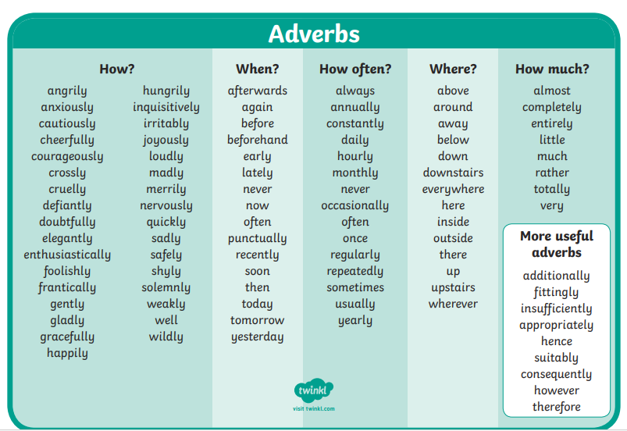

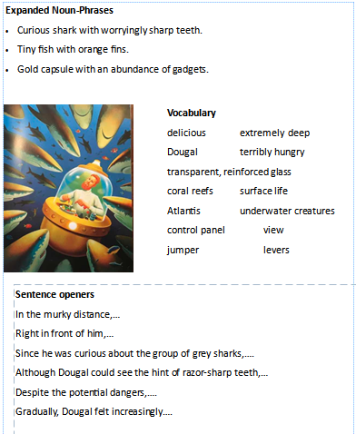

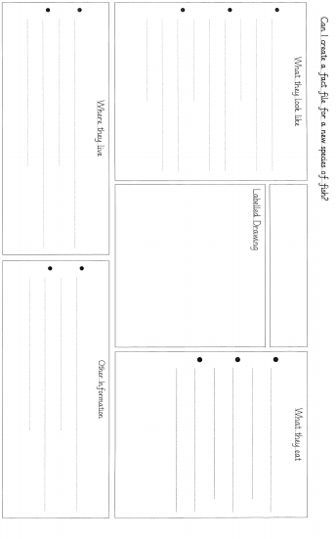
Lesson 2
Lesson 3

