Dougal’s Deep-Sea Diary
Please find within this document all the relevant resources for this weeks English. Each piece of work will be set during the online input and some of the work will be slightly different depending on whether you are in group A or B.

Lesson 1: The aim of this lesson is to plan a part of the story that talks about how the mysterious treasure that Dougal found, got there.

You will need to follow the plan and create your own ideas following our input. Try do get as many words, feelings and sounds to help you write in the next lesson.
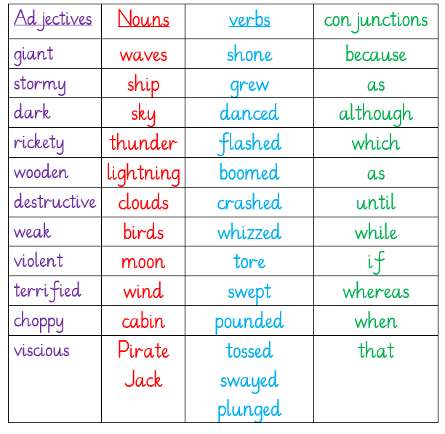

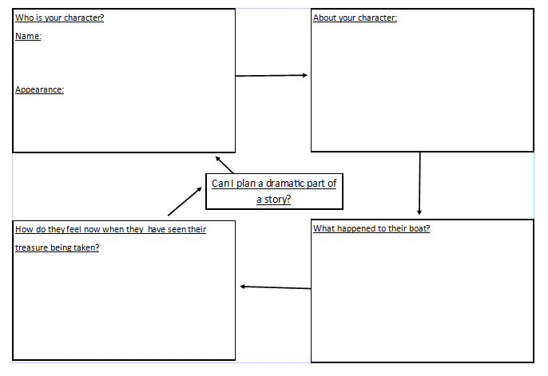
Lesson 2: The aim of this lesson is writing your story using yesterday’s plan. You should use the different boxes on the plan as themes for different paragraphs/sentences. For group B we want you to include adverbs and fronted adverbials into your writing, whilst group A, you should be using your Top Ticks below to help you write.
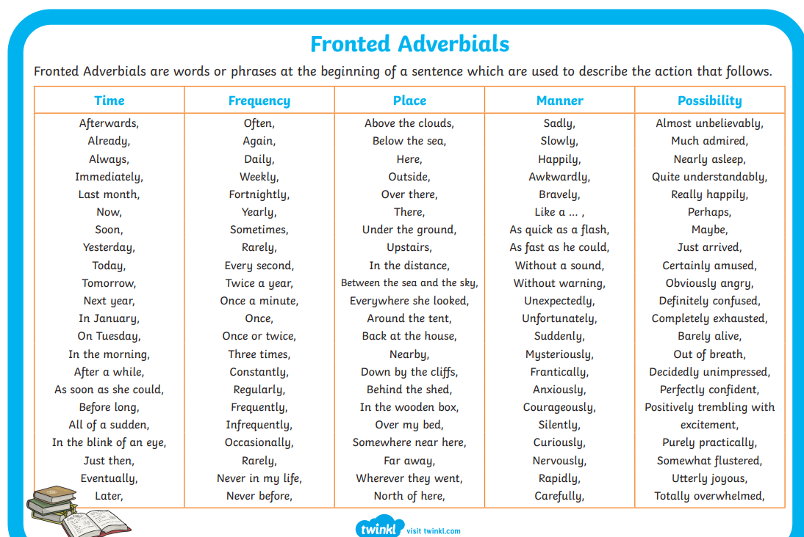

Writing example
A rumble of thunder filled the sky as the clouds grew darker and darker. The ghostly moon shone down on the lonely ship as it danced over the glimmering sea. Slowly, the gentle waves began to grow while the wind became stronger and fiercer. Although One Eyed Jack was a capable seaman, he began to struggle to control his rickety ship in the ever-growing stormy sea. CRASH! A giant wave smashed onto the wooden deck. Shaking with determination, he tried to steer his trusty ship through the destructive waves. Soon, the waves were as tall as houses and each one tore mercilessly into the side of ship. SMASH! One after another they pounded the now devastated ship, tossing it from side to side with ease. Was there any way One Eyed Jack was getting off this ship alive? Terrified, he clung onto the wheel and steadied himself for the next wall of water.

Suddenly there was a CRACK. One Eyed Jack stopped. He looked upwards into the never-ending darkness. What was that? Before he had time to think, the wooden mast came crashing down and tore a hole in the side of the already weakened vessel. Defeated, he let go of the wheel and it begun to spin uncontrollably. All hope had gone. The ship was sinking.....

Lesson 3: In this lesson you are going to pretend that you are a reporter. You need to plan what questions you would like to ask Dougal following his amazing discovery of the long-lost hidden treasure.

Question sentence starters:

Lesson 4: Today we will be writing a response to the questions that we did in the last lesson. You will need to use the template below to copy 3 question’s in to and write your answer. When answering, you must imagine you are Dougal and put yourself in his shoes.

Reporter:

Dougal:

Reporter:

Dougal:

Reporter:

Dougal:

Feeling? | Thinking? | Action?
Excited about what I found | How did this get here? | I was able to call upon my marine mammal friends.
Overwhelmed by all the attention | Should I hand it in or not? | The dolphins and I rescued the treasure.
Proud of being the one that found it. | Is this underwater map Atlantis? | I handed in all the treasure, like the honest person I am.
Gob smacked by what I have found. | It was very eerie in the wreckage. | Mistakenly, I forgot to hand in the underwater maps.
Amazed by all the treasure. | Who might of all this treasure belonged to? | I combed and brushed my hair so I looked handsome for the camera.
Anxious about being inside a wreckage.

