Year Group: Reception – Isolation Week Beginning: 30.11.20

Please continue to refer to our 3-day self-isolation support pack as there are plenty of activity ideas to take you over 3 days. We are also aware that you cannot leave your house during this isolation period so therefore the section titled ‘Amazing Adventures’ are to be carried out in your gardens if you have one.
Please also refer to past News Letters for more activity ideas.
Reading | Be read to for at least 20 minutes each day, this can be broken into smaller sessions. An adult can read the book, pick out ‘key words’ or tell someone at home what has happened. Can you make predictions throughout the book as to what might happen next?  Oxford Owls – a good resource for reading books  Also, please use your new Bug Club logins that have been emailed to you to access the books we have set for your child. As you read each page, look out for the little bug icons to click and answer questions about what you have read so far.  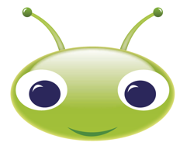
Writing | In class, we have continued to identify initial sounds as well as learning to write simple CVC words and simple captions or phrases. For this week, we would like your child to have a go at the following tasks:  Our focus book for the week is ‘We’re going on a Bear Hunt’. Please share this book together first. If you do not have a copy of this book, use the link below to listen to the audio version and watch Michael Rosen perform it too.  https://www.youtube.com/watch?v=0gyI6ykDwds  https://www.youtube.com/watch?v=kL36gMrHJaI  Challenge 1: Look at the picture below (picture 1) and discuss what you can see with an adult or sibling.  Challenge 2: Using your ideas of what you can see, can you think of the initial sounds for your chosen words and write them down. E.g ‘d’ for dog  Challenge 3: If you’ve had a good go at writing the initial sounds, now extend that with writing words. E.g dog, stick, top, red, back pack  Challenge 4: Using the words you have come up with, can you compose and write a caption for the picture. E.g the dog is black, the top is pink, he has a stick.  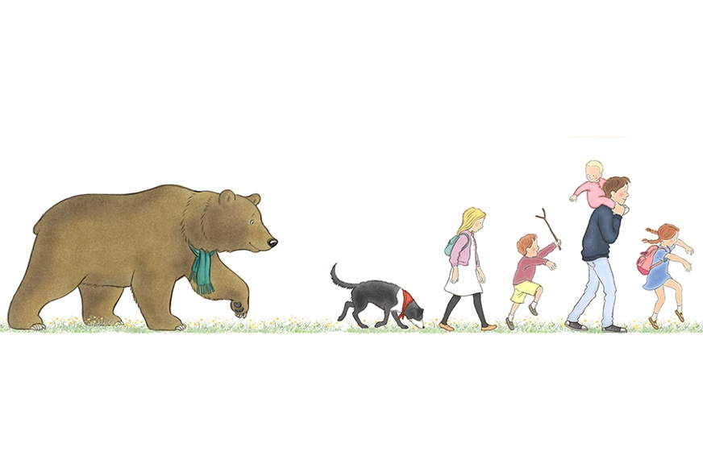Picture 1  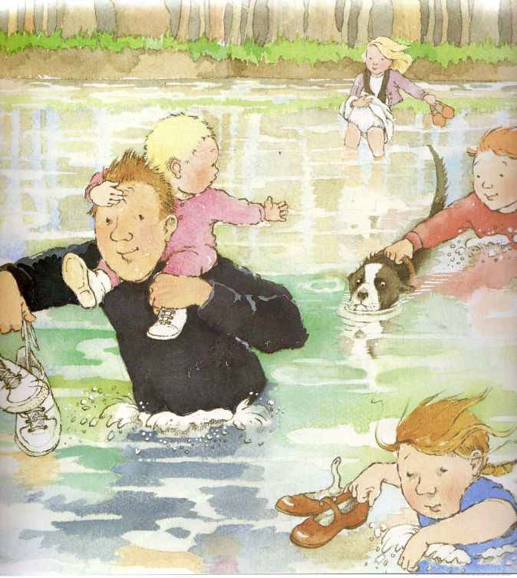Picture 2  Using the format of the above challenges 1-4, please complete using both pictures and a chosen picture by your child from the book.  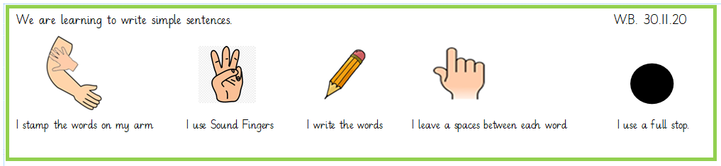  We have started to use this checklist to remind the children to say the word they want to write, use sound fingers to segment the word and the write down the sounds they hear.  At school, we usually have 3 focused writing sessions a week. Please try to do the same.
Phonics | We always practise the letter names of the alphabet as well as the sounds. Do an alphabet puzzle or identify each letter name. You can write the alphabet down on cut up pieces of paper, can they order the alphabet? Can they identify letters that are not in order?  Practise reading and writing the letter sounds we have learnt so far ‘s’ ‘a’ ‘t’ ‘p’ ‘i’ ‘n’ ‘m’ ‘d’ ‘g’ ‘o’ ‘c’ ‘k’ ‘ck’ ‘e’ ‘u’ ‘r’ h’ b’ f’ ff’  Practise reading and writing our tricky words learnt so far:  I, a, to, the, go, no, into  https://www.bbc.co.uk/bitesize/topics/zf2yf4j - Use this website to help you.  Here’s a ‘Tricky words’ song that we sometimes use too.  https://www.youtube.com/watch?v=TvMyssfAUx0  Last week, we taught the children how to play phonics and tricky word bingo. If the children have forgotten, then here is how it works:  First you need a piece of paper and the page needs to be divided into 4, 6 or even 9 boxes. Children then need to choose which sounds or tricky words they want to fill their boxes up with. Finally, someone needs to be a ‘Bingo Caller’ and decide which sounds or tricky words to say. If your child has the sound or tricky word that has been called they can circle it. Once they’ve circled all their boxes they can shout ‘Bingo’. This will be fun for all the family to join in with.  We have a half an hour slot each day at school for phonics. It would be great if you could do the same.
Maths | This week for Maths we would have consolidated our ‘1 more than’ learning and started to look at ‘1 less than’  A good starter each session will always be to recap their number recognition and formation 1-10 and recapping what you’ve done the day before.  Practical objects are great, so whatever you have at home for the children to count, get them out! Explain the language that 1 less is the same as taking away and once you take away objects you have fewer objects left. Line up your objects carefully to count them, touching each one and then physically take one away to count how many you have left. You can challenge your child by translating the practical movements of taking away into a subtraction number sentence. For example if they lined up 5 objects and they took 1 away to find out what 1 less is, they can be shown that 5-1= means exactly the same.  Once the explaining has been done you can try the following activities:  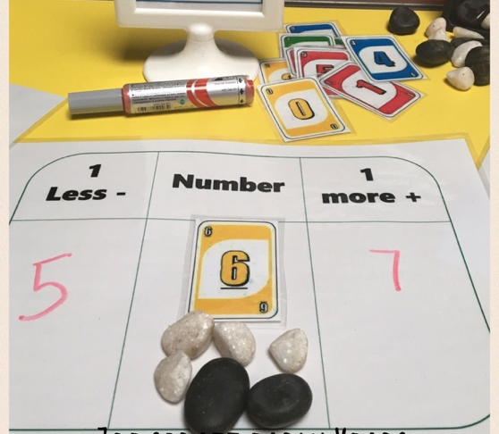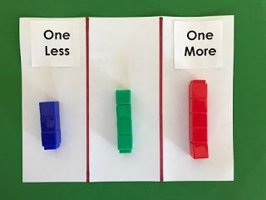  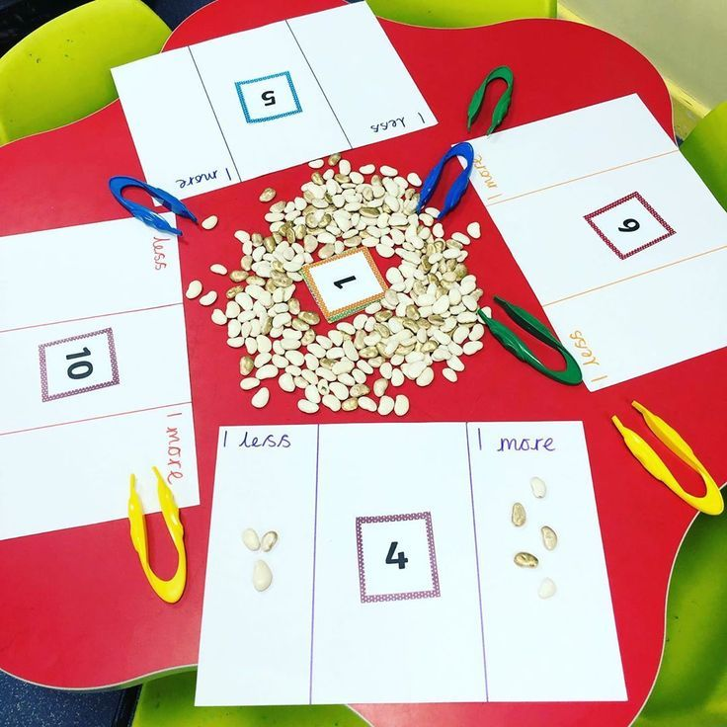  Just like writing, we have 3 focused maths carpet sessions a week and it would be amazing if the same can be followed at home.
Knowledge and Understanding/  Creative | This week have a go at some of the following activities:  Making your very own creative version of a map showing the different environments from the story.  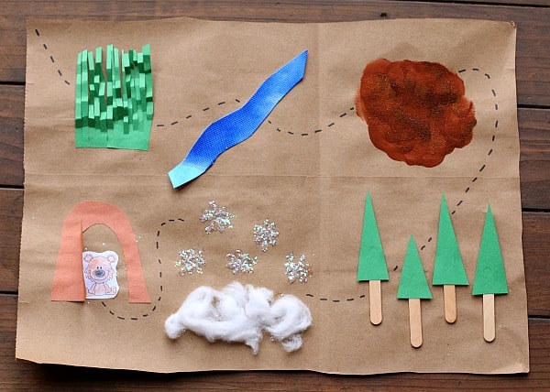  Make a bear mask or a face of a bear on a paper plate. You can decide how friendly or how scary you wish the bear to be.  Using different media, create the different environments from the story. What are you going to use for your long wavy grass, your deep cold river, the thick oozy mud, the big dark forest and the snow storm.  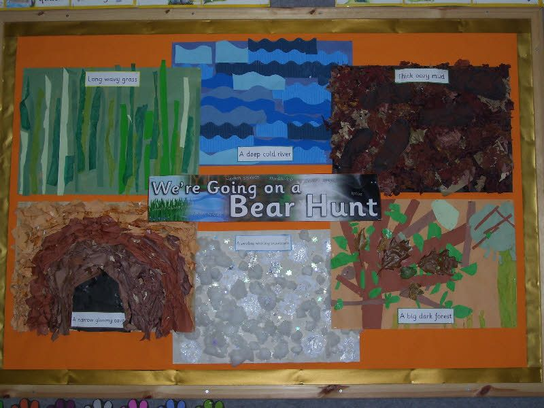
Physical Development | Each morning both classes have a boogie to their ‘Hello’ song. You can start each day the same way. It’s a great way to get them moving too!  Owls ‘Hello’ song https://www.youtube.com/watch?v=gghDRJVxFxU  Robins ‘Hello’ song https://www.youtube.com/watch?v=CuI_p7a9VGs  This term, during PE, we have been working towards skills that will help across all different types of sports. Hand and eye co-ordination being one of our priorities. If you have a small light ball at home e.g. a tennis ball, then you can continue with some of the drills we’ve been working on at school.  Children have been practising rolling the ball on the floor to their partner and stopping it. They have also been passing the ball by lightly tapping it with the inside of their foot and then stopping it with their foot between the ball of their foot and the floor.  Please also continue to use the useful links for different physical activities from the 3-day isolation pack.

