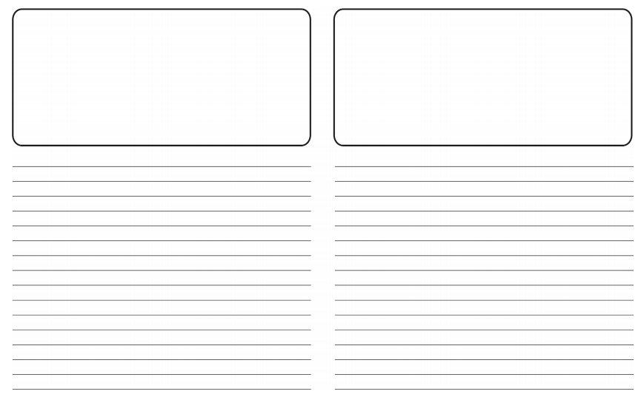

Explain how each version was similar or different from the other.

Explain why you think there were (or could easily be) differences between the first and last recordings.



Which strategies do you think the Anglo-Saxons used to remember and repeat stories (repetition, rhyming, familiar characters) and explain why they might’ve used these.

Describe any strategies that you used or on reflection could have used to make the story easier to remember and repeat?



Thinking about your answers to the last four questions, what implications does this have for using stories as historical sources of information and why? (will they give us a clear view of life in the past? Will the picture of the past be reliable? Why or why not?)