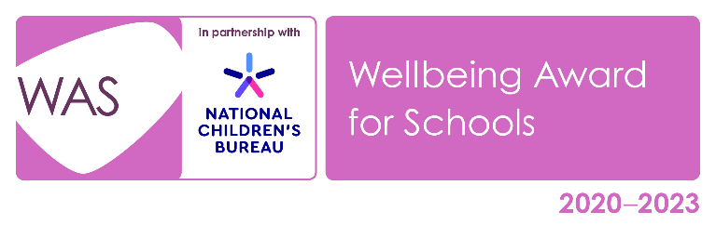

Developed in partnership with the National Children’s Bureau (NCB), the Wellbeing Award for Schools is intended to help schools prepare and equip themselves to promote emotional wellbeing and positive mental health across the whole-school community. NCB’s vision is an education system where good emotional wellbeing and mental health are at the heart of the culture and ethos of all schools, so that pupils, with the support of their teachers, can build confidence and flourish. Evidence shows us that wellbeing is of central importance to learning and attainment, with high levels of wellbeing associated with improved academic outcomes. Conversely, pupils who have mental health problems are more likely to have academic difficulties at school and experience social disadvantage later in adult life.
To achieve this vision of wellbeing at the heart of learning, NCB advocates the use of a ‘whole-school approach’ where all aspects of the school experience are harnessed to promote the emotional wellbeing and mental health of pupils and staff. It is an approach where emotional wellbeing and mental health is everybody’s business.
There is continuing evidence of the impact of the pandemic on the emotional wellbeing and mental health of children, their families and school staff. Bereavement, social isolation, increases in domestic abuse, increases in financial hardship and poverty, the loss of opportunities for staff to spot emerging needs in pupils, the suspension of school-based services and the reluctance of children, families and staff to seek medical help during lockdowns all contributed to both acute and longer-term challenges to emotional wellbeing and mental health. A high percentage of children and young people with pre-existing mental health needs say that their mental health deteriorated during the pandemic, and, for some, for whom working at home reduced their anxiety, there have been challenges in getting back into school and re-establishing regular attendance. Additional pressures arising since the return to school are further increasing financial hardship. Recovery needs to address both the immediate and the longer-term challenges and ensure that the wellbeing of pupils, staff and the wider school community is a priority.
The Wellbeing Award for Schools is a welcome opportunity to recognise the exceptional work that schools do in this area. The key features of a whole-school approach form the basis of the award, and it provides schools with a benchmark of best practice against which to test themselves. We believe that this celebration of success will encourage more schools to adopt an approach that puts emotional wellbeing and mental health at the heart of what they do.

There are four key principles driving the ideas and recommendations behind the award:
- Emotional wellbeing and mental health are a continuum. Related issues can range from positive attitudes and behaviour, through to experiences of emotional distress and mental disorder.
- Schools already experience and manage emotional issues on a daily basis; the objective is to minimise the impact of such issues and maximise the effectiveness of any responses.
- Emotional wellbeing covers a range of dimensions, such as resilience, character building, relationships and self-esteem, etc. Understanding both developmental and mental health awareness is critical.
- Creating a positive school culture requires a whole-school approach that is led from the top while involving all in the school community.
The WAS has eight objectives which focus on areas of evaluation, development and celebration of the work of schools in promoting and protecting emotional wellbeing and positive mental health. Each of these areas is further broken down into Key Performance Indicators (KPIs):
Objective 1: The school is committed to promoting and protecting positive emotional wellbeing and mental health by achieving the Wellbeing Award for Schools.
Objective 2: The school has a clear vision and strategy for promoting and protecting emotional wellbeing and mental health, which is communicated to all involved with the school.
Objective 3: The school has a positive culture which regards emotional wellbeing and mental health as the responsibility of all.
Objective 4: The school actively promotes staff emotional wellbeing and mental health.
Objective 5: The school prioritises professional learning and staff development on emotional wellbeing and mental health.
Objective 6: The school understands the different types of emotional and mental health needs across the whole-school community and has systems in place to respond appropriately.
Objective 7: The school actively seeks the ongoing participation of the whole-school community in its approach to emotional wellbeing and mental health.
Objective 8: The school works in partnerships with other schools, agencies and available specialist services to support emotional wellbeing and mental health.

Preparation for reassessment
Schools have up to 9 months to complete the reassessment process.
- Convening the Review Team
- Completing the self-evaluation, using the stakeholder evaluations to inform this
- Forming an action plan
- Updating the portfolio of evidence
- Prepare for verification
You need to provide one piece of evidence for each KPI in the framework, to show that the whole school approach to emotional wellbeing and mental health has been maintained over the three-year period.

WELLBEING AT VALLEY

