Mathematics Curriculum Intent Statement
At Valley, we recognise that mathematics plays an essential role in everyday life and provides children with the foundational knowledge for understanding the world around them. Visible in the sciences, engineering, technology, necessary for financial literacy and inextricably linked to art and nature itself, our aim is therefore to provide children with the skills to become fluent in the fundamentals of mathematics, equip them with the ability to be able to reason mathematically, enable them to appreciate the beauty and power of mathematics and most importantly to nurture and cultivate a sense of enjoyment and curiosity about the subject. We aim to teach the subject in a way that is relevant and meaningful to all of our pupils, exposing them to a range of mathematical concepts and encouraging them to always apply their skills to real-life situations.
Curriculum structure
Our curriculum promotes and embodies the aims of the National Curriculum - fluency, reasoning and problem solving as we believe that these skills are essential for success in Mathematics and beyond. The development of key numeracy skills is crucial to pupils’ progression in the subject, and so we provide regular opportunities for pupils to practice and consolidate their basic number facts and mental calculation skills across the school. Our curriculum ensures the four components to achieve mastery are taught:
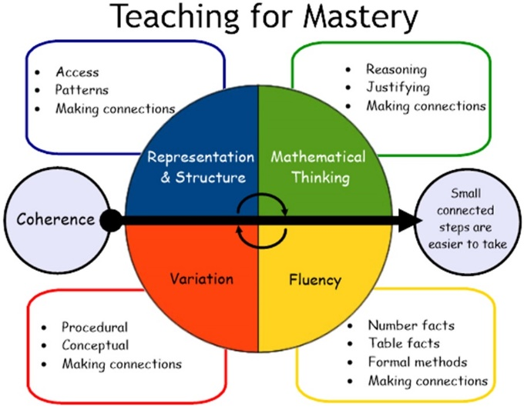
Our curriculum also provides guidance to help pupils become:
Visualisers – We use the CPA approach to help pupils understand mathematics and draw connections between different representations.
Describers – We place great emphasis on mathematical language and questioning so pupils can discuss the mathematics that they are exploring and so support them to take ideas further. Pupils can demonstrate their declarative knowledge by using terms such as “I know that…” when talking about number facts, concepts and rules; show their procedural knowledge with terms such as, “I know how…” when taking about methods and procedures; and show their conceptual knowledge with phrases such as, “I know when…” when problem solving and reasoning -drawing on both their declarative and procedural knowledge.
Experimenters – As well as being fluent mathematicians we want pupils to love what they are learning and have the confidence and perseverance to want to explore further.
Through a carefully planned and sequenced programme of study, we aim to provide pupils with a broad and deepening understanding of Mathematics, as well as the ability to apply their skills to a range of different contexts. In order for pupils to learn mathematics effectively, some things have to be learned before others, e.g. place value needs to be understood before working on addition and subtraction, addition should be learnt before looking at multiplication (as a model of repeated addition). Therefore, our curriculum has been designed with an emphasis on number skills at the beginning of each year in order to best prepare pupils for the learning opportunities that they will encounter within and across each academic year. We have also interspersed those topics which aren’t so reliant on numerical familiarity so that pupils receive a wide variety of mathematical experiences within each term and year.
Teaching and Learning
When teaching mathematics at Valley Primary School, we intend to provide learning experiences which not only inspire and motivate but which also cater to the needs of all individuals. Within the different Key Stages work children work towards the same outcome, with teachers adapting their teaching to ensure all children keep up. Throughout the key stages, learning is structured to include the same elements in lessons, to ensure depth of learning:
Vocabulary teaching – Giving children the confidence to use mathematical vocabulary when explaining or articulating their learning and giving them the skills to decode what mathematical methods and concepts are required to answer a problem.
Daily arithmetic and retrieval practice – To ensure that those number facts, strategies and methods that underpin the curriculum are stored in pupils long term memory.
Fluency – Enabling students to become fluent in their number facts, table facts, methods and form connections.
Variation – Ensuring that pupils are secure in the essential features of a concept or idea when it has been represented differently.
Problem solving and reasoning – Allowing learners to demonstrate mastery and depth of a mathematical concept.
Pupils are also provided with a range of manipulatives both visual and physical in order to support and scaffold their understanding around the new content which is covered. Teachers maintain consistently high expectations of all pupils, who are expected to succeed and make progress from their individual starting points. All children also have the opportunity to identify patterns or connections within their maths; they can use this to predict and reason and to also develop their own pattern or links within maths and other subjects.
By providing pupils with a strong foundation in Mathematics, we know that they will be able to succeed in further studies and in their future careers and lives beyond. Here at Valley Primary School, we are incredibly proud of the Mathematics curriculum that we offer and the high standards of achievement of all our pupils.

