Learning at Home
YEAR 5
Monday 18th January – Friday 22nd January 2021
All the resources are also available on:
ValleyPrimary.co.uk - Curriculum – Lockdown Home Learning –Year 5 - Spring Week 3
Year 5 Teachers welcome emailed copies of the Students Home Learning

Reading | Read for 30 minutes a day.  Answer the Bug questions, using full sentences and punctuation.  Remember to use evidence to back up your answer.  Use your log in details for Bug Club and remember to complete the comprehension questions.  Username: Childs first name  Password Teal (followed by a number)  School Code: AHX7
English | Task 1: Romeo and Juliet, L1, ‘Meanwhile...thoughts on the feast’  Can I write diary entry?  After re-reading Juliet’s discussion with the Nurse and Lady Capulet and also looking at the discussion between Benvolio and Romeo about attending the Capulet’s feast, you are going to consider how Romeo and Juliet are feeling about attending the upcoming feast. You will then have a go at putting yourself in either Romeo’s or Juliet’s shoes and create a diary entry explaining their thoughts and feelings at this point.  Task 2: Romeo and Juliet, L2 ‘Mercutio’  Can I write a character description of Mercutio?  In this session we will find out more about a new character and look at his interactions with Romeo in the lead up to the feast. After thinking about the meaning of his name, his physical appearance, actions, thoughts and feelings you will then create a character description.  Task 3: Romeo and Juliet, L3 ‘Queen Mab Speech Part 1’  Can I understand the first part of Mercutio’s Queen Mab speech?  In this session we will look closely at the first part of Mercutio’s Queen Mab speech, after which you will have a go at illustrating your understanding of Queen Mab.  Task 4: Romeo and Juliet, L4 ‘Queen Mab Speech Part 2’  Can I understand Mercutio’s Queen Mab speech and its relevance to his character?  In this session we will explore the second part of Mercutio’s Queen Mab speech and then consider what the speech shows us about Mercutio’s character. Finally, you can choose from three activities based on the last part of the Queen Mab speech which will demonstrate your understanding of its content and purpose (see below and on PPT).  Write a modern-day Queen Mab speech, explaining what she would do differently in today’s world, describe a dream Queen Mab brings to a person of your choice, imagine you are casting a film about Queen Mab-explain which actor/actress you would want to play her and why (which qualities would they bring to the role?).  Task 5: Reading Comprehension - Greta Thunberg  (Answers available on the Lockdown Home learning page)  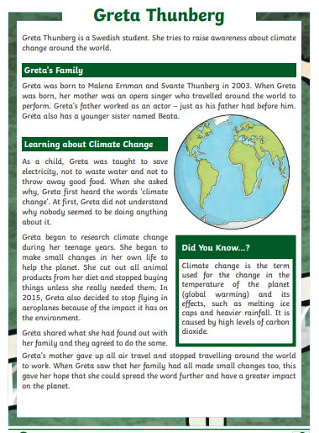  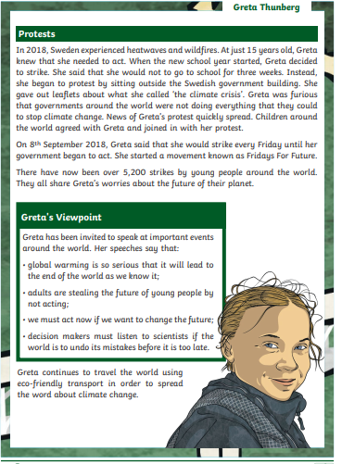  Write the answers in full sentences on lined paper of in your home learning book  1. What is the name of Greta’s father? Tick one. Malena Ernman Svante Beata  2. Which of these was Greta taught as a child? Circle one.  - to use electricity  - to conserve water  - to throw away food to sing  3. Look at the section called Protests. Find and copy one word which means the same as ‘angry’.  4. List one small change that Greta made to help the planet.  5. In addition to Greta, who else gave up air travel to help with climate change?  6. Explain why Greta was confused when she first heard about climate change.  7. Greta continues to travel the world using eco-friendly transport… Explain why the term ‘eco-friendly’ is important in this sentence.
Maths | IXL  Perimeter and Area R1-11  Multiplication D 1-25 New topic  Division E1-17 New Topic  Maths Frame (Practise daily this week in order to help with times table fluency)  https://whiterosemaths.com/homelearning/year-6/week-5/  The questions on the planning sheet are to be completed after the lessons.  The resources on the home leaning page are optional should more practise be required.  Math Group A  Lesson 1: Can I divide 2digits by 1digit numbers? (PPT available)  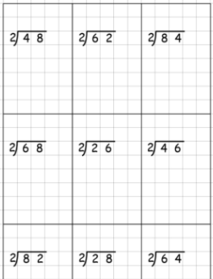  Can I divide 3 digits by 1digit numbers? (PPT available)  https://whiterosemaths.com/homelearning/year-6/week-5/  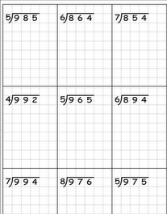  Lesson 2: Can I divide 4 digits by 1digit numbers?  https://whiterosemaths.com/homelearning/year-6/week-5/  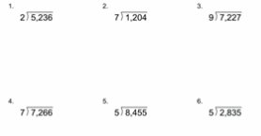  Lesson 3: Can I solve problems using division? (Answers on the Lockdown home Learning page)  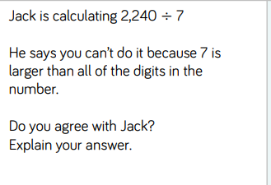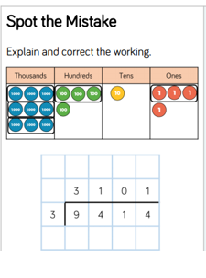  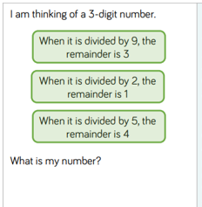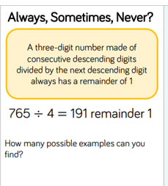  Lesson 4: Can I divide with remainders?  https://whiterosemaths.com/homelearning/year-6/week-5/  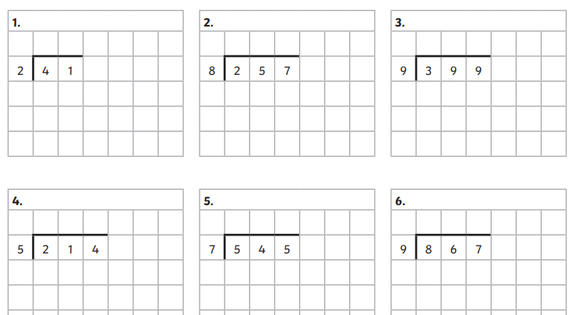  Lesson 5: Can I solve problems using Multiplication and Division?  (Refer to the PPT for questions)  Maths Group B  Lesson 1: Can I divide 2digits by 1digit numbers? (PPT available)  Lesson 2: Can I divide 3 digits by 1digit numbers? (PPT available)  https://whiterosemaths.com/homelearning/year-6/week-5/  Lesson 3: Can I divide 4 digits by 1digit numbers?  https://whiterosemaths.com/homelearning/year-6/week-5/  Lesson 4: Can I solve problems using division?  Lesson 5: Can I divide with remainders?  https://whiterosemaths.com/homelearning/year-6/week-5/
Spelling &  Grammar | Practise the Year 5 spelling rules:  Spelling Rule 54 - Word list – years 5 and 6 - aw- to cont-  https://spellingframe.co.uk/spelling-rule/5/Year-5-and-6  OR  Practise the Year 5/6 Spelling list in your Reading Journals - Look up the tricky words and put them into sentences
Topic  History | Lesson 1- ‘Why do people tell each other stories?’  Can I understand characteristic features of different periods in time?  In this session we will consider story telling from the past and the impact it has had on our understanding of the past. You will have two activities to complete. Firstly, recording your own story telling using a story from the Anglo-Saxon era and secondly you will then evaluate your own storytelling and consider what storytelling may have been like in the Anglo-Saxon times.  Lesson 2- ‘What’s in a word?’  Can I understand about the experiences of people in the past?  In this session we will look back over the storytelling text from the previous lesson, moving on to select your favourite word and writing an explanation to accompany your choice. You will then look at the Anglo-Saxon alphabet and have a go at writing your own name using this alphabet. Finally (if we are able to upload it), there is an e-book based on the Anglo-Saxons for you to enjoy as an optional reading activity. We will let you know in the lesson if the upload has been possible.
DT | Can I explain the movement of different Cams?  Read through the PPT  Print/Copy the different Cams onto Paper and describe their movement  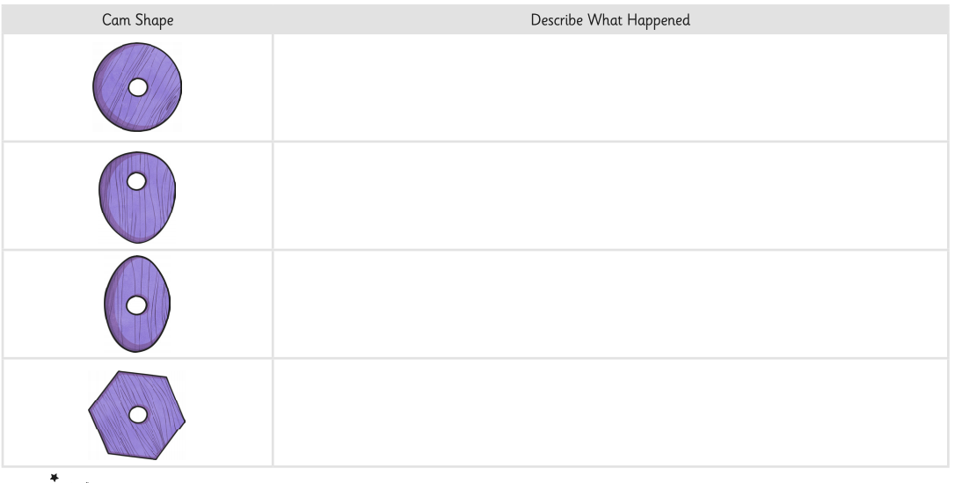  EXTENSION: To follow the diagram below to make your own Cams.  You can use other materials you have at home but please ask permission first.  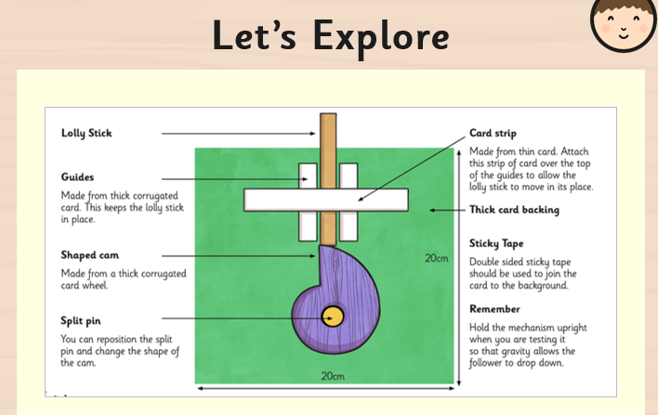
Topic  (Science) | Can I investigate materials that dissolve (soluble) and those that do not dissolve (insoluble) in water?  (PPT available)  THIS INVESTIGATION TO BE RECORDED ON THIS PLANNING SHEET  1) Predict what might happen to these materials when put in water? Use your own experience to make a prediction. Perhaps you have put sugar or flour into water, this may help you predict!  I think these substances will dissolve in water____________________________________________________________________________________________________________________________________________________  I think these substances will dissolve in ater____________________________________________________________________________________________________________________________________________________  2) Watch the videos on dissolving and not dissolving materials  https://www.bbc.co.uk/bitesize/topics/zjty4wx/articles/zpbdpbk (Read through the page on Dissolving)  https://youtu.be/Kdc51ROgSq4 Soluble Song  3) Equipment needed for this investigation: PLEASE ASK PERMISSION FIRST  - 5 beakers/cup that can hold a teaspoon of each of these materials,  - 5 teaspoons water to pour into the beakers/cups,  - coffee, salt, sugar, flour and rice. (if you don’t have all of these at home simply pick out the ones that you do have)  4) What would make this a fair a reliable test? Amount of water? How many stirs?  _________________________________________________________________________________________________________________________________________________________________________________________________________________________________________________________________________________________________________________________________________________________________________________________________  5) Decide how much water to put into the beaker (remember it will have to be the same for each material e.g., 10 tablespoons of water = 1 teaspoon of salt)  6) Decide whether you will stir the mixture (the same will be done for all the other materials), how many stirs will you take? Or will you leave it and observe any changes? Make a note of your decision!  7) Observe any changes to the substances and the water as the mixtures are combined.  8) Choose the table for your results and write them on the page.  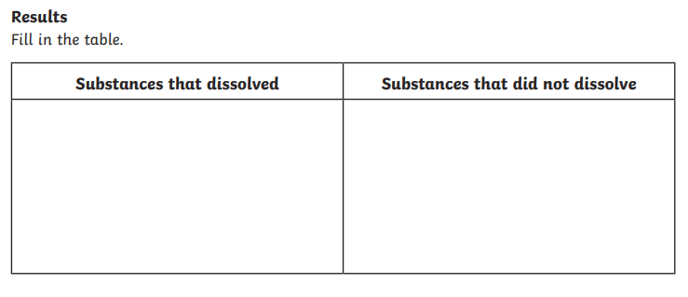  9)Conclusion- Tick the right answer  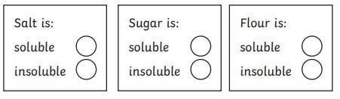  What happened to the rice when it was put in water?  __________________________________________________________________________________________________________________________________________________________  What happened to the coffee when it was put in water?  __________________________________________________________________________________________________________________________________________________________  Do you think there might be a way to separate the salt from the water?  ___________________________________________________________________________________________________________________________________________________________________________________________________________________________________________________________________________________________________________________
German | 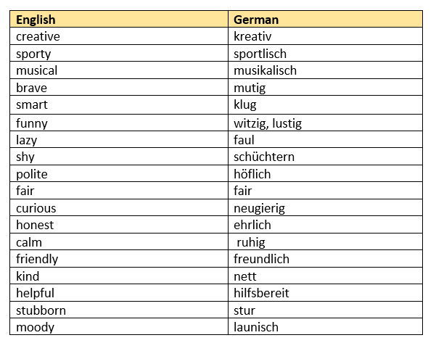

Week 3 Timetable
This is the timetable the Year 5 will be working with; however, changes are sometimes necessary and will be explained during the online lessons.

 | Monday18th January | Tuesday19th January | Wednesday 20th January | Thursday 21st January | Friday 22nd January
9am – 9.35  Group 1 Maths Input | 1 Can I divide 2digits by 1digit numbers?  1Can I divide 3 digits by 1digit numbers?  IXL/Maths Frame | 2 Can I divide 4 digits by 1digit numbers?  IXL/Maths Frame | 3 Can I solve problems using division?  IXL/Maths Frame | 4 Can I divide with remainders?  IXL/Maths Frame | 5Can I solve problems using multiplication and division?  IXL/Maths Frame
9.40- 10.15 Group 2 Maths input | 1 Can I divide 2digits by 1digit numbers?  IXL/Maths Frame | 2Can I divide 3 digits by 1digit numbers?  IXL/Maths Frame | 3 Can I divide 4 digits by 1digit numbers?  IXL/Maths Frame | 4 Can I solve problems using division?  IXL/Maths Frame | 5 Can I divide with remainders?  IXL/Maths Frame
11am-11.35 Group A English input | 1Romeo and Juliet  Can I write a diary entry? | 2 Romeo and Juliet -  Can I write a character description of Mercutio? | 3Romeo and Juliet-  Can I understand Mercutio’s Queen Mab speech and its relevance to his character? | 4Romeo and Juliet-.  Can I understand Mercutio’s Queen Mab speech and its relevance to his character? | 5Reading Comprehension -  Greta Thunberg
11.40-12.15  Group B English Input | 1Romeo and Juliet –  Can I write a diary entry? | 2Romeo and Juliet –  Can I write a character description of Mercutio? | 3Romeo and Juliet-  Can I understand Mercutio’s Queen Mab speech and its relevance to his character? | 4Romeo and Juliet-  Can I understand Mercutio’s Queen Mab speech and its relevance to his character? | 5  Reading Comprehension  Greta Thunberg
2.00-2.40 IPC Input for all | German  Masked Selfie  PE  Complete the activity on Page 1 of the booklet | IPC 1  Why do people tell each other stories? | IPC 2  What is in a word? | Science  Investigation  Can I investigate  materials that dissolve (soluble) and those that do not dissolve  (insoluble) in water? | DT  Can I explain the movement of different Cams?

