Learning at Home
YEAR 5
Monday 25th January – Friday 29th January 2021
All the resources are also available on:
ValleyPrimary.co.uk - Curriculum – Lockdown Home Learning –Year 5 - Spring Week 4
Year 5 Teachers welcome emailed copies of the Students Home Learning

Reading | Read for 30 minutes a day.  Answer the Bug questions, using full sentences and punctuation.  Remember to use evidence to back up your answer.  Use your log in details for Bug Club and remember to complete the comprehension questions.  Username: Childs first name  Password Teal (followed by a number)  School Code: AHX7
English | Task 1: Romeo and Juliet, W4, L1, Love and Hate  In today’s lesson we will start with a fun warm up game and then move on to look at the importance of masks at the feast. We will then briefly touch on ‘iambic pentameters’, before looking in detail at an extract from Romeo. After discussion and a brief look over the extract, which includes a translation, you will be set two tasks to complete. Activity 1 is a set of questions for you to answer based on the entire extract. Activity 2 requires you to illustrate a comic strip version of the Romeo and Tybalt’s experiences at the feast. Please use speech and thought bubbles and a description of each of your drawings in the boxes below the pictures. We have left it up to you to decide if you want to use the modern or original versions of the text.  Task 2: Romeo and Juliet, W4, L2, Holy Love  In this session we will begin by looking at the religious background to the play and references within. You will take notes on the tweet sheet in the lesson if possible or you can return to this task afterwards. After this, we will look at an extract detailing the first time Romeo and Juliet come face to face. You will then be set the activity to write a thought bubble for each character explaining how you think they are now feeling.  .  Task 3: Romeo and Juliet, W4, L3, The power of a name  In this session we will see how Romeo searches for Juliet in order to speak further. We will read through the famous balcony scene and explore the language that Romeo uses to describe Juliet. At the end of today’s session your independent task will be to write a comparative piece describing the different reactions of both Romeo and Juliet (similar to the comparison piece we completed on Scrooge and Fred just before Christmas).  .  Task 4: Romeo and Juliet, W4, L4, The Proposal and an introduction to Friar Lawrence  This session will begin with a re-cap, considering how Romeo and Juliet felt in the last session. We will then read more of the balcony scene considering the language and context. After this, we will meet Friar Lawrence and find out a bit more about him and his encounter with Romeo. As a final task for the week, we’d like you to answer some questions about the exchange between Romeo and Friar Lawrence and then create a fact file about Friar Lawrence using what you have learnt from the PPT and extract.  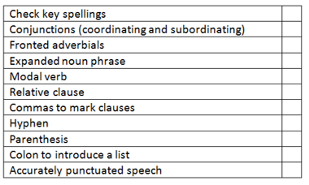  Task 5: Reading Comprehension – The Man who loved the Mountain  (Answers available on the Lockdown Home learning page)  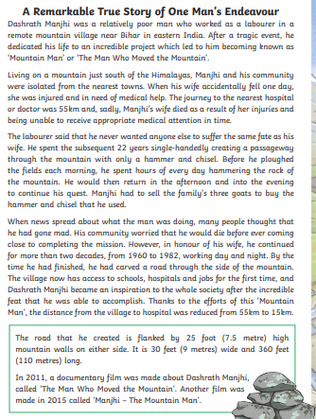  Write the answers in full sentences below.  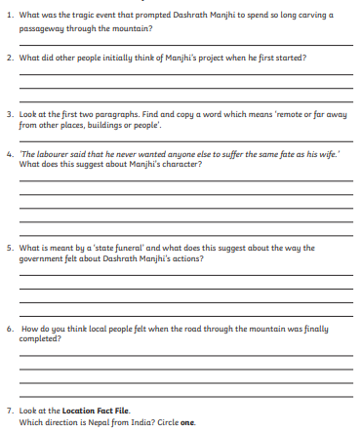  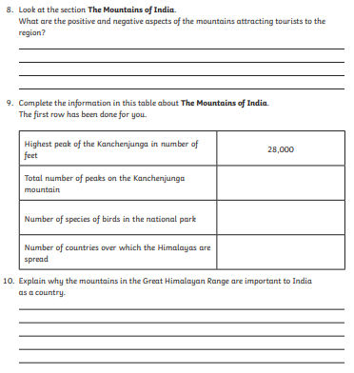
Maths | IXL  Multiplication D 1-25  Division E1-17  Fractions S1-18 New topic  Maths Frame (Practise daily this week in order to help with times table fluency)  https://whiterosemaths.com/homelearning/year-6/week-5/  The questions on the planning sheet are to be completed after the lessons.  The resources on the home leaning page are optional should more practise be required.  Math Group A  Lesson 1: Can I identify, name and write equivalent fractions of a given fraction? (PPT available)  Look through the links below to get you started  https://www.bbc.co.uk/bitesize/articles/zb8wqp3#:~:text=Equivalent%20fractions%20are%20two%20or,add%20and%20subtract%20fractions.  https://whiterosemaths.com/homelearning/year-6/week-8-number-fractions/  TASK 1  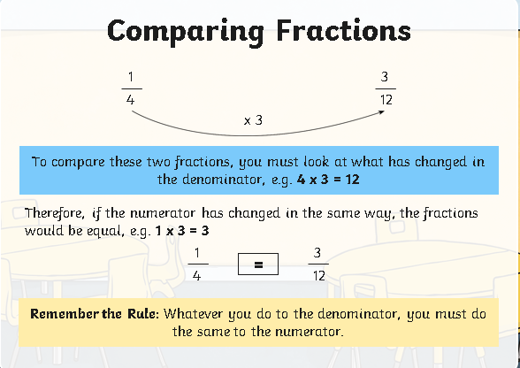  Find the missing numerator to write the equivalent fraction. Remember that you are only multiplying or dividing the numerator and denominator. Don't try to add or subtract, or you'll get the wrong answer!  TASK 2: Write 3 different equivalent fractions to each of the questions below. Remember to show your working out. Do you notice a pattern?  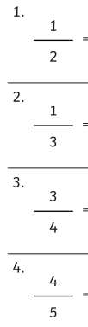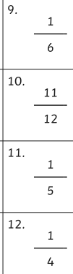  EXTENSION:  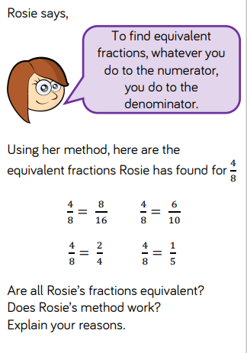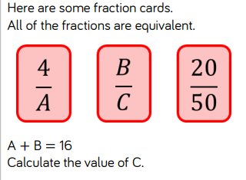  Lesson 2:  Can I recognise mixed numbers and improper fractions and convert from one form to the other?  https://whiterosemaths.com/homelearning/year-6/week-8-number-fractions/  Complete  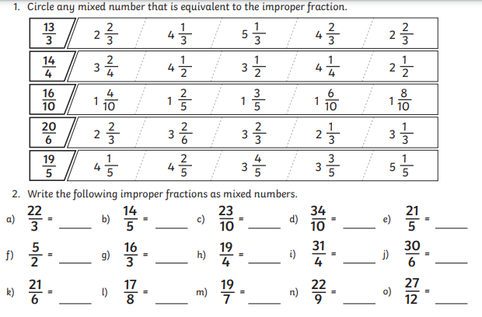  EXTENSION:  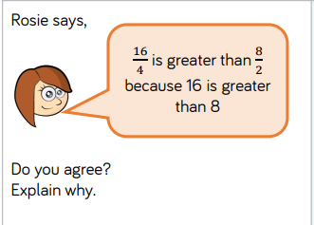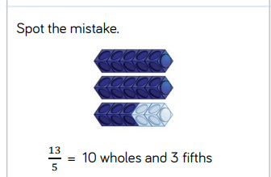  Lesson 3:  Can I compare and order fractions greater than 1? (PPT available)  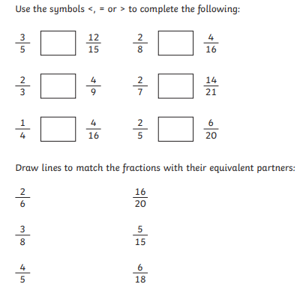  EXTENSION:  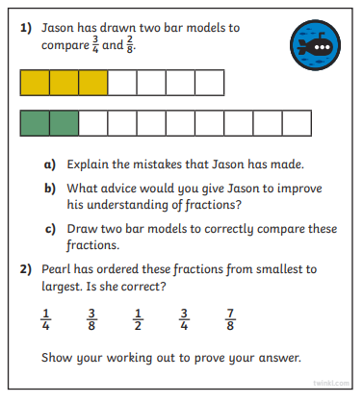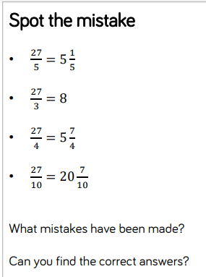  Lesson 4: Can I add and subtract fractions with different denominators? (Resources available)  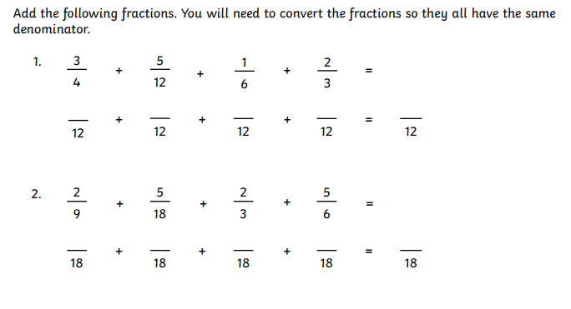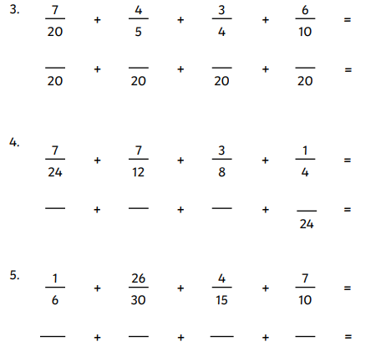  EXTENSION:  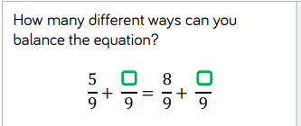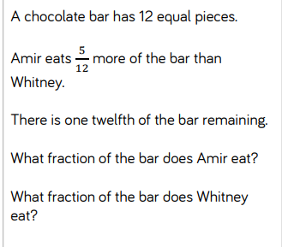  Lesson 5: Can I solve fraction word problems?  (Resource available for extra practice)  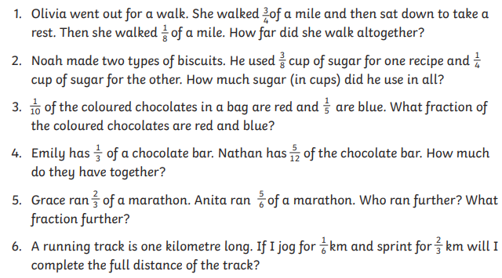  Maths Group B  Lesson 1: Can I Identify, name and write equivalent fractions of a given fraction?  https://whiterosemaths.com/homelearning/year-6/week-8-number-fractions/  Complete the fractions to show their equivalent:  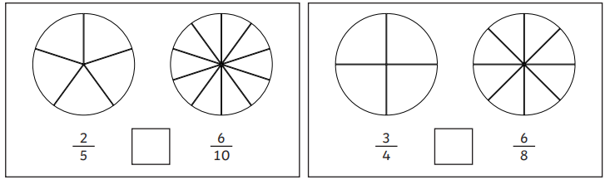  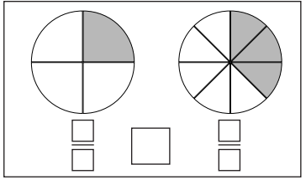  Colour in the fractions and from smallest to largest and fill in the boxes below.  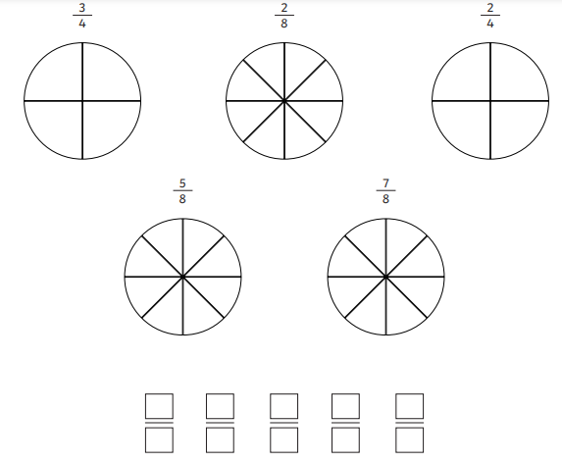  Compare these fractions. Use and 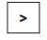 signs to complete this question  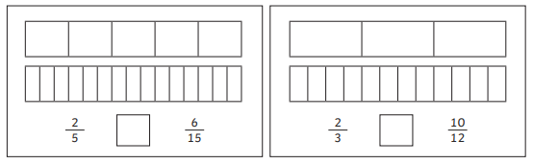  TASK 2: Complete the fraction wall ready for Lesson 2 (resources)  Lesson 2: Can I compare fractions? (PPT available)  Remember: Whatever you do to the denominator you must also do to the numerator!  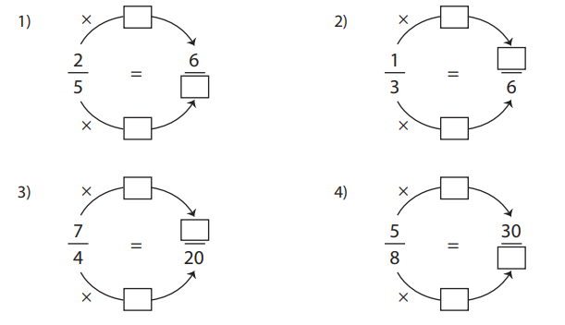  EXTENSION:  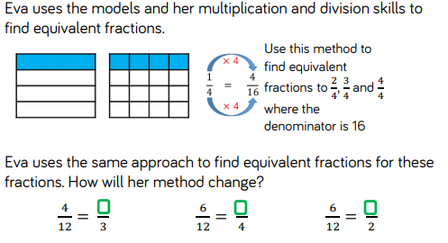  Lesson 3: Can I recognise mixed numbers and improper fractions and convert from one form to the other?  https://whiterosemaths.com/homelearning/year-6/week-8-number-fractions/  Complete the table  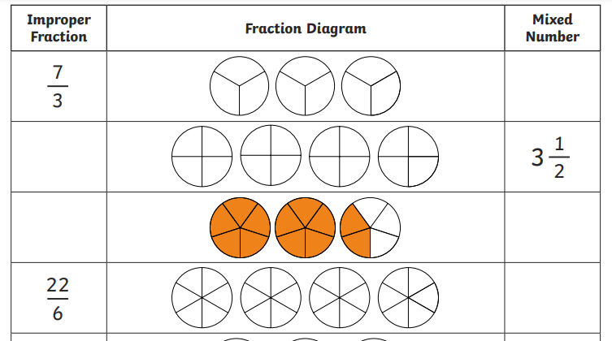  EXTENSION QUESTIONS:  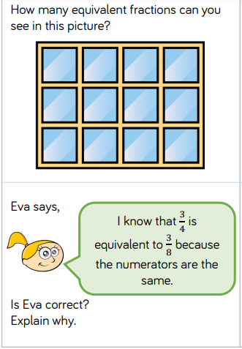  Lesson 4:  Can I add and subtract fractions?  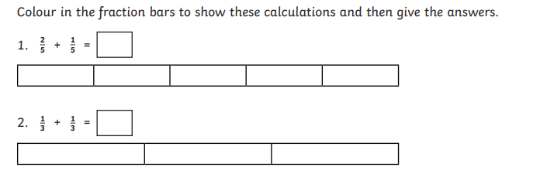  3. 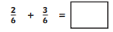 . 4.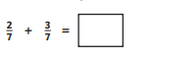5.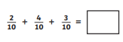  6.Remember to convert to a mixed fraction for the answer  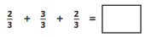  7.Subtract the fractions  8.Subtract the fractions  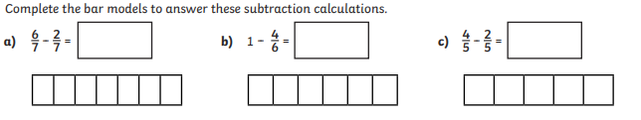  Lesson 5: Can I add and subtract fractions with different denominators? (PPT available)  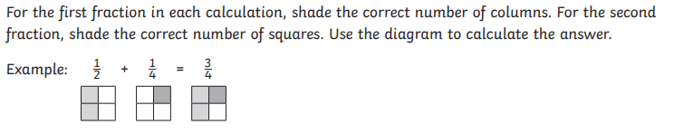  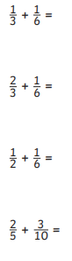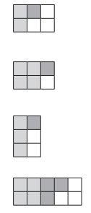  EXTENSION: Now try these  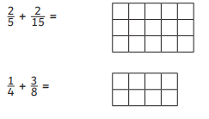
Spelling &  Grammar | Practise the Year 5 spelling rules:  Spelling Rule 55 Word list – years 5 and 6 - a to av-  https://spellingframe.co.uk/spelling-rule/5/Year-5-and-6  OR  Practise the Year 5/6 Spelling list in your Reading Journals - Look up the tricky words and put them into sentences
Topic  History | Lesson 1- Anglo-Saxon artefacts  This week we will be taking a closer look at some Anglo-Saxon artefacts.  Activity 1- draw an Anglo- Saxon artefact and annotate your drawing with things you believe to be true about your artefact. You can use the Historian sheet to give yourself ideas on what to write about your artefact.  Lesson 2- How do stories of the past change depending on whose telling the story?  In this session we will look at a Viking timeline and find out about how they raided Anglo-Saxon England. You will then have 2 activities to complete. The first involves piecing together a Viking timeline. The second activity asks you to create interview questions and answers for a Viking, an Anglo-Saxon and a Christian monk to get their version of events on the Viking raids that occurred. We will then consider how stories of the past can differ depending on historical perspective.
DT | Can I use research and develop design criteria to inform my design?  Read the PPT “Design”  Use the worksheet to design your moving animal, explaining:  - Which part of the animal will move eg front legs back legs of a horse, whole body of a snake?  - Which cams (shapes from previous lesson) you will use to copy the movement of your chosen animal  - Additional features  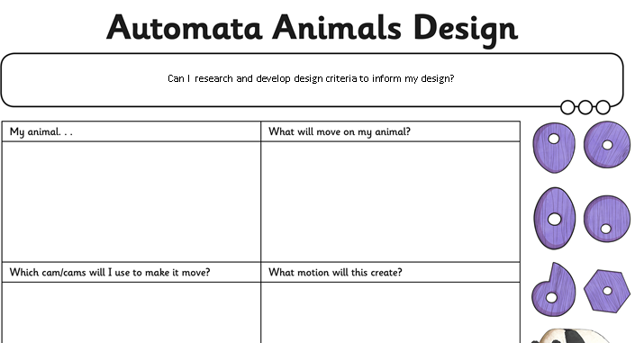  - Do as much research as you can; use images, drawings and detailed explanations to show the movement of your chosen animal  - Your end design should look something like this....  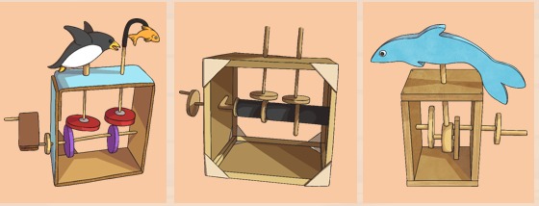  This Home learning is not due until 5th February which gives you enough time to really enjoy and design the most spectacular moving animal!  Please do not send this homework in until February 4th
PE | 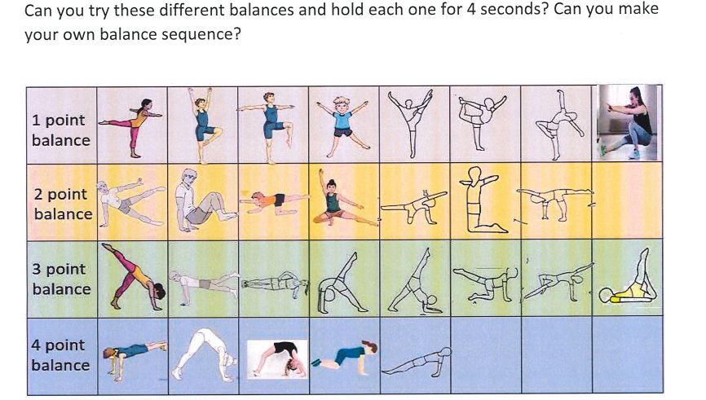
Topic  (Science) | Can I understand the term ‘Saturation’?  - Read the PPT saturation  - Task 1 – Recap the materials that dissolved and did not dissilve from the previous week  - Task 2 – Investigate the term saturation  - You will need salt, sugar, warm water (Please ask an adult to help you. USE WARM WATER FROM THE TAP ONLY) and a teaspoon.  - Task 3 – Show your findings using a bar chart (available in resources)
German | Link in to Arsenal Double Club: Birthdays - Arsenal Double Club Languages  Listen to the short interview with Shkodran Mustafi (who by the way speaks 4 languages)  Answer the three questions.

Week 4 Timetable
This is the timetable the Year 5 will be working with; however, changes are sometimes necessary and will be explained during the online lessons.

 | Monday25th January | Tuesday26th January | Wednesday 27th January | Thursday 28st January | Friday 29th January
9am – 9.35  Group 1 Maths Input | 1 Can I Identify, name and write equivalent fractions of a given fraction?  IXL/Maths Frame | 2 Can I recognise mixed numbers and improper fractions and convert from one form to the other?  IXL/Maths Frame | 3 Can I compare and order fractions greater than 1?  IXL/Maths Frame | 4 Can I add and subtract fractions with different denominators?  IXL/Maths Frame | 5 Can I solve fraction word problems?  IXL/Maths Frame
9.40- 10.15 Group 2 Maths input | 1 Can I Identify, name and write equivalent fractions of a given fraction?  IXL/Maths Frame | 2. Can I compare fractions?  IXL/Maths Frame | 3 Can I recognise mixed numbers and improper fractions and convert from one form to the other?  IXL/Maths Frame | 4 Can I add and subtract three fractions?  IXL/Maths Frame | 5 Can I add and subtract fraction with different denominators?  IXL/Maths Frame
11am-11.35 Group A English input | 1Romeo and Juliet  Love and Hate | 2 Romeo and Juliet -  Holy Love | 3Romeo and Juliet- The power of a name | 4Romeo and Juliet-. The proposal and an introduction to Friar Lawrence | 5Reading Comprehension -  The Man who loved the Mountains
11.40-12.15  Group B English Input | 1Romeo and Juliet –  Love and Hate | 2Romeo and Juliet –  Holy Love | 3Romeo and Juliet- The power of a name | 4Romeo and Juliet- The proposal and an introduction to Friar Lawrence | 5. Reading Comprehension  The Man who loved the Mountains
2.00-2.40 IPC Input for all | German  Birthdays  PE  Balances | IPC 1  Anglo-Saxon Artefacts | IPC 2  How do stories from the past change based on historical perspective? | Science  Can I understand the term saturation?  Can I investigate the term saturate? | DT  Can I use research and develop design criteria to inform my design? (Part 1)

