Group B.
Day 1 Can I count backwards through 0?

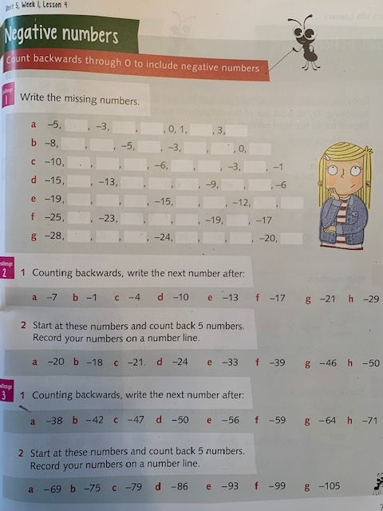

Day 2 Can I count backwards through 0?

Day 3 Can I work out the difference between negative numbers?
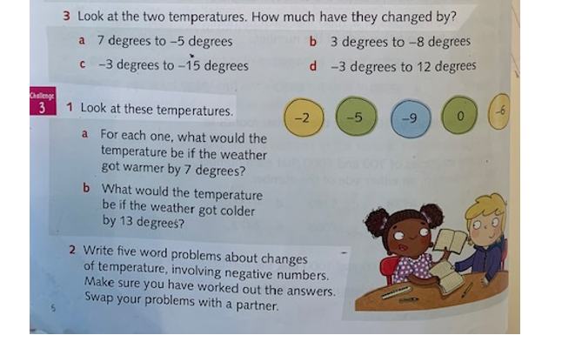

Day 4 Can I read a thermometer suing negative numbers?

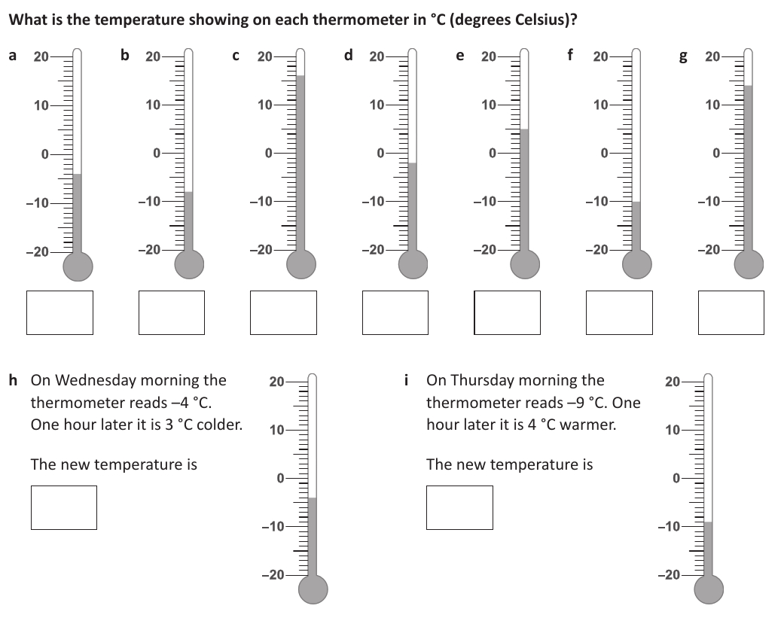

Day 5: Can I solve word problems related to negative numbers?

Reasoning:
