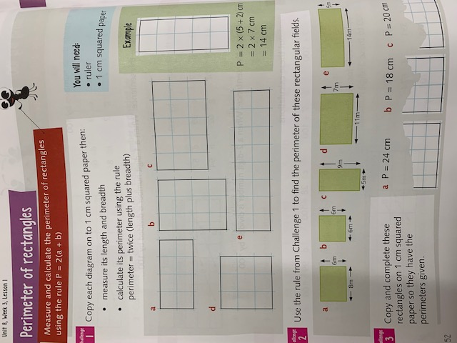Day 1 Group A: Can I find the perimeter of a shape?

Day 2:



Day 2:

Day 3: Can I find the perimeter of a compound shape?

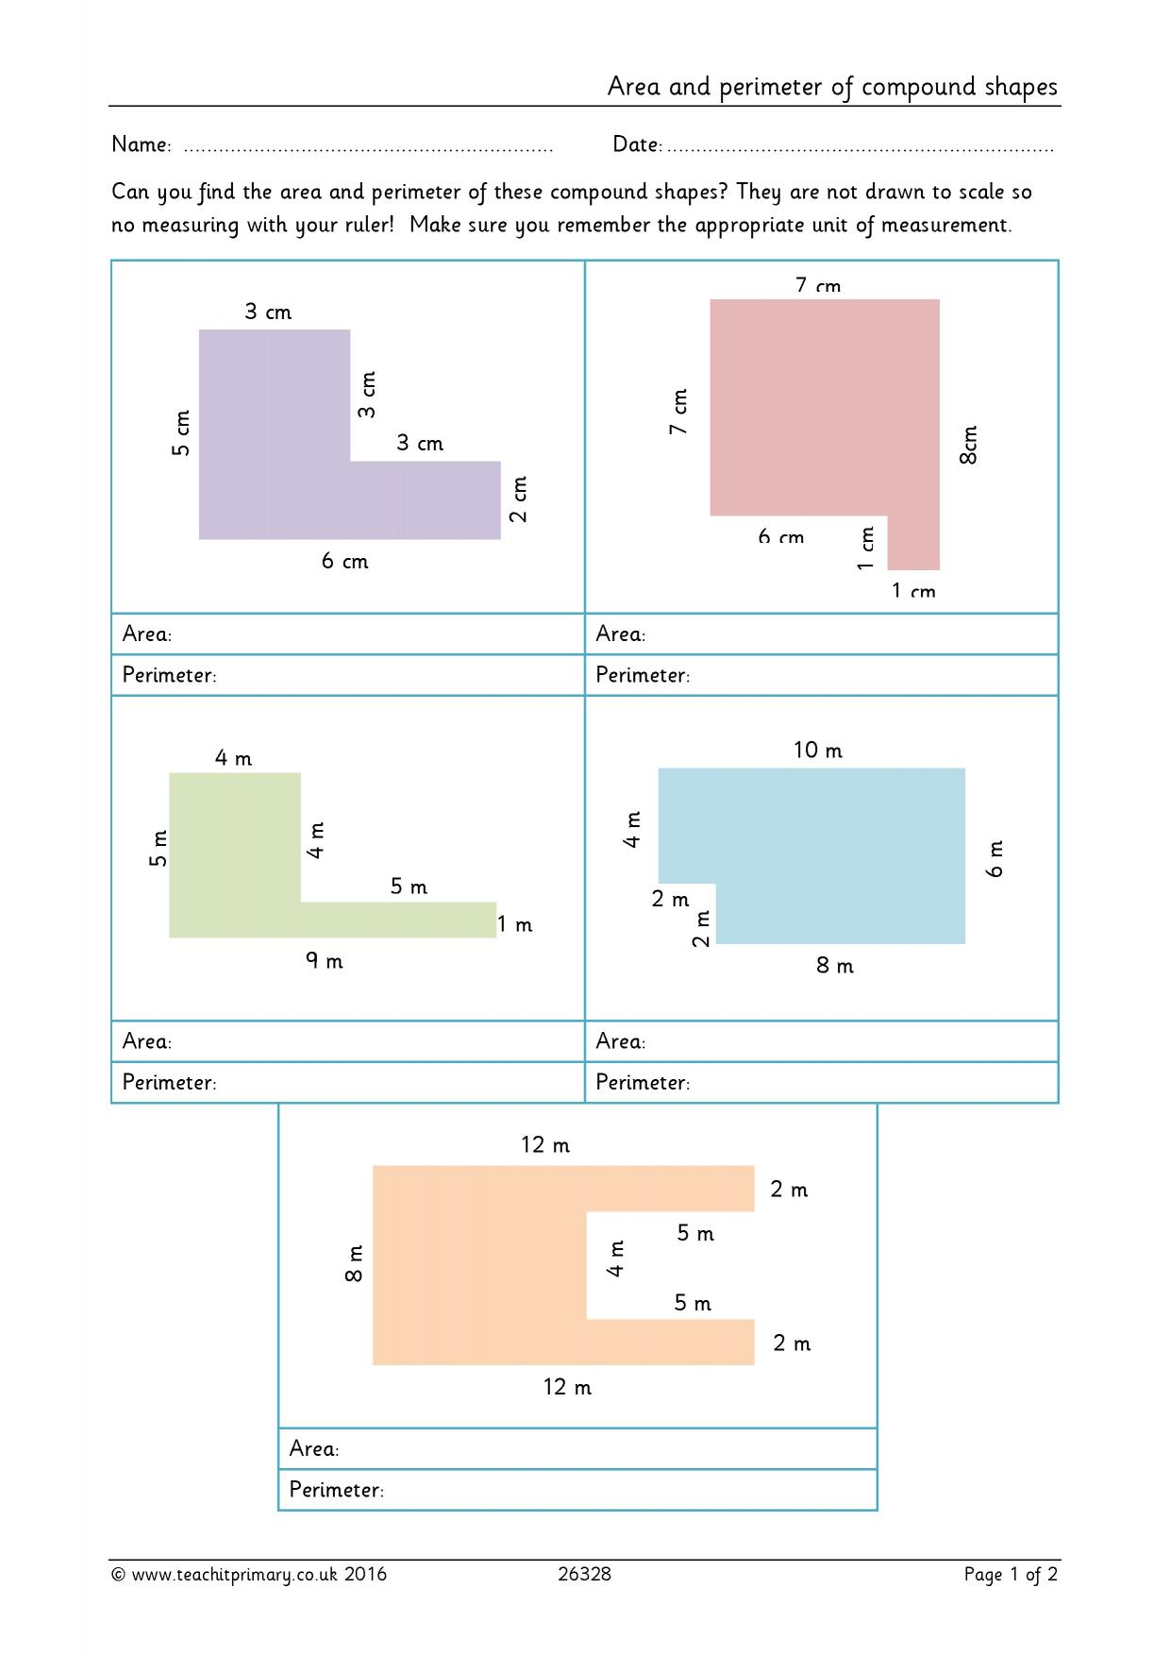

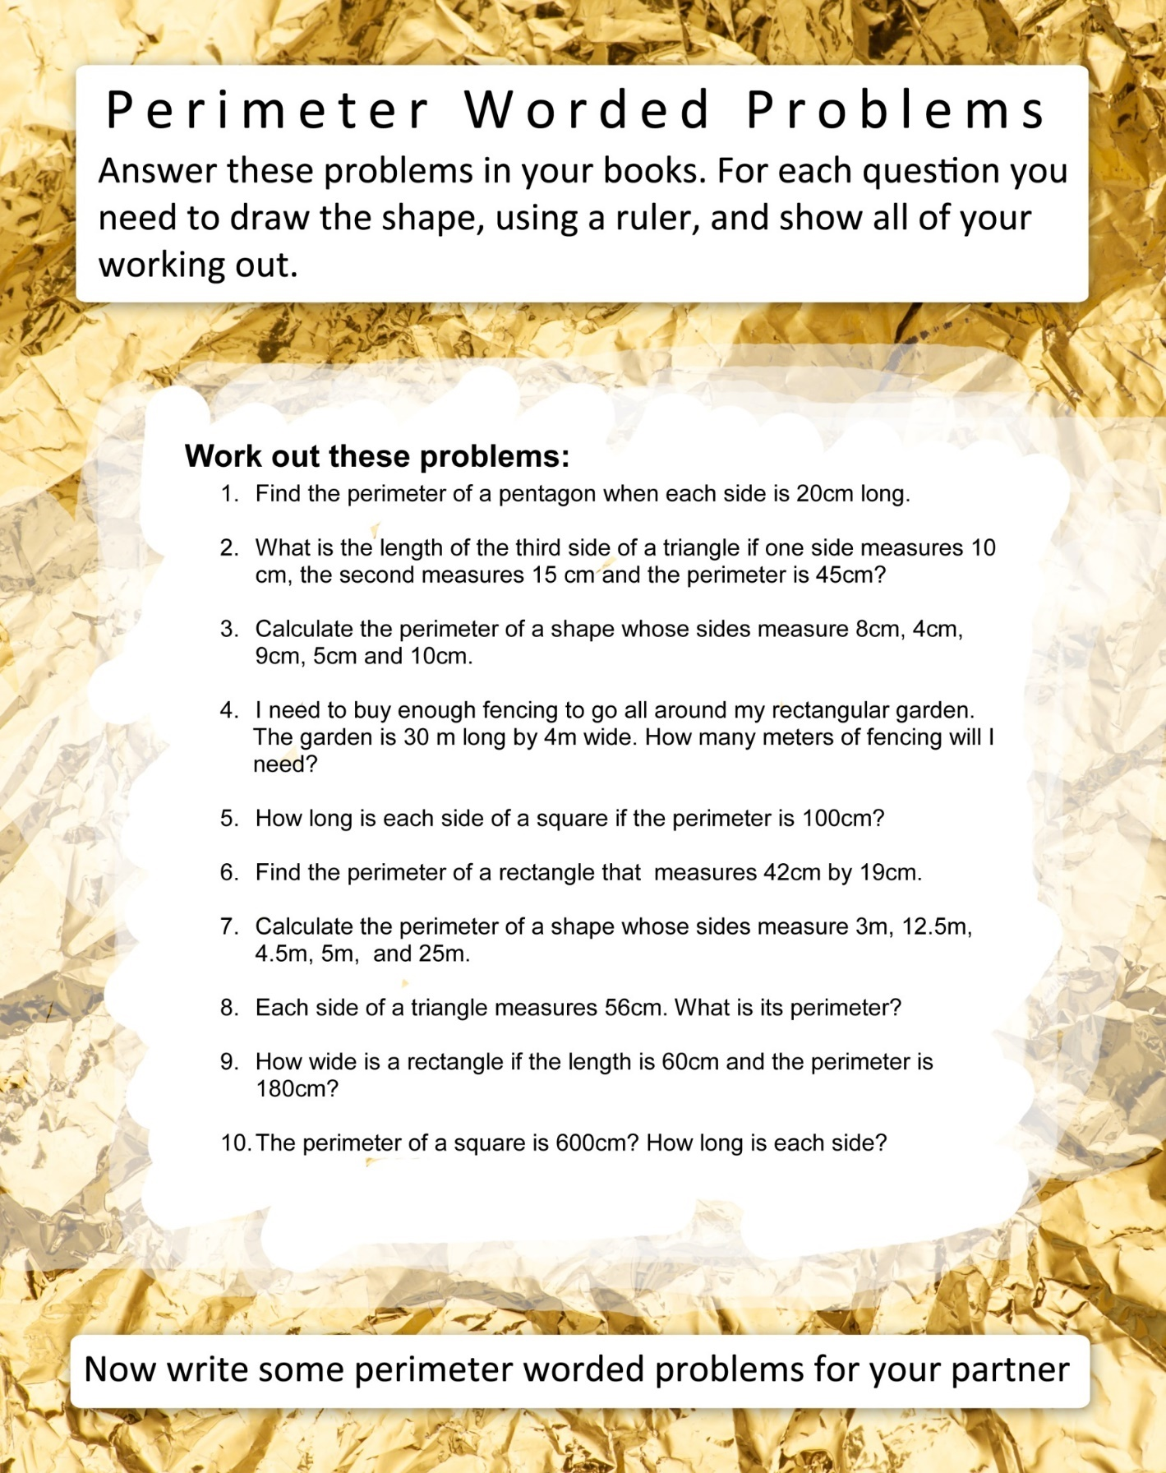Day 4: Can I solve perimeter related word problems?