Books Outdoor
Activities
Toys Music
Valley Pre-School

P.E. Art

Session Times

Monday – Friday

Morning: 9.00 am–12.00 pm
Afternoon: 1.15 pm –3.45 pm

Fees

Most children's places are funded by a Government Nursery Education Grant - please ask for details.

For non-funded places, the fees will be invoiced, half termly, at the Government funded rate.

Half a term’s notice is required for children leaving during the year.

Facilities

The Pre-School is in separate; purpose designed and adapted accommodation on the main school site.

It is a self-contained unit and accommodates 16 children per session, aged 3yrs to 4yrs.

Some of the main school facilities are available for our use
such as:

- the school P.E. apparatus
- the school grounds including the field and football pod.

Activities
These include water, sand, puzzles, books, role-play, music,
computer skills, modelling, painting, outdoor activities,
construction play, science, pencil skills, cutting, sticking,
pre-reading and early mathematical activities. The children
work towards the Early Learning Goals as set out in the EYFS statutory framework.

Staffing

A fully qualified Nursery Nurse (N.N.E.B.) leads the Pre-School with qualified assistants. A teacher within the school liaises closely with Pre-School staff.

Pre-School Administrator: Mrs Soraya Crowley
Tel No: 020 8460 1121
E-Mail: preschool@valley.bromley.sch.uk

Valley Pre-School is in a separate; purpose designed and adapted accommodation on the main site of Valley Primary School. It is a self-contained unit, opening for 38 weeks a year, with its own playground, and is registered to take 16 children, aged 3 to 5, at any one session. No child is permitted to attend for two sessions on the same day. The Pre-School is registered with OFSTED and the setting is inspected regularly.

Our aims are:

- to provide a safe, secure and stimulating environment

- to encourage each child to become confident and independent

- to present opportunities for all children to interact with one another

- to enhance the development and education of the children in our care

We offer your child:

- a planned curriculum leading to approved early learning goals

- fun and friendship with children and other adults

Adult Resources

A fully qualified Nursery Nurse (N.N.E.B.) leads the Pre-School on a day-to-day basis. A teacher within the main school advises on curriculum planning and assessment.
Staff | Title | Qualification
Mrs Lorraine Botros | Manager | Diploma in Pre-School Practice  N.N.E.B
Mrs Katie Quickenden | Deputy Manager | Foundation Degree in Early Years Education
Mrs Maggie Plant | Early Years Practitioner | NCFE Level 2 Teaching Assistant

The staff operate a rota using all members throughout the week. If staff are absent, unexpectedly or for planned training, cover will be provided by suitably qualified staff. Every effort will be made to ensure the supply staff are known to the children, but this may not always be possible.

Admissions Procedures:

- We ensure that the existence of our setting is communicated via the school website, newsletters and external notices on the school building.
- We ensure that information about our setting is accessible, using simple plain English and we will translate wherever possible.
- We operate a free waiting list. At the time when a place is confirmed, a deposit of £20.00 is necessary to secure the place. The deposit will only be returned at the end of the academic year.
- Our policy operates as follows:-
1. Current part-timers who wish to increase or change sessions are given priority over those on the waiting list.
2. Looked After Children and Adopted Children
3. Brothers/sisters of children in the main school and siblings of children currently attending will be given priority for places in our Pre-School.
4. Proximity of home in relation to Valley Pre-School.
- We take into consideration the capacity of the setting to meet the individual needs of the child.
- We offer funded places in accordance with the Code of Practice for Bromley and any local conditions in place at the time.
- Our setting and its practices are welcoming and make it clear that fathers, mothers, other relations and carers are all welcome.
- Our setting and its practices operate in a way that encourages positive regard for and understanding of difference and ability - whether gender, family structure, class, background, religion, ethnicity or competence in spoken English.
- We support children and/or parents with disabilities to take full part in all activities within our setting.
- We monitor the needs and background of children joining our setting on the Registration Form, to ensure that no accidental or unintentional discrimination is taking place.

If a child is absent for more than two consecutive weeks, they will forfeit their place in Pre-School, unless there are exceptional circumstances to be determined at the discretion of the Headteacher. Planned absences must be explained in writing and the date on which the child is due to return to Pre-School must be agreed by the Leader.

Attendance at the Pre-School does not entitle your child to a place at Valley Primary School. The CSA Trust sets the admission criteria for the main school.

Session Offered

Sessions will be offered on a ‘best available’ basis. It would be preferable if your child could access five sessions per week, however, if you require less than that, they will be offered initially in the following blocks: 3 sessions per week, on a Tuesday, Wednesday and Friday or 2 sessions per week on a Monday and Thursday. This is due to assigning key workers for the children. We strongly discourage children from having one session only as they can find it very hard to settle.

Curriculum

How my child will be learning
The EYFS Framework explains how and what your child will be learning to support their healthy development. Your child will be learning skills, acquiring new knowledge and demonstrating their understanding through 7 areas of learning and development.
Children should mostly develop the 3 prime areas first. These are:
Communication and language;
Physical development; and
Personal, social and emotional development.

These prime areas are those most essential for your child’s healthy development and future learning. As children grow, the prime areas will help them to develop skills in 4 specific areas. These are:
Literacy;
Mathematics;
Understanding the world; and
Expressive arts and design.
These 7 areas are used to plan your child’s learning and activities. The professionals teaching and supporting your child will make sure that the activities are suited to your child’s unique needs. This is a little bit like a curriculum in primary and secondary schools, but it's suitable for very young children, and it's designed to be really flexible so that staff can follow your child's unique needs and interests.
Children in the EYFS learn by playing and exploring, being active, and through creative and critical thinking which takes place both indoors and outside.

For example, between 2 ½ and 4 years: learning to be confident in talking to other children when playing, and to talk freely about own home and community
For example, in reading between 2 ¼ and 4 years: learning
how to suggest an
ending to a story

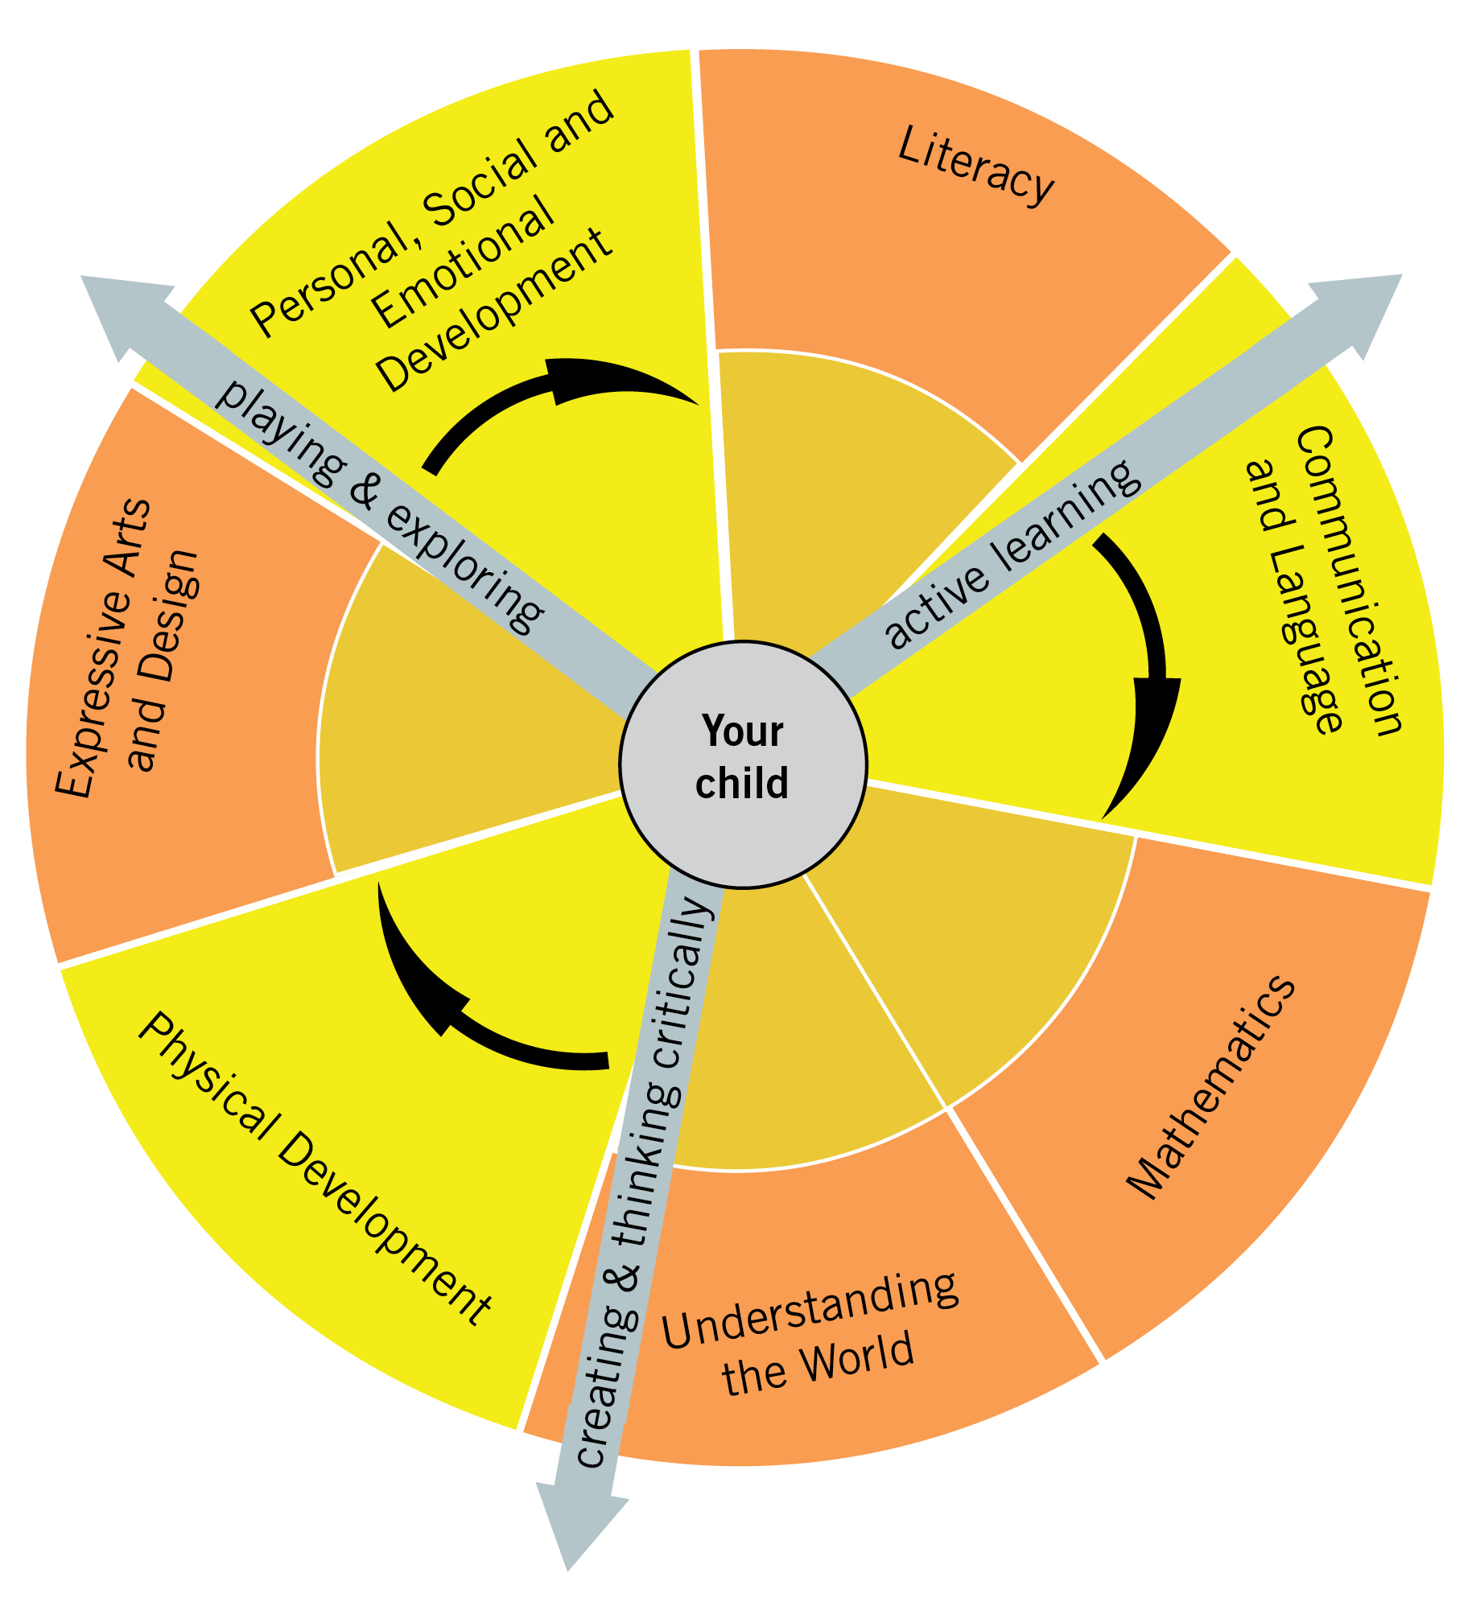

For example, between 1 ¾ and 2 ½ years: developing an understanding of simple concepts such as big/little

For example, between 2 ½ and 4 years: learning how to explore what happens when they mix colours

For example, between 1 ¼ and 2 years: enjoying filling and emptying containers in the bath

For example, between 3 ¼ and 5 years: learning to control objects by pushing, patting, throwing, catching or kicking

For example, between 2 ¼ and 3 ¾ years: learning about special times or events for family or friends and being able to describe them. Being able to talk about some of the things they have observed such as plants, animals, natural and found objects.

Equal Opportunities Policy

We aim to ensure equality for all children and adults regardless of race, religion gender or disability. The staff has a responsibility to teach respect for others and to provide accurate information and positive images of different cultures and lifestyles. Our staff regards racist or derogatory remarks about any child or adult as unacceptable.

Child Protection Policy

Valley Pre-School follows the guidelines for Child Protection laid down by the London Borough of Bromley (Child Protection-Guidelines for Day Care Groups). All staff have a responsibility to take appropriate action if they have any concerns regarding the physical or emotional well being of a child attending the group. Everyone who is employed at the Pre-School, as well as all voluntary helpers, have to undertake a police-check.

Health and Safety Policy

- Fire drills are carried out termly and the results are recorded in the Pre-School register.

- All staff are familiar with emergency drills, escape routes and assembly points. The specific fire drill procedures are posted on the wall in the Pre-School activity room near to the telephone.

- A book is kept detailing all accidents that have occurred at the Pre-School. If your child has had an accident you will be asked to sign the book to show that the Pre-School staff have informed you.

- All visitors to the Pre-School must report to the main school office. They should sign in and obtain a visitor’s sticker. They should then wait for their escort or proceed if authorised.

- No smoking is allowed on the premises.

- No hot drinks are allowed in any area occupied by a child.

- No inappropriate jewellery may be worn.

- Children are not permitted to wear hooped earrings.

- No one is allowed to run inside the premises.

- Children are encouraged to run outside in a safe environment.

- Safety plugs protect all electrical sockets and there are no trailing wires.

- Nuts, eg peanuts, are not allowed in the Pre-School.

- All staff are familiar with First Aid procedures.

- No child is left unsupervised at any time, including whilst at the water tray.

Under no circumstances will a member of staff take a child off the Valley Primary School site unless written consent has been obtained from the parent/carer of the named child.

Management of Behaviour

When children behave in unacceptable ways:

- Physical punishment, such as smacking or shaking, will be neither used nor threatened.

- Children will never be sent out of the room by themselves.

- Techniques intended to single out and humiliate individual children such as the “naughty chair” will not be used.

- Children who misbehave will be given one-to-one adult support in seeing what was wrong and working towards a better pattern.

- In any case of misbehaviour it will always be made clear to the child or children in question that it is behaviour, and not the child, that is unwelcome.

- Adults will not shout or raise their voices in a threatening way.

- Any behaviour problems will be handled in a developmentally appropriate fashion, respecting an individual child’s level of understanding and maturity. Adults will be aware that some kinds of behaviour will arise from a child’s special needs.

- Parents/carers will be made aware of behavioural issues causing special concern.

Infectious Illnesses

Children with bad colds, throat infections, on antibiotics or who have an infectious disease must remain at home for the quarantine period. If you are unsure of the quarantine period, please contact the Pre-School staff. NB: If your child has been prescribed antibiotics they must not attend Pre-School for the first 2 days.

Complaints Procedure

A parent/carer who is uneasy about any aspect of the group’s provision should, first of all, talk over any worries and anxieties with the Leader. If this does not have a satisfactory outcome, the parent/carer should put the concerns or complaint in writing to the Head Teacher of Valley Primary School, Mr Jackson.

We believe that most complaints are made constructively and can be sorted out at an early stage. We also believe that it is in the best interests of the Pre-School and parents that complaints should be taken seriously and dealt with fairly and in a way that respects confidentiality.

Special Needs Policy

The Special Needs Co-ordinator is Mrs Lorraine Botros, who can seek advice from the Area Early Years SENCO for the Local Education Authority and also the SENCO in the primary school. The Pre-School is committed to the Department for Education and Skills Code of Practice on the Identification and Assessment of Special Educational Needs. We aim to provide a welcome and appropriate learning opportunity, for all children.

The parents/carers of any child causing a concern will be notified after careful observations of the child are undertaken. We will then discuss what provision may be required to help the child fulfil their potential in the Pre-School. A written record of the observation will be kept and this will be shared with the child’s parents/carers.

If necessary, a simple structured programme will be designed to meet the child’s needs. This programme will be discussed with the child’s parents.

If it is agreed that the child needs help from an outside agency, the setting’s SENCO will make the necessary contact. These agencies may include the Educational Psychologist, a Health Visitor, Social Services, the Speech and Language Therapy Service or the Pre-School Special Needs Panel.
Parents/carers will be kept fully informed of any referral to an outside agency. Parental consent will be sought before the initial referral.

Reporting to Parents

We aim to ensure that parents are informed on a regular basis about their child’s progress. Staff track children’s progress and carry out assessments. The results are recorded and parents are encouraged to discuss their child’s progress with the key person both formally and informally, sharing information from home. We encourage parents to discuss their child’s progress with the staff at the end of sessions or by making an appointment with the Leader. More formal developmental progress meetings are offered, at the end of each Autumn and Spring term.

Valley Primary School Term Dates 2023 – 2024

Autumn Term 2023
Tuesday 29th August 2023 (school closed to pupils) | Staff Only (Inset Days)
Wednesday 30th August 2023 | Pupils Return to School
Friday 13th October 2023 | Break up
Monday 16th October – Friday 27th October 2023 | 2 week Half-Term Holiday
Monday 30th October 2023 | Pupils Return to School
Tuesday 19th December 2023 | Break up

Spring Term 2024
Wednesday 3rd January 2024 (school closed to pupils) | Staff Only (Inset Day)
Thursday 4th January 2024 | Pupils Return to School
Friday 9th February 2024 | Break up
Monday 12th February – Friday 16th February 2024 | Half-Term Holiday
Monday 19th February 2024 | Pupils Return to School
Thursday 28th March 2024 | Break up

Summer Term 2024
Monday 15th April 2024 | Pupils Return to School
Monday 6th May 2024 (Bank Holiday) | School Closed
Friday 24th May 2024 | Break up
Monday 27th May – Friday 31st May 2024 | Half-Term Holiday
Monday 3rd June 2024 | Pupils Return to School
Friday 19th July 2024 | Break up
Monday 22nd July – Wednesday 24th July 2024  (school closed to pupils) | Staff Only (Inset Days)

INFORMATION FOR PARENTS

- Fees for the Pre-School must be paid half-termly, in advance, on the first day your child attends. Cheques should be made payable to ‘Valley Primary School’. Cash payments should be presented in a sealed envelope marked with the child’s name. Payments can also be made via bank transfer. You will be notified of the amount due prior to the commencement of each half term. If you are claiming the pre-school funding it is your responsibility to ensure you are claiming the correct hours for your child as errors cannot always be rectified.

The fees are non-refundable and the full fees must be paid for a child who is unable to attend owing to illness, holiday etc., in order to secure a place.

- The Pre-School session times are 9.00 am until 12.00 noon, each morning and 1.15 pm until 3.45 pm, each afternoon. Please be prompt in collecting your child at the end of each session. It is imperative we are informed of any changes to your collecting arrangements, as we will not release your child to any persons other than those nominated.

- Children with bad colds, throat infections, on antibiotics or who have an infectious disease must remain at home for the quarantine period.

- Immediate notification of change of address, telephone number (home or work) or change of doctor is required.

- When starting at the Pre-School it would be helpful if your child is able to:

  - Take off his/her outdoor clothing and hang it on a peg.
  - Use the toilet properly and independently.
  - Wash and dry his/her hands.
  - Tidy away his/her toys.
  - Know how to blow his/her nose.
  - Take off and put on his/her shoes.

- Your child will be offered a snack whilst he/she is in the Pre-School and will be given milk or water at every session unless we are told otherwise. Alternative arrangements can be made and staff will collect information with regards to allergies, likes and dislikes.

Registration Form

Child’s Name:

Date of Birth:

Parent/Carer’s Name:

Address:

Home Telephone No:

Email address:

Other Contact Telephone No:

Do you have another child in the Pre-School or at Valley Primary School?

Does your child attend any other Pre-School provision?
Please detail:

Other information (e.g. Special Needs):

I understand that I will be asked to pay a £20 deposit upon offer of a place, in order to secure that place, and that it will only be refunded to me if my child completes the academic year at preschool.

WE OFFER MORNING OR AFTERNOON SESSIONS BUT NOT FULL DAYS.

Signed: ……………………………………………….. Date: …………………………………

Please return this form to the main school office. Please advise the preschool of any changes of address or contact numbers.

Please note: Attendance at the Pre-School does not entitle your child to a place at Valley Primary School. The CSA Trust sets the admission criteria for the main school.

