The _________________ and the Blind Men
Five blind men were at the River Indus when an elephant approaches them. | 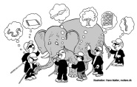  The men decide to… | One man thinks…
Another man thinks… | The last men think… | A boy comes along and says  “

