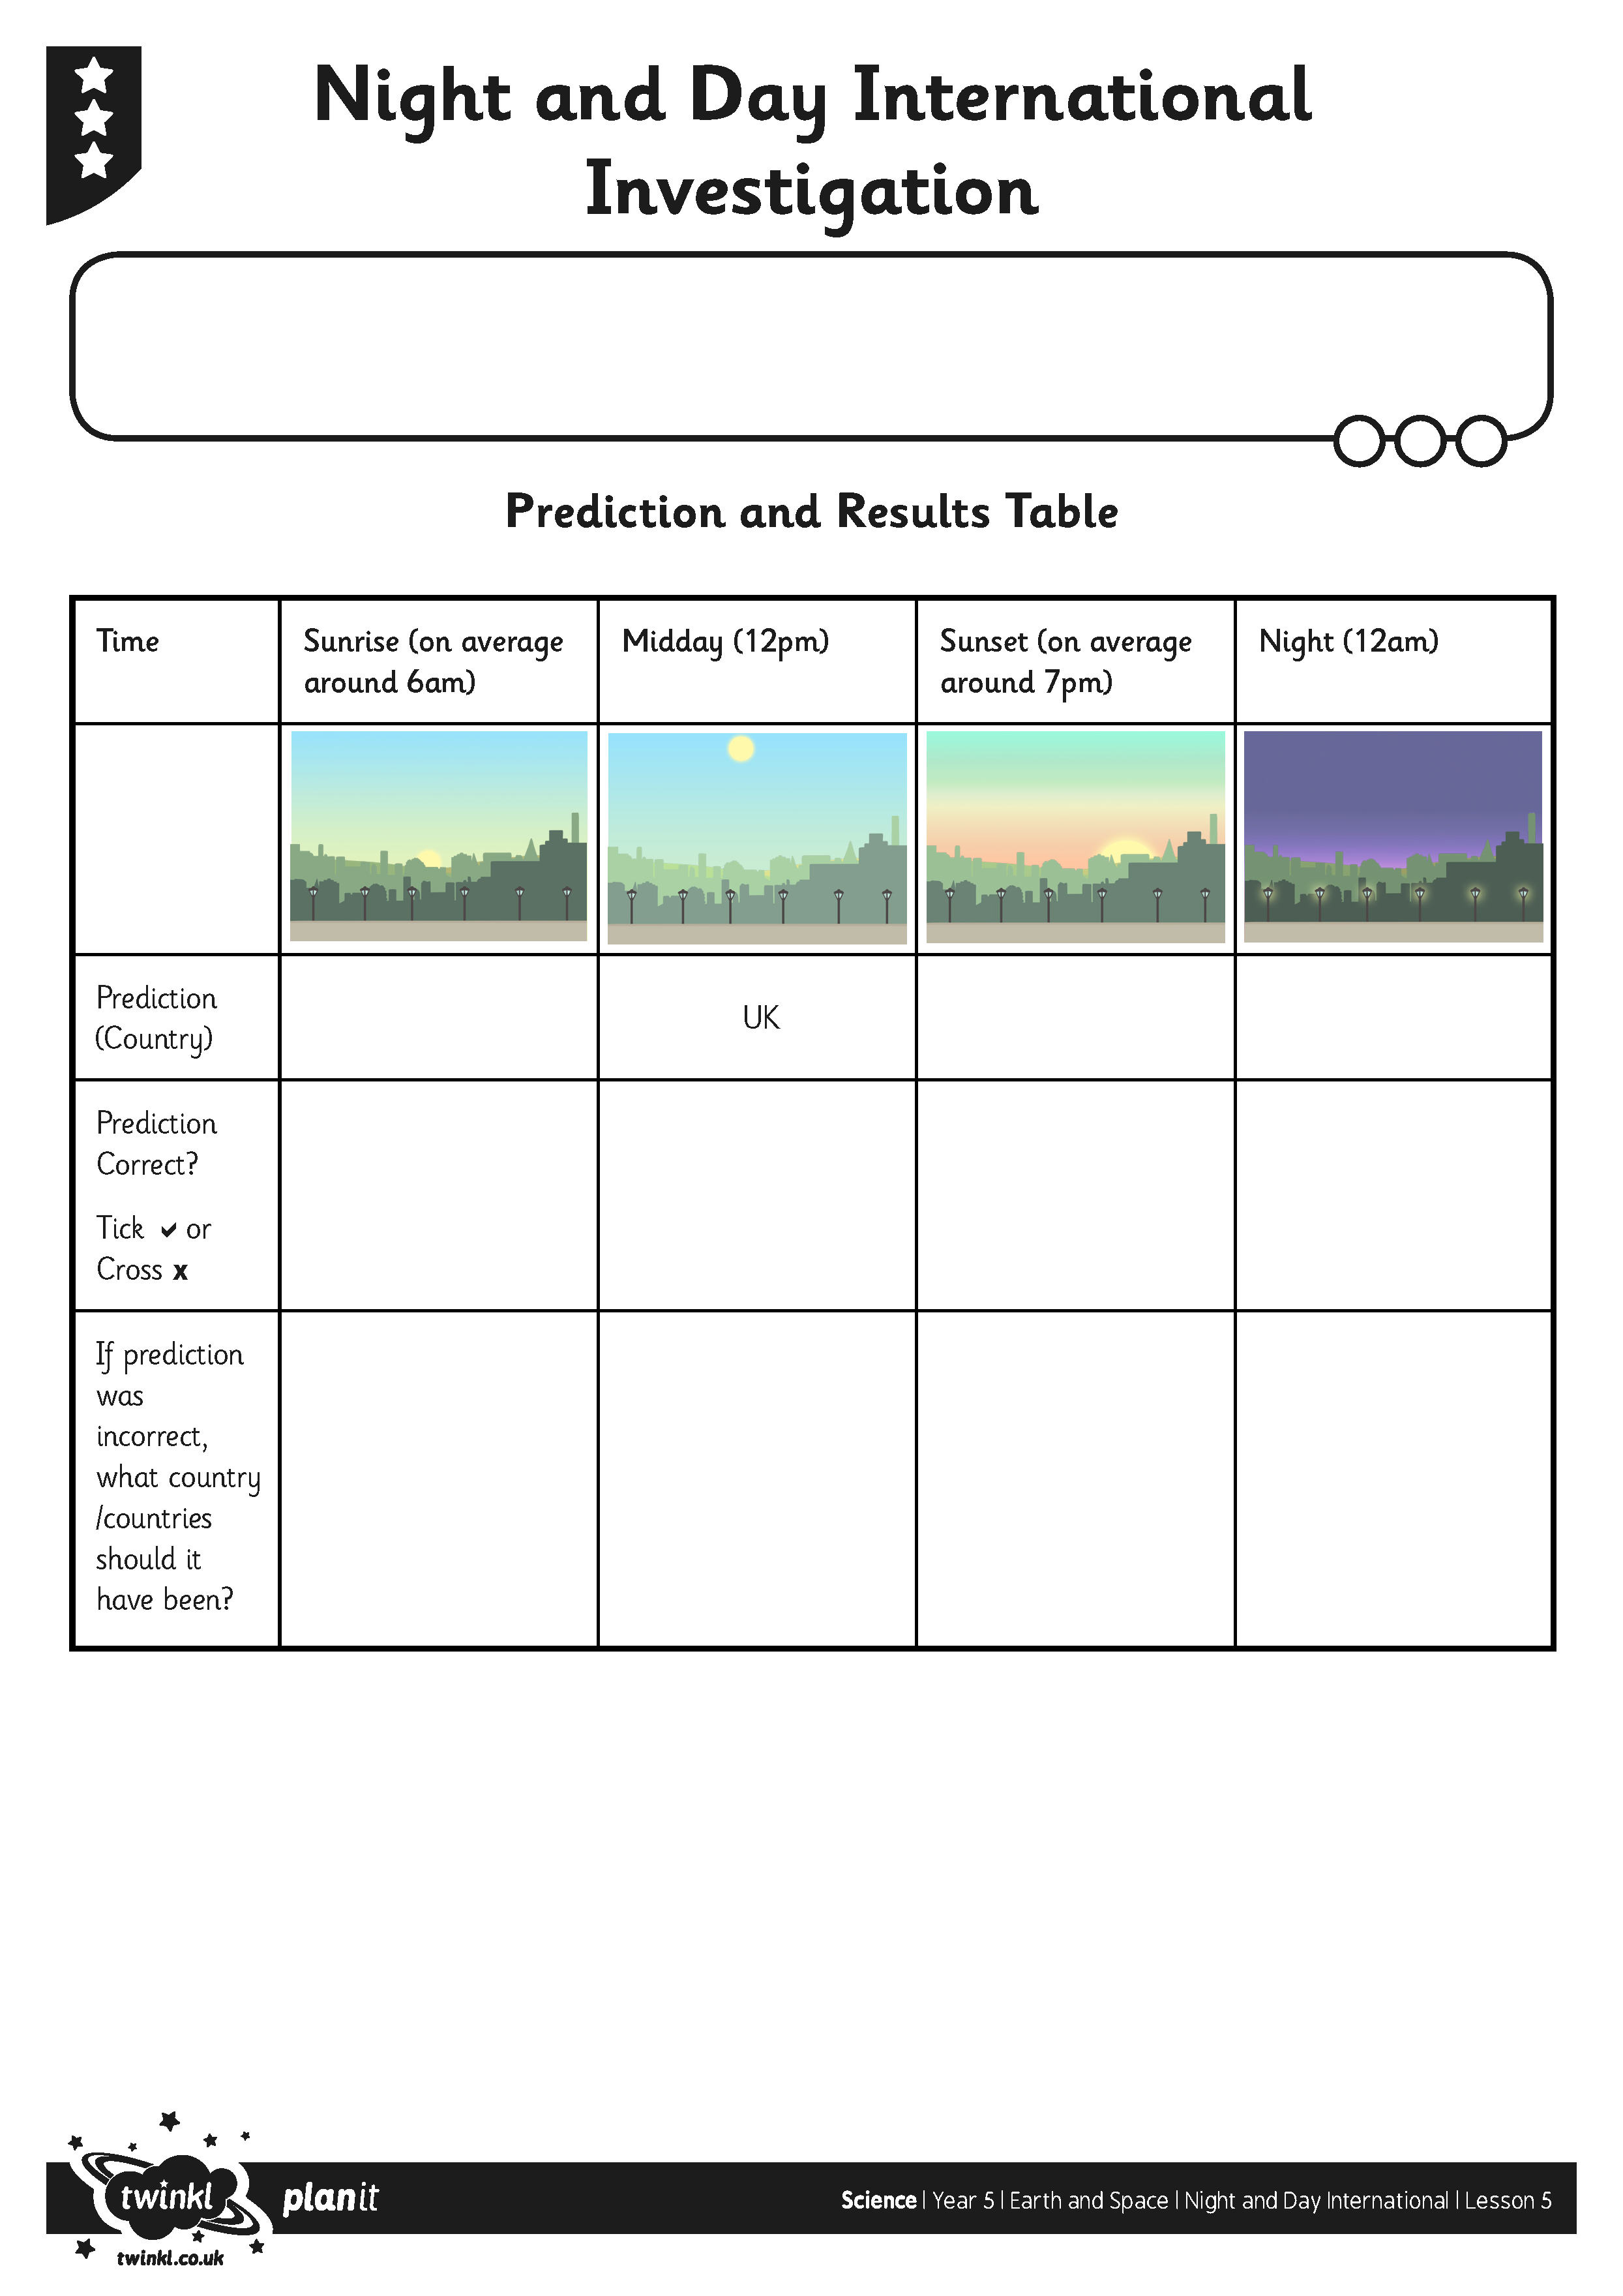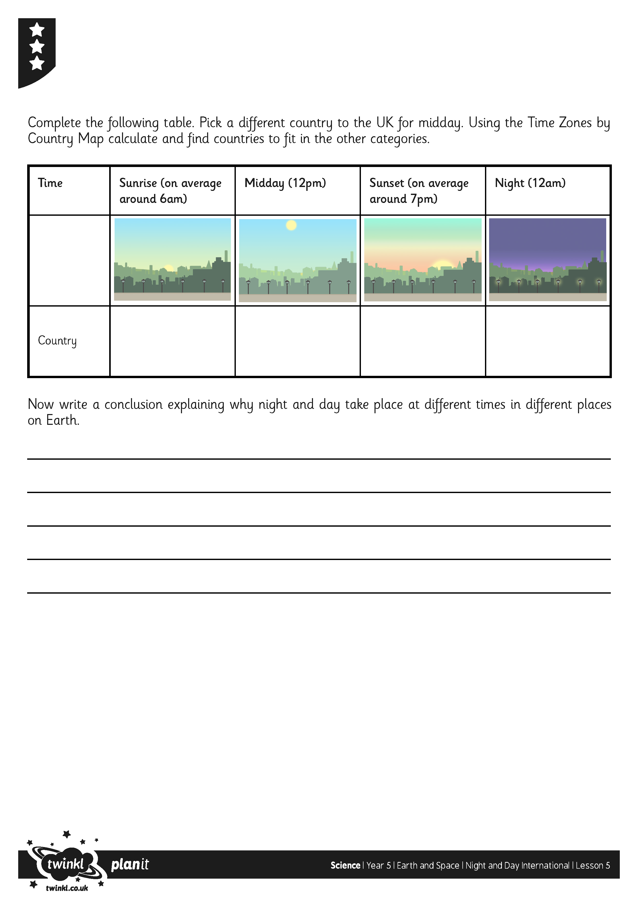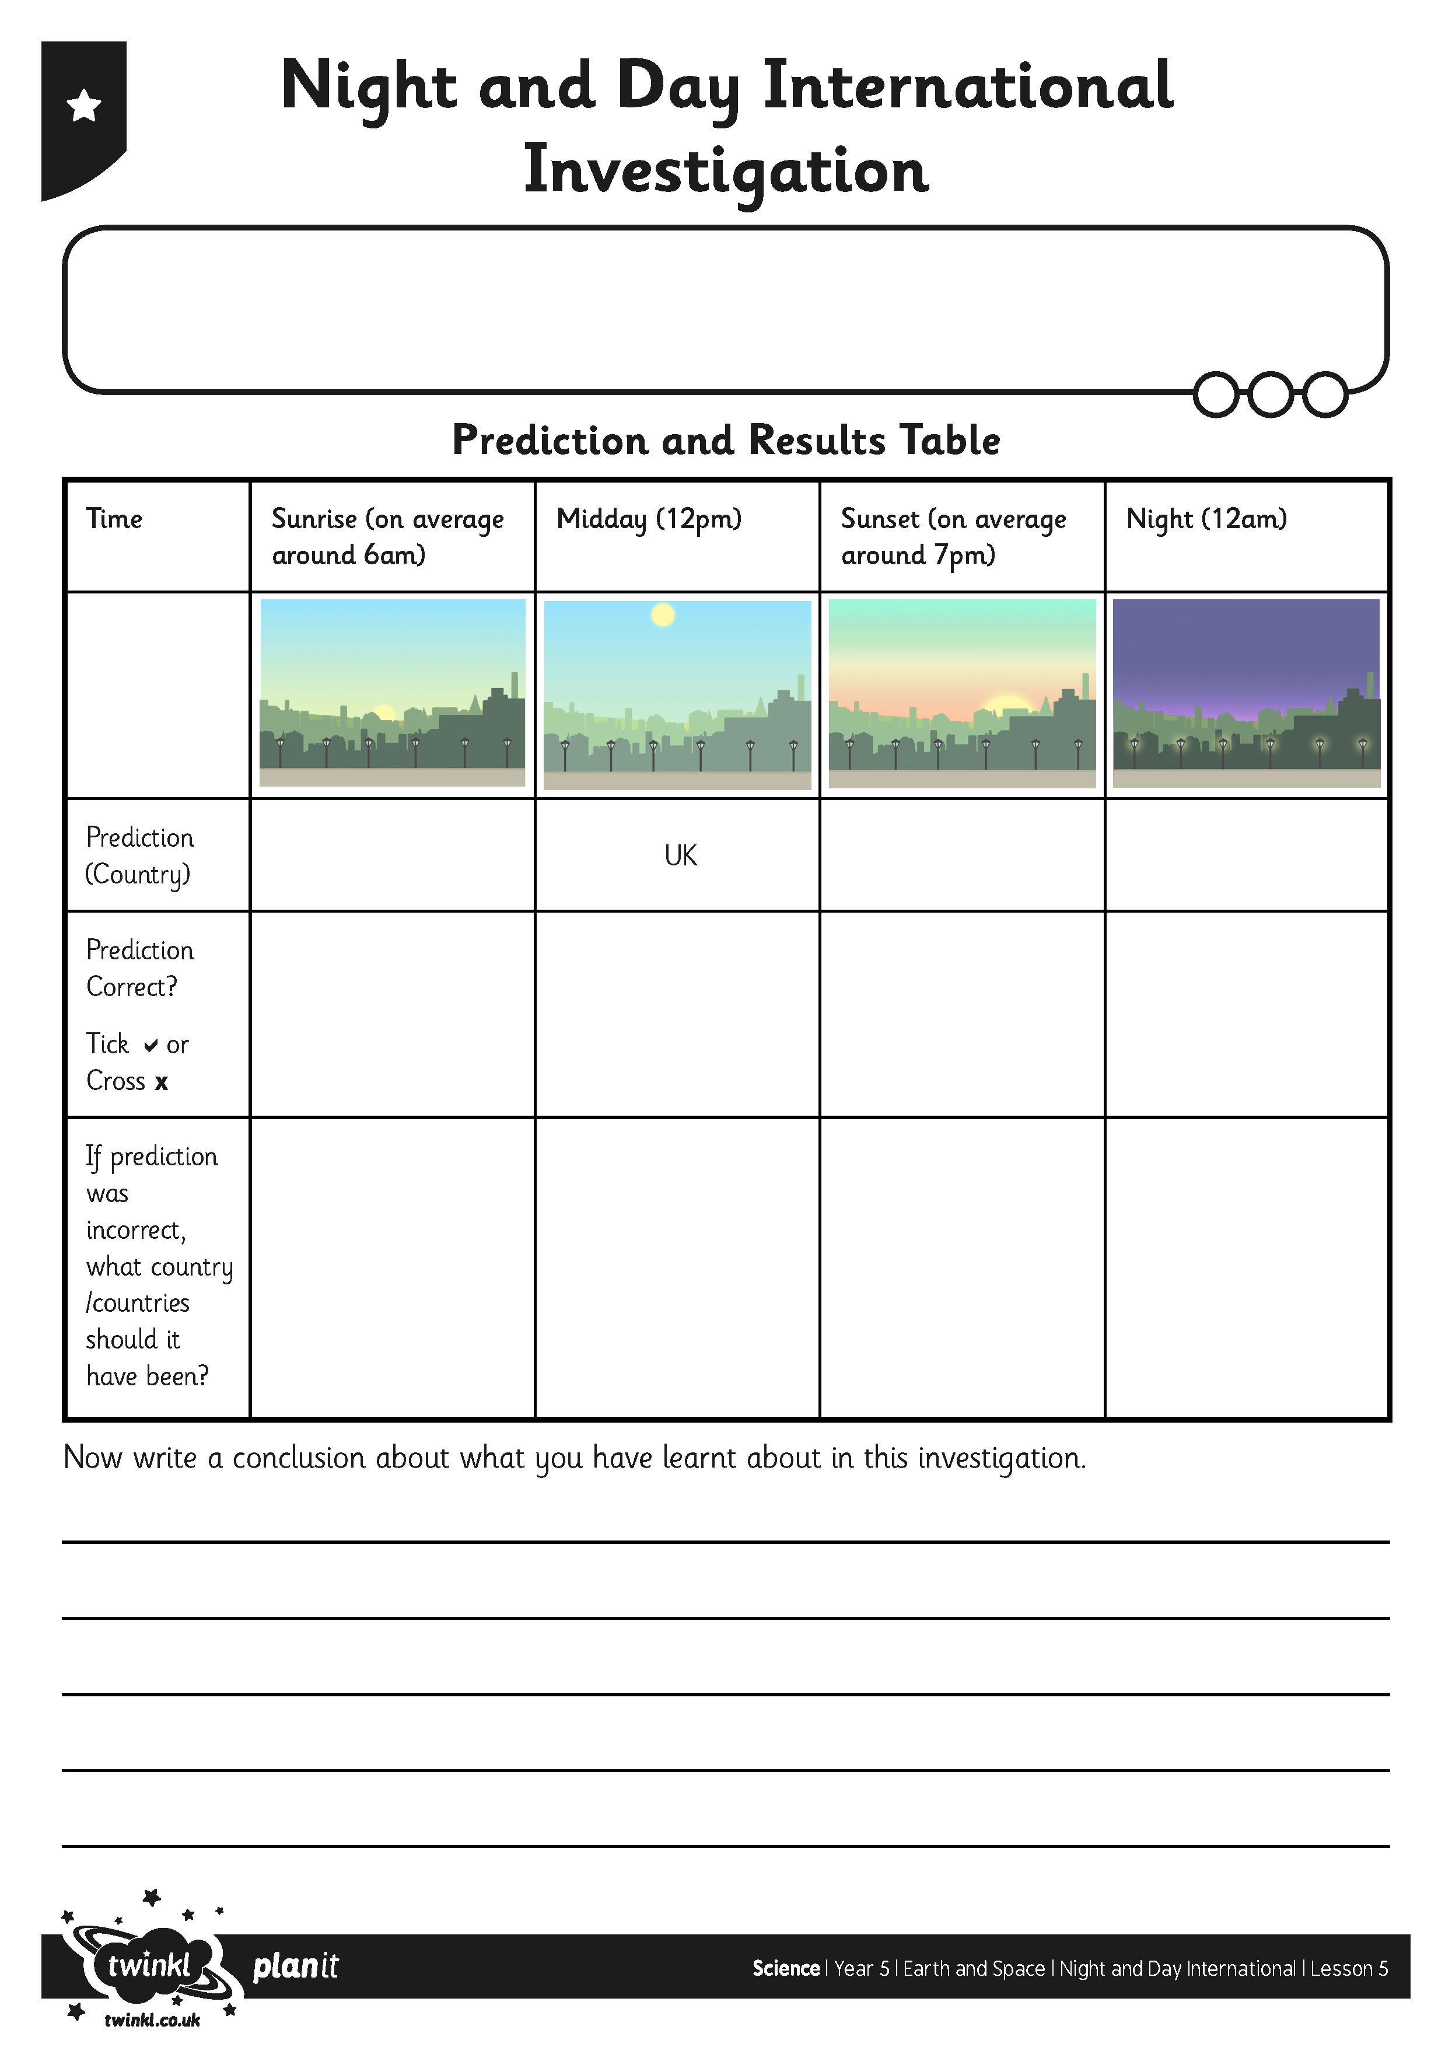
I can investigate night and day in different parts of the Earth.
I can report and present findings from enquiries.
I can investigate night and day in different parts of the Earth.
I can report and present findings from enquiries.

