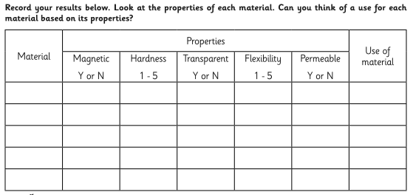
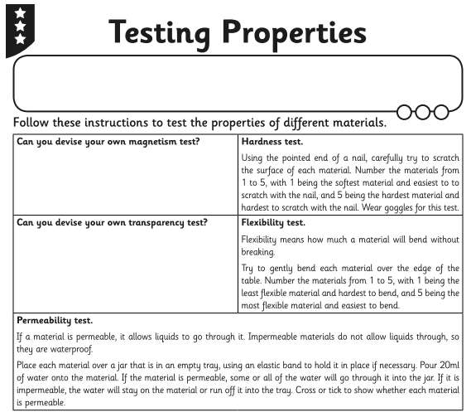
If you have any of these resources available at home you might like to conduct some of the investigations yourself and record the results below.

