Can I understand irreversible Change?
Complete the chart below by identifying which materials are reversible and which ones are irreversible.
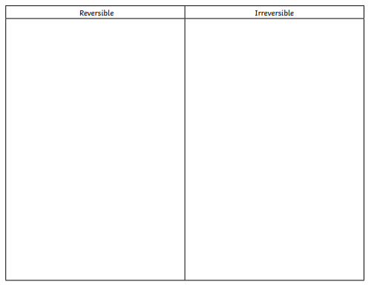

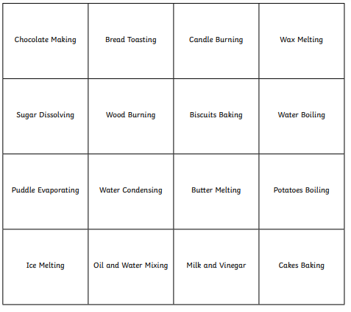
2. For reversible changes, explain how the changes can be reversed.
__________________________________________________________________________________________________________________________________________________________________________________________________________________________________________________________________________________________________________________________________________________________________________________________________________________________________________________________________________________________________________________________________________________
3. For irreversible changes, identify the reactants and the products eg Bread is the reactant and toast is the product
__________________________________________________________________________________________________________________________________________________________________________________________________________________________________________________________________________________________________________________________________________________________________________________________________________________________________________________________________________________________________________________________________________________

