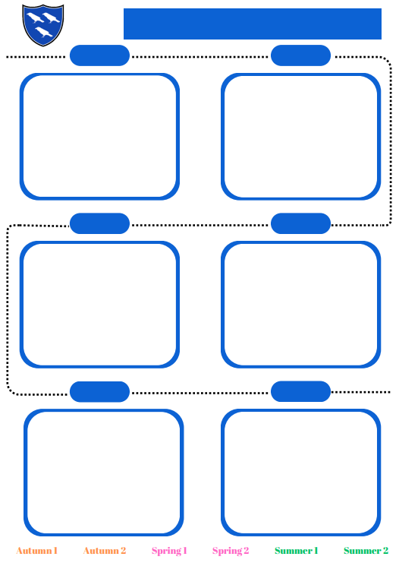

Seasonal Change

Materials

Plants: Common names and basic structures

Animals and Humans

Plants recap: opportunities for longitudinal studies

Exercise, health and the circulatory system

Electricity

How light travels

Living things and their habitats: Classification

Scientific Enquiry

Forces: Effects on Movements

Earth and Space

Material Properties: Testing material properties and reversible changes

Evolution

Life Cycles: Animals and Environment

Plants: Functions of parts of a plant

Material properties: Rocks

Animals: Skeletons and Movement

Animals: Health and Nutrtion

Forces and magnets

Light, reflection and shadows

Animals: Teeth and Digestion

Electricity

Sound

Environment: Living things and their habitats

Material properties and changes: States of Matter

Animals

How we stay healthy

Plants: Plant Growth

Use of Materials

Animals and Environment: Food chains

Habitats

**The Science Curriculum**

**YEAR 2**

**YEAR 6**

**YEAR 5**

**YEAR 4**

**YEAR 3**

**YEAR 1**