Spring 2 Homework Menu Yr 4
Please bring in the one or two pieces for this half-term between the 25th and 27th March. We will share on Wednesday 27th March.

History | History | Music | Science | Experience
Make a Roman shield.  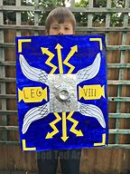 | Make a model of an Anglo-Saxon boat.  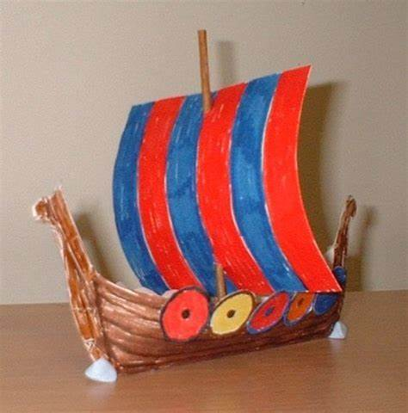 | Choose a genre of music that you enjoy.  Listen and appraise a song with focus on:  - Why you like it.  - What you can hear (instruments)  - The dynamics, tempo and texture. | Carry out a survey of different ways that animals move (such as walking up-right, walking on four legs, swimming, flying etc.).  You could look around your garden or investigate a local park.  You could record your results in a tally chart or bar chart. | Observe plant and animal life while you are out and about.  Look for signs of spring and compare how these places look in other seasons of the year.
Curriculum Drivers | PSHE | Computing | Art
 |  |  |  | Cook or bake something savoury
Focus: Community  Can you think of a way that you can make a contribution to your local community e.g. donating some of your old clothes to a charity shop? | Spending money  Interview an adult at home about how they choose how they spend their money. | See Purple Mash ToDo.  Complete Logo unit quiz. | See Purple Mash ToDo (2 Paint)  Create a William Morris inspired wallpaper design using the ‘pattern’ setting.

For subjects where research is necessary, children can choose how they wish to present their learning, enabling them to produce a piece of work they feel proud of.

