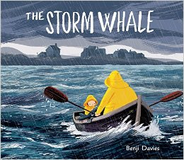
Can I write a recount of the whales return to the sea?

Word bank
Whale Sea lonely noticed busy belonged
Water bobbed beach raindrops weather heavy
Bath fisherman’s arms wasn’t Sadly
Sentence starters
From under my bright, yellow hat……..
Slowly we lifted the whale….
Over the side of the boat we lifted……
In my pocket I put a torch, compass and ………..

