How is power or wealth reflected in the language that people use?

Can I understand the epistemology of words and what they can tell us?

Choose one word from the Anglo-Saxon list and then re-write the sentence, swapping the Anglo-Saxon words for Anglo-Norman ones.
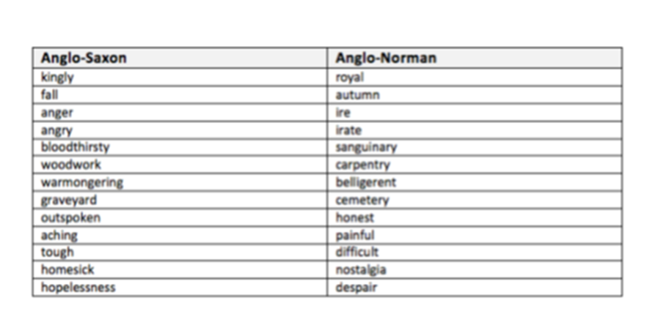
________________________________________________________________________________________________________________________________________________________________________________________________________________________________________________________________________________________________________________________________________________________________________________________________________________________________________________________________________________________________________________________________________________________________________________________________________________________________________________________________________________________________________________________________________________________________________________________________________________________________________________________________________________________________________________________________________________________________________________________________________________________________________________________________________________________________________________________________________________________________________________________________________________________________________________________________________________________________________________________________________________________________
Having explored these words, explain what these words can tell us about life during the time of the Norman Invasion.
______________________________________________________________________________________________________________________________________________________________________________________________________________________________________________________________________________________________________________________________________________________________________________________________________________________________________________________________________________________________________________________________________________________________________________________________________________________________________________________________________________________________________________________________________________________________________________________________________________________________________________________________________________________________________________________________________________________________________________________________________________________________________________________________________________________________________________________________________________________________________________________________________________________________________________________________________________________________________________________________________________________________________________________________________________________________________________________________________________________________________________________________________________________________________________________________________________________________________________________________________________________________________________________________________________________________________________________________________________________________________________________________________________________________________________________________________________________________________________________________________________________________________________________________________________________________________________________________________________________________________________________________________________________________________________________________________________________________________

