- A history of Singapore
- Information about Singpore
- Singapore’s geographical location and facts

- Does Singapore have a lot of natural resources such as water, minerals, food and energy?
Do you think this helped them to become a global island or made it more difficult? Do you think because of this they needed to develop other areas?
Look at the economy section for info on natural resources

- Singapore’s transportation

- Singapore’s economic activity

- Land reclamation in Singapore (just the first sentence in the 2nd QR code is handy). How is land reclamation helping Singapore to continue to expand into an even larger global island? Are there any negative impacts? Does this make them more/less reliant on the global system?

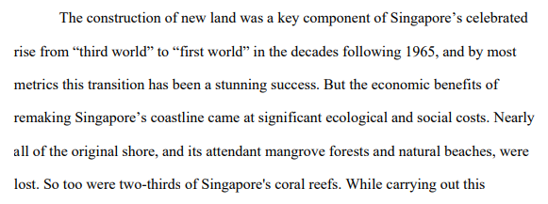
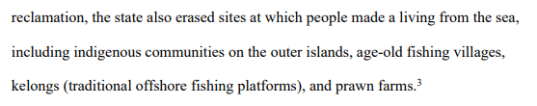
easy website to read about Singapore’s land reclamation.

