Character Questions

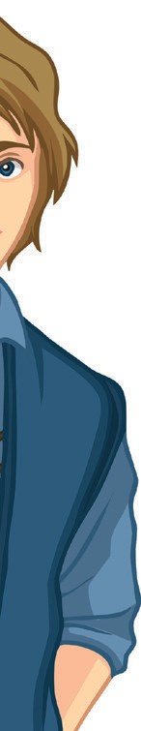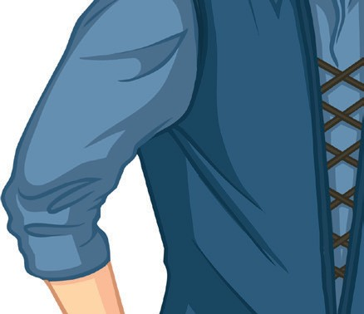
Romeo
Just before Line 95: where has Romeo just come from?
Lines 106-113: why is Romeo refusing to be irritated by Tybalt?
Lines 124-127: why does Romeo love the name Capulet? Lines 149-154: why does Romeo want them to stop fighting?
Read around Line 160: whose fault is it that Mercutio is hurt?
Lines 200-205: what does Romeo blame for his refusal to fight?

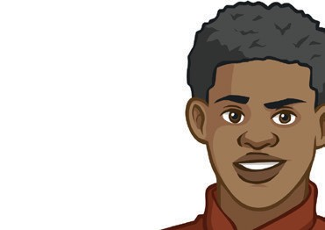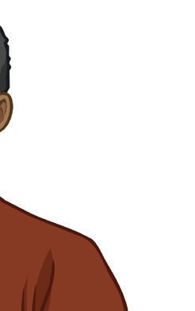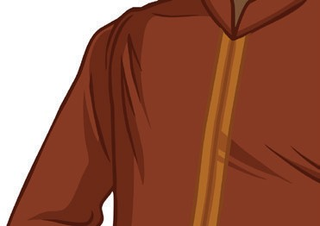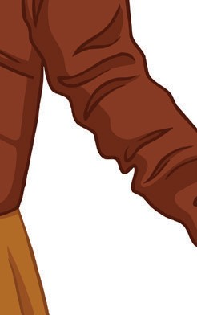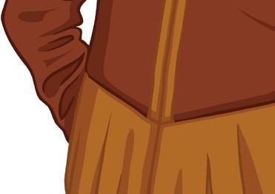
Mercutio
Line 67-69: how does Mercutio immediately rile Tybalt?
Lines 77-80: can you explain the play on words here?
Lines 91-94: what does this show us about Mercutio’s character?
Line 128-129: how does Mercutio feel about Romeo’s response to Tybalt?
Line 166 : what does Mercutio mean by ‘tis enough’?
Line 173-175: can you explain the joke Mercutio is making here?
Line 188-189: what does Mercutio mean by ‘A plague o' both your houses!’?

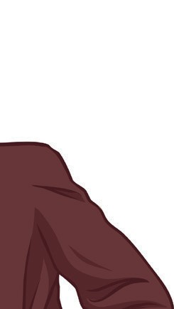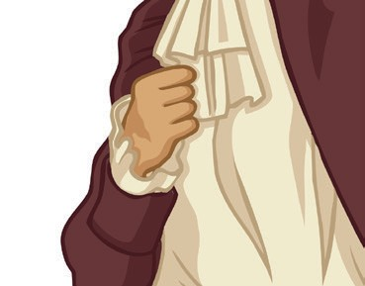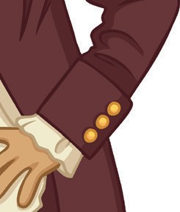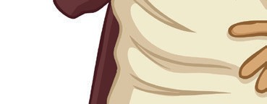

Tybalt
Line 75-76: why is Tybalt looking for Romeo and why is he so angry with him?
Line 114-116: how is Tybalt insulting Romeo here? Line 117: what does Tybalt want Romeo to do?
Line 136-137: how is Mercutio threatening Tybalt here?
Just before Line 160: why does Tybalt flee the scene?

Benvolio
Lines 83-90: what is Benvolio trying to do here and why? Line 149-150: why does Romeo appeal to Benvolio to draw his sword here?
Lines 206-209: how does Benvolio describe Mercutio here? Just after Line 193: why does Benvolio take Mercutio off stage?
Character Que

