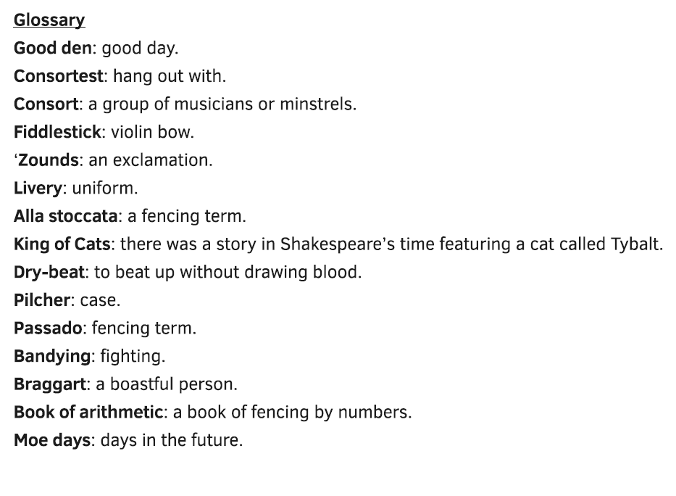
Character List: Mercution, Benvolio, Romeo, Tybalt, Petruchio, (a Capulet), Mercutio’s page

Original Text | Modern Text
Enter MERCUTIO, BENVOLIO, Mercutio’s PAGE, and others | MERCUTIO, his page, and BENVOLIO enter with other men.
BENVOLIO  I pray thee, good Mercutio, let’s retire.  The day is hot; the Capulets, abroad;  (5) And if we meet we shall not ’scape a brawl,  For now, these hot days, is the mad blood stirring. | BENVOLIO  I’m begging you, good Mercutio, let’s call it a day. It’s hot outside, and the Capulets are wandering around. If we bump into them, we’ll certainly get into a fight. When it’s hot outside, people become angry and hot-blooded.
MERCUTIO  Thou art like one of those (10)fellows that, when he enters the confines of a tavern, claps me his sword upon the table and says “God send me no need of thee!” (15) and, by the operation of the second cup, draws it on the drawer when indeed there is no need. | MERCUTIO  You’re like one of those guys who walks into a bar, slams his sword on the table, and then says, “I pray I never have to use you.” By the time he orders his second drink, he pulls his sword on the bartender for no reason at all.
BENVOLIO  Am I like such a fellow? | BENVOLIO  Am I really like one of those guys?
MERCUTIO  (20) Come, come, thou art as hot a Jack in thy mood as any in Italy, and as soon moved to be moody, and as soon moody to be moved. | MERCUTIO  Come on, you can be as angry as any guy in Italy when you’re in the mood. When someone does the smallest thing to make you angry, you get angry. And when you’re in the mood to get angry, you find something to get angry about.
BENVOLIO  (25) And what to? | BENVOLIO  And what about that?
MERCUTIO  Nay, an there were two such, we should have none shortly, for one would kill the other. Thou, why, thou wilt quarrel (30) with a man that hath a hair more or a hair less in his beard than thou hast. Thou wilt quarrel with a man for cracking nuts, having no other (35) reason but because thou hast hazel eyes. What eye but such an eye would spy out such a quarrel? Thy head is as full of quarrels as an egg is (40) full of meat, and yet thy head hath been beaten as addle as an egg for quarreling. Thou hast quarreled with a man for (45)coughing in the street because he hath wakened thy dog that hath lain asleep in the sun. Didst thou not fall out with a tailor for wearing his (50)new doublet before Easter? With another, for tying his new shoes with old ribbon? And yet thou wilt tutor me from quarreling! | MERCUTIO  If there were two men like you, pretty soon there’d be none because the two of you would kill each other. You would fight with a man if he had one more whisker or one less whisker in his beard than you have in your beard. You’ll fight with a man who’s cracking nuts just because you have hazelnut-colored eyes. Only you would look for a fight like that. Your head is as full of fights as an egg is full of yolk, but your head has been beaten like scrambled eggs from so much fighting. You started a fight with a man who coughed in the street because he woke up a dog that was sleeping in the sun. Didn’t you argue it out with your tailor for wearing one of his new suits before the right season? And with another for tying the new shoes he made with old laces? And yet you’re the one who wants to teach me about restraint!
BENVOLIO  (55) An I were so apt to quarrel as thou art, any man should buy the fee simple of my life for an hour and a quarter. |  | BENVOLIO  If I were in the habit of fighting the way you are, my life insurance rates would be sky high.
MERCUTIO  The fee simple? O simple! |  | MERCUTIO  Your life insurance? That’s foolish.
Enter TYBALT, PETRUCHIO, and other CAPULETS |  | TYBALT, PETRUCHIO, and CAPULETS enter.
BENVOLIO  (60) By my head, here comes the Capulets. |  | BENVOLIO  Oh great, here come the Capulets.
MERCUTIO  By my heel, I care not. |  | MERCUTIO  Well, well, I don’t care.
TYBALT  Follow me close, for I will speak to them.  (65) Gentlemen, good e'en. A word with one of you. |  | TYBALT  (to PETRUCCIO and others) Follow me closely, I’ll talk to them. (to the MONTAGUES) Good afternoon, gentlemen. I’d like to have a word with one of you.
MERCUTIO  And but one word with one of us? Couple it with something. Make it a word and a blow. |  | MERCUTIO  You just want one word with one of us? Put it together with something else. Make it a word and a blow.
TYBALT  (70) You shall find me apt enough to that, sir, an you will give me occasion. |  | TYBALT  You’ll find me ready enough to do that, sir, if you give me a reason.
MERCUTIO  Could you not take some occasion without giving? |  | MERCUTIO  Can’t you find a reason without my giving you one?
TYBALT  (75) Mercutio, thou consort’st with Romeo. |  | TYBALT  Mercutio, you hang out with Romeo.
MERCUTIO  Consort? What, dost thou make us minstrels? An thou make minstrels of us, look to hear (80) nothing but discords. Here’s my fiddlestick. Here’s that shall make you dance. |  | MERCUTIO  “Hang out?” Who do you think we are, musicians in a band? If we look like musicians to you, you can expect to hear nothing but noise. (touching the blade of his sword) This is my fiddlestick. I’ll use it to make you dance.
BENVOLIO  We talk here in the public haunt of men.  (85) Either withdraw unto some private place,  And reason coldly of your grievances,  Or else depart. Here all eyes (90) gaze on us. |  | BENVOLIO  We’re talking here in a public place. Either go someplace private, or talk it over rationally, or else just go away. Out here everybody can see us.
MERCUTIO  Men’s eyes were made to look and let them gaze.  I will not budge for no man’s pleasure, I. |  | MERCUTIO  Men’s eyes were made to see things, so let them watch. I won’t move to please anybody.
Enter ROMEO |  | ROMEO enters.
TYBALT  (95) Well, peace be with you, sir. Here comes my man. |  | TYBALT  Well, may peace be with you. Here comes my man, the man I’m looking for.
MERCUTIO  But I’ll be hanged, sir, if he wear your livery.  Marry, go before to field, he’ll be your follower.  (100) Your worship in that sense may call him “man.” |  | MERCUTIO  He’s not your man. Alright, walk out into a field, and he’ll chase you. In that sense you can call him your “man.”
TYBALT  Romeo, the love I bear thee can afford  No better term than this: thou (105) art a villain. |  | TYBALT  Romeo, there’s only one thing I can call you. You’re a villain.
ROMEO  Tybalt, the reason that I have to love thee  Doth much excuse the appertaining rage  (110) To such a greeting. Villain am I none.  Therefore, farewell. I see thou know’st me not. |  | ROMEO  Tybalt, I have a reason to love you that lets me put aside the rage I should feel and excuse that insult. I am no villain. So, goodbye. I can tell that you don’t know who I am.
TYBALT  Boy, this shall not excuse the (115) injuries  That thou hast done me. Therefore turn and draw. |  | TYBALT  Boy, your words can’t excuse the harm you’ve done to me. So now turn and draw your sword.
ROMEO  I do protest I never injured thee,  (120) But love thee better than thou canst devise,  Till thou shalt know the reason of my love.  And so, good Capulet—which (125) name I tender  As dearly as my own—be satisfied. |  | ROMEO  I disagree. I’ve never done you harm. I love you more than you can understand until you know the reason why I love you. And so, good Capulet—which is a name I love like my own name—you should be satisfied with what I say.
MERCUTIO  O calm dishonourable, vile submission!  (130) Alla stoccata carries it away. (draws his sword)  Tybalt, you ratcatcher, will you walk? |  | MERCUTIO  This calm submission is dishonorable and vile. The thrust of a sword will end this surrender. (draws his sword) Tybalt, you rat-catcher, will you go fight me?
TYBALT  What wouldst thou have with (135) me? |  | TYBALT  What do you want from me?
MERCUTIO  Good King of Cats, nothing but one of your nine lives, that I mean to make bold withal, and, as you shall use me hereafter, (140) dry-beat the rest of the eight. Will you pluck your sword out of his pilcher by the ears? Make haste, lest mine be about your ears ere it be out. |  | MERCUTIO  Good King of Cats, I want to take one of your nine lives. I’ll take one, and, depending on how you treat me after that, I might beat the other eight out of you too. Will you pull your sword out of its sheath? Hurry up, or I’ll smack you on the ears with my sword before you have yours drawn.
TYBALT  (145) I am for you. (draws his sword) |  | TYBALT  I’ll fight you. (he draws his sword)
ROMEO  Gentle Mercutio, put thy rapier up. |  | ROMEO  Noble Mercutio, put your sword away.
MERCUTIO  Come, sir, your passado. |  | MERCUTIO  (to TYBALT) Come on, sir, perform your forward thrust, your passado.
MERCUTIO and TYBALT fight |  | MERCUTIO and TYBALT fight
ROMEO  (draws his sword) Draw, (150)Benvolio. Beat down their weapons.  Gentlemen, for shame! Forbear this outrage.  Tybalt, Mercutio! The Prince (155) expressly hath  Forbidden bandying in Verona streets.  Hold, Tybalt! Good Mercutio! |  | ROMEO  (drawing his sword) Draw your sword, Benvolio. Let’s beat down their weapons. Gentlemen, stop this disgraceful fight. Tybalt, Mercutio, the Prince has banned fighting in the streets of Verona. Stop, Tybalt. Stop, good Mercutio.
ROMEO tries to break up the fight TYBALT stabs MERCUTIO under ROMEO’s am |  | ROMEO tries to break up the fight. TYBALT reaches under ROMEO’s arm and stabs MERCUTIO.
PETRUCHIO  Away, Tybalt. |  | PETRUCHIO  Let’s get away, Tybalt.
Exeunt TYBALT, PETRUCHIO, and the other CAPULETS |  | TYBALT, PETRUCHIO, and the other CAPULETS exit.
MERCUTIO  (160) I am hurt.  A plague o' both your houses! I am sped.  Is he gone and hath nothing? |  | MERCUTIO  I’ve been hurt. May a plague curse both your families. I’m finished. Did he get away clean?
BENVOLIO  What, art thou hurt? |  | BENVOLIO  What, are you hurt?
MERCUTIO  (165) Ay, ay, a scratch, a scratch. Marry, ’tis enough.  Where is my page?—Go, villain, fetch a surgeon. |  | MERCUTIO  Yes, yes. It’s a scratch, just a scratch. But it’s enough. Where is my page? Go, boy. Get me a doctor.
Exit MERCUTIO'S PAGE |  | MERCUTIO'S PAGE exits.
ROMEO  Courage, man. The hurt cannot (170) be much. |  | ROMEO  Have courage, man. The wound can’t be that bad.
MERCUTIO  No, ’tis not so deep as a well nor so wide as a church-door, but ’tis enough, ’twill serve. Ask for me tomorrow, and you shall (175) find me a grave man. I am peppered, I warrant, for this world. A plague o' both your houses! A dog, a rat, a mouse, a cat to scratch a man to death! (180) A braggart, a rogue, a villain that fights by the book of arithmetic! Why the devil came you between us? I was hurt under your arm. |  | MERCUTIO  No, it’s not as deep as a well, or as wide as a church door, but it’s enough. It’ll do the job. Ask for me tomorrow, and you’ll find me in a grave. I’m done for in this world, I believe. May a plague strike both your houses! I can’t believe that dog, that rat, that mouse, that cat could scratch me to death! That braggart, punk villain who fights like he learned swordsmanship from a manual! Why the hell did you come in between us? He struck me from under your arm.
ROMEO  (185) I thought all for the best. |  | ROMEO  I thought it was the right thing to do.
MERCUTIO  Help me into some house, Benvolio,  Or I shall faint. A plague o' both your houses!  (190) They have made worms' meat of me. I have it,  And soundly too. Your houses! |  | MERCUTIO  Take me inside some house, Benvolio, or I’ll pass out. May a plague strike both your families! They’ve turned me into food for worms. I’m done for. Curse your families!
Exeunt MERCUTIO and BENVOLIO |  | MERCUTIO and BENVOLIO exit.
ROMEO  This gentleman, the Prince’s near ally,  My very friend, hath got his (195) mortal hurt  In my behalf. My reputation stained  With Tybalt’s slander.Tybalt, that an hour  (200) Hath been my kinsman! O sweet Juliet,  Thy beauty hath made me effeminate  And in my temper softened (205) valor’s steel! |  | ROMEO  This gentleman Mercutio, a close relative of the Prince and my dear friend, was killed while defending me from Tybalt’s slander—Tybalt, who had been my cousin for a whole hour! Oh, sweet Juliet, your beauty has made me weak like a woman, and you have softened my bravery, which before was as hard as steel.
Enter BENVOLIO |  | BENVOLIO enters.
BENVOLIO  O Romeo, Romeo, brave Mercutio is dead!  That gallant spirit hath aspired the clouds,  (210) Which too untimely here did scorn the earth. |  | BENVOLIO  Oh Romeo, Romeo, brave Mercutio is dead! His brave spirit has floated up to heaven, but it was too early for him to leave life on earth.
ROMEO  This day’s black fate on more days doth depend.  This but begins the woe others (215) must end. |  | ROMEO  The future will be affected by today’s terrible events. Today is the start of a terror that will end in the days ahead.

