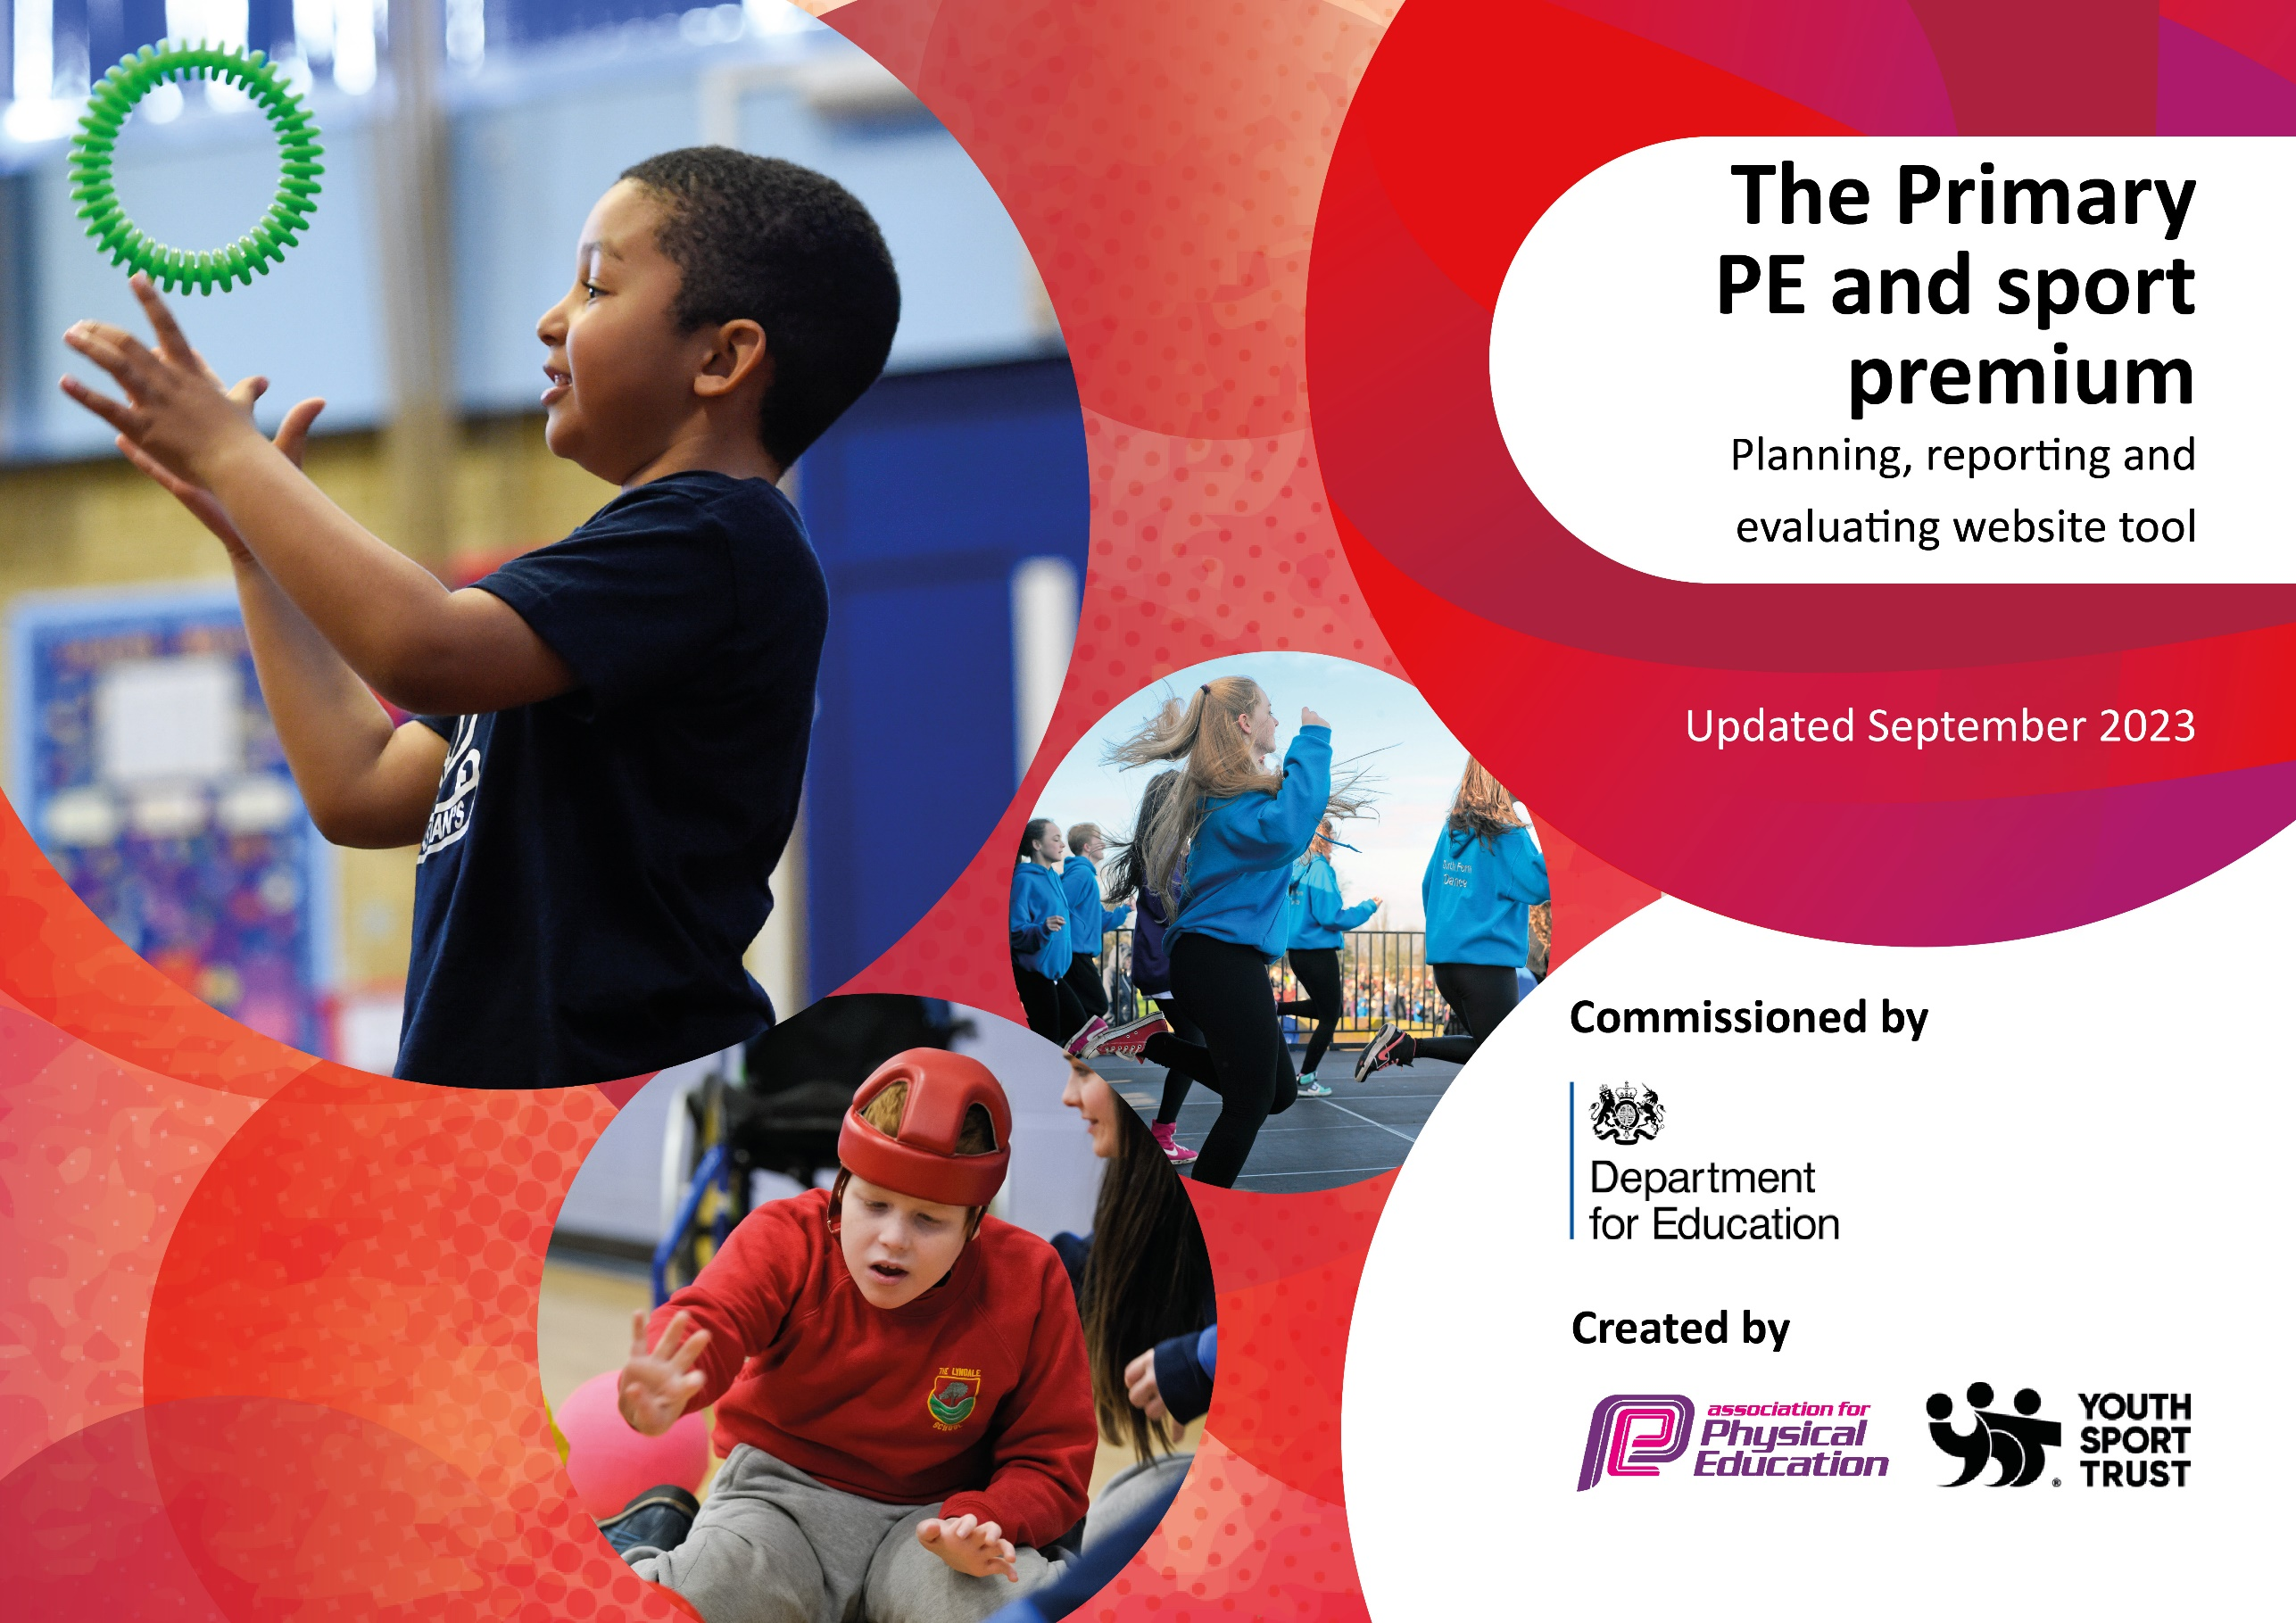

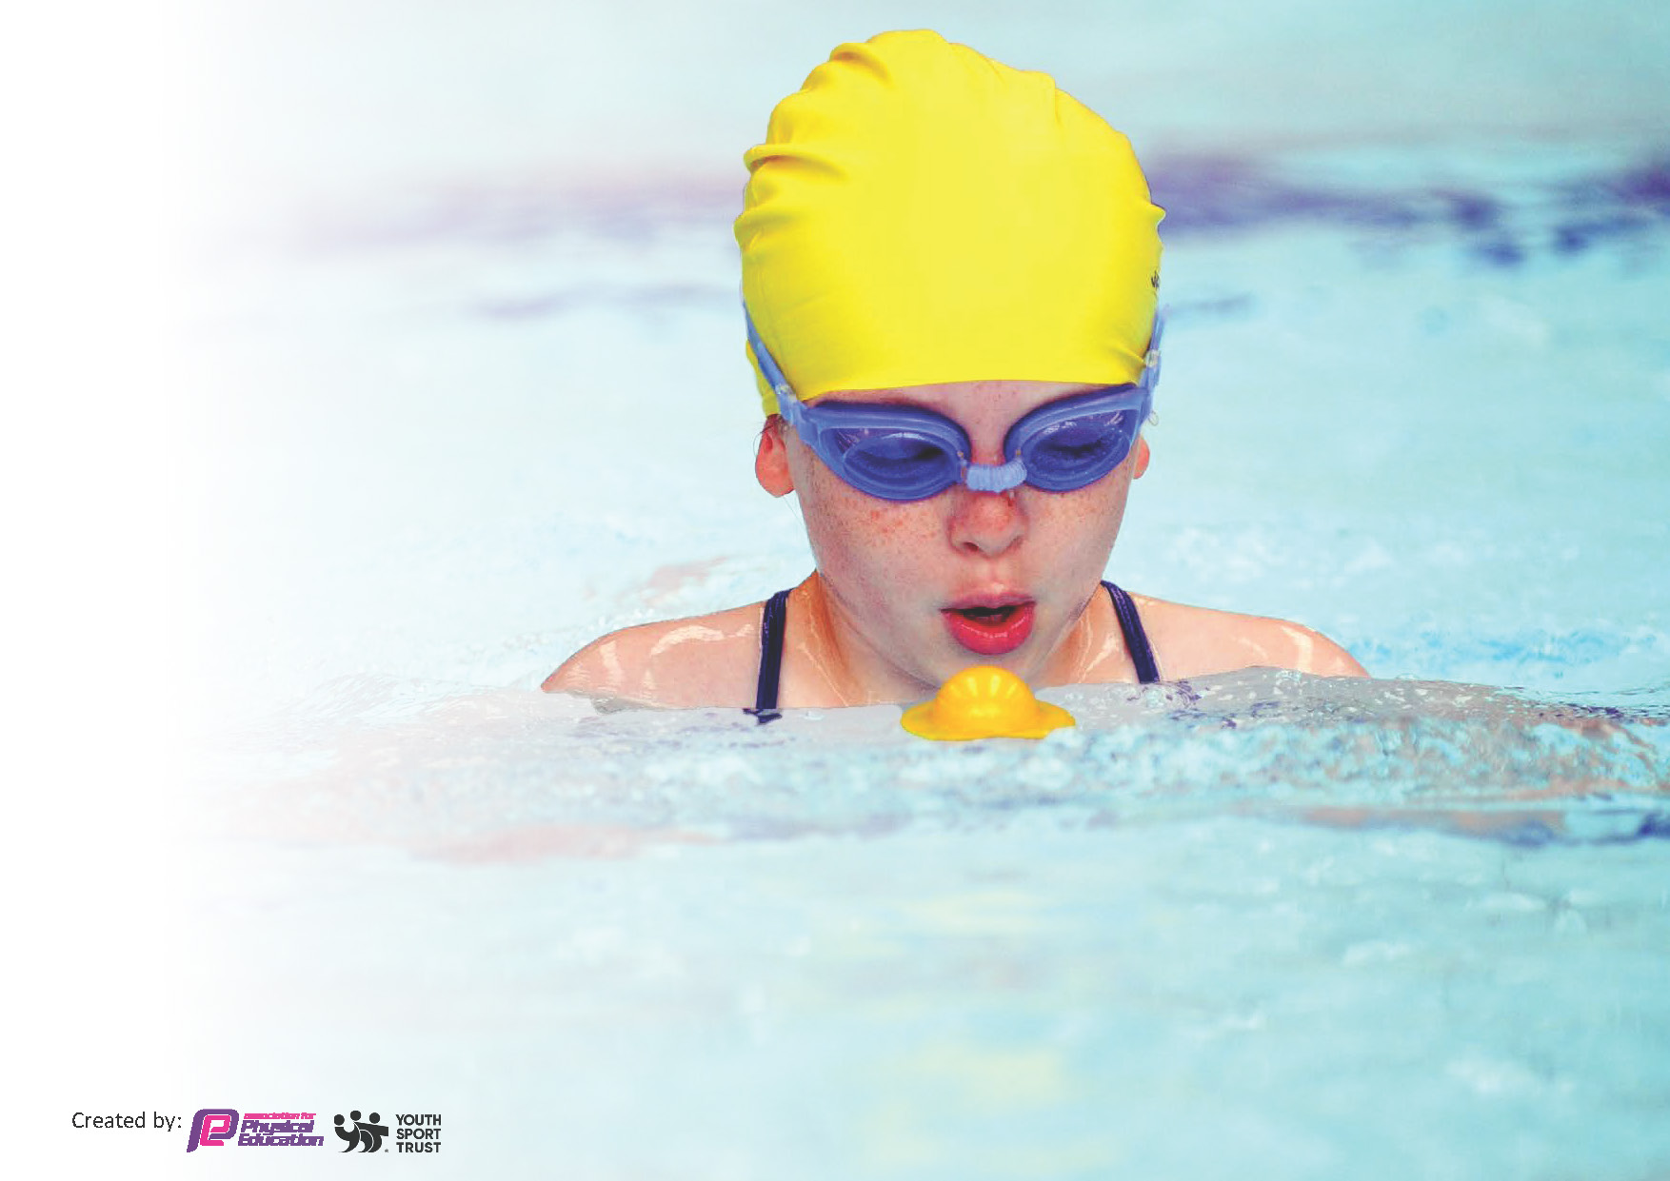
This template can be used for multiple purposes:
by:
- It enables schools to effectively plan their use of the Primary PE and sport premium
- It helps schools to meet the requirements (as set out in guidance) to publish information on their Primary PE and sport premium
- It will be an effective document to support Ofsted inspections enabling schools to evidence progress in Physical Education (PE) and evidence swimming attainment, which forms part of the PE National Curriculum. We would recommend schools consider
the Intent, Implementation and Impact of any spend, as examined within the Education Inspection Framework.

It is important that your grant is used effectively and based on school need.

Schools must use the funding to make additional and sustainable
improvements to the quality of the PE, School Sport and Physical Activity (PESSPA)
they offer. This means that you should use the Primary PE and sport premium to:

- Build capacity and capability within the school to ensure that improvements made now will benefit pupils joining the school in future years
- Develop or add to the PESSPA activities that your school already offers.

The Primary PE and sport premium should not be used to fund capital spend projects; the school’s core budget should fund these. Further detail on capital expenditure can be found in the updated Primary PE and sport premium guidance.

The Primary PE and sport premium guidance, outlines 5 key priorities that funding should be used towards. It is not

necessary that spending has to meet all the key priorities, you should select the priorities that you aim to use any funding towards.

Although completing this template is not a requirement for schools, schools are required to publish details of how they spend this funding. Schools must also outline what the impact this funding has had on pupils’ PE and sport participation and attainment and how any spending will be sustainable in the future. All funding must be spent by 31st July 2024.

The Department for Education has worked closely with the Association for Physical Education (afPE) and the Youth Sport Trust (YST) to develop this template and encourages schools to use it. This template is an effective way of meeting the reporting requirements of the Primary PE and sport premium.
Review of last year’s spend and key achievements (2022/2023)

We recommend you start by reflecting on the impact of current provision and reviewing your previous spend.

Activity/Action | Impact | Comments
- Healthy eating lessons to continue to be part of the curriculum to make children aware of the importance of eating these types of foods.  - Increase number of girls’ involved in extracurricular activities from 49.2% up to 60%. Bromley Wild Cats – Girls Only Football  - Staff to be upskilled in assessment both in formative and summative assessment methods following introduction of assessment in PE.  - PE lead to deliver staff training on new assessment tool. | Over 62% of our KS2 pupils are eating a healthy snack with 49% of those pupils having their healthy snack provided by the school.  Legacy has been created by having a girls’ only day for football. This provides pupils with chance to play football in a more relaxed setting and it gives the girls’ similar opportunities to our boys.  81% of our staff team have stated that they now feel confident and enjoy teaching PE across all topic areas. This has meant that our pupils experience far more enjoyable and accessible lessons with this being reflected in positive outcomes in our pupil voice. | We have established routines of how to lead a healthy lifestyle and this reinforces that alongside our science, PSHE and PE curriculum.  We now have a female member of staff running this at lunchtime to provide our girls with an inhouse role model.  Focus will now be on EYFS assessment, OAA and Gymnastics.

Key priorities and Planning
This planning template will allow schools to accurately plan their spending.

Action – what are you planning to do | Who does this action impact? | Key indicator to meet | Impacts and how sustainability will be achieved? | Cost linked to the action
Purchase of new equipment.  Offer a multisports session for SEND pupils and to enter teams into a Bromley School Games competition.  Workshops for obscure new activities.  - JDK Fitness: Rebound fit activity day  - New Wave Academy: Brazilian Jiu Jitsu taster session.  Sports Leader Training for Year 4 and 5 pupils  6 – 1 hour sessions at lunchtime. | The equipment will impact pupils at lunchtime, during their curriculum learning and also for extra-curricular activities.  SEND pupils get extended opportunity to take part in extracurricular activities.  All pupils will get access to different activities. In previous years we did an African Dance workshop and skipping workshop.  All pupils and staff who are on duty at lunch time. | Key indicator 4: Broader experience of a range of sports and activities offered to all pupils.  Key indicator 4: Broader experience of a range of sports and activities offered to all pupils.  Key indicator 4: Broader experience of a range of sports and activities offered to all pupils.  Key indicator 4: Broader experience of a range of sports and activities offered to all pupils. | We will now introduce golf as part of a breakfast club initiative that is designed to increase the variety of sports offered at Valley.  Purchase of roll out metal goals will provide Valley with the opportunity to host more fixtures and tournaments that will in turn raise the numbers of pupils that represent our school (60 pupils in the last academic year.  Palace for Life foundation to offer 3x 8-week interventions to support pupils across a variety of different sports.  Workshops to be organized with local providers that give pupils access to different activities to try and offer pupils new experiences.  - Squash  - Trampolining  - Jiu Jitsu  - American football  20 new pupils will be trained and upskilled as a Sports leader so that we can offer a wider rang of games at lunchtime; including bowls, golf and four-square. | £7202.39 – quality equipment that will prevent us from replacing so often. Increase in range of opportunities.  £720  £990  £210

CPD for teachers to increase competence in delivering PE.  Orienteering training for two staff member.  Staff support for new members and update on STEP and assessment.  Affiliation costs to local school games organizers and leagues.  Development of school football teams and introduction of a new b team.  Afpe mark application  KS2 Fruit  Career days – to give pupils access and exposure to the different careers within PE and sport.  Increase in pupil’s engagement in regular physical activity. | Primary generalist teachers.  This will allow to staff members to be fully trained on teaching orienteering to help support staff deliver this part of our curriculum.  Teaching staff who will have the support from an external provider and pupils in those lessons.  Pupils who can now access football more affordably.  Whole school will benefit from this mark and school will have a strategy in place for following 3 years.  Over 49% of our KS2 pupils rely on the fruit that the school provide.  All pupils, it will support the development of our Curriculum Drivers – ambition and aspiration.  All pupils will have access to daily activity to help reach 30-minute recommended time. | Key Indicator 1: Increased confidence, knowledge, and skills of all staff in teaching PE and sport.  Key indicator 5: Increased participation in competitive sport.  Key indicator 5: Increased participation in competitive sport.  Key indicator 3: Profile of PE and sport is raised across the school as a tool for whole school improvement.  Key indicator 3: Profile of PE and sport is raised across the school as a tool for whole school improvement.  Key indicator 2: Engagement of all pupils in regular physical activity. | Training with Gymspire coach to support EYFS in the delivery of gymnastics in line with early learning goals.  Complete PE to be trialed in EYFS to help support the progression of their teaching and provide them with an assessment framework. KS2 staff will also have access to follow an OAA scheme as this was an area of development highlighted by staff team. Whole school will shift from current scheme to complete PE.  AFPE membership to allow subject lead to keep up with recent changes and trends within PE.  This will allow Valley to have a fully embedded orienteering course and we will be able to host events and begin to use it as an extracurricular activity.  Prostars Coaching to offer 6 1-hour-long team-taught sessions with 2 new members of staff and one existing to support with subject knowledge and assessment.  Bromley School Games Buy-In will allow us to compete in a variety of different competitions. We plan to enter at least 5 more new competitions in addition to the 5 that we always take part in.  Cross country fees to allow over 50 pupils across KS2 to take part in the Crystal Palace Cross-Country competition.  Bromley league affiliation costs to allow us to enter a girls and boys team into the football league as well as enter a B team for the first time. We will also be able to enter a cricket team.  Valley tournament to be hosted for a 2nd consecutive year that will focus on including pupils to represent their school in a sport that they had not yet had an opportunity in.  We are now working closely alongside prostars who will develop football at Valley providing us with the opportunity to offer a Valley Frist Team and a Developmental Team. This will already increase the number of pupils who represent the school football team from 15 to 35.  By applying for this mark we will be able to come together and showcase the progress we have made in the last 5 years. This mark will show how important the profile of PE and sport is to our school.  We will link this to our Science topics that look at healthy foods and diets so that our KS2 pupils understand the importance of a balanced diet and eat a healthy snack. Our aim is to have 75% of KS2 pupils eating a healthy snack.  We will use Sports for Champions to provide us with an Olympian (GB athlete) to deliver a talk.  Career day to be planned using our school community that will focus on different careers that cover PE and sports. Money will be needed to release subject lead to deliver assemblies and time table.  Wake up and shake up initiative to be introduced across the whole school – this will be time tabled for each class throughout the day to get the class moving for an additional 15 minutes a day. | £420 – gymspire  £890 – Complete PE Scheme  £189 – Afpe Membership.  £247  £720 – 6 weeks for 3 members of staff.  £900  £192  £250  £150 for trophy and referee costs.  £1800  £350  £1800  £500  £150 – to provide class equipment that can be used and easily accessible to support these sessions.  Total - £17,960.39

Key achievements 2023-2024
This template will be completed at the end of the academic year and will showcase the key achievements schools have made with their Primary PE and sport premium spending.

Activity/Action | Impact | Comments

Swimming Data
Meeting National Curriculum requirements for swimming and water safety.
Priority should always be given to ensuring that pupils can perform safe self-rescue even if they do not fully meet the first two requirements of the National Curriculum programme of study

Question | Stats: | Further context  Relative to local challenges
What percentage of your current Year 6 cohort can swim competently, confidently and proficiently over a distance of at least 25 metres? | 74.5% | This cohort were affected by COVID and had to have a catch-up swimming programme put in place. We will identify pupils who are unable to swim and work together with parents and local providers to try and put something into place.
What percentage of your current Year 6 cohort can use a range of strokes effectively [for example, front crawl, backstroke, and breaststroke]? | 74.5% | This cohort were affected by COVID and had to have a catch-up swimming programme put in place. We will identify pupils who are unable to swim and work together with parents and local providers to try and put something into place.

What percentage of your current Year 6 cohort are able to perform safe self-rescue in different water-based situations? | 93.1% | We have introduced water safety into a PSHCE curriculum to ensure that pupils are aware of the risks, benefits and the self-rescue techniques when in water. This has also been covered in swimming sessions provided.
If your schools swimming data is below national expectation, you can choose to use the Primary PE and sport premium to provide additional top-up sessions for those pupils that did not meet National Curriculum  requirements after the completion of core lessons. Have you done this? | Yes/No
Have you provided CPD to improve the knowledge and confidence of staff to be able to teach swimming and water safety? | No | We offer this externally.

Signed off by:

Head Teacher: | (Name)
Subject Leader or the individual responsible for the Primary PE and sport premium: | (Name and Job Title)
Governor: | (Name and Role)
Date:

