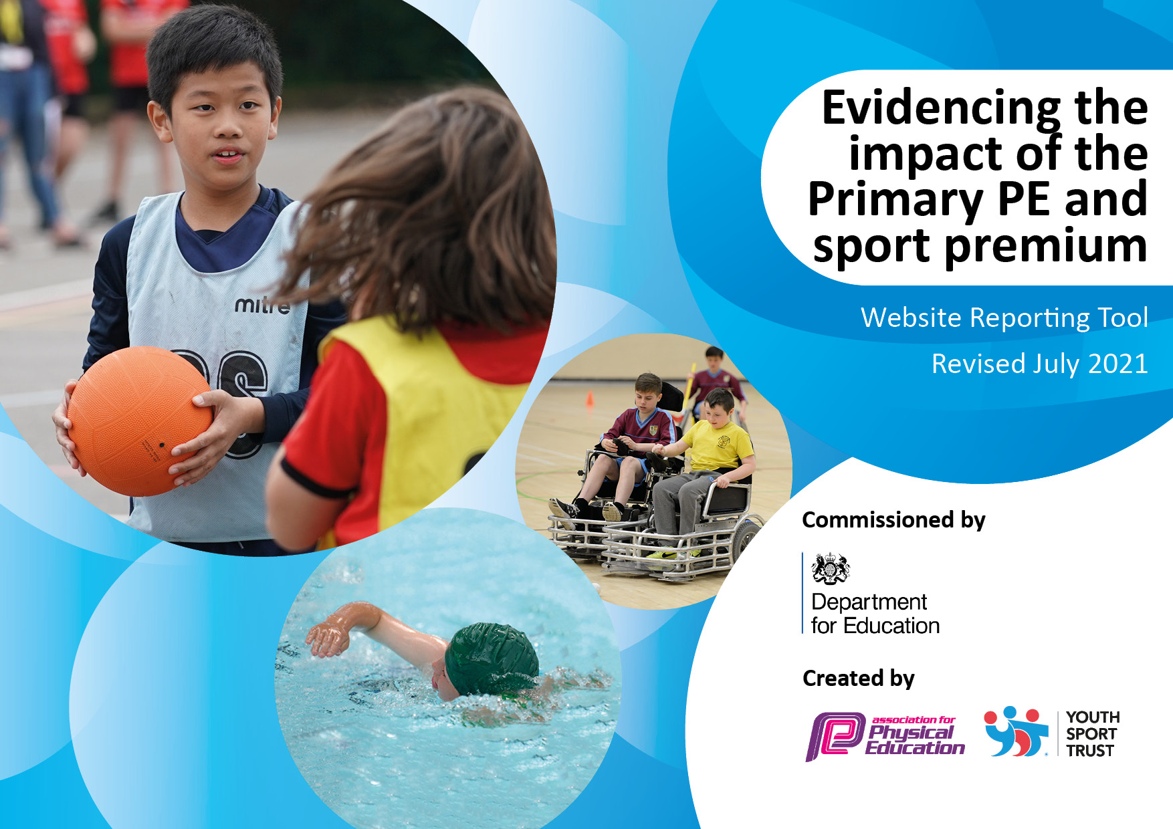
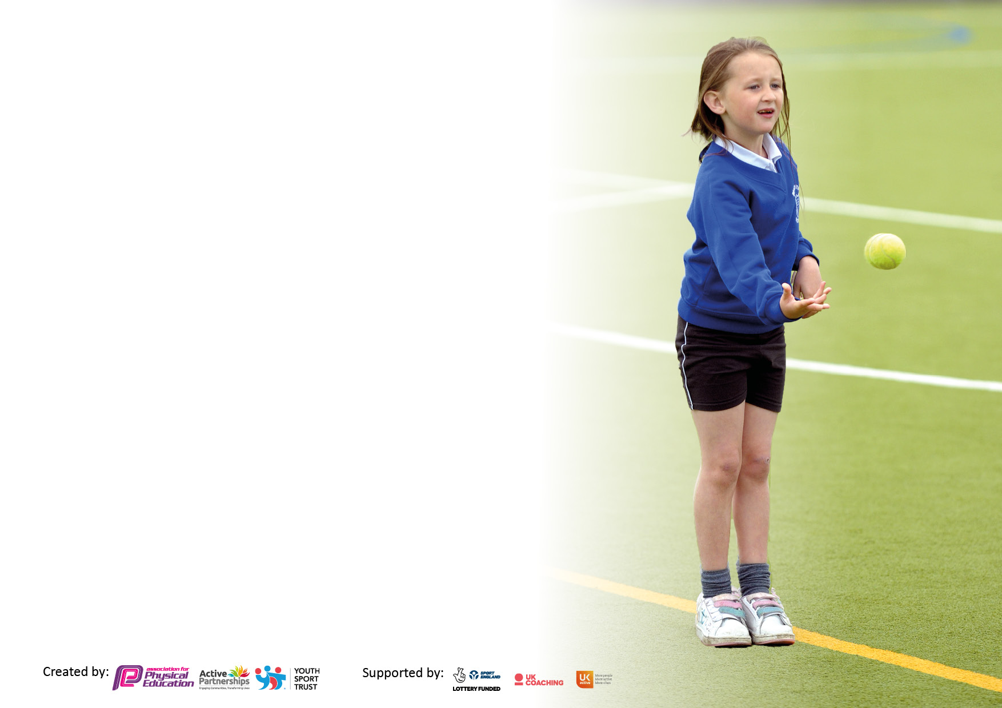

It is important that your grant is used effectively and based on school need. The Education Inspection Framework makes clear there will be a focus on ‘whether leaders and those responsible for governors all understand their respective roles and perform these in a way that enhances the effectiveness of the school’.

Under the Quality of Education Ofsted inspectors consider:
Intent - Curriculum design, coverage and appropriateness
Implementation - Curriculum delivery, Teaching (pedagogy) and Assessment
Impact - Attainment and progress

To assist schools with common transferable language this template has been developed to utilise the same three headings which should make your plans easily transferable between working documents.

Schools must use the funding to make additional and sustainable improvements to the quality of Physical Education, School Sport and Physical Activity (PESSPA) they offer. This means that you should use the Primary PE and sport premium to:

- Develop or add to the PESSPA activities that your school already offer
- Build capacity and capability within the school to ensure that improvements made now will benefit pupils joining the school in future years
- The Primary PE and sport premium should not be used to fund capital spend projects; the school’s budget should fund these.

Pleasevisitgov.ukfortherevisedDfEguidanceincludingthe5keyindicatorsacrosswhichschoolsshoulddemonstrate animprovement.Thisdocumentwillhelpyoutoreviewyourprovisionandtoreportyourspend.DfEencouragesschools to use this template as an effective way of meeting the reporting requirements of the Primary PE and sport premium.

We recommend you start by reflecting on the impact of current provision and reviewing the previous spend.

Schools are required to publish details of how they spend this funding, including any under-spend from 2019/2020, as well as on the impact it has on pupils’ PE and sport participation and attainment. All funding must be spent by 31st July 2022.

We recommend regularly updating the table and publishing it on your website throughout the year. This evidences your ongoing self-evaluation of how you are using the funding to secure maximum, sustainable impact. Final copy must be posted on your website by the end of the academic year and no later than the 31st July 2021. To see an example of how to complete the table please click HERE.
Created by: Supported by:

Details with regard to funding
Please complete the table below.

Total amount carried over from 2021/22 | £2,090
How much (if any) do you intend to carry over from this total fund into 2022/23? | £2,090
Total amount allocated for 2022/23 | £19,750
Total amount of funding for 2022/23. To be spent and reported on by 31st July 2023. | £21,840
Swimming Data
Please report on your Swimming Data below.

Meeting national curriculum requirements for swimming and water safety.

N.B. Complete this section to your best ability. For example you might have practised safe self-rescue techniques on dry land which you can then transfer to the pool when school swimming restarts.
Due to exceptional circumstances priority should be given to ensuring that pupils can perform safe self rescue even if they do not fully meet the first two requirements of the NC programme of study
What percentage of your current Year 6 cohort swim competently, confidently and proficiently over a distance of at least 25 metres?  N.B. Even though your pupils may swim in another year please report on their attainment on leaving primary school at the end of the summer term 2021.  Please see note above | 84%
What percentage of your current Year 6 cohort use a range of strokes effectively [for example, front crawl, backstroke and breaststroke]?  Please see note above | 81%
What percentage of your current Year 6 cohort perform safe self-rescue in different water-based situations? | 82%
Schools can choose to use the Primary PE and sport premium to provide additional provision for swimming but this must be for activity over and above the national curriculum requirements. Have you used it in this way? | No

Action Plan and Budget Tracking
Capture your intended annual spend against the 5 key indicators. Clarify the success criteria and evidence of impact that you intend to measure to evaluate for pupils today and for the future.

Academic Year: 2022/23 | Total fund allocated:£22,460 | Date Updated:
Key indicator 1: The engagement of all pupils in regular physical activity – Chief Medical Officers guidelines recommend that primary school pupils undertake at least 30 minutes of physical activity a day in school |  |  |  | Percentage of total allocation:
 |  |  |  | 16.69 %
Intent | Implementation |  | Impact
Your school focus should be clear what you want the pupils to know and be able to do and about  what they need to learn and to  consolidate through practice: | Make sure your actions to achieve are linked to your intentions: | Funding allocated: | Evidence of impact: what do pupils now know and what can they now do? What has changed?: | Sustainability and suggested next steps:
Headline Intended Impact on Pupils – Over 80% of children in KS2 to all have a healthy snack on a daily basis.  School to provide all of KS2 children with a healthy snack at play times.  Headline Intended Impact on Pupils – To increase number of girls who take part in football and extracurricular activities.  Girls football to be offered across KS1 and KS2.  Increase number of girls’ involved in extracurricular activities from 49.2% up to 60%.  Get girls playing initiative. | - Healthy eating lessons to continue to be part of the curriculum to make children aware of the importance of eating these types of foods.  - Pupil voice by the end of Spring term to update the figures and ensure we are meeting are targeting.  - During the last academic year, we noticed that only 49.2% of children who were attending clubs were girls.  - Aim is to increase number of girls who take part in extracurricular activities to increase to 60% due to an increase in what we offer; this has followed a pupil voice.  - Following our KS2 football team being established, we now want to offer a girl only football session to all children. Bromley FC to provide female coaches during lunchtime as role models and to engage more girls to take part. | £2,500  £1,250 | Over 62% of our KS2 pupils are eating a healthy snack with 49% of those pupils having their healthy snack provided by the school.  Girls’ participation in extracurricular clubs has now increased to 50%.  We now have a KS1 Girls’ football session on a Thursday afternoon due to demand.  We have now allocated a girls’ only day to our POD timetable that enables girls’ to have their own day to play football that has 25 – 60 pupils a week. | To continue funding and we will now target pupils who do not eat a healthy snack and we aim to have 75% of our pupils accessing a healthy snack in KS2.  Girls’ only Wednesday will now become a legacy and this will be a day that celebrates girls’ playing football and enables them to have their own safe space to play football.  We will now look to introduce a ‘B’ team for girls football fixtures due to demand and interest.
Key indicator 2: The profile of PESSPA being raised across the school as a tool for whole school improvement |  |  |  | Percentage of total allocation:
 |  |  |  | 3.6 %
Intent | Implementation |  | Impact
Your school focus should be clear what you want the pupils to know and be able to do and about  what they need to learn and to  consolidate through practice: | Make sure your actions to achieve are linked to your intentions: | Funding allocated: | Evidence of impact: what do pupils now know and what can they now do? What has changed?: | Sustainability and suggested next steps:
Headline Intended Impact on Pupils – To increase play experience in line with our OPAL award.  Sports Leader Award | - CM consultancy to set up VPS as a training hub for the Sports Leader Award.  - CM consultancy to provide 6 hours of Sports Leader training to pupils in Year 4-6.  - High visibility vests and caps to be bought for Sports Leaders and OPAL helpers.  - PE lead to deliver 6 week training to OPAL Helpers.  - Equipment to be bought to support pupils in above positions (whistles, clipboards) | £600  £179  £50 | 54 pupils are now volunteer Sports Leaders and Opal Helpers providing an opportunity for our pupils to develop their leadership skills.  Structured timetable of activities lead by helpers ha helped reduce playground incidents from 73 in the Autumn term down 23 in the Spring term. | Valley will now become a hub meaning that we can help support and deliver our sports leader training internally. We will continue to use the older children as role models to help support new Year 4’s to develop into the role.

Key indicator 3: Increased confidence, knowledge and skills of all staff in teaching PE and sport |  |  |  | Percentage of total allocation:
 |  |  |  | 43%
Intent | Implementation |  | Impact
Your school focus should be clear | Make sure your actions to | Funding | Evidence of impact: what do | Sustainability and suggested
what you want the pupils to know | achieve are linked to your | allocated: | pupils now know and what | next steps:
and be able to do and about | intentions: |  | can they now do? What has
what they need to learn and to |  |  | changed?:
consolidate through practice:
Headline Intended Impact on Pupils – Staff to be given 1:1 support from external agency to help them develop differentiation and assessment with their lessons.  JP6 coaching / Prostars CPD Support | - Staff to be upskilled in assessment both in formative and summative assessment methods following introduction of assessment in PE.  - External provider to provide alternative lesson plans and to give lesson examples of how to introduce STEP.  - PE lead to deliver staff training on new assessment tool.  - All teachers to be confident in new assessment tool, methods of STEP and how to make accurate assessments.  - AFPE memberships to continue. | £9,500  £178 | External provider changes in December 2022.  81% of our staff team have stated that they now feel confident and enjoy teaching PE across all topic areas. This has meant that our pupils experience far more enjoyable and accessible lessons with this being reflected in positive outcomes in our pupil voice. | Focus now to be on EYFS gymnastics and introducing a new scheme for EYFS to follow to support their assessment and upskill staff member in OAA.
Key indicator 4: Broader experience of a range of sports and activities offered to all pupils |  |  |  | Percentage of total allocation:
 |  |  |  | 15.5%
Intent | Implementation |  | Impact
Your school focus should be clear | Make sure your actions to | Funding | Evidence of impact: what do | Sustainability and suggested
what you want the pupils to know | achieve are linked to your | allocated: | pupils now know and what | next steps:
and be able to do and about | intentions: |  | can they now do? What has
what they need to learn and to |  |  | changed?:
consolidate through practice:
Headline Intended Impact on Pupils – All pupils’ will be exposed to new areas of activity.  Supporting the target for all pupils to be active on average 30 minutes a day, 7 days a week | Palace for Life SEND sessions to be introduced as an intervention for pupils on our SEND register. This is intended to engage them in physical activity while also improving their agility, balance and coordination.  Introduction to new activities during lunchtime; four square, mud kitchen, sand pit, tyre play, speaker system. This is to provide a broader range of activities on offer across play times.  Introduction of new community links with local clubs; Sundridge Golf Club, Shortland Lawn and Bowling Club. | £1000  £2000  £500 | All pupils made expected progress and this was evident in their PE lessons and on their individual provision maps.  Valley now has a broad range of activities at lunchtime. Since the introduction of this alongside our Sports Leaders we have seen a reduction of playground incidents drop from 73 in Autumn to 23 by end of Spring term.  This was not spent and will now become a focus for 23/24. | We will now begin a multi-sport intervention to continue to focus on a different set of skills to further engage our SEND pupils and begin to enter them into School Games competitions.  Valley will continue to use reusable resources to support the majority of our OPAL play and we will begin to introduce Valley Helpers from the local community to support a wider range of activities.

Key indicator 5: Increased participation in competitive sport |  |  |  | Percentage of total allocation:
 |  |  |  | 5.1%
Intent | Implementation |  | Impact
Your school focus should be clear | Make sure your actions to | Funding | Evidence of impact: what do | Sustainability and suggested
what you want the pupils to know | achieve are linked to your | allocated: | pupils now know and what | next steps:
and be able to do and about | intentions: |  | can they now do? What has
what they need to learn and to |  |  | changed?:
consolidate through practice:
Headline Intended Impact on Pupils – Increase the number of pupils participating in an increased range of competitive opportunities. Supporting the target for all pupils to be active on average 60 minutes a day, 7 days a week and supporting personal development of all pupils.  Hosting a development tournament for the first time to increase pupil participation in football for both girls’ and boys’. | - Valley to participate in the standing fixtures that we have competed in the past. Football League Affiliation, Cricket league Affiliation and Rugby Affiliation.  - Valley to enter new competitions in 2022/2023 academic years through Bromley School Games.  - Increase in pupils and families engaging in sport at community clubs through Valley Volunteers project.  - Valley to begin hosting friendly and intra school fixtures to ensure that all KS2 pupils take part in a competitive fixture. | £250  900  £150 | 48 different pupils took part in league fixtures across football, cricket and rugby increasing our participation from 31 last year.  Valley took part in 5 competitions this year, including swimming for the first time since covid. This provided opportunity for pupils to take part in a wide range of sport competitions.  Valley Cup took place against 4 other local schools targeting pupils who may not have had an opportunity to represent the school. This was aimed at Year 4 and 5 pupils.  Valley also gained the School Games Gold Award for the actions put in place from this SP spend. | Valley to target 10 competitions next year and gain School Games Mark  This competition will become an annual event to help increase participation in competitive events across our school.

Signed off by
Head Teacher:
Date:
Subject Leader: | Tobias Riddoch
Date: | 16/7/2023
Governor:
Date:

