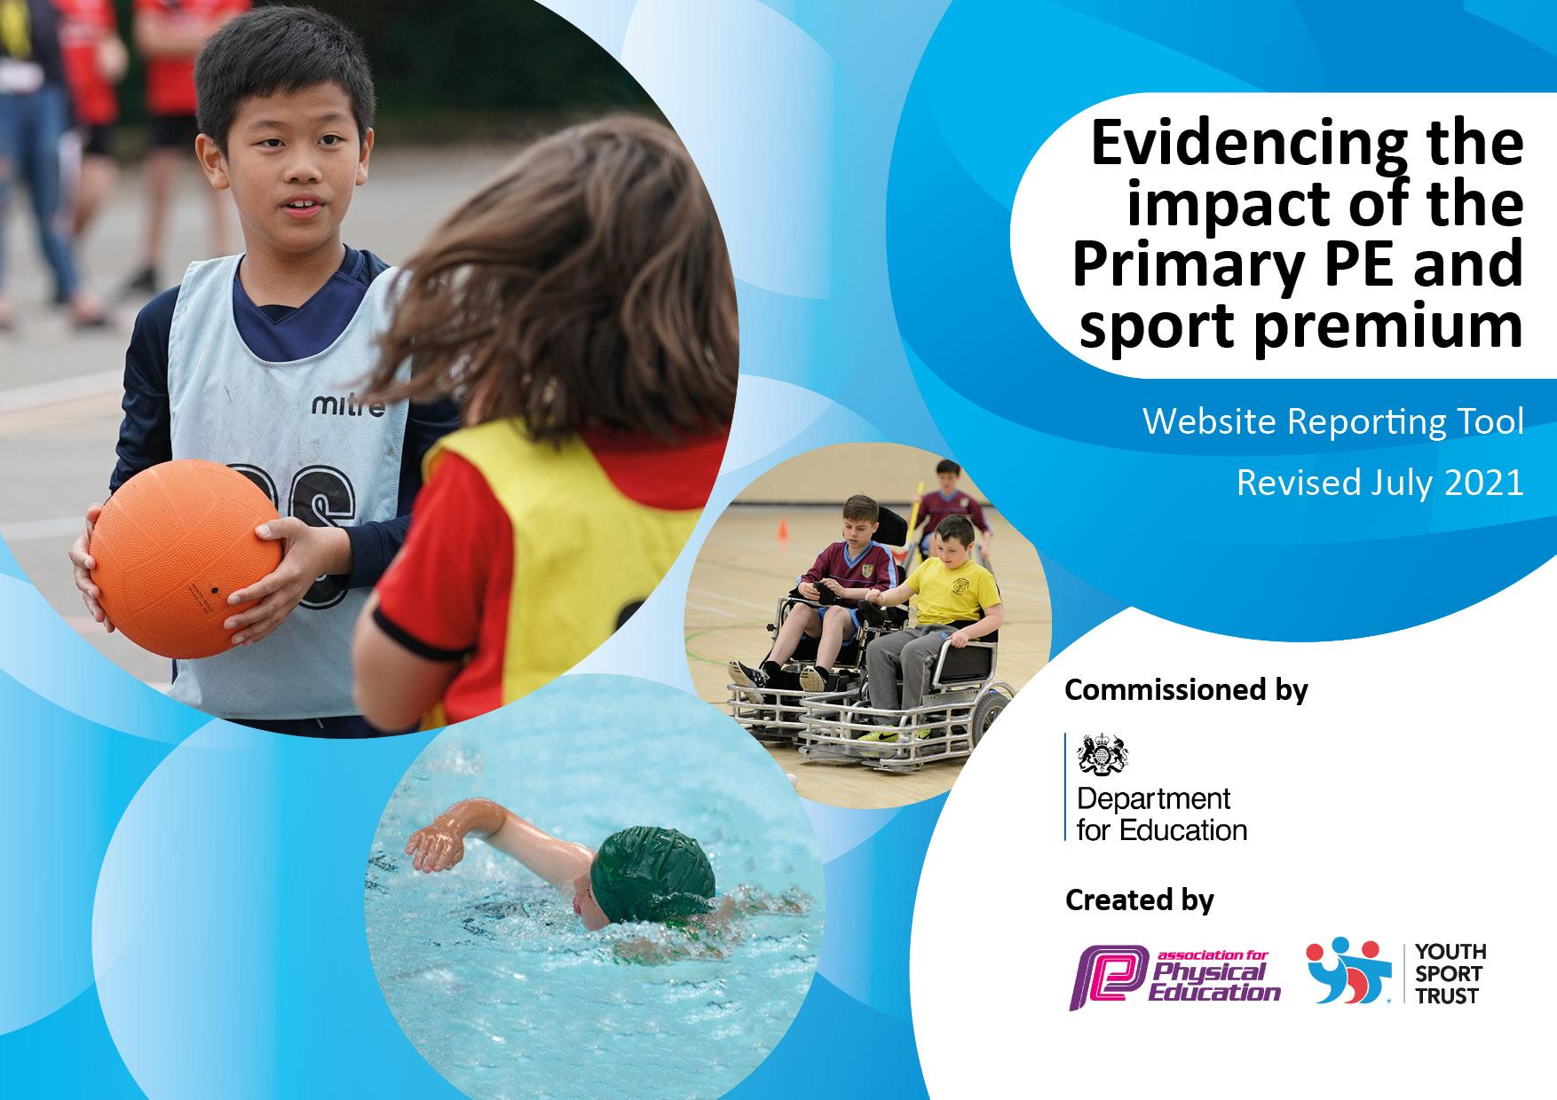
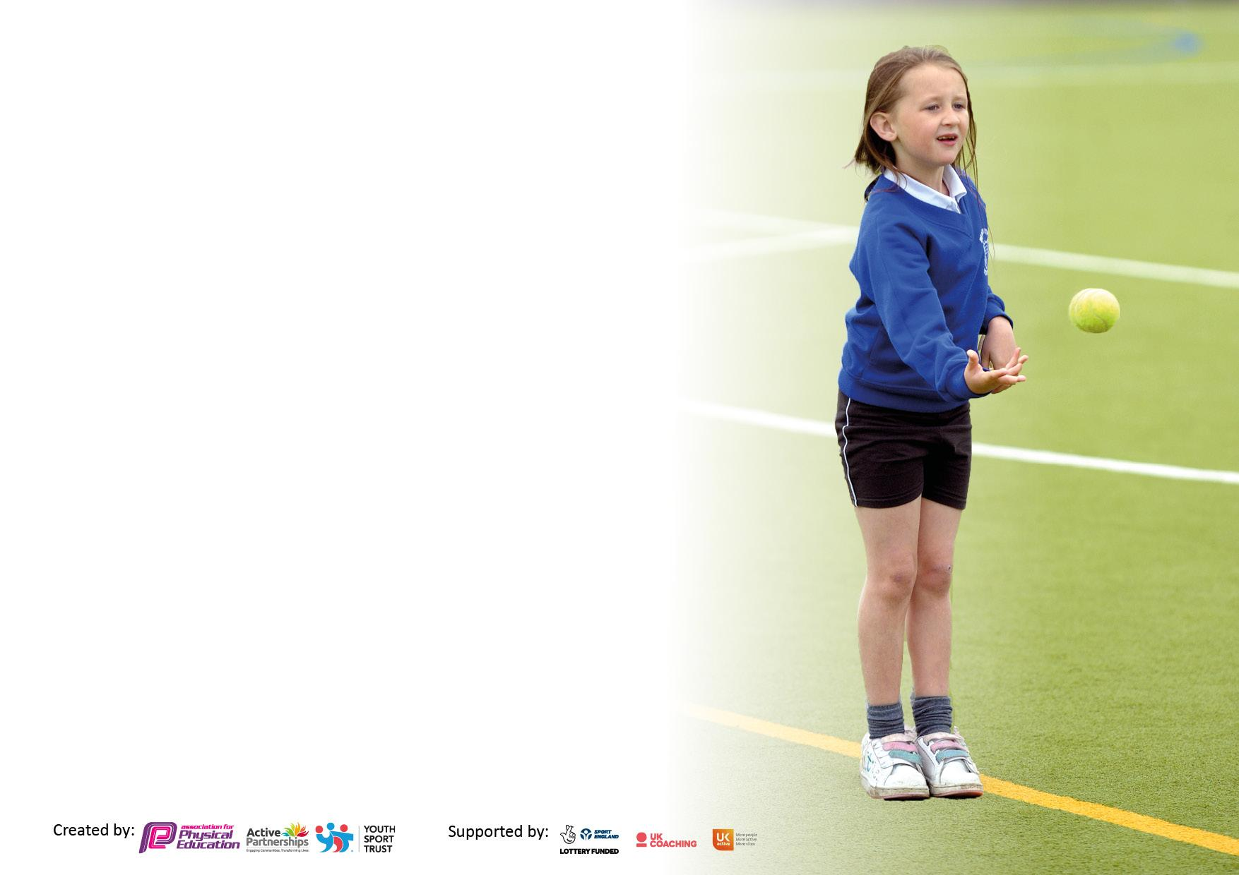

It is important that your grant is used effectively and based on school need. The Education Inspection Framework makes clear there will be a focus on ‘whether leaders and those responsible for governors all understand their respective roles and perform these in a way that enhances the effectiveness of the school’.

Under the Quality of Education Ofsted inspectors consider:
Intent - Curriculum design, coverage and appropriateness
Implementation - Curriculum delivery, Teaching (pedagogy) and Assessment
Impact - Attainment and progress

To assist schools with common transferable language this template has been developed to utilise the same three headings which should make your plans easily transferable between working documents.

Schools must use the funding to make additional and sustainable improvements to the quality of Physical Education, School Sport and Physical Activity (PESSPA) they offer. This means that you should use the Primary PE and sport premium to:

- Develop or add to the PESSPA activities that your school already offer
- Build capacity and capability within the school to ensure that improvements made now will benefit pupils joining the school in future years
- The Primary PE and sport premium should not be used to fund capital spend projects; the school’s budget should fund these.

Pleasevisitgov.ukfortherevisedDfEguidanceincludingthe5keyindicatorsacrosswhichschoolsshoulddemonstrate animprovement.Thisdocumentwillhelpyoutoreviewyourprovisionandtoreportyourspend.DfEencouragesschools to use this template as an effective way of meeting the reporting requirements of the Primary PE and sport premium.

We recommend you start by reflecting on the impact of current provision and reviewing the previous spend.

Schools are required to publish details of how they spend this funding, including any under-spend from 2019/2020, as well as on the impact it has on pupils’ PE and sport participation and attainment. All funding must be spent by 31st July 2022.

We recommend regularly updating the table and publishing it on your website throughout the year. This evidences your ongoing self-evaluation of how you are using the funding to secure maximum, sustainable impact. Final copy must be posted on your website by the end of the academic year and no later than the 31st July 2021. To see an example of how to complete the table please click HERE.

Details with regard to funding
Please complete the table below.

Total amount carried over from 2019/20 | £5,000
Total amount allocated for 2020/21 | £25,380
How much (if any) do you intend to carry over from this total fund into 2021/22? | £5,000
Total amount allocated for 2021/22 | £25,380
Total amount of funding for 2021/22. To be spent and reported on by 31st July 2022. | £23,291

Swimming Data
Please report on your Swimming Data below.

Meeting national curriculum requirements for swimming and water safety.

N.B. Complete this section to your best ability. For example you might have practised safe self-rescue techniques on dry land which you can then transfer to the pool when school swimming restarts.
Due to exceptional circumstances priority should be given to ensuring that pupils can perform safe self rescue even if they do not fully meet the first two requirements of the NC programme of study
What percentage of your current Year 6 cohort swim competently, confidently and proficiently over a distance of at least 25 metres?  N.B. Even though your pupils may swim in another year please report on their attainment on leaving primary school at the end of the summer term 2020.  Please see note above | 81%
What percentage of your current Year 6 cohort use a range of strokes effectively [for example, front crawl, backstroke and breaststroke]?  Please see note above | 78%
What percentage of your current Year 6 cohort perform safe self-rescue in different water-based situations? | 77%
Schools can choose to use the Primary PE and sport premium to provide additional provision for swimming but this must be for activity over and above the national curriculum requirements. Have you used it in this way? | Yes

Academic Year: 2022/23 | Total fund allocated: | Date Updated:
Key indicator 1: The engagement of all pupils in regular physical activity – Chief Medical Officers guidelines recommend that primary school pupils undertake at least 30 minutes of physical activity a day in school |  |  |  | Percentage of total allocation:
 |  |  |  | 36.89%
Intent | Implementation |  | Impact
Your school focus should be clear what you want the pupils to know and be able to do and about  what they need to learn and to  consolidate through practice: | Make sure your actions to achieve are linked to your intentions: | Funding  Allocated | Evidence of impact: what do pupils now know and what can they now do? What has changed?: | Sustainability and suggested next steps:
Headline Intended Impact on Pupils – Over 75% of children in KS2 to all have a healthy snack on a daily basis.  School to provide all of KS2 children with a healthy snack at play times.  Headline Intended Impact on Pupils – All pupils to be active in at least 30 minutes of physical activity a day for 7 days a week.  An increase in the variety of sports that we provide during lunchtime and after school club. Whilst also engaging a wider variety of pupils and parents into regular physical activity.  Headline Intended Impact on Pupils – All pupils to be able to swim competently, confidently and proficiently over a distance of at least 25 metres before Year 6.  Top up sessions provided to pupils of 2 cohorts that have not been able to take part in swimming due to COVID-19. | - Healthy eating lessons to continue to be part of the curriculum to make children aware of the importance of eating these types of foods.  - Pupil voice by the end of Spring term to update the figures and ensure we are meeting are targeting.  - Introduction of physical activity logs to help children recognise and celebrate the amount of time they spend being active.  - Review of our Extracurricular club registers to build a picture of the amount of children who take part and highlight those children on our SEND and PP registers.  - Parent questionnaire to be sent out to those parents who do not enrol their children in extracurricular activities to provide us with feedback/suggestions.  - Introduction of parent and children sessions to support families with engaging in physical activity.  - The school will target Year 4 and 5 with a 10 week period of 1 hour lessons to ensure that these pupils are competent swimmers following no lessons during lock down. | £1,626  £462 (21 hours of PE coordinator release).  £10,380 | In 2020-2021 50% of KS2 pupils stated that they either did not have a healthy snack during the school day. Following this, we have begun to provide pupils in KS2 a healthy snack during playtimes. We predict that by Spring 2021 that at least 75% of the children in KS2 will be eating a healthy snack at school.  WIDER IMPACT AS A RESULT OF ABOVE.  Through the introduction of our physical activity log books in KS2 we will aim to celebrate pupil’s engagement in regular physical activity through certificates and prizes. We will also host regular parent and pupils fitness sessions to promote and support physical activity within families.  We predict that by the end of 2021/22 school year is to have engaged 75% of both FSM pupil and pupils on the SEND register in an extracurricular activity. | Continue to monitor the number of children eating a healthy snack in school and ensure that our healthy eating lessons are taught through KS2 so that pupils are aware of the positive impact that these food choices can have on our body.  Continue to liaise with parents and families to ensure that all children have access to our extracurricular clubs. We will continue to do regular feedback sessions and ensure that PP and FSM families are provided with the choice of 1 free club per term.  Following catch up with Year 4 and 5 swimming, 70% of our pupils in these cohorts are now at KS2 level for swimming. We will look to continue to support the other children in the next academic year. Each child has been taught water safety in addition to this.
Key indicator 2: The profile of PESSPA being raised across the school as a tool for whole school improvement |  |  |  | Percentage of total allocation:
 |  |  |  | 26.2%
Intent | Implementation |  | Impact
Your school focus should be clear what you want the pupils to know and be able to do and about  what they need to learn and to  consolidate through practice: | Make sure your actions to achieve are linked to your intentions: | Funding allocated: | Evidence of impact: what do pupils now know and what can they now do? What has changed? | Sustainability and suggested next steps:
Headline Intended Impact on Pupils – All pupils’ personal development will be developed and celebrated.  In addition, supporting the target for all pupils to be active on average 60 minutes a day, 7 days a week  To provide all pupils with their own skipping rope as a way to increase physical activity.  School football Kit  Badges  We will launch our Orienteering scheme throughout the whole of KS2 with an Orienteering day.  Continue with our OPAL project to ensure that we reach a platinum award for our Play provision. | - The Parent and child club will encourage learning about the importance of PA together.  - To engage the whole school in physical activity we will aim to provide all pupils with their own skipping rope  - Valley skipping day will take place and all pupils will take part in a skipping workshop.  - To have our school badge embroidered onto our new football kit.  - The introduction of the orienteering plaques and schemes of work for KS2.  - An orienteering specialist to come in for an afternoon to introduce orienteering throughout the whole of KS2.  - To continue with the implementation of Play policies and formalising Play.  - To provide CPD and training for all members of the play team.  - To develop our playground to support with achieving a platinum award from OPAL. | £100  £770  £175  £300  £2000 | All pupils will have access to a skipping rope which they will be able to use to help contribute to their 30 minutes of physical activity a day. By providing external coaches twice a week, we will aim to engage our most inactive pupils in regular physical activity whilst providing them with skills and good habits to ensure that this is sustained when support is no longer available.  For all of our football team to have a new kit with the school badge on it. This will mean that when representing the school in matches our team will have a kit to be proud of.  We predict that by the end of the 2021/22 academic year that all of our KS2 classes would have taken part in OAA and orienteering with it being part of our school curriculum. We also predict that this will then be used for our Outdoors club as part of our extracurricular timetable.  The will be impacted through training given to Curricular leads that will support class teachers a long with the scheme of work that can be used to design lessons.  We predict that by the end of 2021/22 academic year that all members of our play team will be trained in the different play types. We also predict that incidents on the playground would have fallen (to liaise with RC on data) and that our playground would be clearly organised in zones with a wide range of activities taking place. | Through pupil voice, activity logs and parent feedback will we aim to ensure that our most inactive pupils are supported in PA and also our pupils are celebrated for their achievements in sport. Skip-a-thons will take place to provide regular whole school fitness sessions in the next academic year.  Following the orienteering launch, we are now ready to include this as part of our curriculum. We now have a course set up and the software to enable us to adapt this. Next action will be to map out how this looks.  We will continue to work alongside the OPAL mentor on developing our play provision and working with the school community to gather feedback and provide a play that the children are proud with. This will also contribute to engaging more of our pupils in being active. This has been delayed slightly due to COVID. We will still look to achieve this award in the 22/23 school year.

Key indicator 3: Increased confidence, knowledge and skills of all staff in teaching PE and sport |  |  |  | Percentage of total allocation:
 |  |  |  | 5.3%
Intent | Implementation |  | Impact
Your school focus should be clear | Make sure your actions to | Funding | Evidence of impact: what do | Sustainability and suggested
what you want the pupils to know | achieve are linked to your | allocated: | pupils now know and what | next steps:
and be able to do and about | intentions: |  | can they now do? What has
what they need to learn and to |  |  | changed?
consolidate through practice:
Headline Intended Impact on Pupils – All teaching staff to be provided with at least two CPD sessions to increase their confidence and competence in teaching the PE curriculum. | - Through a staff voice, we identified three key areas of the PE curriculum where staff did not feel confident; games, gymnastics and OAA.  - CPD provided to all teaching staff and specific support staff for a 2-hour training session on invasion games.  - In class support from specialist coaches in squash and tennis for Years 1,2 and 4,6.  - PE curricular lead to be given mentoring by CM consultancy to develop their subject knowledge and confidence in leading, overserving and supporting staff.  - Introduction to assessment against our Threshold Concepts for PE.  - AFPE memberships to continue. | £275  £150  £675  £178 | As a result of a bespoke CPD (Local authority support/courses, In house 1-1 CPD, staff insets, courses, interactive SOW and updating equipment we expect to see significant impact:  WIDER IMPACT AS A RESULT OF ABOVE  - Staff value PE the impact of High-Quality PE on the pupils.  - Fitter pupils = higher attainment in Maths and English. See Maths and English Data.  - Confidence in PE lead to be able support all members of staff and introduce an effective assessment tool across the school.  Staff have been supported in the introduction of the new curriculum and how to use the resources that been introduced; including threshold concepts and knowledge organiser. Staff have also been supported with invasion games, introduction to assessment and also orienteering to help support their professional development. | Staff voice to be sent out to reflect on staff confidence and more lesson observations planned to ensure that staff are supported on how to implement the training that has been given.  Through the mentoring given to the curriculum lead, they have now experienced planning, organising and conducting their own CPD session and they have been given external training on orienteering to help support staff in other areas of need within the curriculum.
Key indicator 4: Broader experience of a range of sports and activities offered to all pupils |  |  |  | Percentage of total allocation:
 |  |  |  | 14.10%
Intent | Implementation |  | Impact
Your school focus should be clear | Make sure your actions to | Funding | Evidence of impact: what do | Sustainability and suggested
what you want the pupils to know | achieve are linked to your | allocated: | pupils now know and what | next steps:
and be able to do and about | intentions: |  | can they now do? What has
what they need to learn and to |  |  | changed?:
consolidate through practice:
Headline Intended Impact on Pupils – All pupils’ will be exposed to new areas of activity.  Supporting the target for all pupils to be active on average 30 minutes a day, 7 days a week | Palace for Life SEND sessions to be introduced as an intervention for pupils on our SEND register. This is intended to engage them in physical activity while also improving their agility, balance and coordination.  To increase the variety of activities that we offer to our pupils we are actively engaging with local clubs including Sundridge Park Tennis Club and Shortlands Golf Club to increase the variety of sports that we deliver across the school.  Purchasing of new equipment to allow teachers to deliver niche sports such as golf and squash during lesson time.  Collaboration with JP6 Active Coaching and the Bromley School Games organisers to increase the number of girls who take part in sport within the curriculum and in extracurricular activities. | £1000  £500  £2000  £1800 | We predict that by the end of the 2021/22 academic year that we would have introduced at least 2 new sports to our pupils either within the curriculum or as an after-school club. We also aim to work alongside Bromley Squash Club to establish a Valley Squash Academy.  We also aim to ensure that pupils on our SEND register benefit from the specialist coaching to support physical and social development.  WIDER IMPACT AS A RESULT OF ABOVE  Following a 10-week period of coaching offered by JP6 within our curriculum, we were able to see that girls had equal opportunity to football within the curriculum. Following this, we saw a a sharp increase in the number of girls taking part in our extracurricular activities. In the autumn term 28% of pupils taking part in clubs were girls, however this increased to 49.2% in the summer term. | As a result of the SEND sessions, we will see an improvement in targets being met on individual provision maps and also increase the number of SEND pupils taking part in regular physical activity.  We will continue to work with local communities and parents to provide a wide variety of sports for the pupils in our school.  More girls’ only clubs have been put on offer to support the children in building their confidence within sports as this came up as a barrier during our pupil interviews. We are continuing to offer role models from a variety of sports to support with ambition.

Key indicator 5: Increased participation in competitive sport |  |  |  | Percentage of total allocation:
 |  |  |  | 3.18%
Intent | Implementation |  | Impact
Your school focus should be clear | Make sure your actions to | Funding | Evidence of impact: what do | Sustainability and suggested
what you want the pupils to know | achieve are linked to your | allocated: | pupils now know and what | next steps:
and be able to do and about | intentions: |  | can they now do? What has
what they need to learn and to |  |  | changed?:
consolidate through practice:
Headline Intended Impact on Pupils – Increase the number of pupils participating in an increased range of competitive opportunities. Supporting the target for all pupils to be active on average 60 minutes a day, 7 days a week and supporting personal development of all pupils. | - Valley to participate in the standing fixtures that we have competed in the past.  - Valley to enter new competitions in 2020/2021 academic years.  - Increase in pupils and families engaging in sport at community clubs through Valley Volunteers project.  - Valley to begin hosting friendly and intra school fixtures to ensure that all KS2 pupils take part in a competitive fixture. | £900 | By July 2022 this will increase the number of external competitions that we enter our school into and the number of in whilst also increasing the competition in lesson time. We predict that 100% of KS1 will access 5 competitions and 100% of KS2 5 competitions.  Competitions to have a focus on success via demonstration of specific life skills and values.  2020/21, 0% of KS1 took part in a level 2 competition and 6% of KS2 participated in Level 2 competitions (football, cricket, orienteering) due to Covid restrictions being in place.  B By July 2022, we predict that 50% of KS1 and 100% of KS2 will take part in either a intra or inter school competition.  - Schools own data / registers of teams  - Calendar of events / fixture lists  - School Games mark | Valley took part in 6 competitions this year, entering around 80 pupils. This was largely due to some events being cancelled and this target is one that we will continue to focus on in the 22/23 academic year.

Signed off by
Head Teacher:
Date:
Subject Leader: | Tobias Riddoch
Date: | 15.7.2022
Governor:
Date:

