Home Learning
Year Group: 4 Week Beginning: 1st February 2021
Reading | - Read for 20 minutes daily  - Check your books on Bug Club
English | -Please refer to the English document for this week’s lessons  Remember to use your writing targets  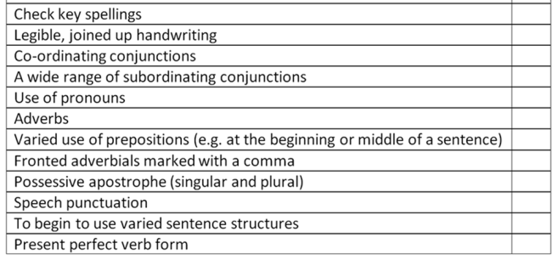  ]
Maths | Fractions: Equivalent Fractions  -Refer to either the Maths A or Maths B document  -IXL: Understanding Fractions AA.1-AA.7
Spelling | Please refer to the spellings document.  There will be a spelling test on Friday at 2pm.
Punctuation and Grammar | All activities that are set are topics that have been covered in class and should be completed independently.  -Superhero Shopping Trip (Purple Mash)  -Frank’s Clever Window (Purple Mash)  -Prefix sheet
Afternoon Lessons | PSHE  IPC  German  Science  Spellings

