Learning at Home
YEAR 5
Monday 1st – Friday 5th February 2021
All the resources are also available on:
ValleyPrimary.co.uk - Curriculum – Lockdown Home Learning –Year 5 - Spring Week 5
Year 5 Teachers welcome emailed copies of the Students Home Learning

Reading | Read for 30 minutes a day.  Answer the Bug questions, using full sentences and punctuation.  Remember to use evidence to back up your answer.  Use your log in details for Bug Club and remember to complete the comprehension questions.  Username: Childs first name  Password Teal (followed by a number)  School Code: AHX7
English | Task 1: Romeo and Juliet, The Marriage  Can I evaluate how key characters are feeling at the end of Act II?  Can I write a diary entry as either the Nurse or Juliet to explain how I am feeling about events that occur in Act II, Scene V?  In this lesson, we will start by creating a handy glossary of words that will appear throughout this lesson and task. Then, we will look at arrangements that are made by key characters in Act II, Scene IV and think about the impact of these in relation to the Nurse and Juliet. For the first independent activity you will read an extract from the Nurse and Juliet, selecting one character to focus on (either Juliet or the Nurse), each time they speak you will complete a thought bubble to show what they are thinking. You will then use this to help you complete Activity 2, which is to create a diary entry as the character you have focused on. In the diary entry you will explain how you are feeling as that character based on the arrangements made in Act II, Scene IV. There are also two optional tasks that you might like to complete to develop your understanding of the end of Act II even further.  Task 2: Romeo and Juliet, Mercutio, Act III, Scene I, the very beginning  Can I answer questions aboout the actions and thoughts of characters in the first part of Act III, Scene I?  Task 3: Romeo and Juliet, Mercutio, Act III, Scene I, the fall-out  Can I create an obituary for the character of Mercutio, reflecting on his character and role and the feelings and actions of other characters towards him?  Task 4: Romeo and Juliet, Justice, Act III, Scene I  Can I create a timeline of events for Romeo so far in the play?  Can I translate Romeo’s words into modern english?  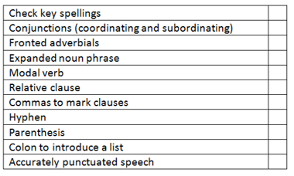  Task 5: Reading Comprehension – A New Hero  Answer the questions using full sentences. You will need to use a dictionary for the first question.  https://kids.wordsmyth.net/
Maths | IXL  Multiplication D 1-25  Division E1-17  Fractions S1-18  The questions on the planning sheet are to be completed after the lessons.  The resources on the home leaning page are optional should more practise be required.  Math Group A  Lesson 1:  TASK 1  TASK 2:  EXTENSION:  Lesson 2:  EXTENSION:  Lesson 3:  EXTENSION:  Lesson 4:  EXTENSION:  Lesson 5: Can I  Math Group B  Maths Frame (Practise daily this week in order to help with times table fluency)  https://mathsframe.co.uk/en/resources/resource/477/Multiplication-Tables-Check  Lesson 1: FRACTION RECAP We will work through a couple of examples in each task today and then you will complete them independently.  TASK 1: Equivalent fractions  Remember: Whatever you do to the denominator you must also do to the numerator!  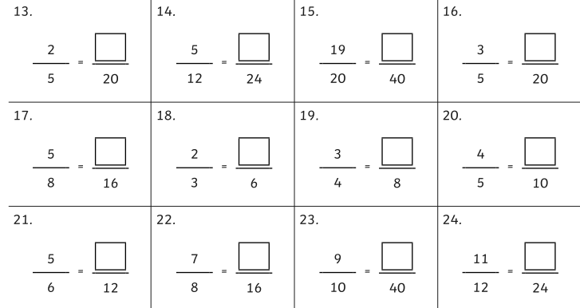  TASK 2: Improper fractions to mixed fractions  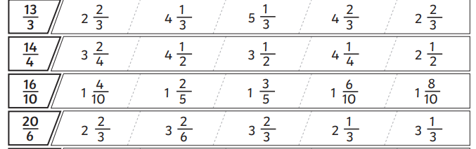  TASK 3: Adding and Subtracting Fractions. Can you convert the answer into a mixed fraction?  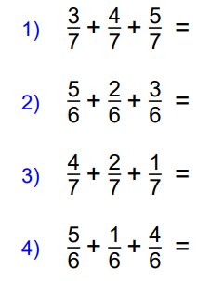 EXTENSION: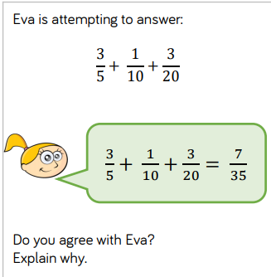  TASK4: Fraction with different denominators (Refer to the PPT to remind yourself of the calculation needed)  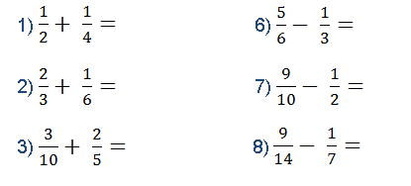  Lesson 2: Can I add and subtract mixed numbers? Look at the example below. Convert the fractions before you add the fractions!  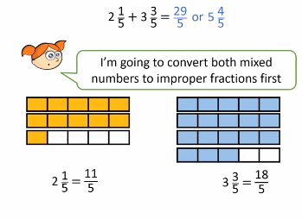  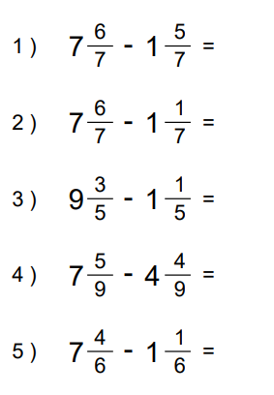  EXTENSION:  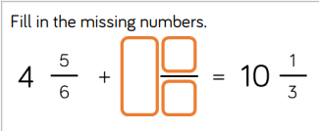  Lesson 3: Can I subtract fractions breaking the whole number?  https://www.youtube.com/watch?v=BVEioffrOt8  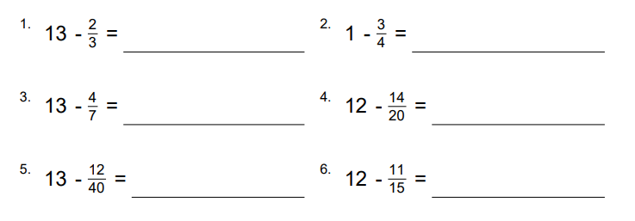  EXTENSION:  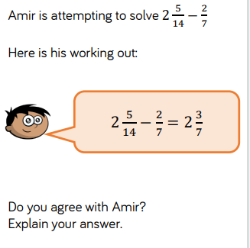  Lesson 4:  Lesson 5: Can  EXTENSION: Now try these
Spelling &  Grammar | Practise the Year 5 spelling rules:  - Spelling Rule 56 - Word list – years 5 and 6 - eq to f  https://spellingframe.co.uk/spelling-rule/5/Year-5-and-6  OR  Practise the Year 5/6 Spelling list in your Reading Journals - Look up the tricky words and put them into sentences
Topic  History | Lesson 1-  Lesson 2-
DT
PE | Yoga- How long can you hold these poses for? Record our results.
Topic
(Science)
German
PHSCE | Children’s Mental Health  - https://rivermillprimaryschool-my.sharepoint.com/:v:/g/personal/jberry_valley_bromley_sch_uk/ESYz_ZEIz1JLptNfygQzYEAB1iXsWxf-ufegVS0hvr4FcA?e=b73blk  - Complete one of the activities in resources

Week 5 Timetable
This is the timetable the Year 5 will be working with; however, changes are sometimes necessary and will be explained during the online lessons.

 | Monday1st February | Tuesday 2nd February | Wednesday 3rd February | Thursday 4th February | Friday 5th February
9am – 9.35  Group 1 Maths Input | 1 Can I  IXL/Maths Frame | 2 Can I  IXL/Maths Frame | 3 Can  IXL/Maths Frame | 4 Can I  IXL/Maths Frame | 5 Can I  IXL/Maths Frame
9.40- 10.15 Group 2 Maths input | 1.  RECAP of last week  IXL/Maths Frame | 2. Can I  IXL/Maths Frame | 3 Can I  IXL/Maths Frame | 4 Can I  IXL/Maths Frame | 5 Can I  IXL/Maths Frame
11am-11.35 Group A English input | 1Romeo and Juliet | 2 Romeo and Juliet - | 3Romeo and Juliet- | 4Romeo and Juliet-. | 5Reading Comprehension -  A New Hero
11.40-12.15  Group B English Input | 1Romeo and Juliet – | 2Romeo and Juliet – | 3Romeo and Juliet- | 4Romeo and Juliet- | 5.Reading Comprehension  A New Hero
2.00-2.40 IPC Input for all | PHSCE  Children’s Mental Health  PE  Yoga | IPC 1 | IPC 2 | Science | DT

