Home Learning
Year Group: 4 Week Beginning: 20th April 2020
Reading | - Read for 20 minutes daily  (Record in reading record books)
English | - The Empty School  - Can I write a newspaper report?  - Remember to use your writing targets  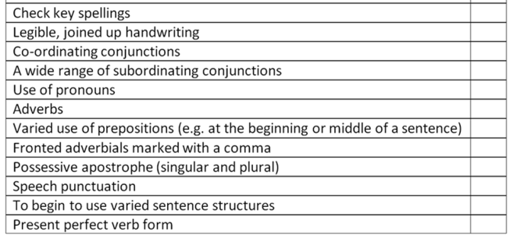  (2 do on Purple Mash)
Maths | - IXL Add and Subtract Fractions BB1-7  - IXL Equivalent Fractions AA1-7  - Purple mash - Division with remainders  - Division questions  - Complete ‘Maths frame times table check’ and record your result in the blue homework book  (Pupil Log in is in your reading record books)
Spelling | 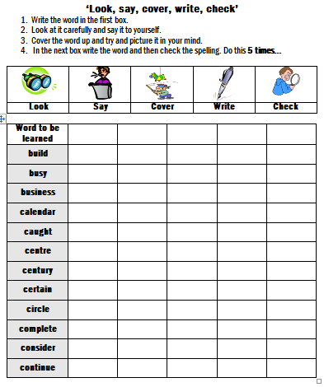  1 ) Rewrite these spellings into your blue homework book.  2) Use 5 of these spellings to write new sentences with the grammar you have already learnt.
Punctuation and Grammar | Complete on Purple mash  - Day Out (fronted Adverbials)  - Past and Present  - Word Combos (Paragraphs)  (Pupil Log in is in your reading record books)
IPC/Science | Go on to  www.purplemash.com  Use your login to complete any 2Dos that have been set by your teacher  Remember to save work as it is completed  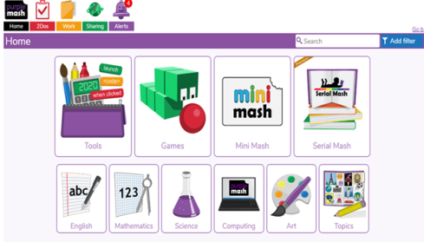  - History and Geography (A separate document)  2) Rules

German | Children should practice the learned German vocabulary in Linguascope.  To access these resources, please follow the steps below:  