Home Learning
Year Group: 4 Week Beginning: 25th January 2021
Reading | - Read for 20 minutes daily  - Check your books on Bug Club
English | -Please refer to the English document for this week’s lessons  Remember to use your writing targets  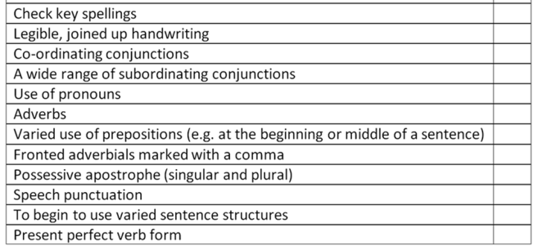  ]
Maths | Fractions: Tenths and Hundredths  -Refer to either the Maths A or Maths B document  -IXL: Understanding Fractions Y.1-Y.21
Spelling | Please refer to the spellings document.  There will be a spellings test on Friday at 2pm.
Punctuation and Grammar | All activities that are set are topics that have been covered in class.  -The Fox and the Hen on Purple Mash (Speech)  -Inverted Commas sheet  Group A- page 2 or 3  Group B- page 1 or 2

